

NAME:
MAHEEN RAZA

ROLL NO:
FA22-BSE-086

CLASS:
BSE-8B

SUBJECT:
DEVOPS OR CLOUD COMPUTING

SUBMITTED TO:
SIR MUHMMAD IBRAHIM

SUBMISSION DATE:
4/11/ 2026

INSTALLING JDK:
Java Development Kit (JDK) is required to run Jenkins because Jenkins is built in Java. First, download and install the JDK from the official website to enable Java support on your system.
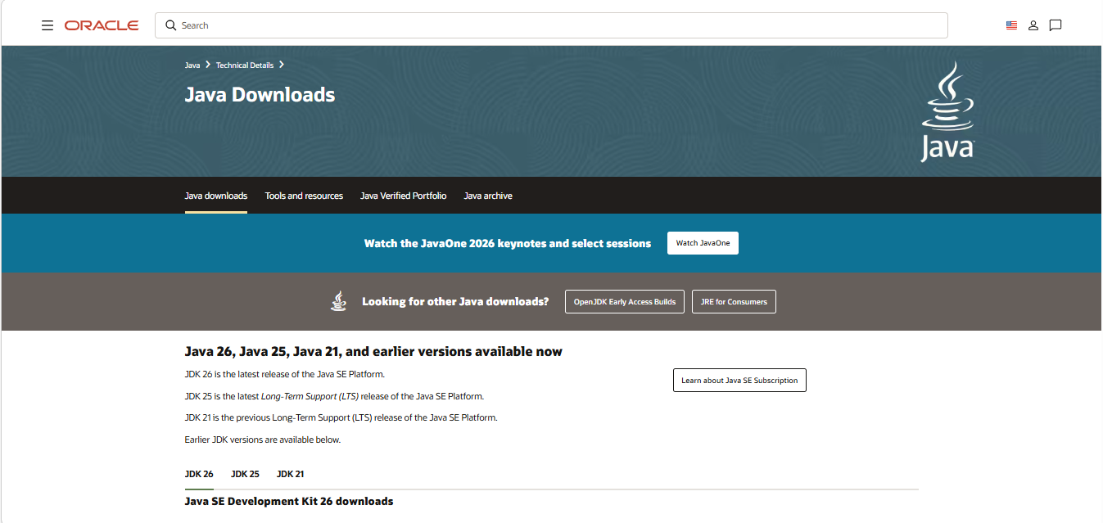
SETTING ENVIRONMENT VARIABLES:
After installing JDK, environment variables like JAVA_HOME are set so the system can recognize Java commands globally. This ensures Jenkins and other tools can run properly.
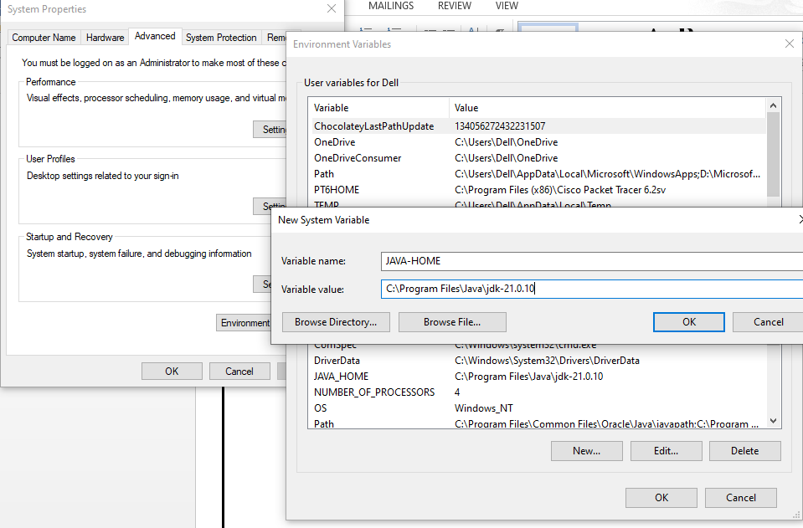
DOWNLOADING JENKINS:
Jenkins is downloaded from its official website. It is an open-source automation tool used for continuous integration and continuous delivery (CI/CD).
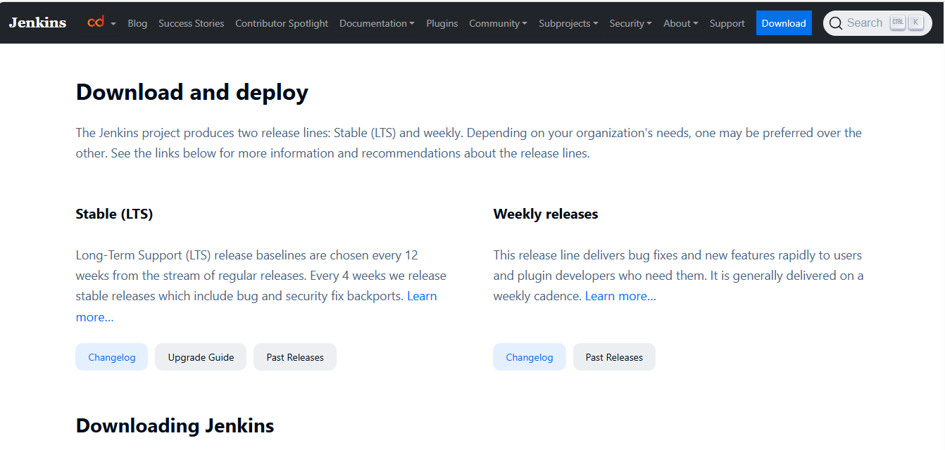
SELECTING WINDOWS:
While downloading Jenkins, the Windows version is selected based on the operating system being used. This ensures compatibility with the system.

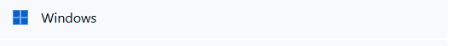
INSTALLING JENKINS:
Jenkins is installed using the downloaded setup file. The installation wizard guides through the process, including selecting default settings.
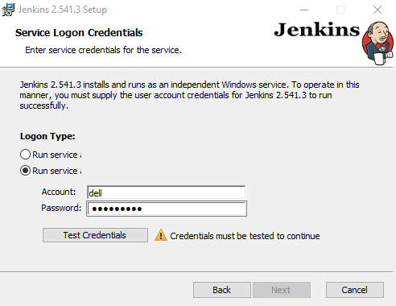

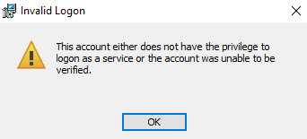

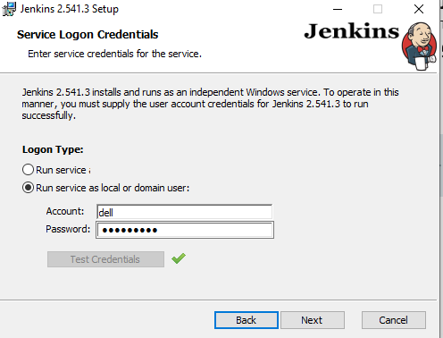
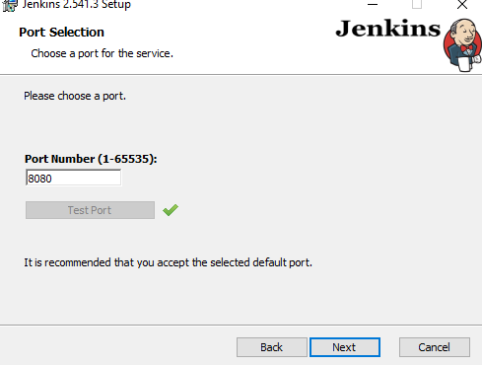
LOCALHOST 8080:
After installation, Jenkins runs locally on port 8080. You can access it in a browser using http://localhost:8080 to open the Jenkins interface.

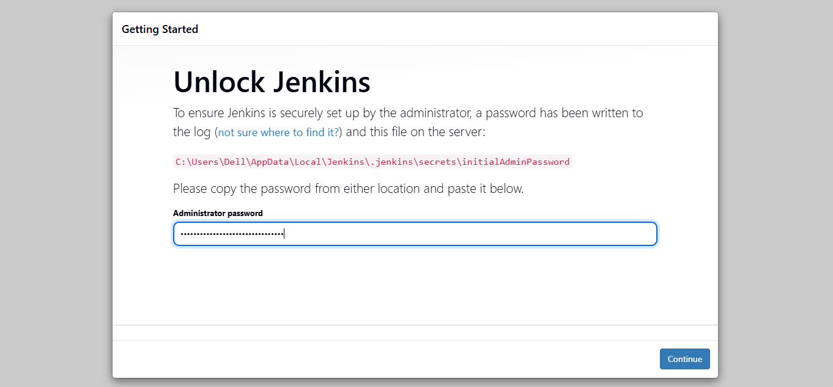
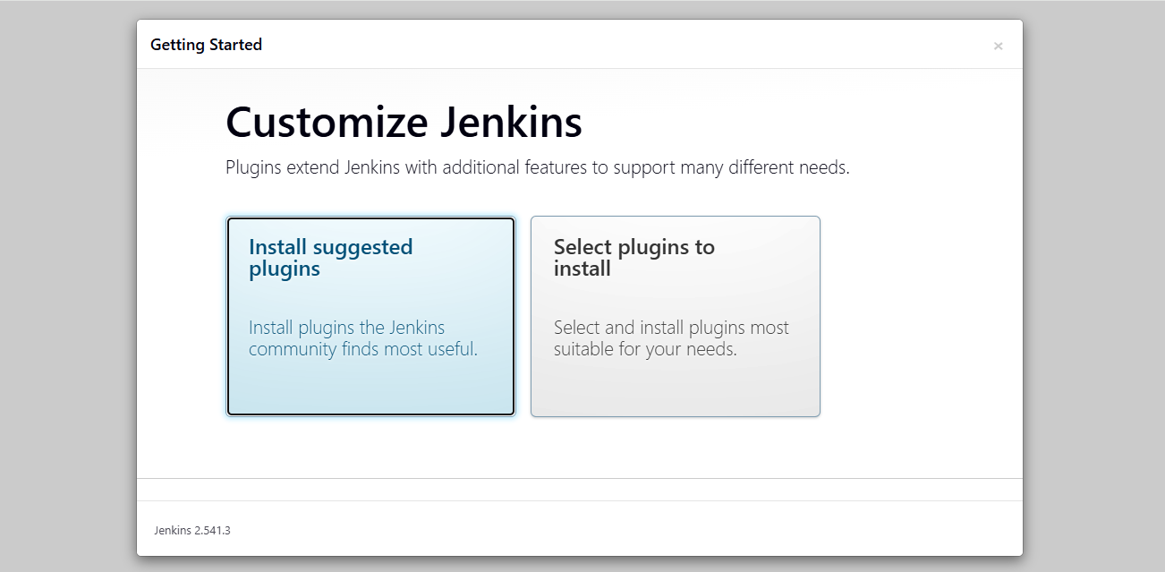
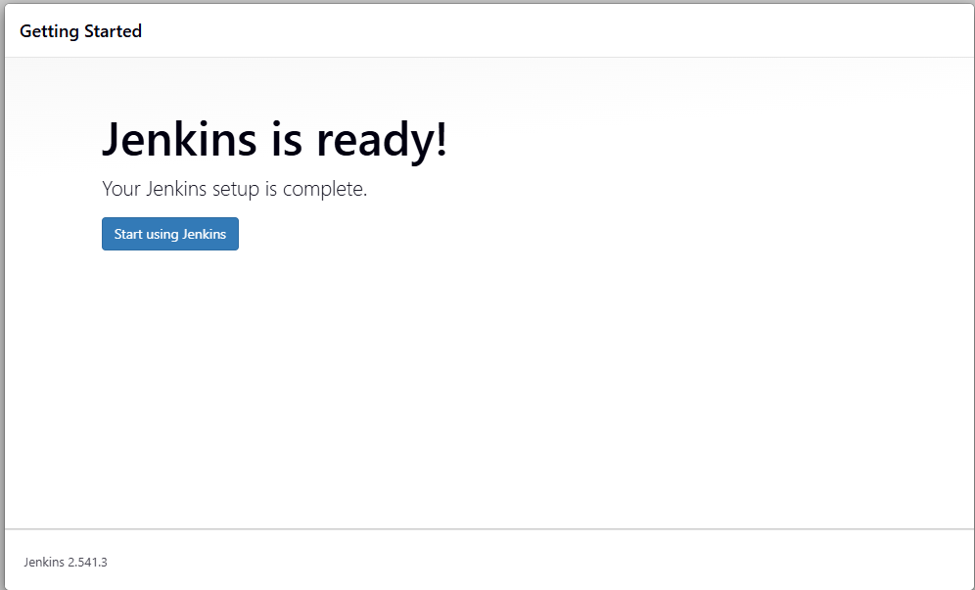

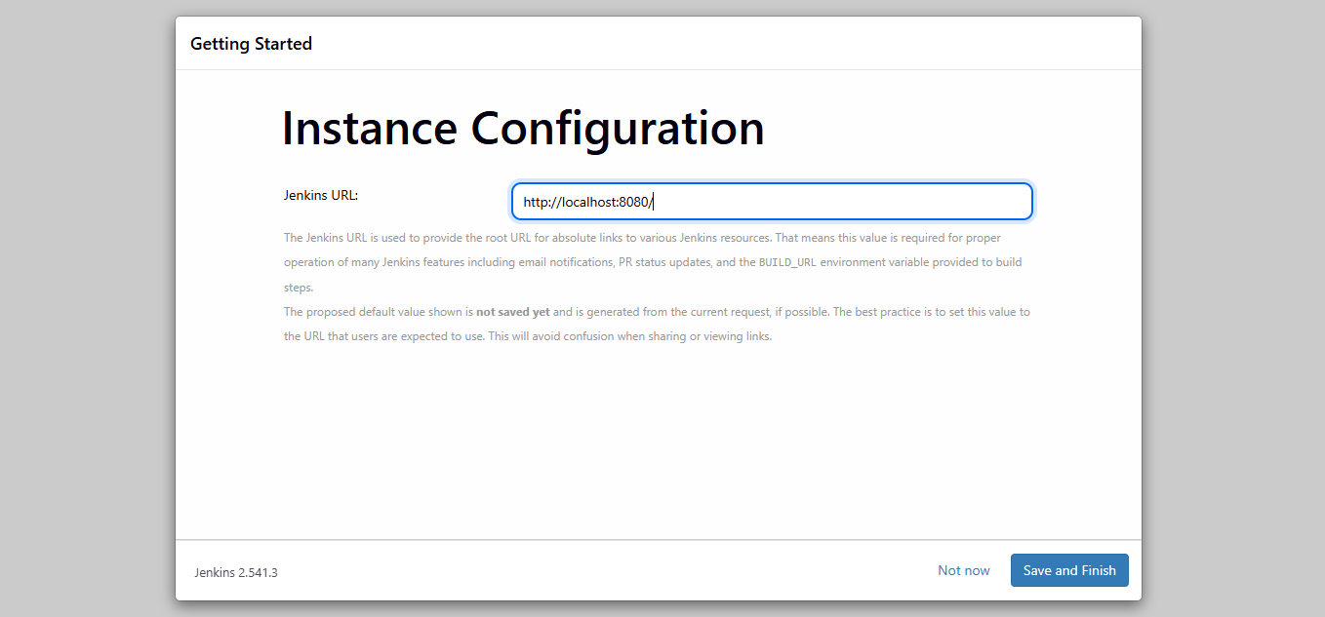
JENKIN DASHBOARD
The Jenkins dashboard is the main interface where all jobs, builds, and system status are displayed. It is used to manage and monitor automation tasks.
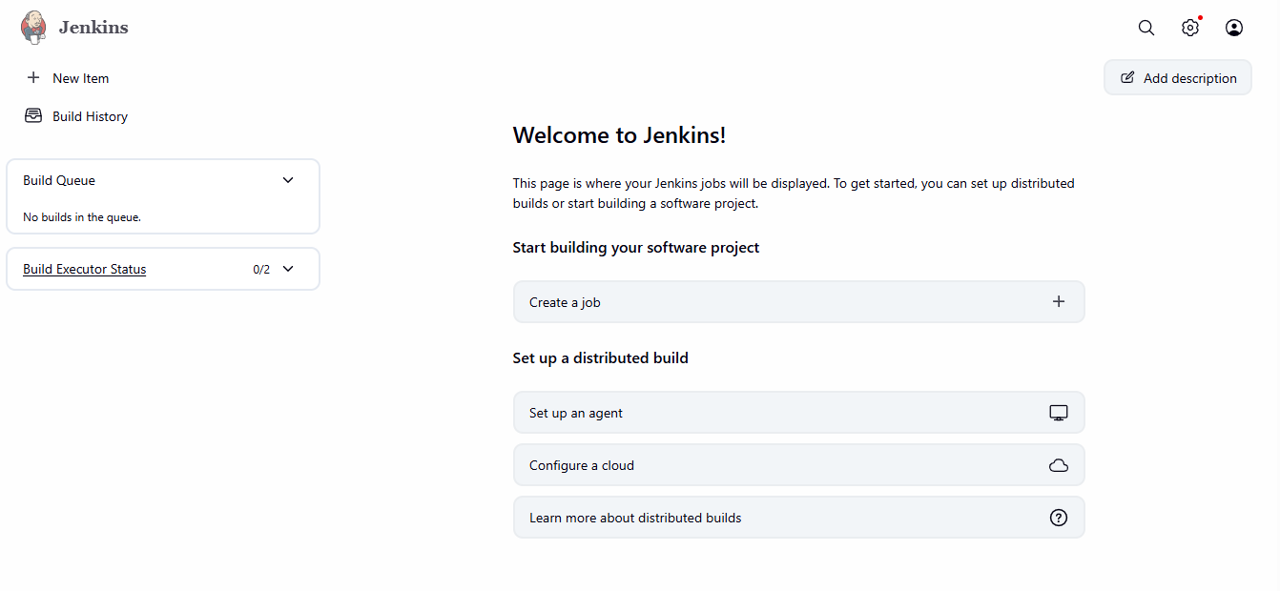
CREATING JOB:
A job (or project) is created in Jenkins to automate tasks like building and testing code. It defines what actions Jenkins will perform.
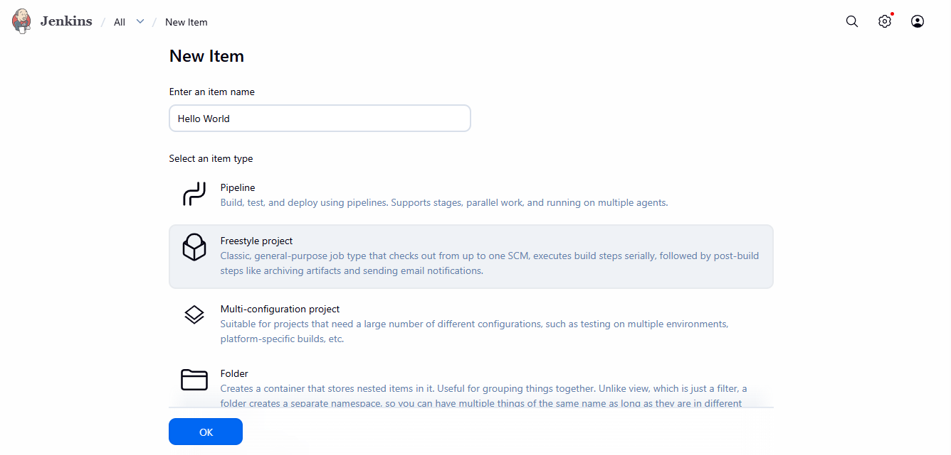
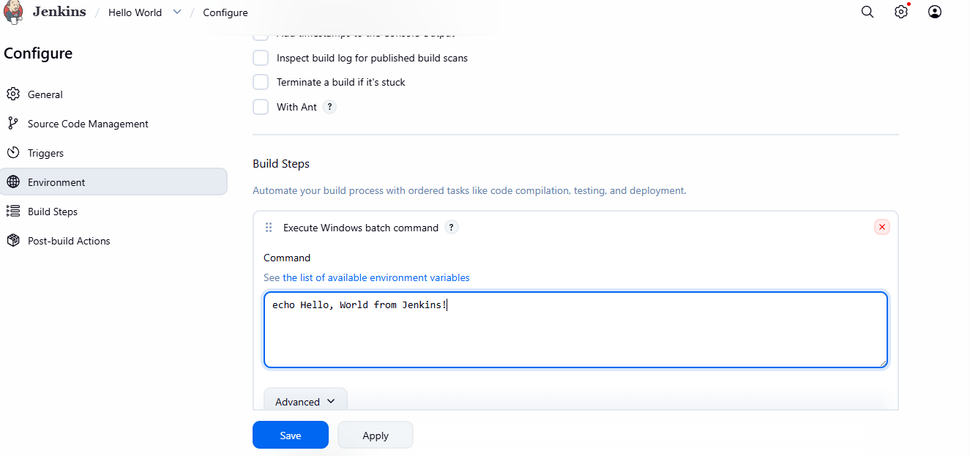
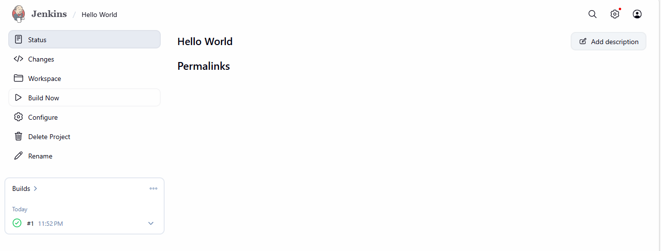
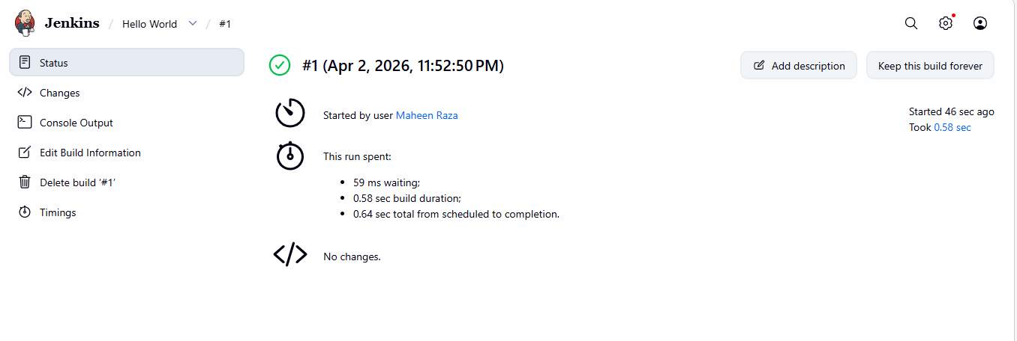
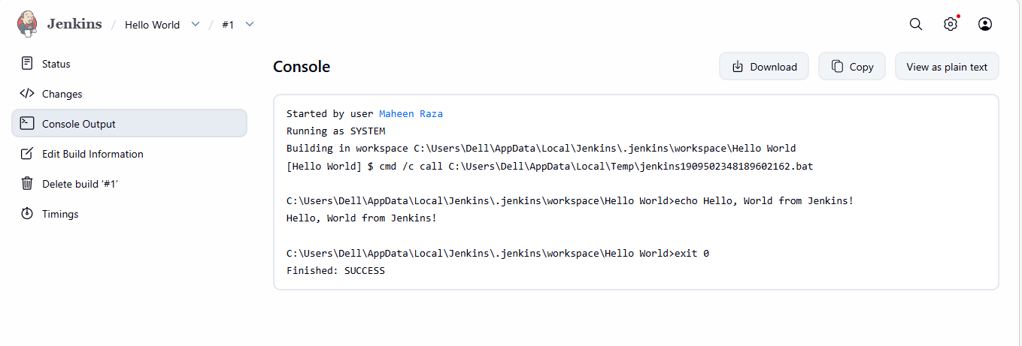
INTEGRATION WITH GITHUB
Jenkins is connected with GitHub to automatically fetch code from repositories. This enables continuous integration whenever changes are made.
CREATING NEW REPOSITORY:
A new repository is created on GitHub to store project files. This repository is later linked with Jenkins for automation.
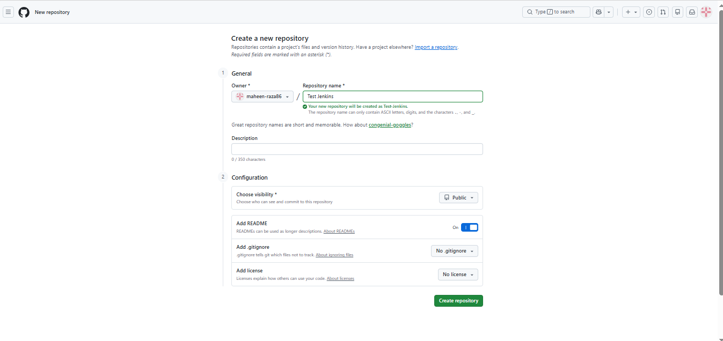
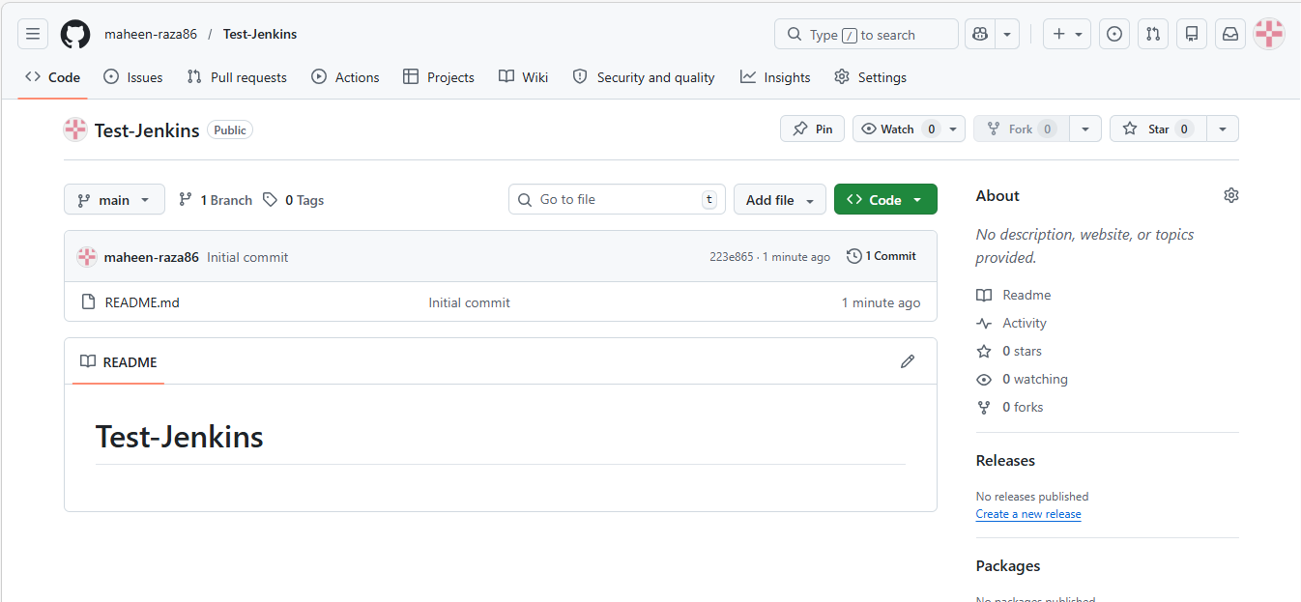
CREATING NEW JOB:
A new job is configured in Jenkins by selecting project type and linking it with the GitHub repository. Build triggers and steps are also defined here.

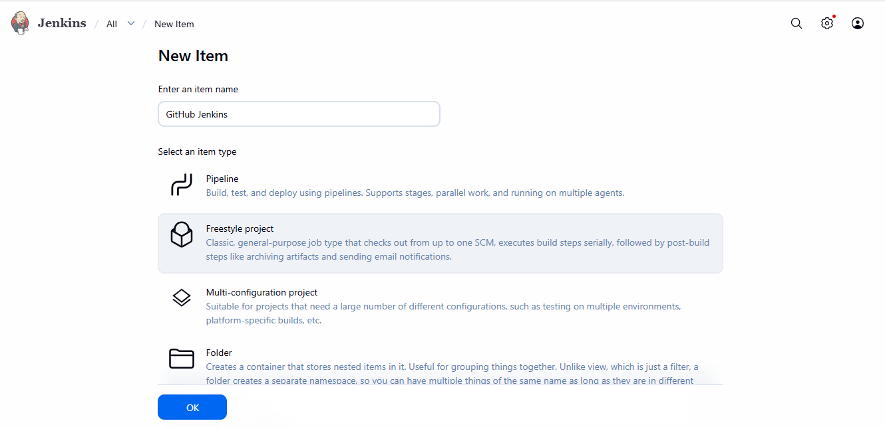
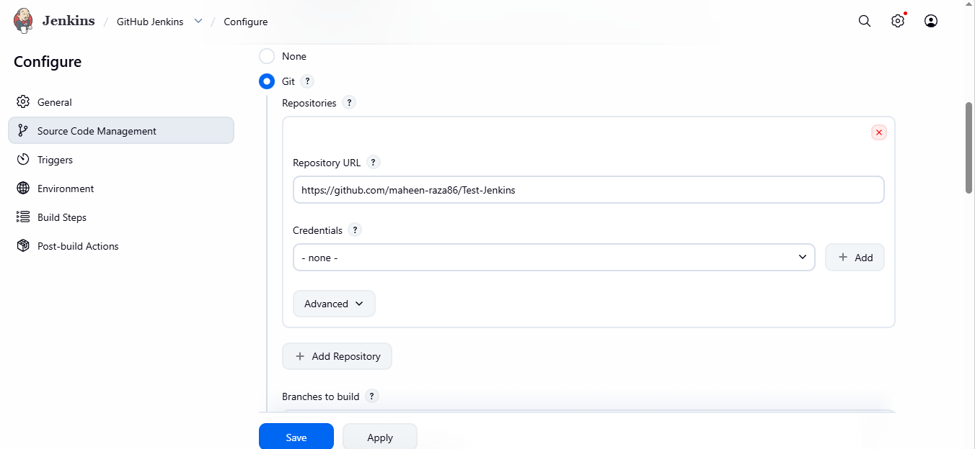
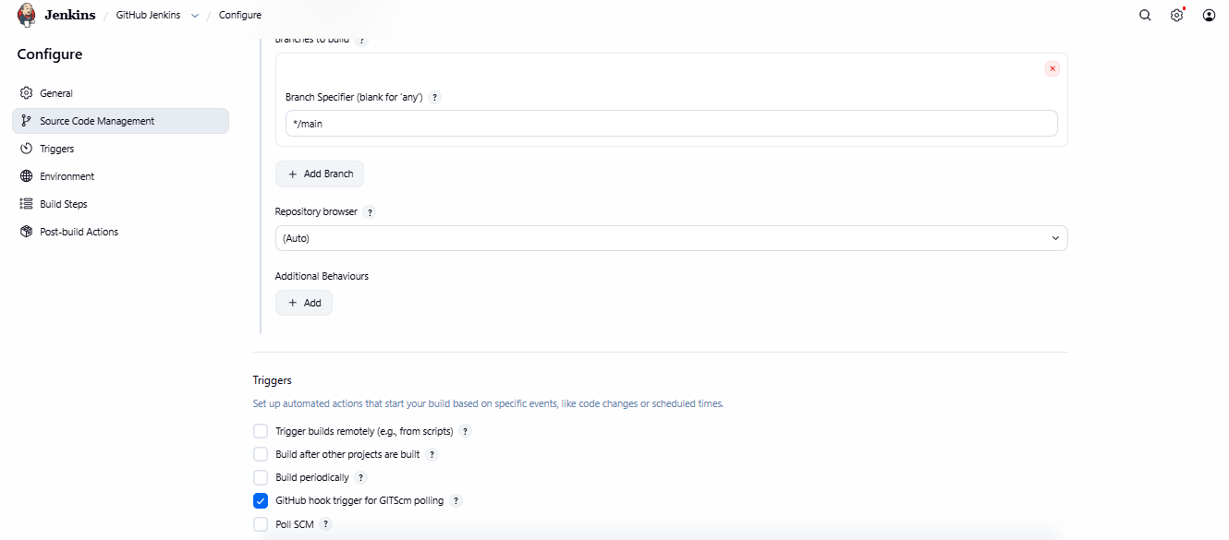
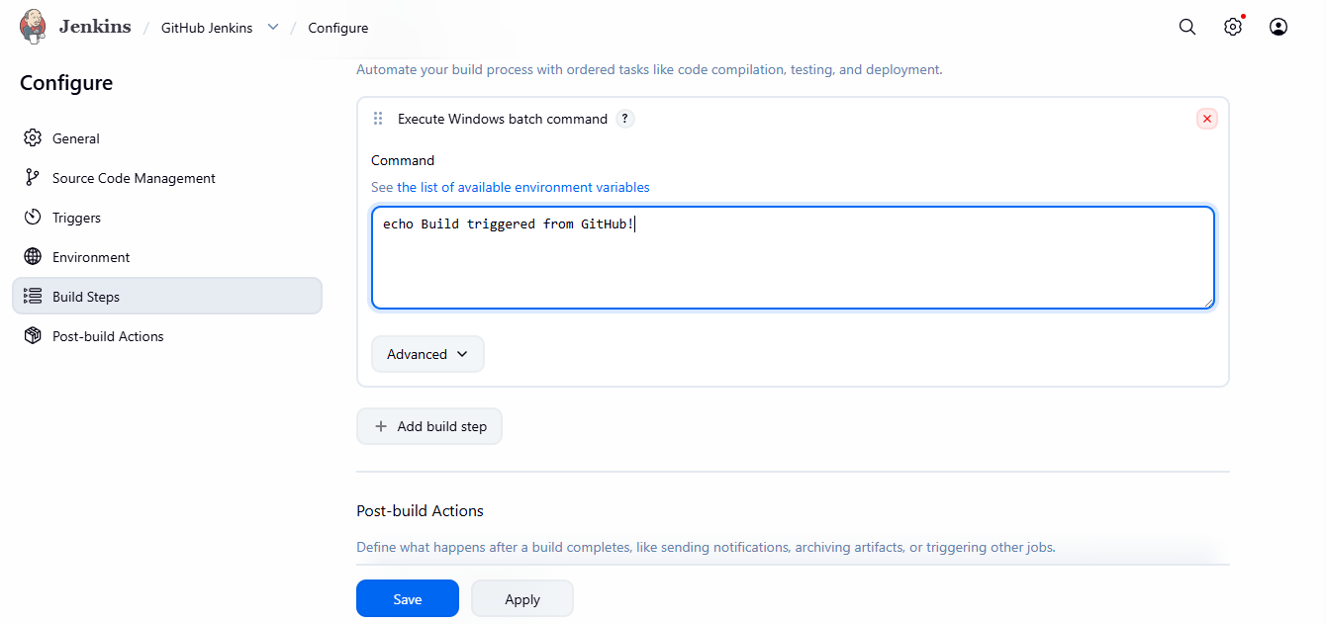
NGROK DOWNLOAD:
Ngrok is downloaded to expose the local Jenkins server to the internet. This helps GitHub communicate with Jenkins via webhooks.
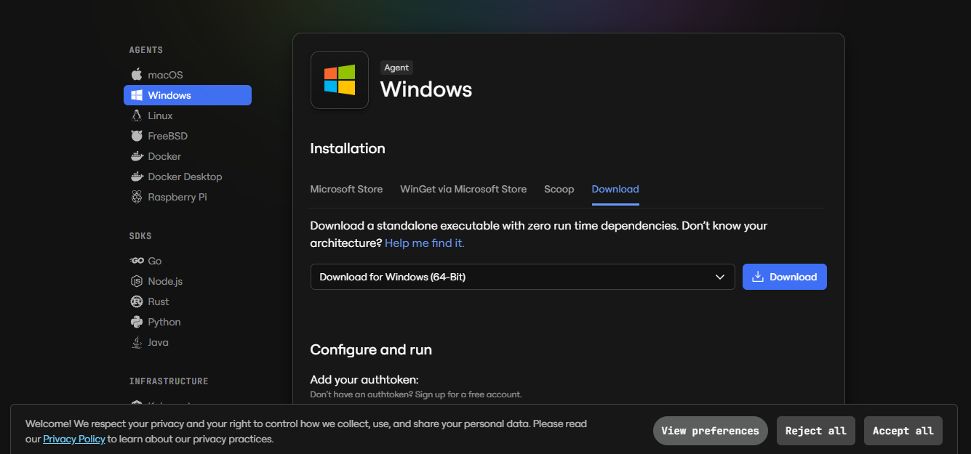
CREATING NGROK ACCOUNT:
An account is created on ngrok to get an authentication token. This token is required to run ngrok securely.
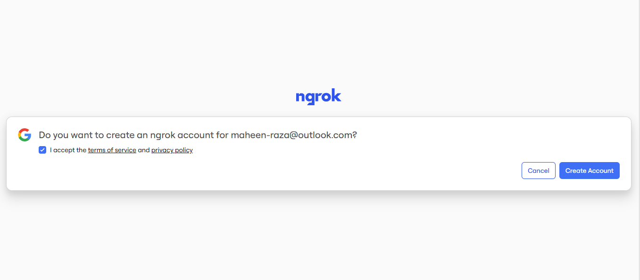
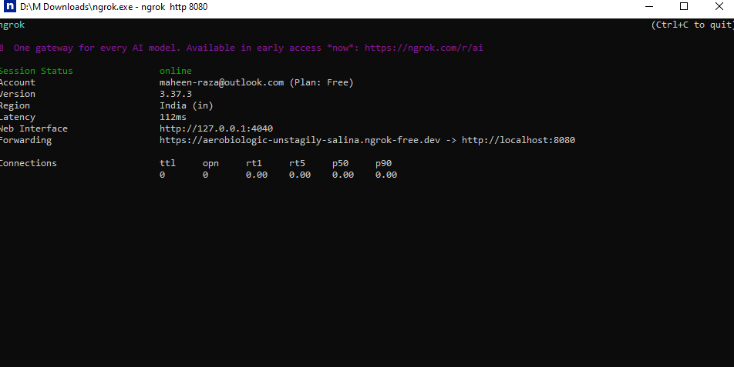
WEBHOOKS IN GITHUB
Webhooks are set in GitHub to notify Jenkins whenever changes are pushed to the repository. This automates the build process.
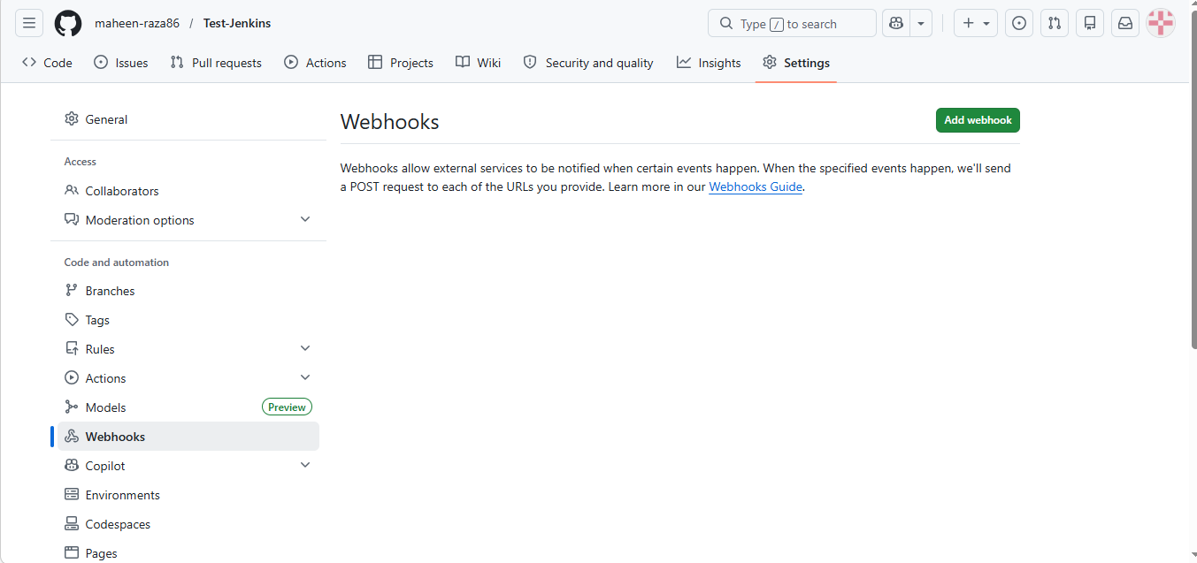
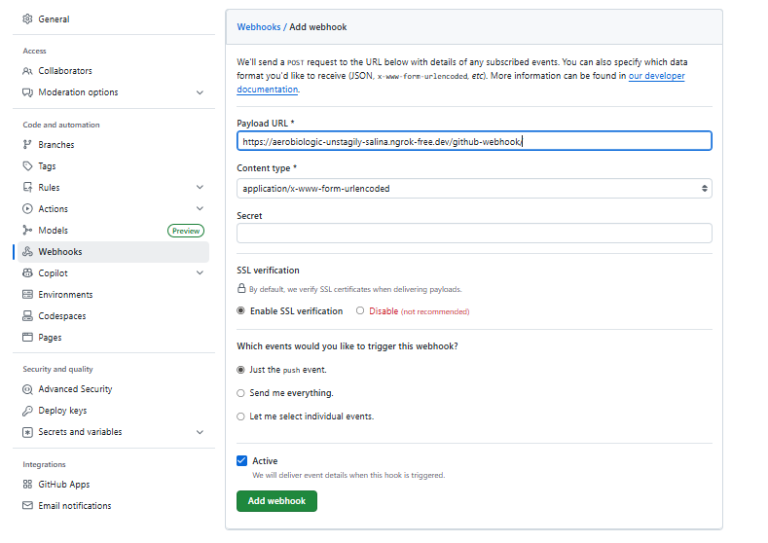
WEBHOOK CREATED SUCCESSFULLY:
This confirms that the webhook is properly configured and connected to Jenkins through ngrok.
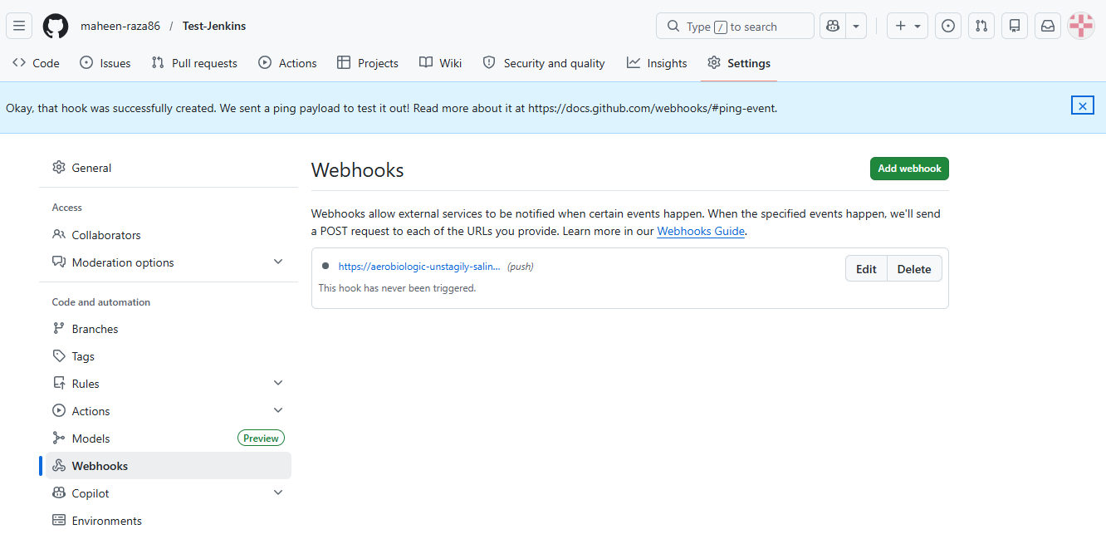
MAKING CHANGES IN REPOSITORY:
Changes are made in the GitHub repository (like editing files or adding code) to test the automation workflow.
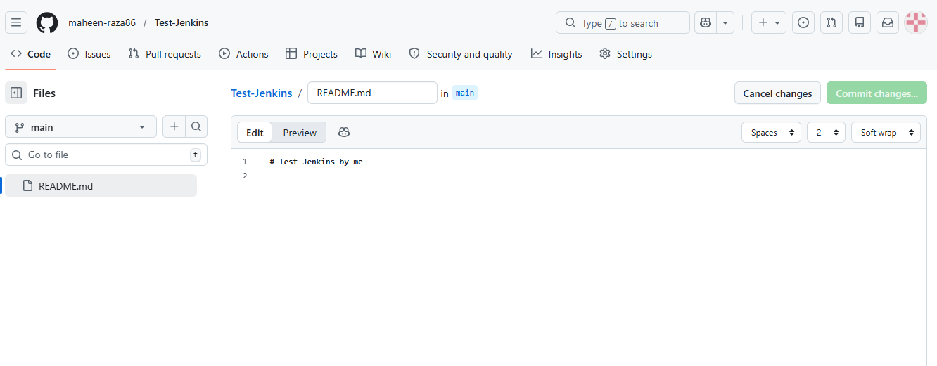
SUCCESSFULLY JOB EXECUTED IN JENKINS:
After pushing changes, Jenkins automatically triggers the job and executes it successfully, showing that CI/CD pipeline is working.
