Secure Software Design and Development

Threat Model Report
Submitted to:
Engr Muhammad Ahmad Nawaz
Prepared by:
Maheen Aamir (SP23-BCT-027)
Malik Muhammad Huzaifa (SP23-BCT-029)
Muzamil Ali Akhtar (SP23-BCT-043)
Maryum Masood (SP23-BCT-031)
Department of computer science
(Cyber Security)
Threat Model Report

1. Scope and System Context
This threat model is based on the current source code of the Flask To-Do application. The analysis covers all authentication and task-management routes, data models, application factory, and configuration module.

Files in Scope
This threat model is based on the current code in:
- app/routes/auth.py — /register, /login, /logout
- app/routes/tasks.py — /, /tasks/create, /tasks/<int:task_id>/edit, /tasks/<int:task_id>/delete
- app/models/user.py and app/models/task.py
- app/__init__.py (application factory) and config.py

1.2 Data Storage
Data is persisted in SQLite (todo.db). The Task.user_id foreign key serves as the primary ownership boundary between user records. All object-level access decisions are based on this boundary.

2. STRIDE Threat Analysis
The following table presents the full STRIDE threat register for the Flask To-Do application, covering each threat category with a concrete application example and current mitigation status.

STRIDE Category | Threat Description | Example in this To-Do App | Mitigation Status in Code
S (Spoofing) | Attacker acts as another user by stealing credentials/session. | POST to /login with stolen credentials then access / to read tasks. | Passwords hashed with generate_password_hash() and verified with check_password_hash(). Authenticated routes use @login_required. Gap: no lockout/rate limit on login.
T (Tampering) | User alters task data they do not own. | Change task_id in /tasks//edit or /tasks//delete. | Mitigated: _get_user_task_or_404() uses Task.query.filter_by(id=task_id, user_id=current_user.id).first_or_404().
R (Repudiation) | User denies making a change; no forensic trail. | User claims they did not delete a task. | Gap: only flash messages; no persistent audit log (user id, IP, timestamp, route).
I (Information Disclosure) | Unauthorized data exposure between users or via unsafe runtime config. | View tasks by ID enumeration; stack traces if debug=True. | Per-user queries exist, object-level checks in place. Gap: run.py currently starts Flask with debug=True.
D (Denial of Service) | Resource exhaustion blocks legitimate use. | Repeated POST flooding on /login or saturates app/DB. | Gap: no request throttling, CAPTCHA, or reverse-proxy limits in code.
E (Elevation of Privilege) | Regular user performs actions outside their scope. | Normal user attempts to access other users' tasks. | Mitigated: task ownership enforced. No admin role currently.

3. Data Flow Diagram (DFD)
The following DFD describes the data flows between the browser, the Flask application, the ORM layer, and the SQLite database, including the security controls applied at each layer.
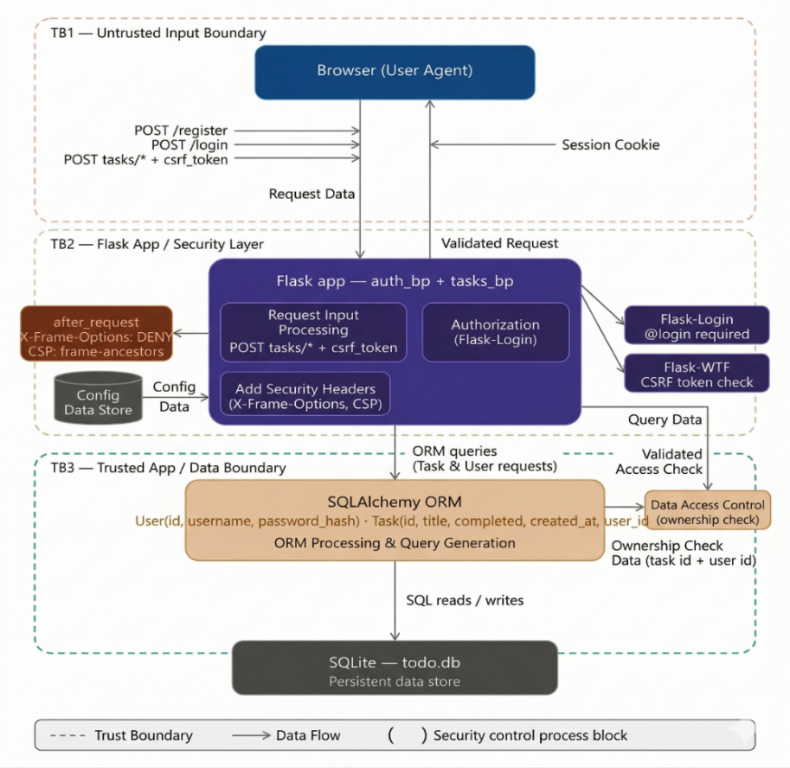
The system architecture is structured into three distinct trust boundaries that act as security gates for data as it moves from the user to the database:
TB1 — Untrusted Input Boundary (Client Layer)
This boundary separates the Browser from the server. All data coming from the user agent is considered hostile or untrusted. Security at this transition focuses on verifying that the request is legitimate (Authentication) and that it was intentionally sent by the user (CSRF verification).
TB2 — Flask App / Security Layer (Application Layer)
This is the internal processing zone where the Flask Blueprints reside. Once a request crosses TB1, it enters this layer to be filtered. Here, middleware enforces access rules (like @login_required) and injects security headers (X-Frame-Options) into the response to protect the user from UI-based attacks like clickjacking.
TB3 — Trusted App / Data Boundary (Data Layer)
This boundary sits between the application logic and the SQLite database. It is the most critical line of defense for data privacy. At this stage, the SQLAlchemy ORM applies Ownership Checks (IDOR mitigation). It ensures that even if a request is authenticated, the user only has permission to read or write data where the user_id matches their own session identity.

4. Attack Tree — Unauthorized Task Access
The following attack tree maps the exploitation paths an adversary could use to read or modify another user's task. All three paths are currently mitigated by implemented controls.

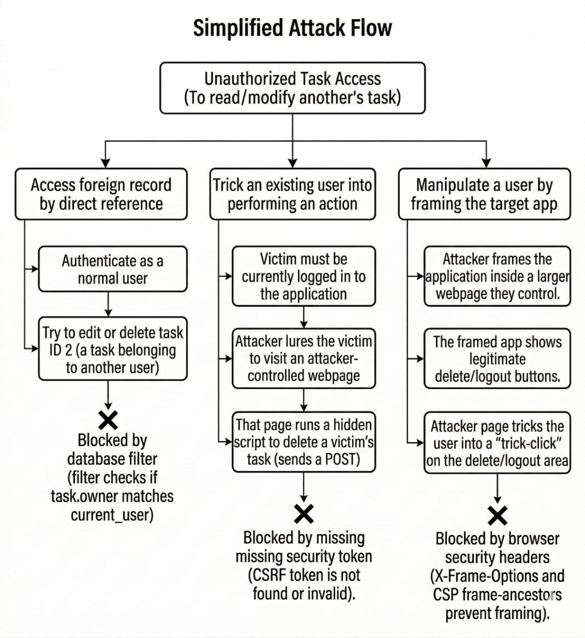

5. Implemented Mitigations
The following controls have been implemented and verified in the current codebase:

Control | Vulnerability Addressed | Implementation Detail | Status
Object-level ownership check | IDOR | _get_user_task_or_404() filters Task by task_id AND current_user.id | Implemented
CSRF protection | CSRF | csrf.init_app(app) + hidden csrf_token in all auth and task forms | Implemented
Logout hardening | CSRF on logout | /logout changed to POST method with CSRF token in navbar form | Implemented
Session cookie hardening | Session hijack / CSRF | SESSION_COOKIE_SAMESITE = 'Lax' set in config.py | Implemented
Anti-framing headers | Clickjacking | app.after_request sets X-Frame-Options: DENY and CSP frame-ancestors 'none' | Implemented

6. Residual Gaps and Recommended Actions
The following gaps remain open and should be addressed before production deployment:

Gap ID | Risk Area | Current State | Recommended Action | Priority
G-01 | Information Disclosure | run.py starts Flask with debug=True | Set DEBUG=False via environment variable in all non-development contexts | High
G-02 | Denial of Service / Spoofing | No rate limit or lockout on /login | Integrate Flask-Limiter to throttle login attempts; add exponential back-off or account lockout | High
G-03 | Repudiation | No persistent audit log | Implement structured audit logging capturing user_id, IP address, timestamp, HTTP method, and route for all auth and task CRUD events | Medium

7. CVSS v3.1 Risk Ratings
The following CVSS v3.1 base scores were assigned to the three primary vulnerabilities. Scores reflect the exploitability and impact characteristics of each finding in the context of this application.
Vulnerability | CVSS v3.1 Vector | Base Score | Severity | Remediation Priority
CSRF — Unauthorized form submission | AV:N/AC:L/PR:N/UI:R/S:U/C:N/I:H/A:N | 8.8 | High | P1 — Addressed (CSRFProtect)
IDOR — Unauthorized task access | AV:N/AC:L/PR:L/UI:N/S:U/C:L/I:H/A:N | 6.5 | Medium | P2 — Addressed (ownership filter)
Clickjacking | AV:N/AC:L/PR:N/UI:R/S:C/C:L/I:L/A:N | 5.4 | Medium | P3 — Addressed (XFO + CSP)

Score Rationale
- CSRF (8.8 High): No privileges required; any network attacker can craft the forged request. Integrity impact is high as any POST action can be triggered without the user's knowledge.
- IDOR (6.5 Medium): Requires a low-privilege authenticated account. Direct high integrity impact as any task record can be modified or deleted by a non-owner.
- Clickjacking (5.4 Medium): Requires user interaction and produces partial confidentiality and integrity impact via UI deception. Scope change (S:C) reflects browser context boundary crossing.

8. Summary and Conclusion
The Flask To-Do application implements a solid baseline of security controls across its three primary threat vectors. IDOR, CSRF, and Clickjacking are all mitigated through code-level controls verified in the current codebase.
The three residual gaps — debug mode enabled in production execution paths, absent login rate limiting, and no audit logging — should be addressed in the next sprint before the application is deployed to any non-development environment.
Area | Posture
IDOR protection | Mitigated — user-scoped object lookup on all task mutation routes
CSRF protection | Mitigated — global CSRFProtect + tokenized forms including logout
Clickjacking protection | Mitigated — X-Frame-Options: DENY + CSP frame-ancestors 'none'
Session security | Partially hardened — SameSite=Lax set; HttpOnly and Secure flags should be confirmed
Debug mode | Gap — debug=True in run.py must be removed for production
Login rate limiting | Gap — no throttling on /login; brute-force risk remains open
Audit logging | Gap — no persistent event log; repudiation risk remains open

