bulb
Our best bulb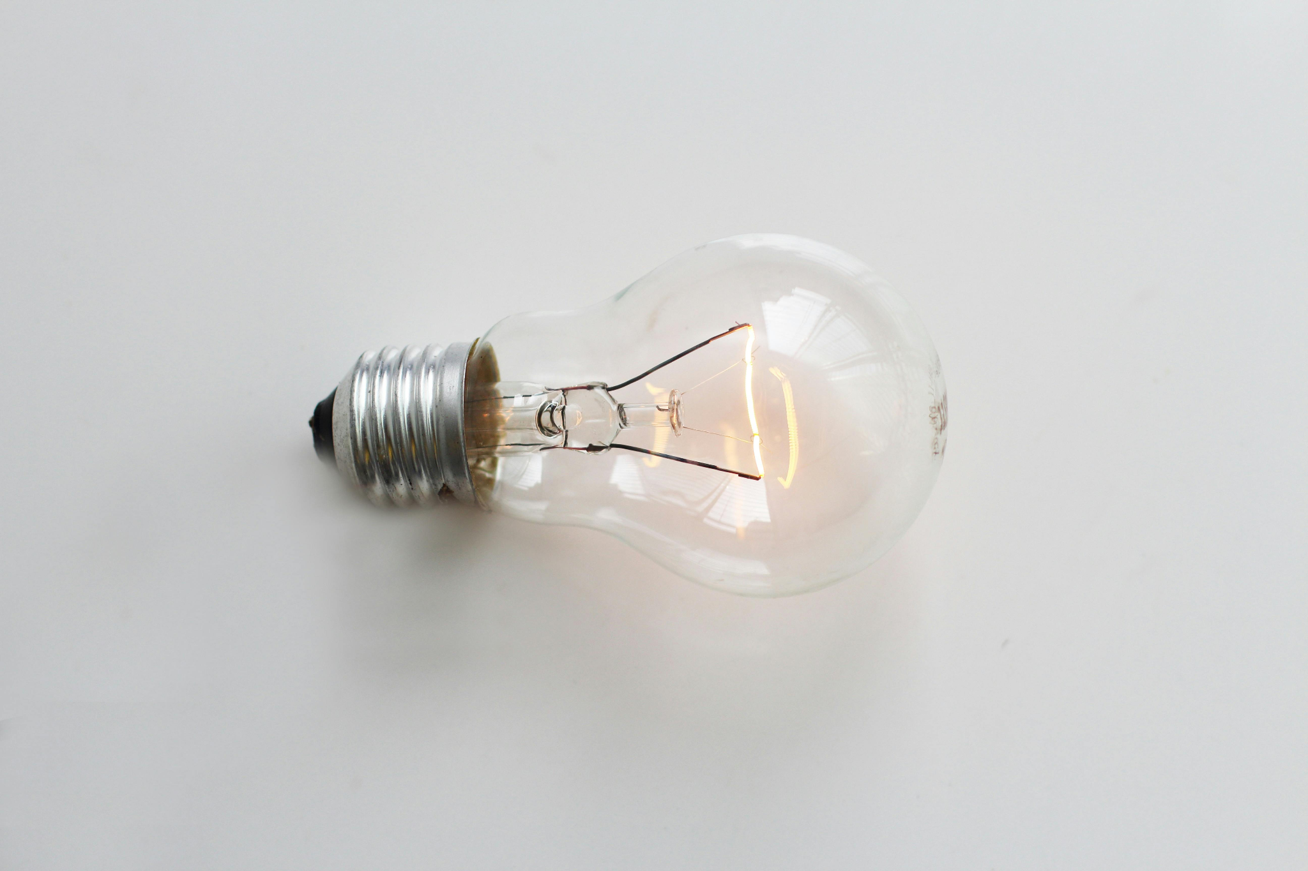
Price:250
Color: white
Material: Glass

💡 BULB OVERVIEW
A bulb is a basic lighting device used in homes, offices, and other spaces to provide light. It converts electrical energy into light energy, making it easier to see in dark environments. Modern bulbs come in different types like LED, energy-saving, and smart bulbs.

⚙️ PERFORMANCE & FEATURES
Bulbs are available in different brightness levels (lumens) and colors such as warm white, cool white, and daylight. LED bulbs are energy-efficient and long-lasting. Some smart bulbs can be controlled through mobile apps for brightness and color adjustment.

🔧 INSTALLATION & MAINTENANCE
Bulbs are very easy to install—just fit them into a compatible holder. To ensure long life, avoid frequent switching on/off and use proper voltage. LED bulbs require very little maintenance and are generally more durable than traditional bulbs.

