button
Our best button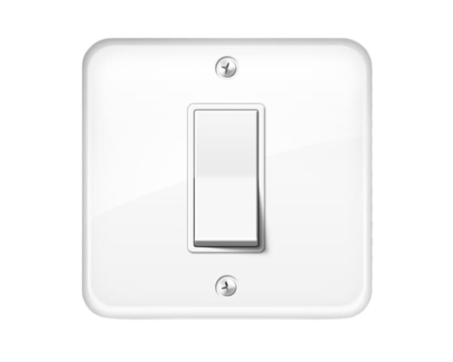
Price:250
Color: white
Material: plastic

🔘 BUTTON OVERVIEW
A button is a small electrical device used to control circuits by pressing it. It is commonly used in electronic devices, machines, and home electrical systems. Buttons help in starting or stopping a function with simple press action.

⚙️ PERFORMANCE & FEATURES
Buttons are designed for easy and quick operation. They come in different shapes and sizes such as push buttons, switch buttons, and reset buttons. Many buttons are made with durable plastic or metal for long-lasting use.

🔧 INSTALLATION & MAINTENANCE
Buttons should be installed properly in the correct circuit connection. Regular checking is important to ensure smooth functioning. Keeping buttons clean and dust-free helps improve performance and durability.

