Fan
Our ceiling fan
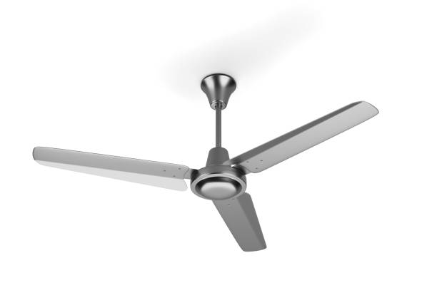
Price:4999
Color: black
Material: Metall
CEILING FAN OVERVIEW
A ceiling fan is a common home appliance that helps circulate air and keeps the room cool. It works using rotating blades that spread air evenly, making the environment more comfortable. Modern fans also come in stylish designs that enhance home décor.
PERFORMANCE & FEATURES
Ceiling fans offer multiple speed settings to control airflow. Many advanced models include remote controls, timers, and energy-efficient motors for quiet and smooth operation.
INSTALLATION & MAINTENANCE
Ceiling fans are easy to install but should be fitted securely. Regular cleaning and occasional servicing help maintain performance and extend the fan’s lifespan.

