Gycier
Our best gycier
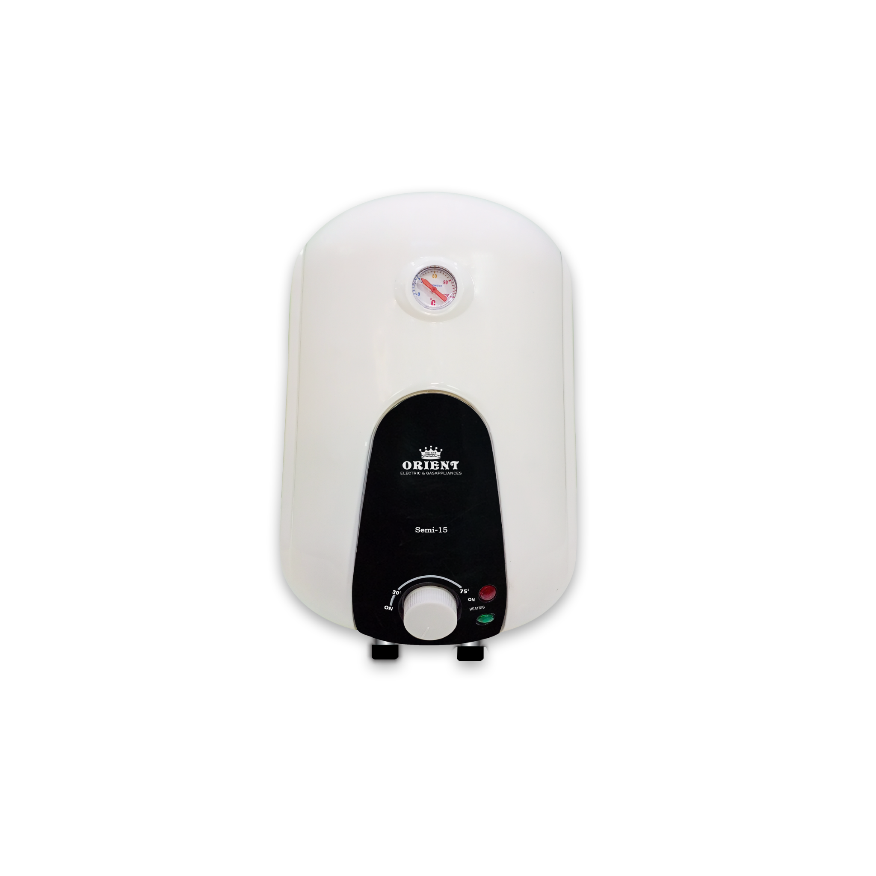
Price:6500
Color: white
Material: metal

💧 GYSER OVERVIEW
A geyser is a home appliance used to heat water for bathing, washing, and other daily needs. It stores and heats water using electricity or gas, providing hot water whenever required. Modern geysers are designed to be energy-efficient and safe for household use.

⚙️ PERFORMANCE & FEATURES
Geysers come with different capacities and heating speeds. Many modern models include temperature control, automatic cut-off systems, and energy-saving modes. Some advanced geysers heat water quickly while maintaining safety and consistent temperature.

🔧 INSTALLATION & MAINTENANCE
Geysers should be installed by a professional to ensure safety. Proper water pressure and electrical connection are lifespan.

