Switch
Our best switch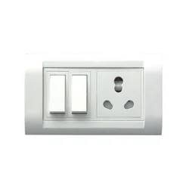
Price:450
Color: white
Material: plastic

🔌 SWITCH OVERVIEW
A switch is an electrical device used to turn appliances on and off. It controls the flow of electricity in a circuit, making it an essential part of every home and building. Modern switches come in stylish designs that match interior décor.

⚙️ PERFORMANCE & FEATURES
Switches are designed for smooth operation and long-lasting use. They are available in single, double, and multi-gang options. Some advanced switches include safety features like shock protection and fire-resistant materials.

🔧 INSTALLATION & MAINTENANCE
Switches should be installed by a qualified electrician to ensure safety. Proper wiring is very important for correct functioning. Regular checking of loose connections helps prevent electrical issues and increases safety.

