|  |
| --- |
| FS-Analytics-Dashboard: Consulting Report |
| As of latest refresh (Sep. 2025) |

# KPI Overview

* Total Revenue: £1.3M
* Average Order Value: £158
* Total Orders: 8000
* Distinct customers: 500
* Active Customers (30D): 271
* Cohort Retention (30D): 58.5%
* Late Settlement Revenue: £563.9K
* Late Settlements: 44.7%
* Average Days to Settle: 8.72

# Region & Other Breakdowns

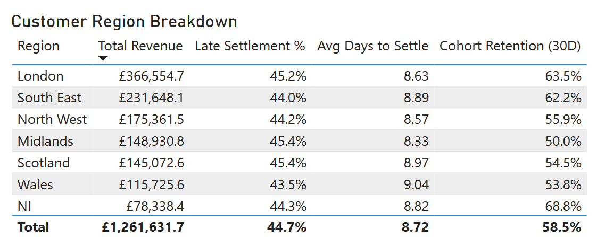

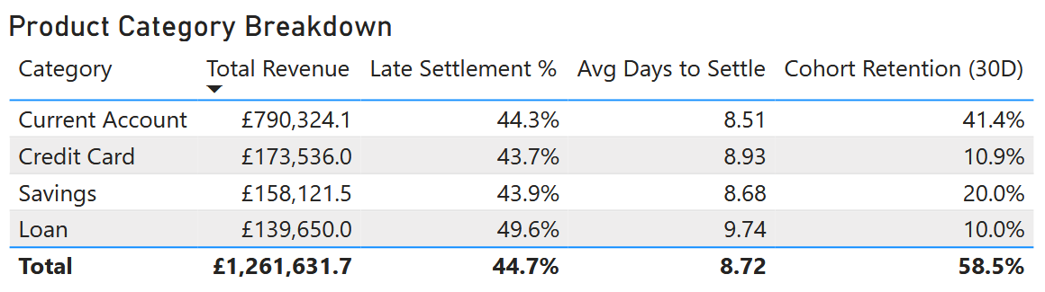

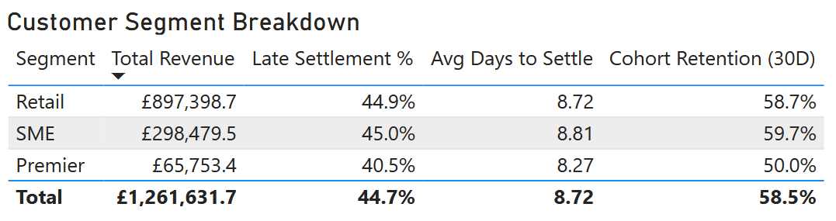

# Insights

* London region drives most revenue (£367k); ‘Retail’ generates 71.1% of revenue across all segments; ‘Current Account’ generates 62.3% of revenue across all categories.
* Late settlements are uniform across all regions (range of 1.4%); ‘Loan’ transactions have notably high occurrences of late settlements (49.6% | +4.9% avg); ‘Premier’ transactions have notably low occurrences of late settlements (40.5% | -4.2% avg).
* Average days to settle is uniform across all regions (range of 0.45 days), with the sole exceptioon of ‘Loan’ transactions (9.74 avg days to settle | +1.02 days avg)
* NI region shows greatest retention (68.8%) with average late settlement proportion (44.3%)

# Actions

**Next 30-60 days, with owners and targets**

* **Target cohorts with highest historical late impact**. Prioritise London and South East given their revenue domination. Work the top 20 repeat-late accounts (by historical Late Settlement %) with a T+0/T+2/T+5 cadence and one-click payment links. Measure change vs baseline in the next period. Target (next period): −5–10pp in Late Settlement %.
* **Fix the historically slow product journey (Loan).** With historical late settlement proportion of 49.6% and 9.74 average days to settle, A/B test pre-due reminders, invoice clarity, and a net-14 pilot for high-risk cohorts. Target (next period): Avg Days ≤ 8.5; Late % < 45%.
* **Lift historically weak retention cohorts and preserve strong.** Raise ‘Premier’ via Day 1/7/21 onboarding and 30–120d win-backs; keep NI (68.8%) cadence stable. Target (next period): +3–5pp in 30D retention.
* **Operating rhythm (historical → forward).** Lock today’s baselines and track rolling 3-week averages for Late Settlement %, Avg Days to Settle, and 30D retention by Region/Segment/Category. Target (next period): ≥2 targets hold for 3 consecutive weeks.

# Definitions

* **Late Settlement %** = proportion of settled transactions that settled after due date (48 hours after transaction date) within the period.
* **Cohort Retention (30D)** = proportion of customers active in current 30 days who also purchased in the preceding 30 days.
* **T+0 / T+2 / T+5 cadence** = timed outreach sequence relative to a trigger (e.g., invoice due or missed payment). **T+0** = same day, **T+2** = 2 days later, **T+5** = 5 days later.
* **Net-14 pilot** = controlled test of **14-day** payment terms (vs. your current term) for a defined cohort (e.g., late-prone SMEs). Run A/B with a holdout. Success = lower **late settlements** and **avg days** with minimal churn/complaints.
* **Day 1/7/21 onboarding** = three-touch post-signup/first-use journey: **Day 1** quick-start + “pay/settle” setup; **Day 7** benefits/features; **Day 21** habits/next best action. Goal: improve early retention and reduce avoidable lateness.
* **30–120d win-backs** = re-engagement to customers whose last activity was **30–120 days** ago. Offer value-led nudges (not blanket discounts); measure lift in **30D retention** and conversion vs. control.