Women’s mobility in Trikala - Key findings of the 1st phase of the ELABORATOR research
ELABORATOR: The European Living Lab on designing Sustainable Urban Mobility towards climate-neutral cities, funded by the Horizon EU programme, is a project dedicated to advancing safe, sustainable and inclusive urban mobility strategies. As part of its implementation strategy, ELABORATOR will demonstrate key interventions across a selection of 12 European cities. Among these, Trikala is identified as one of the six Lighthouse Cities of the project (alongside Milan, Copenhagen, Helsinki, Issy-les-Moulineaux, and Zaragoza).
The role of URBANA in the project is twofold. As a horizontal partner, URBANA assists the consortium in creating inclusive engagement strategies, ensuring that diverse social groups of future users and stakeholders are represented throughout the project. At the same time, URBANA supports the city of Trikala as a local technical partner in implementing mobility solutions tailored to local needs. A key focus is researching women's mobility patterns.
As a first stage of the research towards this direction, in January 2025, a targeted survey was launched via the Municipality of Trikala's website, gathering insights from 117 women (residing in Trikala, its suburban areas, and nearby villages) to address their mobility patterns and needs.
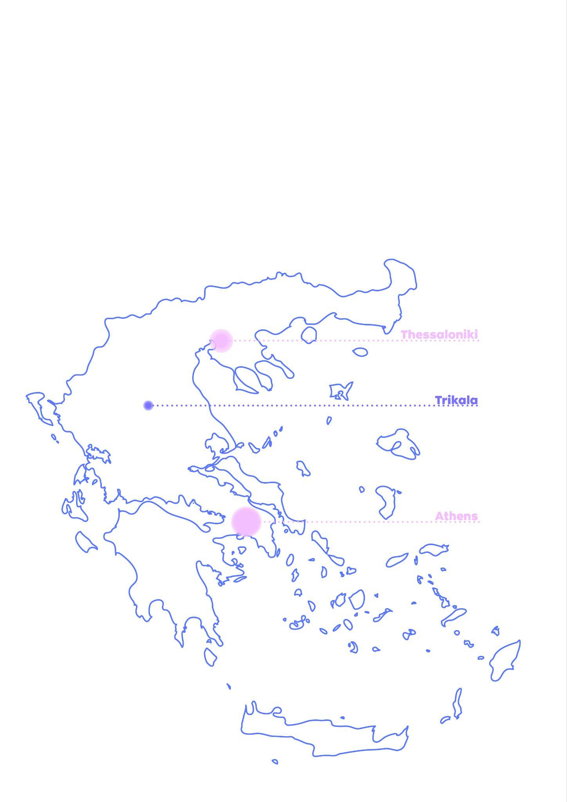
Trikala is one of Greece’s most bike-friendly cities, with an existing cycling culture supported by its terrain, infrastructure, and initiatives. However, several sociocultural and physical factors still limit women's access to cycling (and other ways of sustainable mobility). Understanding these challenges will be critical in developing targeted interventions that promote cycling and other active and sustainable mobility options as practical alternatives among women.

Picture 1: Trikala is a mid-sized city in Central Greece, located 322 km from the capital, Athens, with a population of 85,608 in the urban area and 120,895 in the wider municipality, according to the 2021 national census (Hellenic Statistical Authority, 2022).

KEY FINDINGS
>> Mobility of care: The impact of care responsibilities on mobility choices
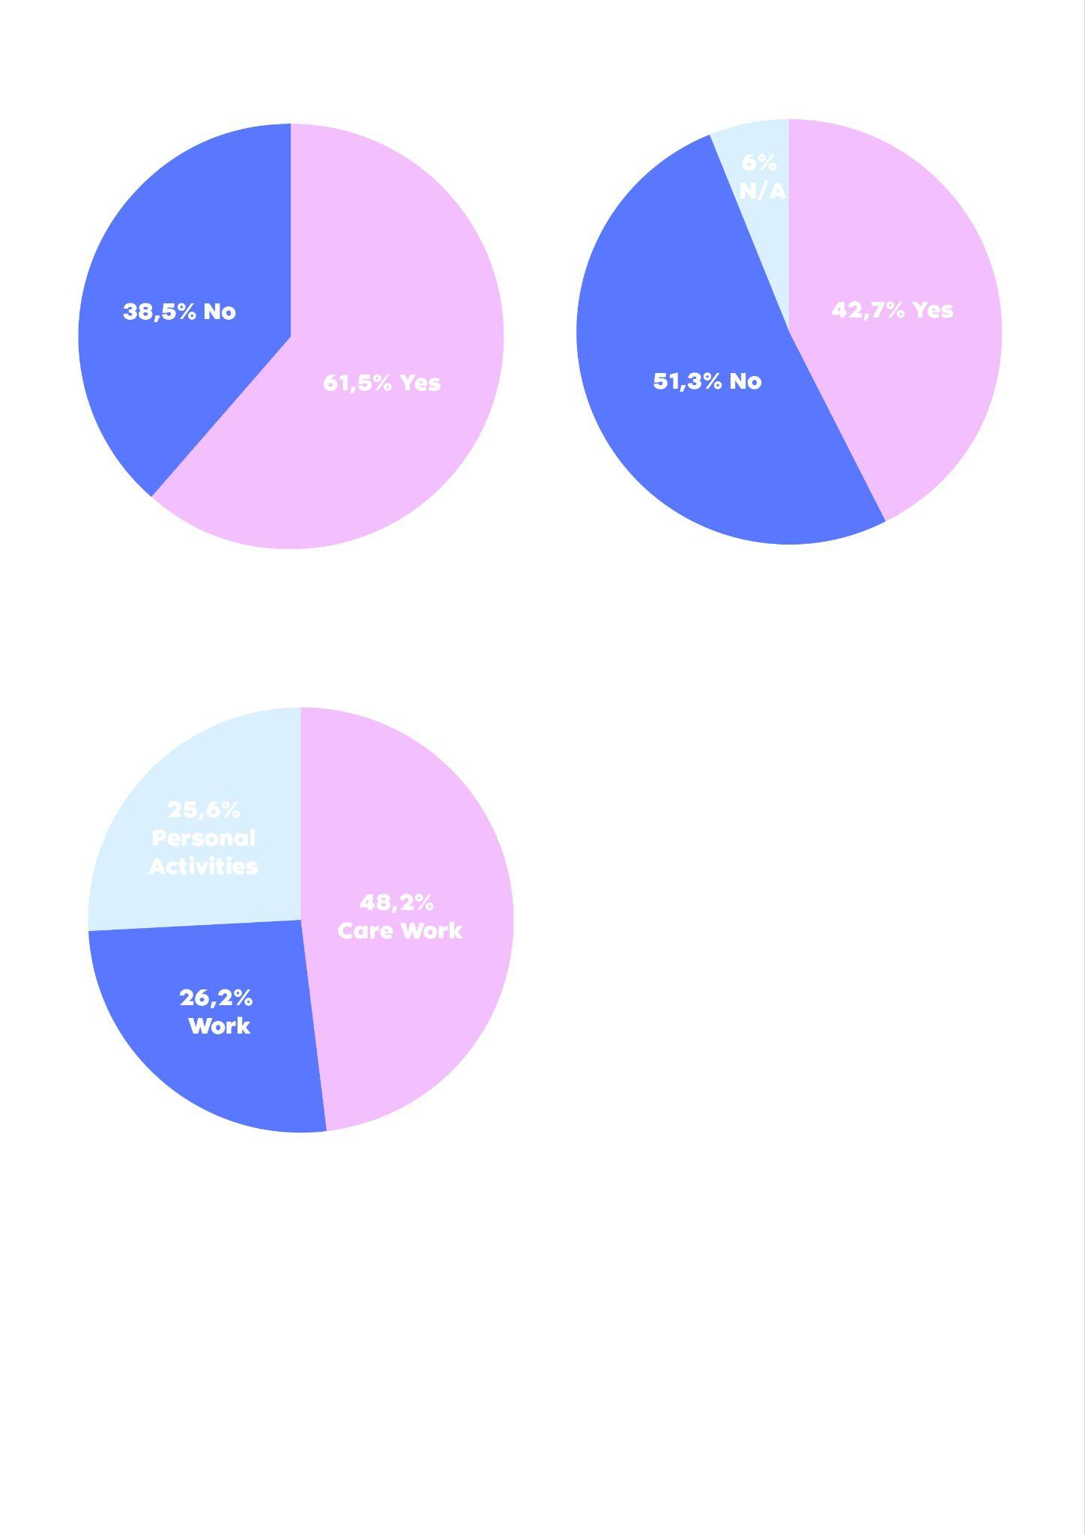
Care responsibilities play a significant role in shaping mobility patterns, particularly for women in Trikala. In our survey, 50.4% of respondents identified as caregivers, balancing multiple responsibilities such as caring for children, older adults, and people with disabilities. These caregiving duties create intricate daily mobility patterns. Many women make multiple trips each day -accompanying children to school, running errands, and attending to dependent family members. Caregiving-related trips (i.e. accompanying a child or other dependent family/community member, daily shopping, etc), accounted for 48.2% of all reported daily travel.

Graphic 2: What are the daily activities that require your mobility?
To meet these demands efficiently, many caregivers rely on private cars. One respondent explained:
"The car is more convenient, especially when I have at least one more person with me (a child) or when I'm carrying things."
Others emphasized how inadequate infrastructure leaves them with limited mobility options. A lack of accessible sidewalks and public spaces makes travel particularly difficult for those transporting dependents:
"I use the car for transporting a person with a disability because most sidewalks are not wheelchair accessible."

"Mobility for people with disabilities and mothers with strollers is a nightmare."

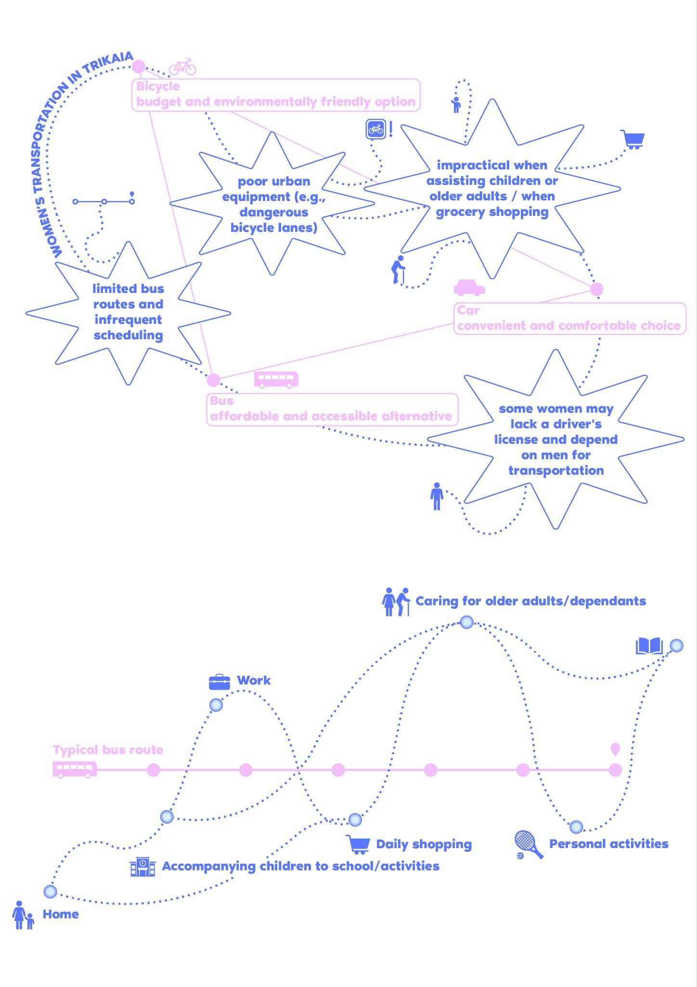
Graphic 3: The complexity of daily routes of caregivers.
While some caregivers incorporate bicycles into their routines, cycling remains underutilized (42.4% of respondents never use a bicycle). Car dependency is widespread, with nearly half of caregivers using a car at least occasionally. Public transportation is almost entirely absent from their mobility choices, as 88.1% of caregivers reported not using it at all, highlighting a severe lack of viable alternatives.
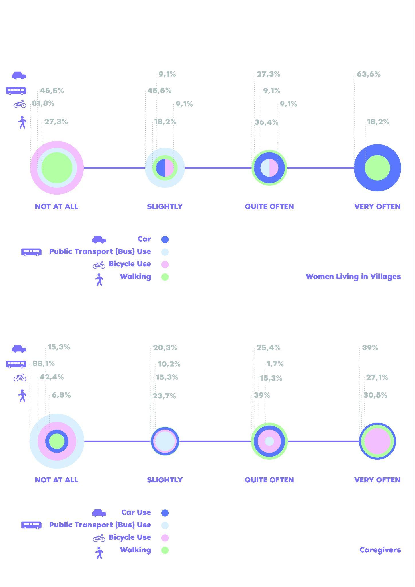
Graphic 4: Caregiver's transportation modes in the Trikaia Municipality,
highlighting car, bus, bicycle, and walking usage.

For those juggling three or more daily caregiving-related activities requiring mobility, the reliance on private cars becomes even more pronounced. Bicycle use declines further in this group, with over half avoiding it altogether.
These findings underscore the strong connection between caregiving responsibilities and mobility constraints, revealing an urgent need for mobility solutions that accommodate the realities of caregivers, such as improved public transport accessibility and safer cycling infrastructure.

>> Women’s mobility in rural areas: Car dependency and limited alternatives
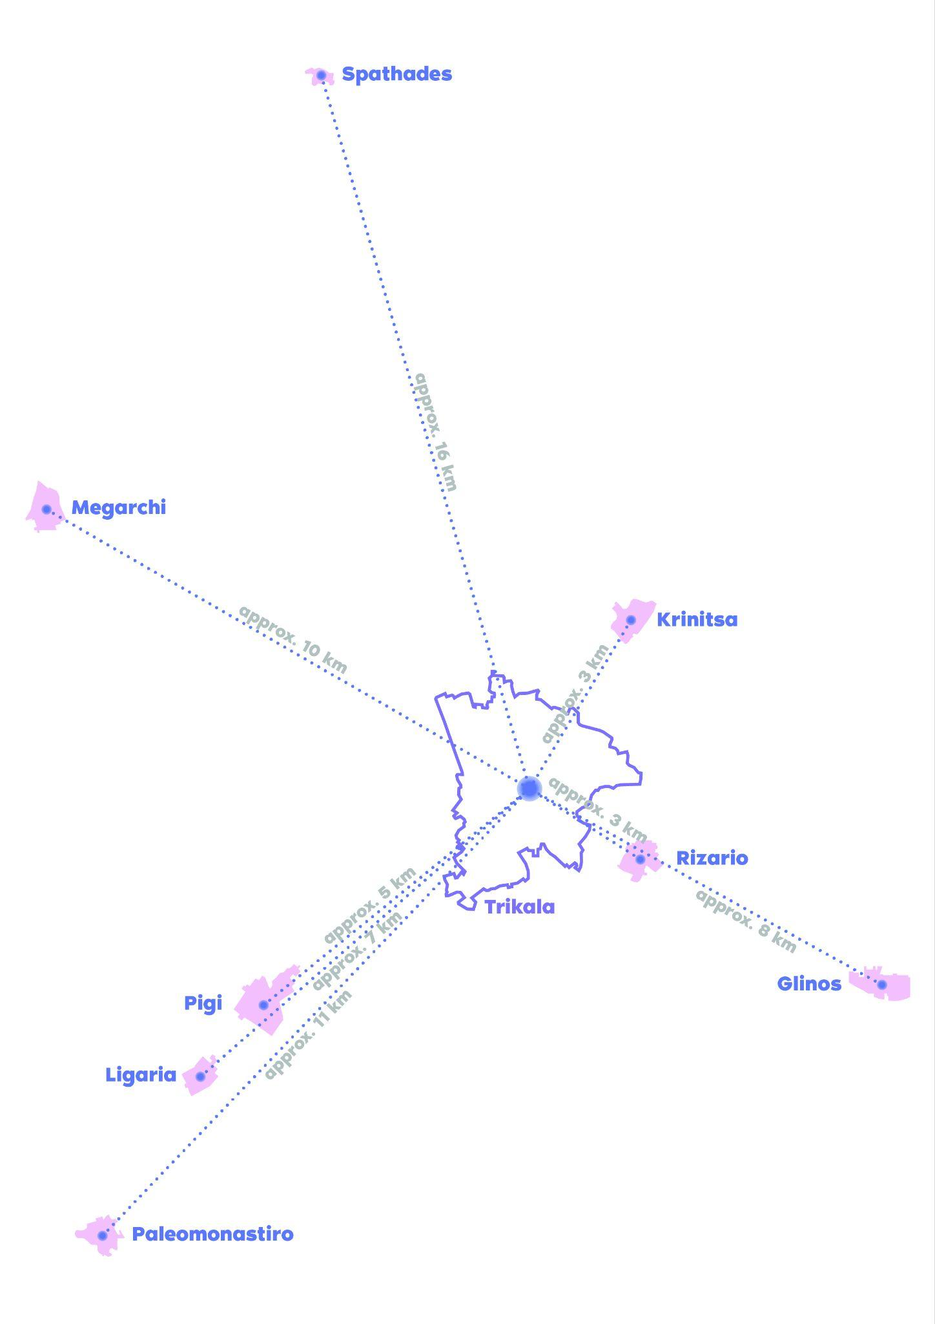
Women in the villages surrounding Trikala face significant mobility challenges due to limited transportation options and infrastructure gaps. Public transport remains largely inaccessible, with 45.5% of rural women never using it due to inadequate routes and schedules. Bicycle usage is notably lower in rural areas, with 81.8% of rural women never using a bicycle. In contrast, car use is widespread -63.6% of rural women use cars frequently, and 27.3% quite often.
Although private cars are the dominant mode of transport, this high car usage does not equate to independence as some survey respondents without a driving license still reported using a car, indicating dependence on others. This pattern reflects broader trends. A study on Thessaloniki, Greece found that men are more likely to drive, while women travel as passengers or rely on public transit (Basbas et al., 2023). In the same research, male participants had a significantly higher rate of driving licenses (90%) compared to females (63%). With limited alternatives, rural women remain dependent on male-controlled mobility, highlighting the urgent need for accessible and inclusive transport solutions.

Graphic 5: The graph shows the villages where the respondents live and their distances from the center of Trikala.
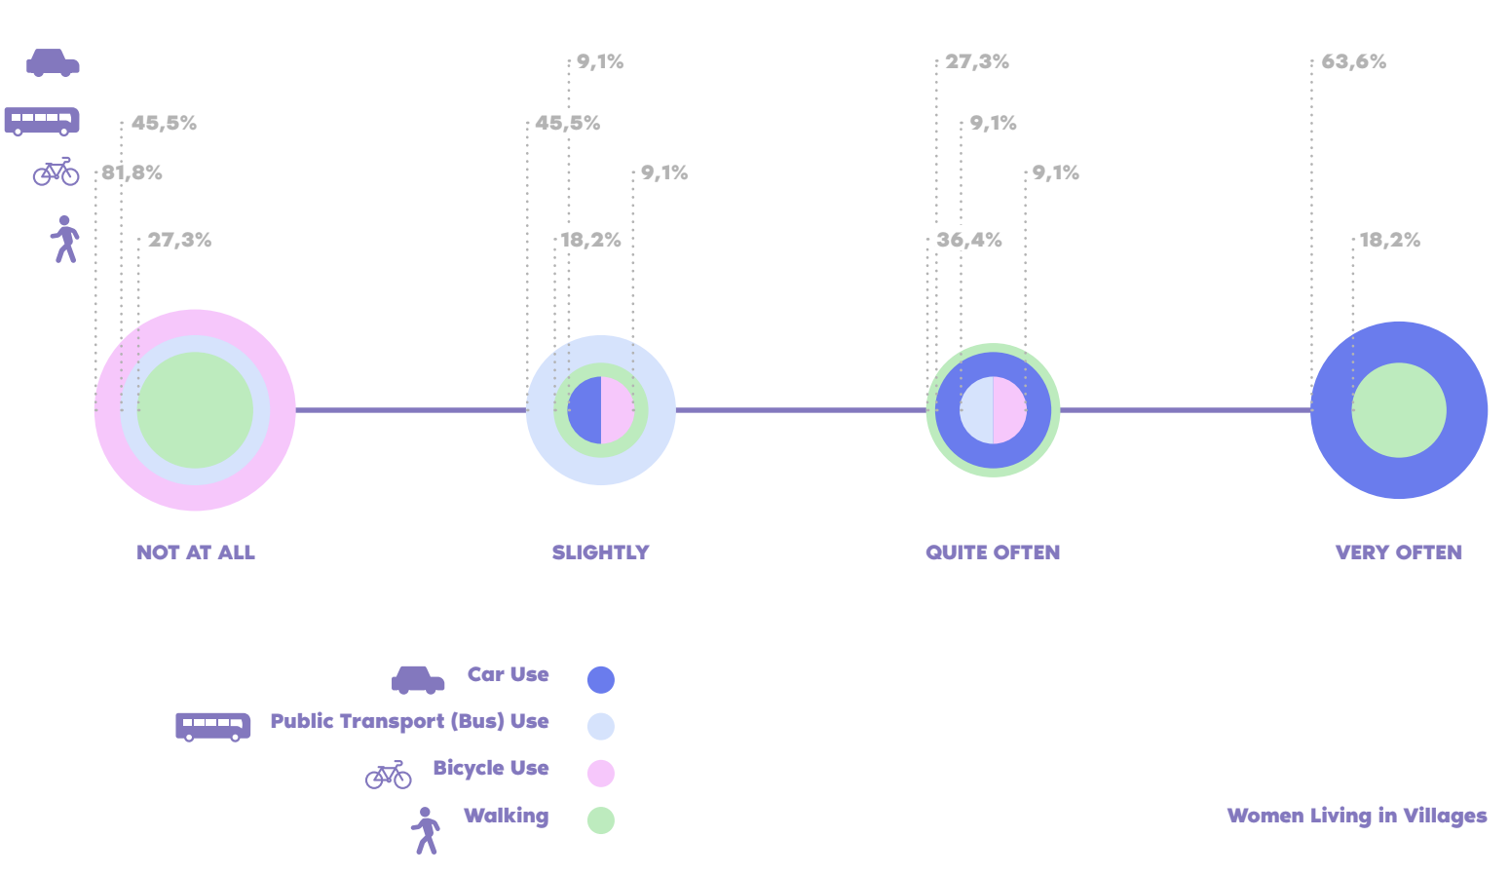
Graphic 6: Women's transportation modes in villages surrounding Trikala,
highlighting car, bus, bicycle, and walking usage
>> Sense of (un)safety
Safety concerns play a critical role in shaping women's mobility choices in Trikala, especially at night. A significant 61.5% of respondents reported altering their routes or avoiding certain areas due to safety risks, citing poor lighting, deserted streets, and the fear of harassment. Additionally, 42.7% of women have experienced harassment during their daily mobility, while 6% preferred not to answer, underscoring the pervasive nature of gender-based violence.
  Do you avoid specific routes due to safety concerns? |   Have you experienced harassment during your daily mobility in the city?

Insufficient lighting was the most frequently mentioned concern, with many respondents explicitly describing their fear of "dark" or poorly lit areas. Other key reasons for avoiding certain routes included the lack of vitality in some areas and concerns about harassment or violence. One woman explained,
"I choose streets that are well-lit and usually have people around because I don't feel safe on dark streets where someone might follow me, either on foot or by car (it has happened before)."
Another respondent highlighted the constant sense of fear, stating,
"There is not enough lighting, many teenage boys with aggressive behavior, and in general, as a femininity, I have learned to be afraid and cautious."
These findings emphasize how safety concerns restrict women's mobility and access to public spaces. The lack of adequate lighting and the fear of harassment force many to adjust their travel behavior, ultimately limiting their freedom of movement, particularly at night. Addressing these issues through improved infrastructure and safer public spaces is essential for ensuring equal mobility opportunities for women.

NEXT STEPS of the ELABORATOR research in women’s mobility in Trikala
The research so far highlights the gendered dimensions of mobility in Trikala, underscoring the urgent need for transport solutions that reflect women's daily realities. Key findings reveal that sustainable transport options, such as cycling and public transport, remain underutilized -especially by caregivers and rural women- due to safety concerns, inflexible routes, and infrastructure gaps. Meanwhile, car dependency is high among these groups, largely due to the unreliability of public transport. Safety concerns further shape mobility patterns, with many women avoiding specific areas, particularly after dark.
To address these barriers URBANA in collaboration with e-Trikala in the following months will host a series of workshops in Trikala, engaging diverse focus groups of women. These sessions will capture lived experiences and co-develop practical recommendations for more inclusive mobility solutions. Recognizing that the online survey format may have limited participation from older women and those with less digital access, future outreach efforts will adopt more inclusive engagement strategies.
By integrating survey findings with insights from these workshops, ELABORATOR will contribute to gender-sensitive urban mobility policies in Trikala. Prioritizing women's voices and addressing their needs will pave the way for safer, more accessible, and equitable mobility solutions.

Basbas, S., Chaniotakis, E., & Kourmpa, I. (2023). Gendered mobility patterns and accessibility to public transportation in Thessaloniki: Insights for urban mobility planning. International Journal of Transport Development and Integration, 7(2), 201–211. https://doi.org/10.18280/ijtdi.070201

