Mobility Needs and Aspirations of Women in Trikala Questionnaire Analysis

INTRODUCTION 2
I. WOMEN'S PROFILE 3
II. ANALYSIS OF RESPONSES 3
1. What are the daily activities that require your mobility? 3
2. Why do you prefer this mode of transportation over others? 7
4. How safe do you feel when moving around the city during the day? 8
5. How safe do you feel when moving around the city at night? 8
8. What changes would you like to see in the mobility network so that you feel more comfortable and safe to move with more sustainable means of transport (e.g. public transport, bicycle, walking) within the city of Trikala and from/to Trikala? 10
9. Is there anything else you would like to mention? 10
III. FOCUS ON KEY GROUPS: Women Living in Villages 13
1. How old are you? 13
2. How do you choose to move daily and with what frequency? 13
3. Why do you prefer this mode of transportation over others? 14
IV. FOCUS ON KEY GROUPS: Caregivers 15
1. Is there someone in your family/friendly environment whom you need to care for on a daily basis? 15
2. What are the daily activities that require your mobility? 16
3. How do you choose to move daily and with what frequency? 17
4. Why do you prefer this mode of transportation over others? 19
V. CONCLUSIONS 20

INTRODUCTION
This report presents an analysis of the findings from a survey conducted within the framework of the Horizon Europe-funded project, ELABORATOR: The European Living Lab on designing Sustainable Urban Mobility towards climate-neutral cities. The project focuses on co-creating sustainable urban mobility solutions that support the transition to climate-neutral cities, with a strong emphasis on inclusivity and gender-sensitive approaches. Within this framework, URBANA plays a key role in ensuring that the needs and experiences of underrepresented and vulnerable groups—including women—are actively considered throughout the project.
To support this effort, a targeted survey was launched in January 2025 to explore and assess the daily mobility patterns, needs, and challenges faced by women in Trikala, including those living in suburban areas and nearby villages.
Located in Central Greece, approximately 322 km from Athens, Trikala is a mid-sized city with a population of 85,608 in its urban area and 120,895 in the wider municipality. The city experiences a number of mobility-related challenges, such as limited public transport—particularly in rural areas—high car dependency, congestion in the city center, and deteriorating air quality. These challenges are compounded by climate change, urbanization, and concerns around road safety.
The survey was conducted through an online questionnaire (Google Form), distributed in collaboration with the Municipality of Trikala and other local services. This collaboration helped reach the female population and facilitate data collection. In total, 117 women from Trikala, its suburban areas, and nearby villages participated in the survey. Their responses provided valuable insights into how these challenges shape their everyday mobility, revealing their complex travel behaviors, daily needs, and aspirations for a more inclusive and accessible urban environment.

WOMEN'S PROFILE

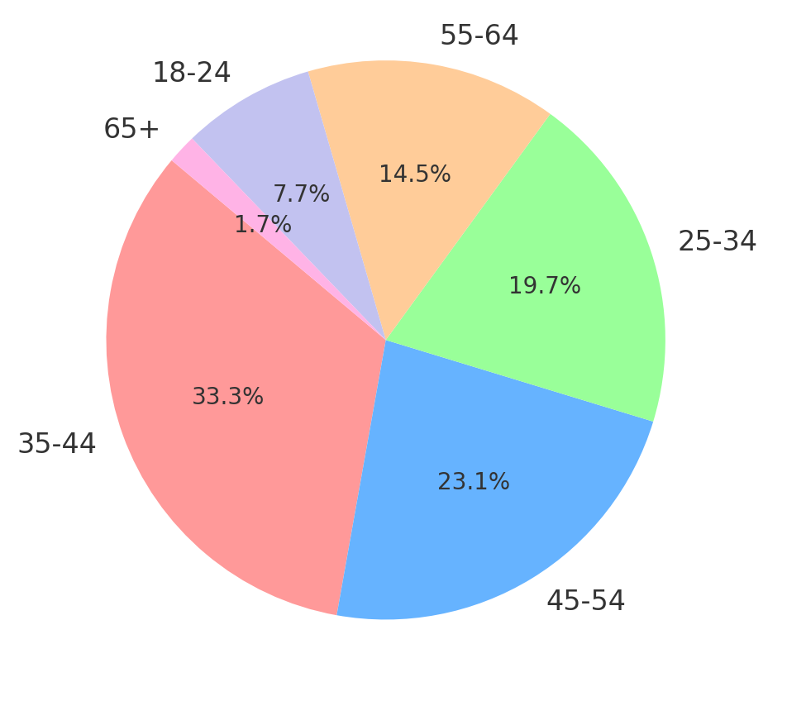
Age Groups (in percentages):
- 35-44 (33.3%)
- 45-54 (23.1%)
- 25-34 (19.7%)
- 55-64 (14.5%)
- 18-24 (7.7%)
- 65 and older (1.7%)

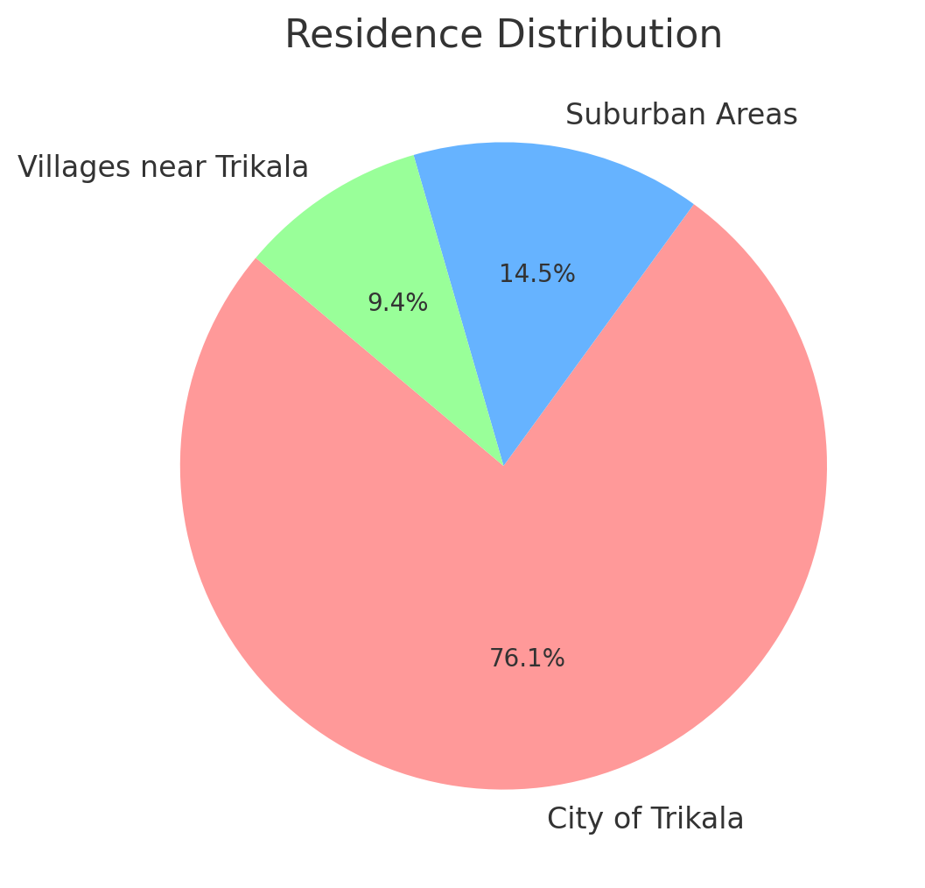
Residence:
- 76.1% of women live in the city of Trikala
- 14.5% of women live in suburban areas
- 9.4% (11 women) live in villages near Trikala:
  - Lygaria (1)
  - Glinos (2)
  - Rizario (2)
  - Paliomonastiro (2)
  - Pigi (1)
  - Spathades (1)
  - Krinitsa (1)
  - Megarchi (1)

ANALYSIS OF RESPONSES

What are the daily activities that require your mobility?
Women's routes within the city are often more complex due to the multiple activities, obligations, and needs they face. Combining paid work with caregiving routes for dependents, such as children, older adults, or people with disabilities, women structure their mobility in a way that reflects their multifaceted responsibilities. The city's structure can either facilitate or hinder these movements, directly affecting their daily mobility.

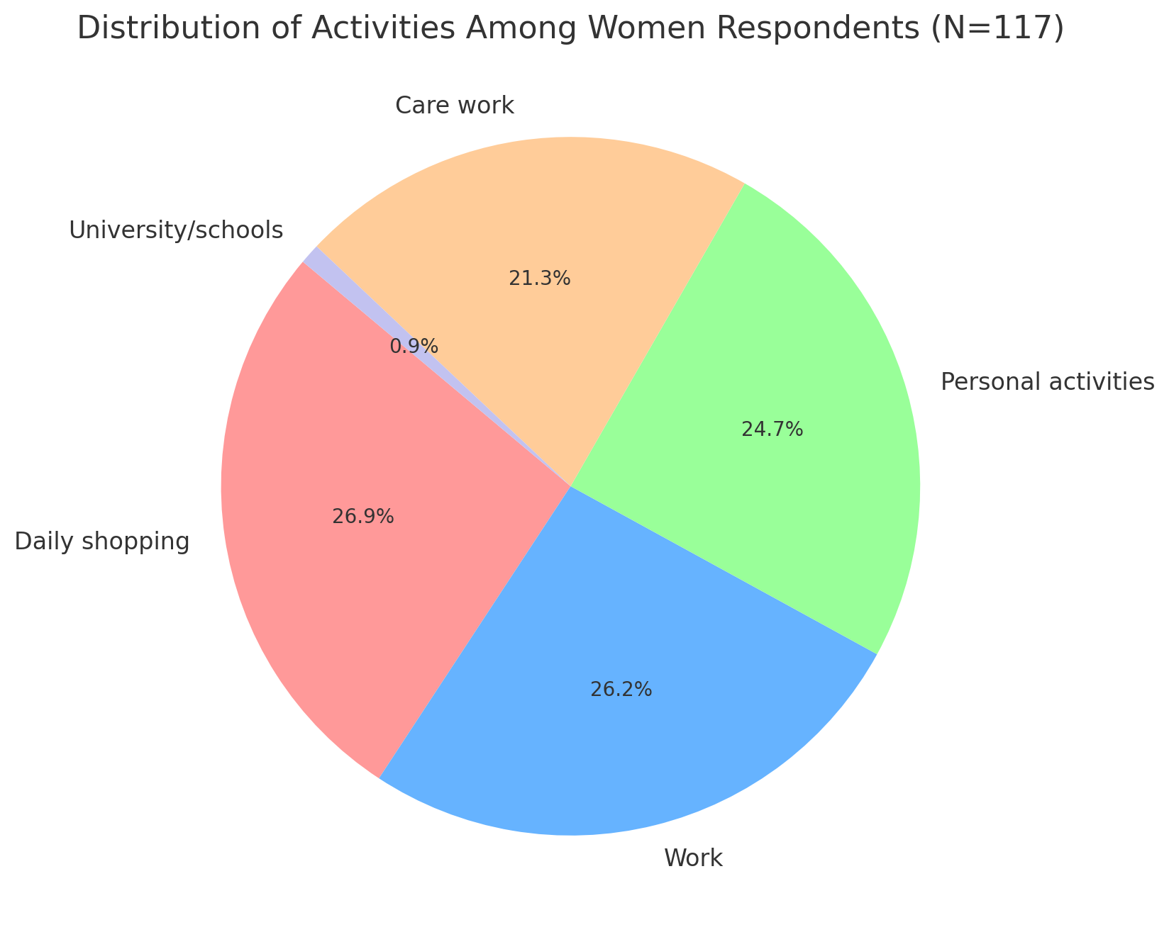

- Daily shopping: 26.9%
- Work: 26.2%
- Personal activities: 24.7%
- Care work (including accompanying children to school and other caregiving responsibilities): 21.3%
- University/schools: 0.9% (only 3 responses)

48.2% of daily trips reported by participants were related to caregiving: Among the daily mobility activities reported by participants, 68 responses (21.3%) directly indicate care-related trips. However, when including daily shopping (86 responses, 26.9%), which often overlaps with care responsibilities (e.g., shopping for family, caregiving tasks, or groceries), the percentage increases significantly. Combining caregiving and daily shopping activities reveals that 48.2% of women’s daily trips are linked to caregiving responsibilities.
Significant mobility patterns (arising because they could select more than one answer):
- Work/Care work
- Work/Daily shopping/Personal activities
- It’s worth mentioning that both patterns include work, reflecting the fact that the majority of respondents (76.1%) belong to the active population (ages 25-54), a group whose daily mobility is shaped by multiple responsibilities. Their daily travel routines are often complex, as they combine work-related trips with additional caregiving responsibilities. This layered mobility pattern shapes their transport choices and highlights the need for inclusive mobility solutions that accommodate these multifaceted mobility needs.

- How do you choose to move daily and with what frequency?
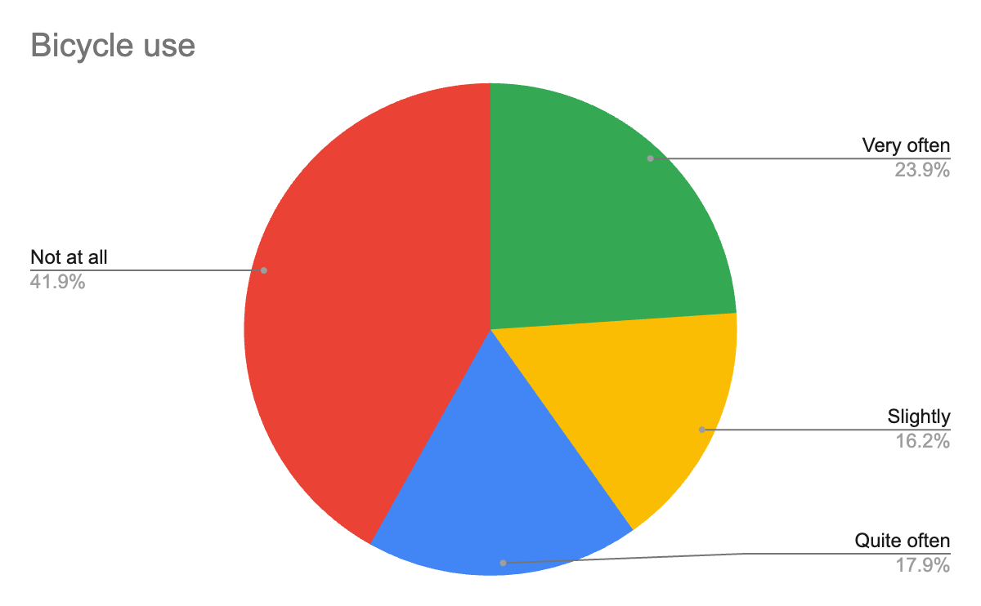

58% (Slightly, Quite often, Very often) use a bicycle.

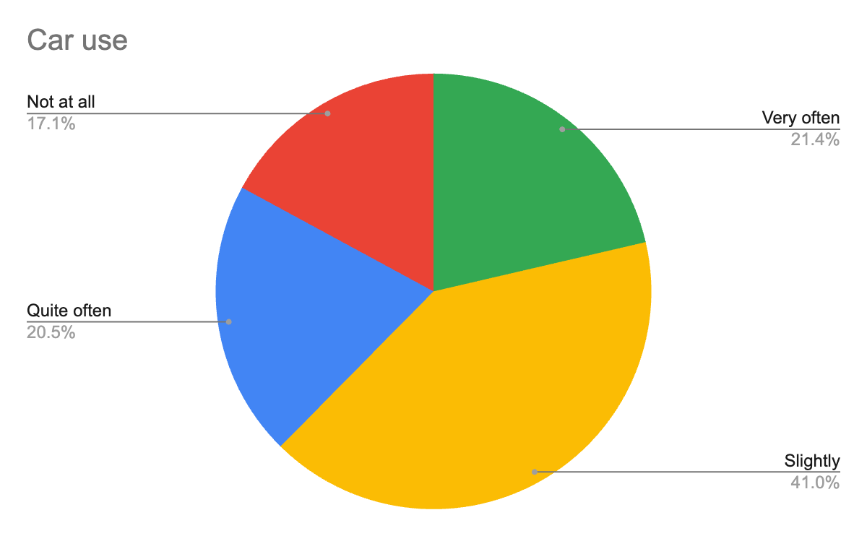

82.9% (Slightly, Quite often, Very often) use a car.

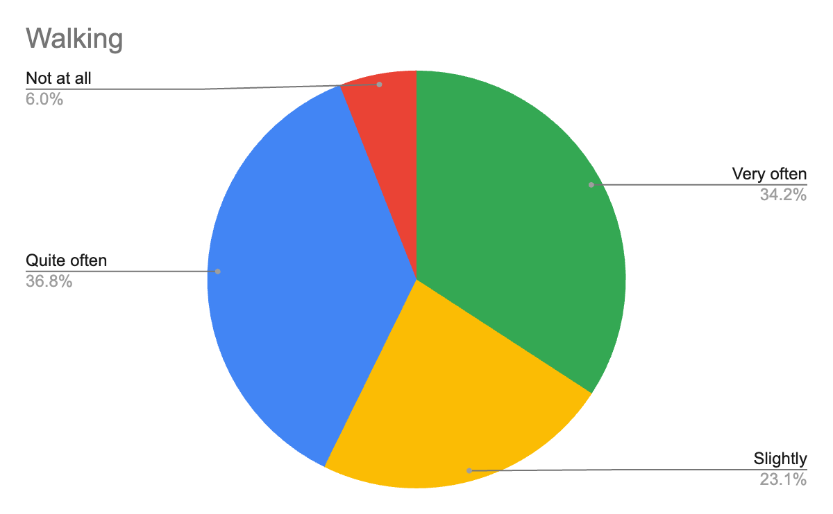

94% of the respondents (Slightly, Quite often, Very often) walk.

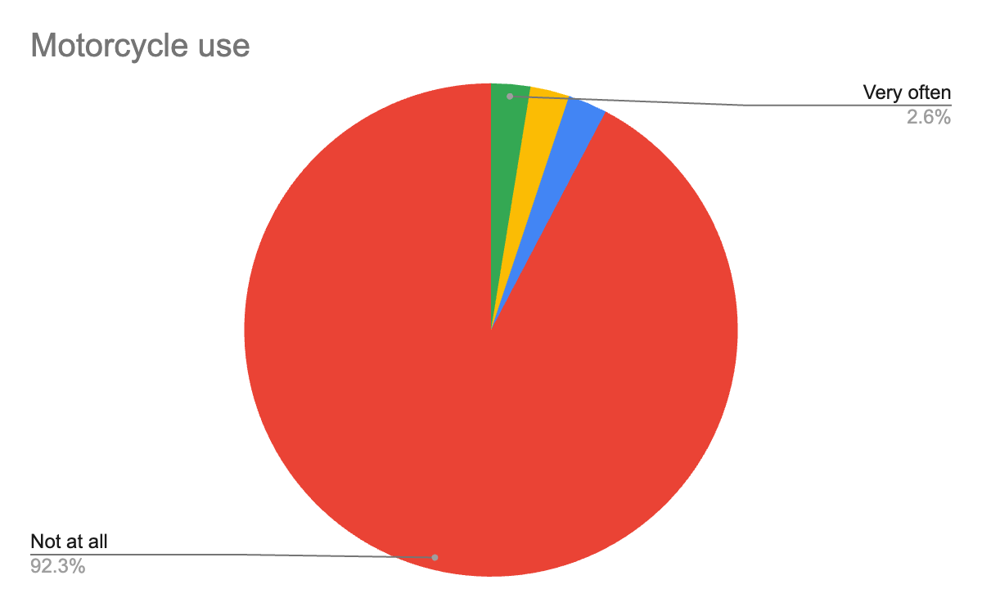

92.3% do not use a motorcycle.

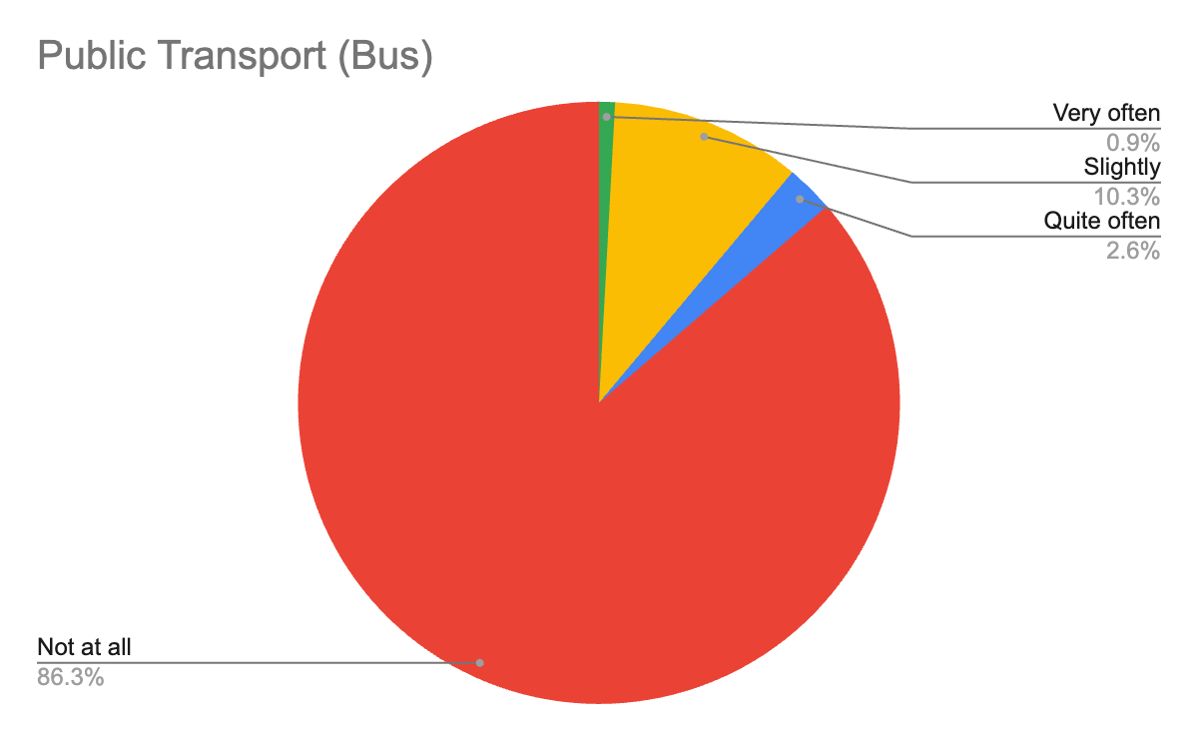

86.3% do not use the bus.

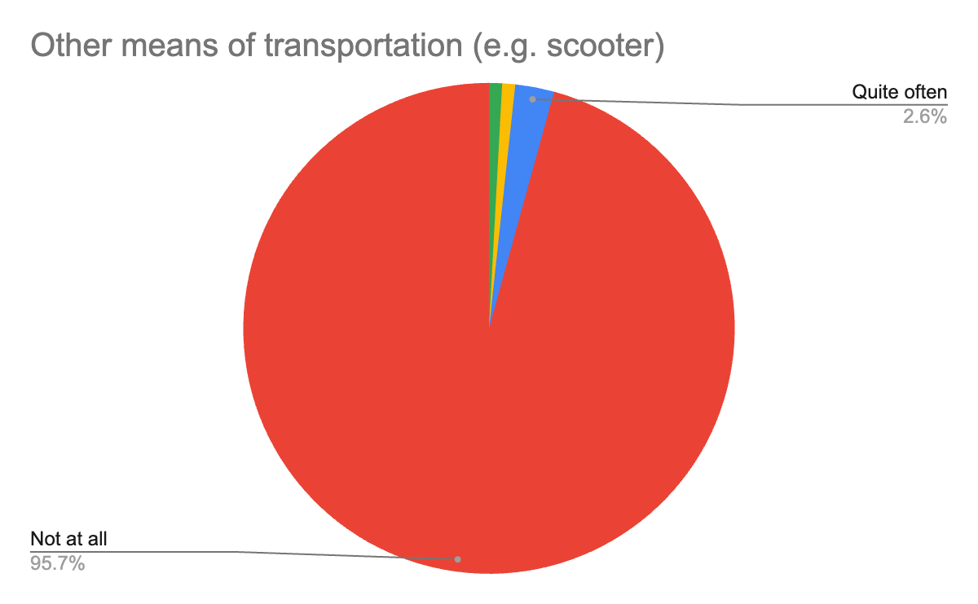

The majority (95.7%) do not use other means of transportation (e.g. scooter).

The analysis of women's transportation choices in Trikala reveals a significant trend toward sustainable mobility. 94% of women report walking daily, while a significant number choose bicycles as a means of transportation (58%). This trend aligns with broader international findings. According to research, women tend to rely more on walking, non-motorized means, and public transport compared to men.

However, car usage remains high at 82.9%, a trend driven not only by a lack of alternatives to meet daily needs but also by long distances and limited public transport options, especially for women living in suburban and rural areas. This is further reflected in the low percentage of bus usage with 86.3% of respondents reporting that they do not use the bus at all, pointing to accessibility issues, inadequate schedules, and an overall lack of reliable public transport infrastructure. Given that the study includes women from the city center, suburban areas, and surrounding villages, it is essential to examine car and bus use in correlation to better understand these mobility patterns.

Why do you prefer this mode of transportation over others?
Thematic analysis was applied to identify the main reasons women provided for their mobility choices. Thematic analysis is a qualitative research method used to examine textual data and identify recurring themes, patterns, and ideas. In this case, responses were categorized into several themes, and some responses fall into multiple categories. The following themes emerged, with the number of responses provided in each category converted to percentages to highlight the prioritization of reasons behind women's mobility choices:

- Convenience & Comfort (mainly for women living in the city center who can walk or use bicycles): 29.69%
- Speed & Time (car and bicycle): 1) Faster movement, 2) Time saving (related to parking and traffic): 27.34%
- Lack of Alternatives: 1) Lack of a license or vehicle, 2) Ιnadequate public transport, 3) Geographical constraints (villages and suburban areas): 20.31%
- Health & Physical Activity: 5.47%
- Other (e.g., "I like it"): 5.47%
- Economy & Cost: 4.69%
- Needs & Daily Life (mainly for caregivers' specific needs): 4.69%
- Safety: 2.34%

Quotes from women about their transportation choices in Trikala:
Speed & Time (27.34%)
- "It's fast and easy because you don't have to look for parking." (bicycle)
- "I live far from the city center. There is no other way." (car)
- "I cycle to avoid the traffic in the city centre and because with a car it is difficult to find a parking space. I use the car only in cases where I know there is parking (supermarket) and for my work (out of town)."
- "To avoid traffic." (bicycle)
Convenience & Comfort (29.69%)
- "For longer distances, regionally or outside the city limits, I use my car rather than another means (e.g. urban/intercity bus) because of the comfort, convenience and autonomy it offers." (car)
- "I live downtown and everything is close by, I walk to everything. For work, by car."
Lack of Alternatives (20.31%)
- "Because there is no bus!" (bicycle)
- "I would love to use a city bus, but the bus service is not frequent, the last one is very early and there is none during the weekend." (car, woman living in a village)
- "There is no Spathades - Trikala bus service.” (car, woman living in a village)
- “Incomplete bike lane-narrow roads, sudden interruption of bike lane without ramp in several places. " (walking)
Economy & Cost (4.69%)
- "The bicycle is affordable."
- "The electric scooter is more economical and more convenient to park."
Health & physical activity (5.47%)
- "They offer physical and mental health, well-being and quality of life." (bicycle & walking)
- "I like it and it gives me the opportunity to exercise." (bicycle)
Needs & Daily Life (4.69%)
- "I use a car for disabled travel because most pavements do not have wheelchair access."
- "The car is more convenient, especially when I have at least 1 other person with me (minor child) or I am carrying things."
The variety of responses highlights the diverse needs and challenges faced by women in Trikala. Their travel choices are primarily influenced by factors such as speed, convenience, lack of alternatives and individual needs. Despite the existence of viable options such as walking and cycling, the lack of reliable infrastructure and the need for quick and practical solutions lead many women to rely on the car.

How safe do you feel when moving around the city during the day?
- Not at all: 6%
- Slightly: 17%
- Quite: 46%
- Very: 31%

How safe do you feel when moving around the city at night?
- Not at all: 10%
- Slightly: 42%
- Quite: 34%
- Very: 14%

Women's sense of safety in Trikala varies significantly depending on the time of day. During the day, most women feel relatively safe, with 46% responding "Quite" and 31% "Very." However, at night, the situation changes dramatically: responses of "Not at all" and "Slightly" increase significantly, reaching 10% and 42%, respectively. In contrast, the percentage of women feeling "Quite" and "Very safe" drops notably, with only 34% and 14% feeling this way at night. This difference highlights the effect of insufficient lighting, reduced traffic and the general insecurity that prevails at night. These concerns are confirmed by the women's responses to the following questions, where they describe experiences of harassment in public spaces and highlight the routes they avoid in the city.

- Have you ever experienced any form of harassment during your daily mobility?
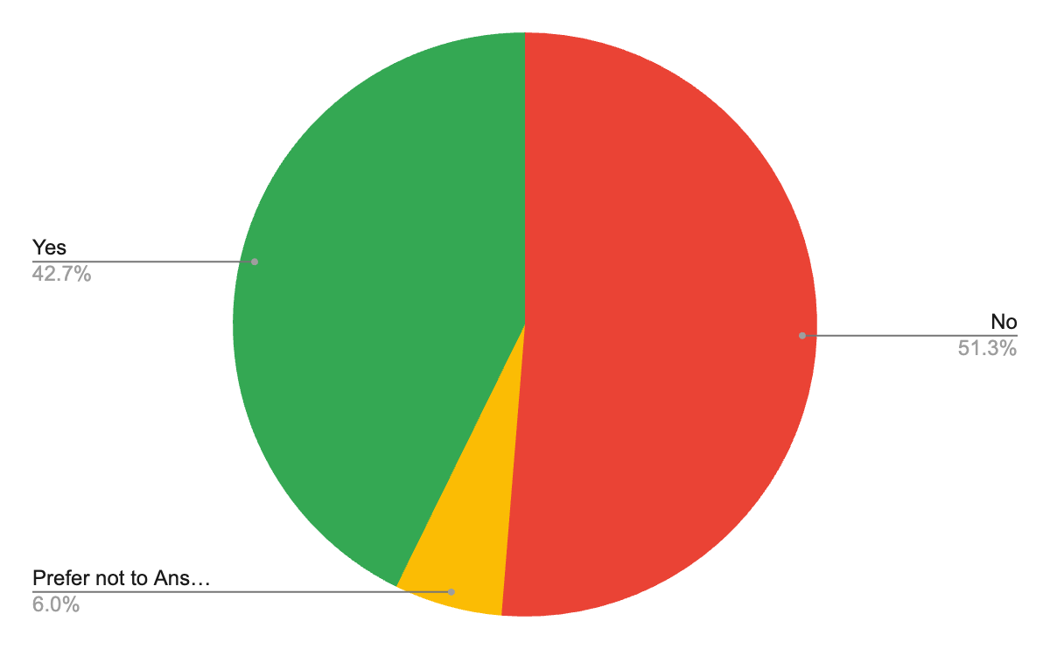
42.7% responded that they have experienced some form of harassment during their daily commute. 51.3% of the women who responded to the questionnaire said they had not experienced it. It is worth noting that there is a 6% who did not want to answer the question.

- Are there routes/streets/areas you avoid when moving within, to/from the city of Trikala (during the day or/and at night)?

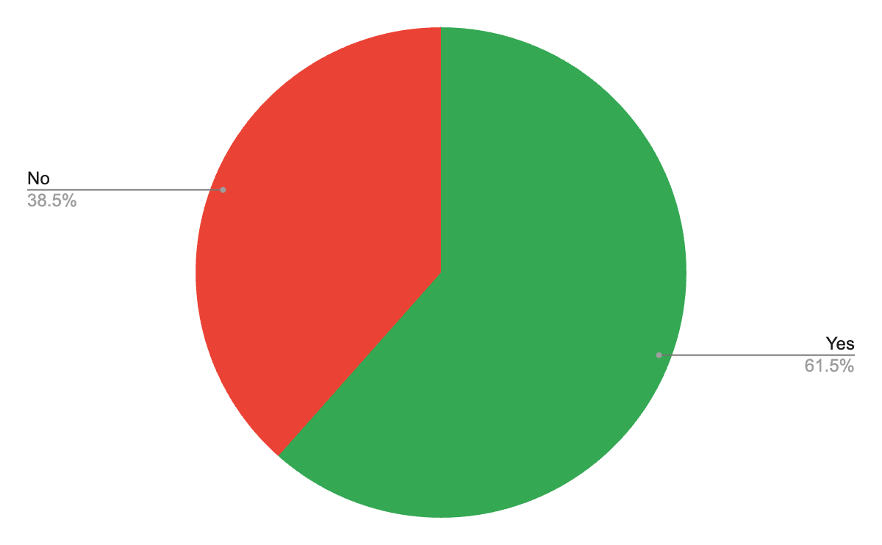
The majority (61.5%) avoid specific routes, especially at night. The reasons for avoidance focus mainly on a lack of safety and negative experiences. It is worth noting that out of the 60 women (51.3%) who answered that they have not experienced harassment in the previous question, 25 of them (41.7%) answered that they avoid specific routes in the city.

Reasons for avoiding specific routes:
- Inadequate lighting: 45.37% (often mentioning the words "dark" & "darkness")
- Lack of vitality: 11.35%
- Gender-based violence/harassment: 10.31%
- Poor road conditions & infrastructure: 9.28%
- Criminality: 6.18%
- Fear/Feeling of insecurity: 6.18%
- Other: 6.18% (mostly for daytime issues)
- Presence of stray animals: 5.15%

Quotes from women about avoiding specific routes in Trikala:
- "Darkness, poor access, bad condition of the sidewalks."
- "I choose streets that are lit and usually crowded because I don't feel safe on dark streets where someone can follow me either on foot or by car (it has happened in the past)."
- "Not all areas are suitable for walking alone, as a woman, at night."
- "In case something happens or there is someone who might harass me. I prefer Kondyli Street, which has plenty of light, for example."
- "They don't have lights, they're not busy areas."
- "Risk of harassment, theft, sense of insecurity, fear, darkness."
- "Because it has a lot of potholes and a lot of the roads are a little dark and without traffic."
- "I have been harassed even on the main street of the city at night (Larissis) so I definitely avoid dark streets and streets that seem empty."
- "Because I am a woman."
- "Because there are some places that are not safe enough for a woman to walk alone at night."
- "There is not enough lighting, many underage boys mostly with aggressive behaviour, in general, as a femininity I have learned to be afraid and careful."
- "Streets with dark corners and no people."
- "Dark and dangerous streets and alleys where something bad can happen."

What changes would you like to see in the mobility network so that you feel more comfortable and safe to move with more sustainable means of transport (e.g. public transport, bicycle, walking) within the city of Trikala and from/to Trikala?

Is there anything else you would like to mention?

Thematic analysis was again employed to identify the key changes participants would like to see in the mobility network. The responses were organized into several themes, with some responses fitting into more than one category. The themes presented here highlight the prioritization of participants' concerns regarding the improvement of the mobility network in Trikala:

Pedestrian Walkways and Sidewalks (19.5%)
- More space for walking and larger pavements.
- Clean pavements without obstacles and potholes.
- Walkways and ramps for people with disabilities and parents with strollers.
Bicycle Network (17.08%)
  - More and continuous bike lanes. Network development.
  - Safe and smooth access to specific points.
Road Safety and Infrastructure (15.44%)
  - Improving the quality of the road surface.
  - Need for clearer traffic signals and lane markings.
Lighting (12.2%)
  - More lighting on dark routes and improved sense of safety.
  - Strengthening of municipal lighting: Points with inadequate lighting that cause a feeling of insecurity, especially for women and pedestrians.
  - Targeted interventions: Proposal for more lights on specific routes (e.g., Karditsa near TRIKKI, road to Spathades).
Public Transport (8.13%)
  - More frequent services and coverage of more areas.
  - Connection to regional areas and return of public transport to the city centre.
Traffic Control and Enforcement (7.32%)
  - Complaints about lack of controls on motorbikes (especially delivery) and bicycles that are using the bike lanes.
  - Reports of bicycles and motorbikes encroaching on pedestrian rights and entering squares and pedestrian streets.
  - Parking violations: certain parts of the city (e.g. Kanouta, Sefora, post office) have a strong problem of double parking and obstruction of bus stops.
Policing (6.5%)
  - Better policing to control infringements. Especially in the evening hours and in certain parts of the city that are considered "problematic".

Parking and Traffic (4.88%)
  - More parking spaces (including for bicycles).
  - Regulation of illegal parking.
  - Reduction of car traffic in the centre.
Care - Management of Stray Animals (4.07%)
  - Stray management-care: complaints about packs of strays creating a danger to pedestrians and cyclists.
  - Compliance with legislation: More effective enforcement of rules on the care and control of stray animals is needed.
Other (4.88%)
Quotes from women about problems & interventions in Trikala:

- "The streets are a mess and the sidewalks are deadly hazards."
- "Mobility for people with disabilities and mothers with strollers is a nightmare."
- "Public transport should be more frequent, on all days and at all times! More space for walking, with wider sidewalks!"
- "The city center should be only for pedestrians and bicycles."
- "Extension of bike lanes, better street lighting, in areas of the city that are less densely populated, but within the urban fabric."
- "Bike lanes everywhere, lighting, continuous public transport."

The women's proposals for improving the mobility network in Trikala highlight a number of critical needs that would enhance both their comfort and safety. The expansion and improvement of the cycle path network (17.08%), the enhancement of public transport with more frequent services and better coverage (8.13%), and the improvement of pavements (19.5%) are the main suggestions. Women also point to the need for more lighting (12.2%), particularly on dark routes, and for better road safety and infrastructure (15.44%). Policing (6.5%) and control of traffic rules (7.32%) are mentioned as necessary to tackle problems such as illegal parking and uncontrolled movement of bicycles and motorcycles. In addition, the management of stray animals (4.07%) is highlighted as an issue that is characteristic of the rural nature of the city. The presence of stray animals is a particularity that creates risks for pedestrians and cyclists, and at the same time reveals an aspect of everyday life that would not be evident without the participation and experiences of women.
These proposals would not only improve the daily mobility of women, but also contribute to the creation of a more sustainable and humane city.

FOCUS ON KEY GROUPS: Women Living in Villages

How old are you?

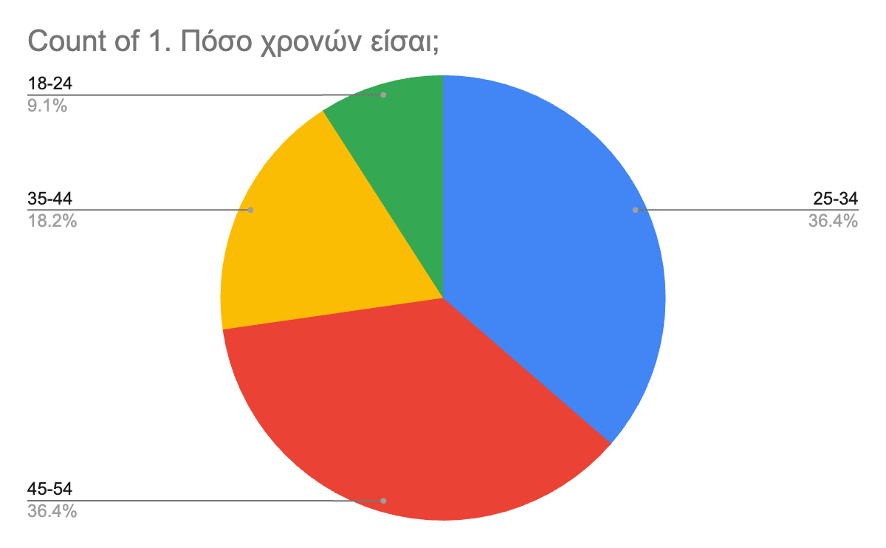
Age groups (in percentages):

- 45-54 (36.4%)
- 25-34 (36.4%)
- 35-44 (18.2%)
- 18-24 (9.1%)
- 55-64 (0%)
- 65 and over (0%)

How do you choose to move daily and with what frequency?
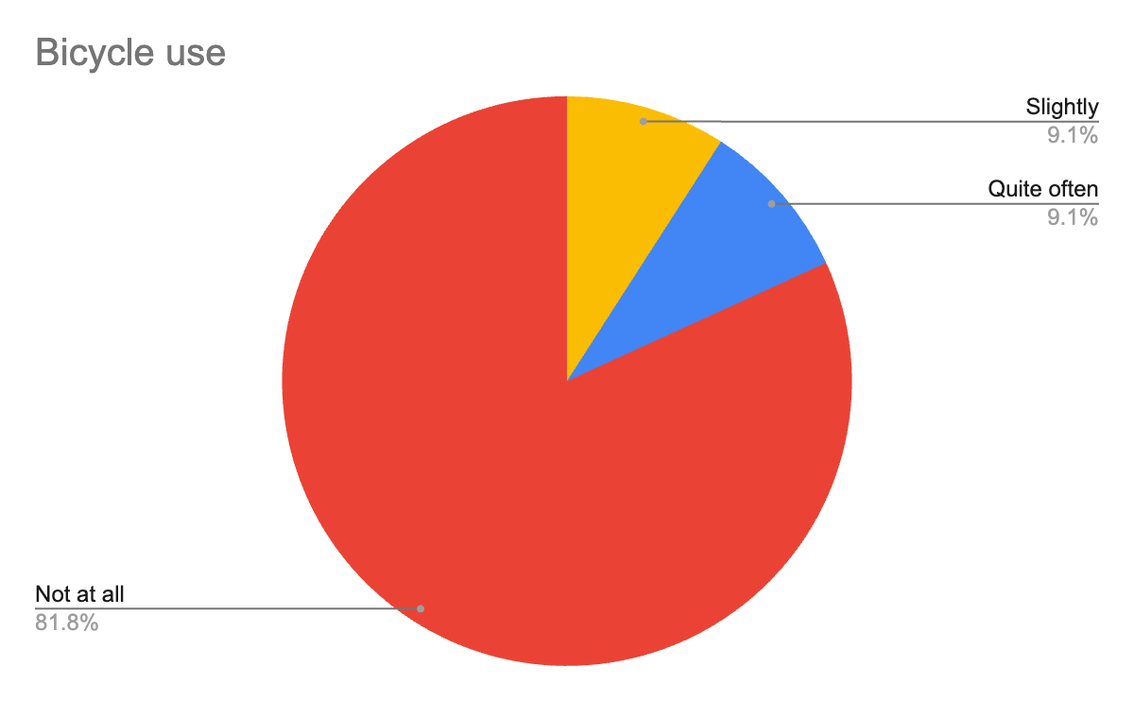

Bicycle use is extremely low, with 81.8% stating that they do not use it at all.

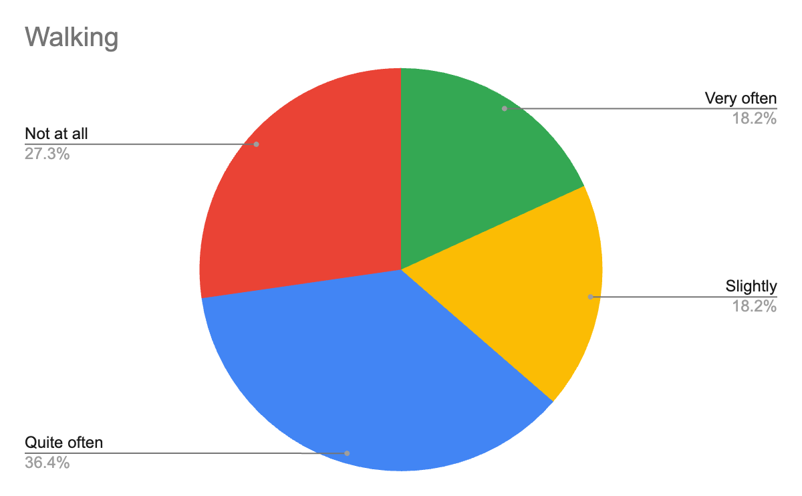
Walking, although present as an option, shows mixed responses: 36.4% walk "Quite often", 27.3% "Not at all," 18.2% "Very often" and 18.2% "Slightly." There is a notable difference here compared to the responses from the general population, where only 6% stated that they do not walk at all.

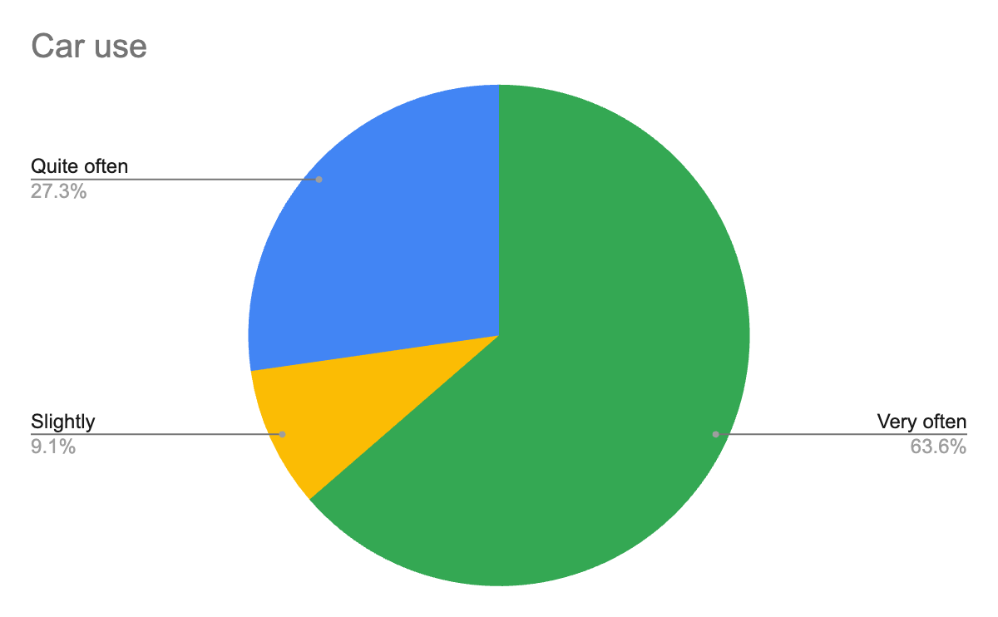
Women in villages rely heavily on cars, with 63.6% using them "Very often" and 27.3% "Quite often." There are no responses for "Not at all".

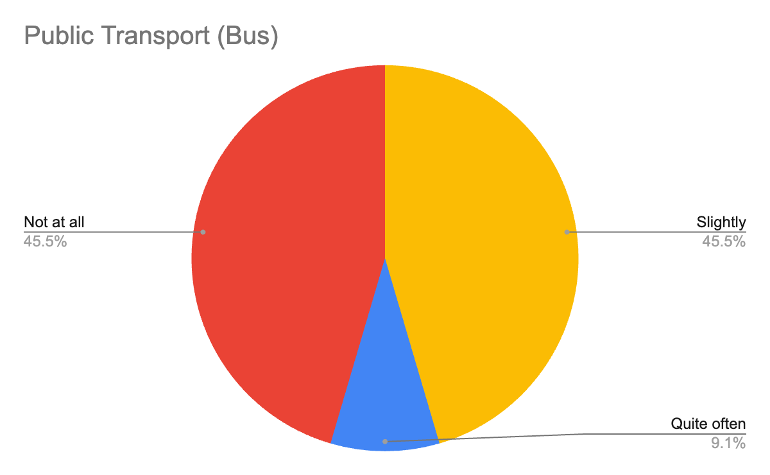

Public transport does not meet their needs, with 45.5% stating they do not use the bus at all and another 45.5% using it "Slightly".

* Motorcycles and other means are not mentioned at all.

Why do you prefer this mode of transportation over others?

- "I would love to use a city bus, but the bus service is not frequent, the last one is very early and there is none during the weekend." (car)
- "There are no other options."
- "It's a matter of necessity, not a matter of preference." (car)
- "Car: There is no public transport between Spathades and Trikala. Walking versus bicycle: Incomplete bike path-narrow roads, sudden interruption of bike path without ramp in various places."
- "Because the city is 4 km away and the city bus is not convenient." (car)
- "I get there faster and travel outside the city centre since public transport is not convenient." (car)

Women in villages face unique challenges compared to women in urban centres - always compared to the responses from the general population - , such as lack of public transport, car dependency and difficulty in accessing sustainable means of transport. Unlike women in the city, who have more options (walking, cycling, public transport), women in villages face greater difficulties in getting around, which affects their daily life and choices.
Car usage in rural regions is more prevalent. However, it is important to note that this high car usage does not necessarily reflect equal access; many older women and young girls rely on male drivers due to the lack of driving licenses, which restricts their mobility options. As highlighted by Spyropoulou et al.in their study on travel patterns in Greece, the reliance on cars is further complicated by gender and age dynamics. Notably, in our survey, 4 women reported not having a driving license yet indicated that they slightly use a car. This suggests that they likely depend on another driver (likely a male family member - father, son, or husband), reinforcing the argument that women’s mobility in rural areas is often shaped by external factors beyond their control.
These disparities highlight the need for improvements in infrastructure and transport services to ensure access and safety for all women, regardless of where they live.

FOCUS ON KEY GROUPS: Caregivers

Is there someone in your family/friendly environment whom you need to care for on a daily basis?

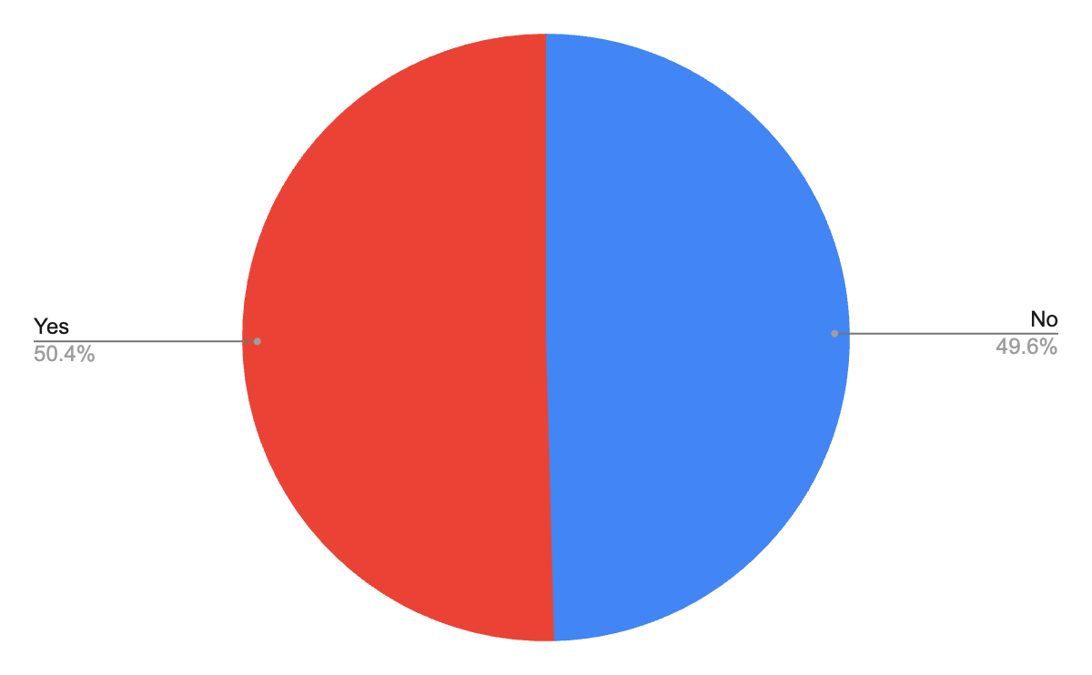
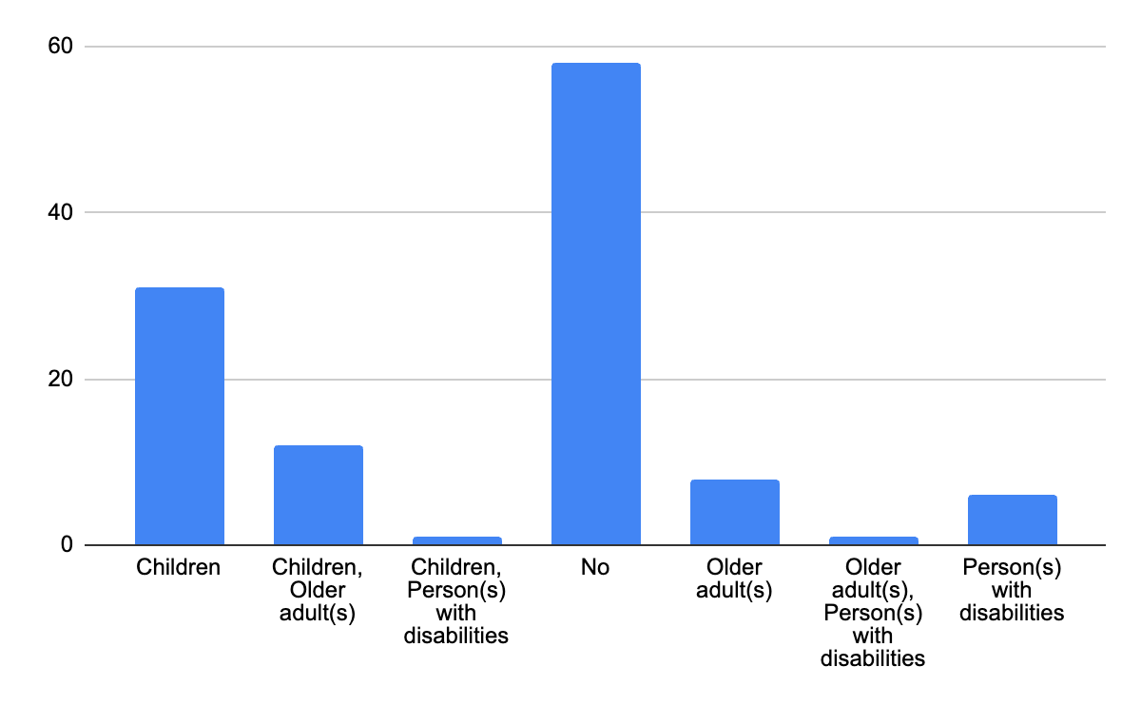

According to the questionnaire responses, 50.4% of the women who participated are caregivers, while 49.6% are not caregivers (or do not perceive themselves as such). Caregivers manage multiple responsibilities, including caring for children, older adults, and people with disabilities.

What are the daily activities that require your mobility?

Individual Activities:
- Work: 29%
- Daily shopping: 23.7%
- Accompanying children to school/activities: 18.32%
- Personal activities: 15.27%
- Caregiving for older adults/dependents: 13.75%
Mobility patterns:
- Most common pattern: Work → accompanying children → daily shopping → personal activities.
- Second most common: Work → accompanying children → caregiving → daily shopping → personal activities.
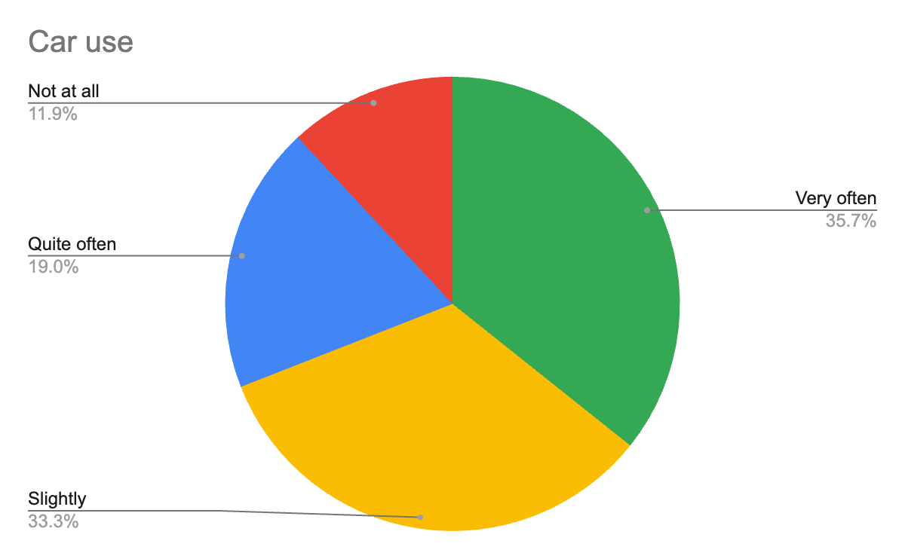
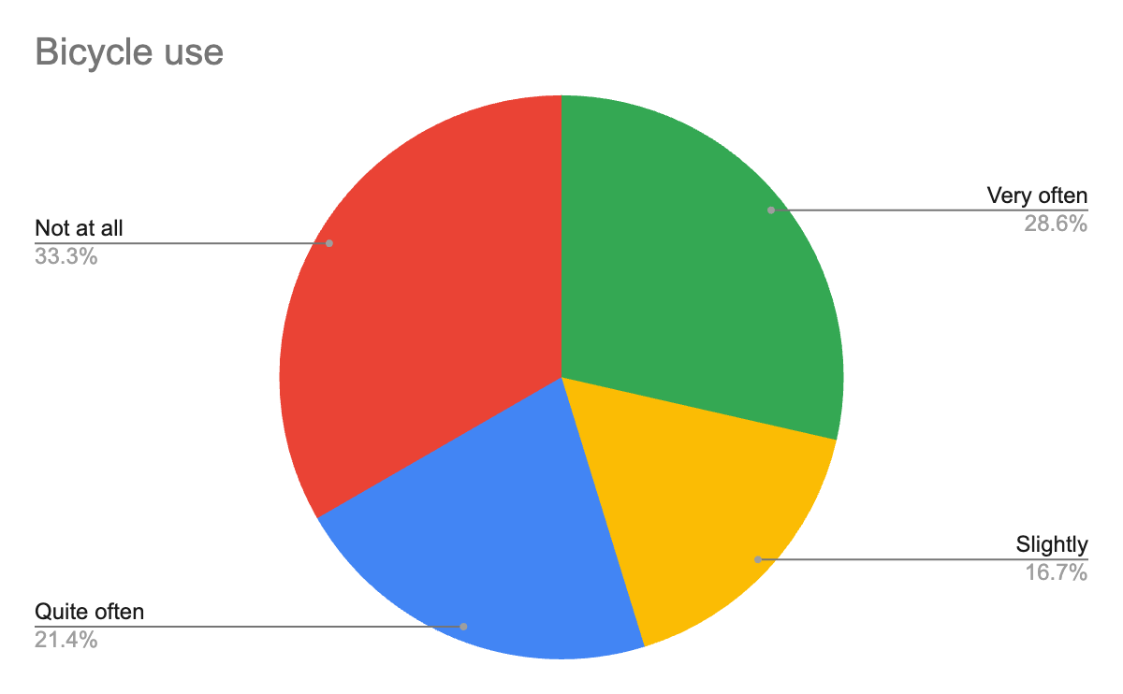
- It is noteworthy that caregivers with more complex routes—those who selected three or more daily activities requiring travel—show limited or no use of bicycles: 50% fall into this category, with 33.3% never using a bicycle and 16.7% using it slightly. In contrast, car usage is significantly higher: 35.7% use it extensively, 19% moderately, and 33.3% occasionally, while only 11.9% report not using a car at all.

The daily activities of caregivers are characterised by multiple and complex responsibilities. Work appears as a central activity, often combined with childcare, caregiving and daily needs such as shopping. These multiple responsibilities underline the intensity of the roles that women take on, as they have to balance between professional, family and personal needs. Caring is a central aspect of their daily lives, significantly influencing their travel choices and the structure of their day.

How do you choose to move daily and with what frequency?

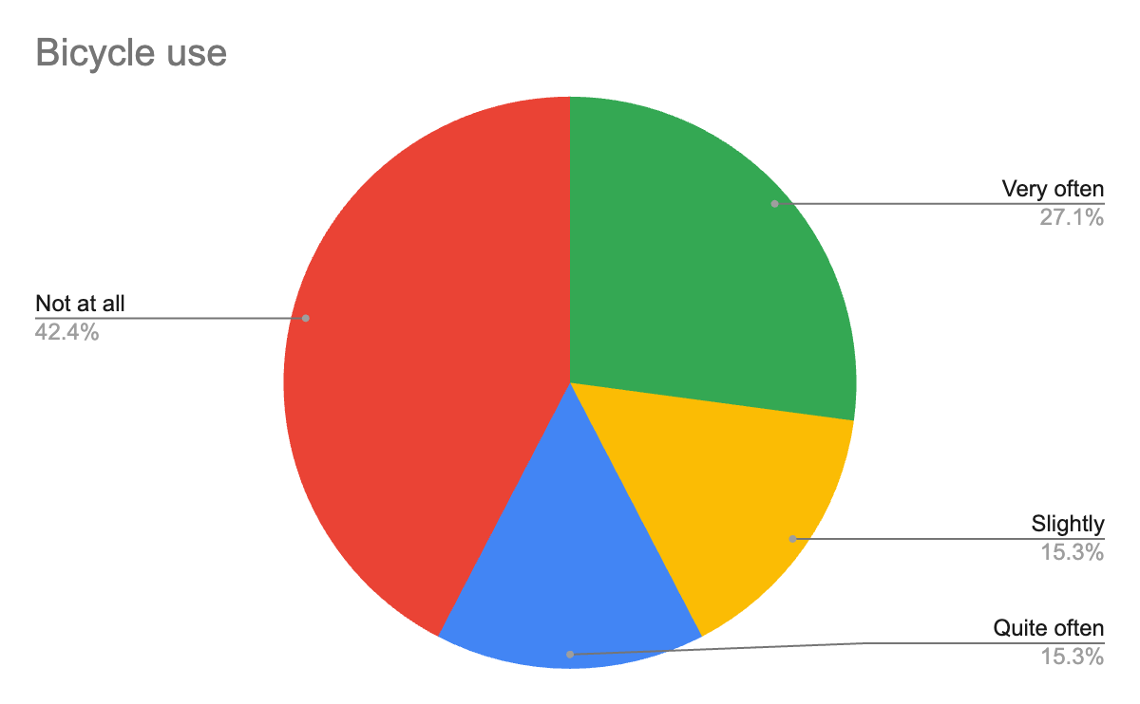
27.1% use it "Very often", 15.3% "Quite often", 15.3% "Slightly" and 42.4% "Not at all."

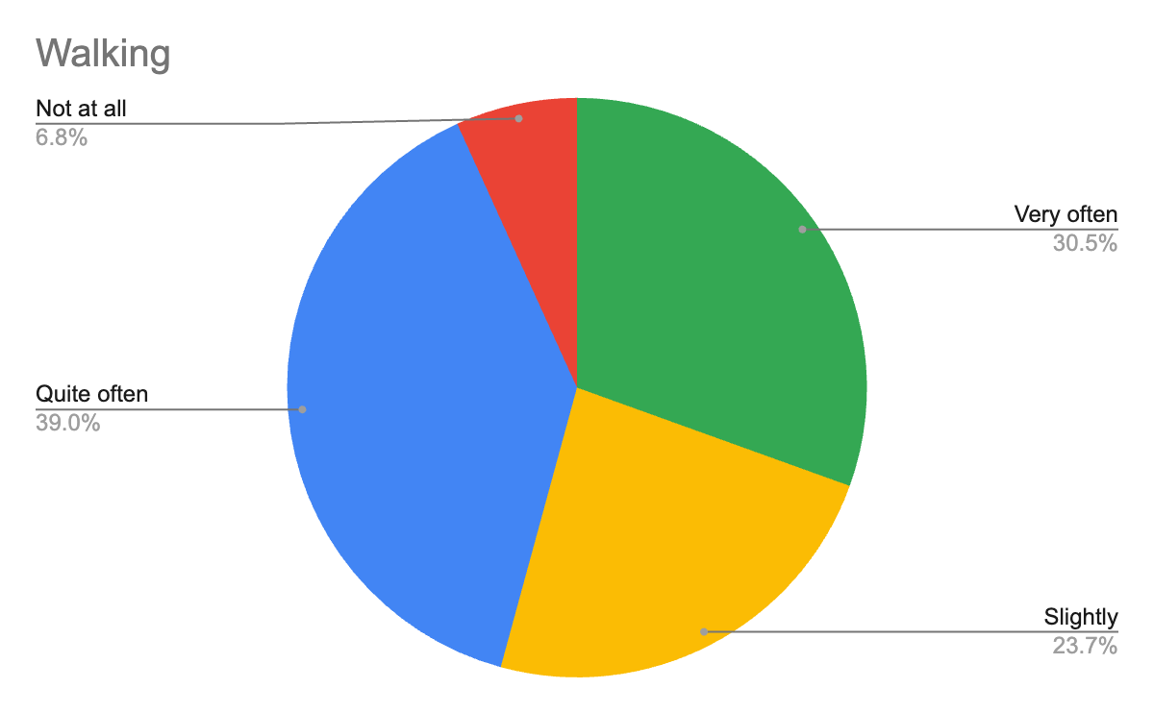

30.5% walk "Very often", 39% "Quite often", 23.7% "Slightly" and 6.8% "Not at all."

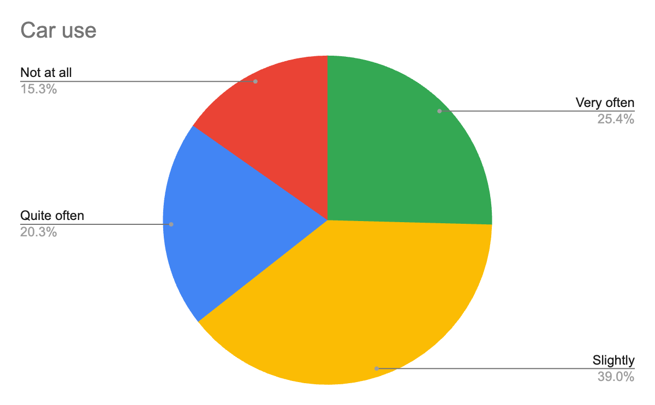

25.4% use it "Very often", 20.3% "Quite often", 39% "Slightly" and 15.3% "Not at all."

93.2% do not use it at all, while 3.4% use it "Quite often".

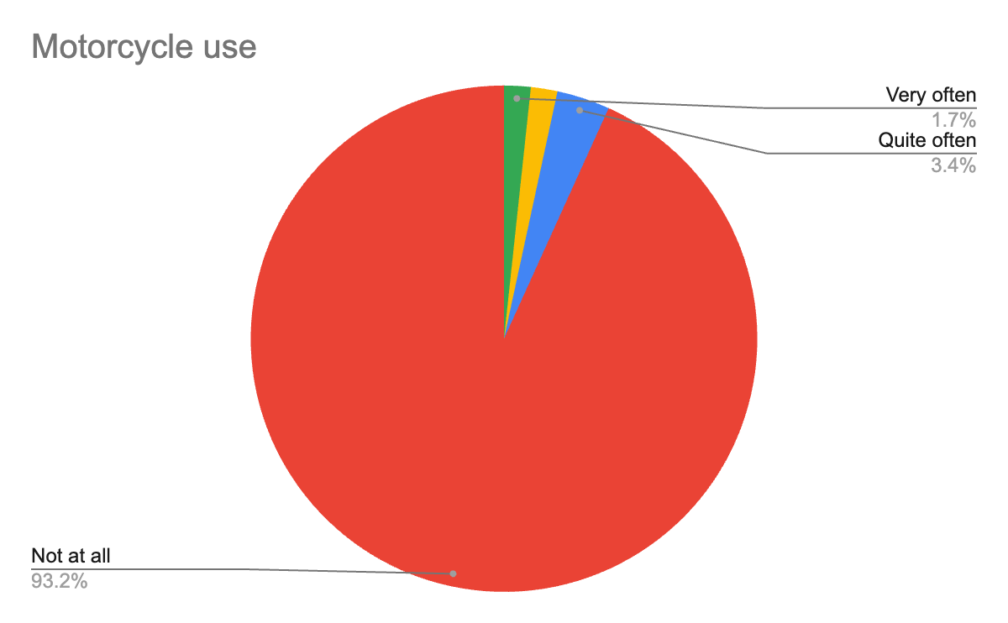

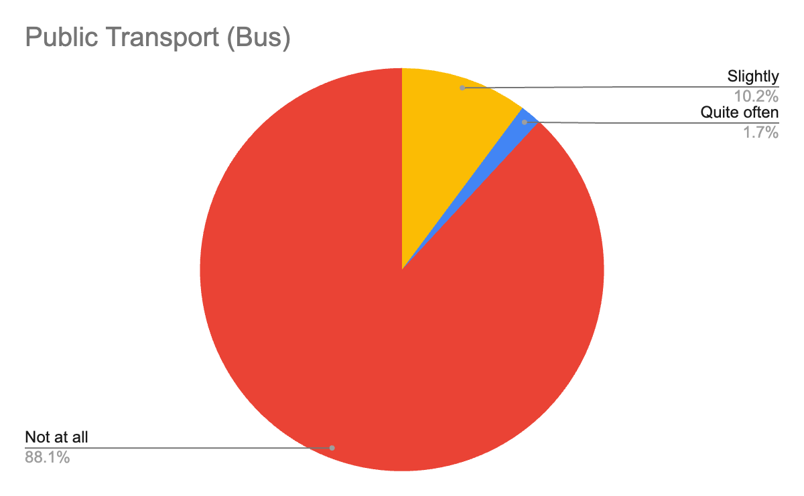
88.1% do not use it at all, 10.2% use it "Slightly" and 1.7% use it "Quite often".

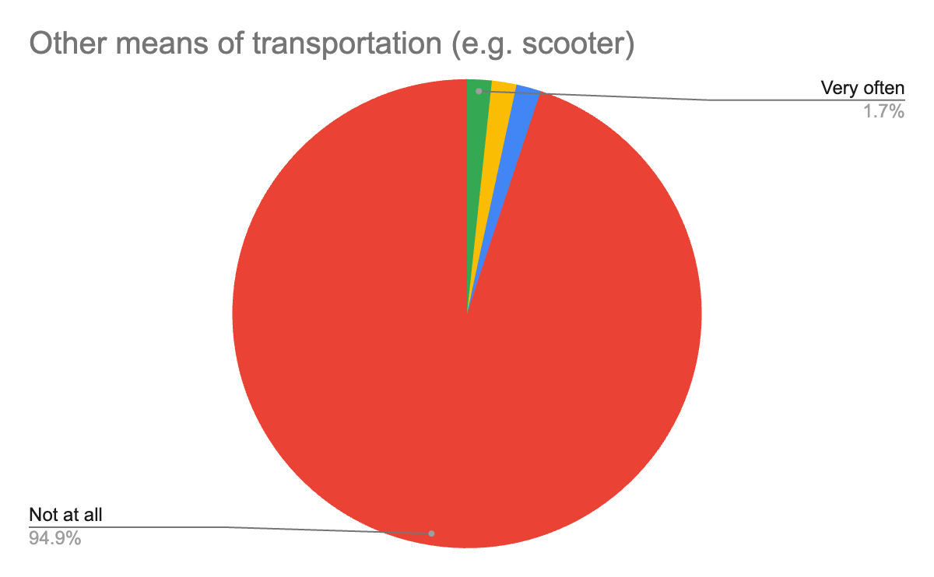

94.9% do not use other means such as scooters at all, while 1.7% use them "Quite often".

Quotes from caregivers about their transportation choices in Trikala:

- "It allows me to carry items, groceries, and my child." (car)
- "The car is more convenient, especially when I have at least one more person with me (a minor child) or when I'm carrying things."
- "I use the car for transporting a person with disabilities because most sidewalks are not wheelchair accessible."
- "I can't commute with any other means of transport because of my place of residence and obligations." (car)

Caregivers rely primarily on cars for their daily transportation, with 25.4% using them "Very often" and 20.3% "Quite often". This is due to the need for quick and flexible mobility, especially when they need to transport children, older adults, or goods. The use of other means, such as motorcycles, buses, or bicycles, is extremely limited, mainly due to inadequate infrastructure, the lack of reliable public transport, and the practical difficulties they face. Their responses highlight that the choice of a car is not always a matter of preference but of necessity, driven by the lack of alternatives and their multiple responsibilities.

Why do you prefer this mode of transportation over others?

Categories that stand out based on responses (in relation to car use):

Time and Speed of Movement (48.65%)
- "Faster movement over longer distances."
- "To get my tasks done quickly."
- "It’s the fastest way."
- "I get my work done faster!!!"
- "For greater speed."
- "I get there faster and go outside the city center since public transport doesn’t work for me."
Limited Options and Lack of Public Transport (40.55%)
- "There are no other options."
- "There is no frequent public transport."
- "Because there is no bus!"
- "I would really like to use the bus, but the schedules are infrequent, the last one is too early, and there is no service on weekends."
- "I can’t use anything else due to where I live and my responsibilities."
Caregiving (10.8%)
- "It allows me to transport items, groceries, and my child."
- "The car is more convenient, especially when I have at least one other person with me (a child) or need to carry things."
- "On the bicycle, my child gets cold and is still too young for so much walking."
- "I use the car to transport a person with a disability because most sidewalks are not wheelchair accessible."
The transportation choices of female caregivers are determined by a series of factors directly related to the caregiving responsibilities they undertake. Speed and flexibility are central reasons, as many mention needing quick trips to cover their multiple obligations, such as accompanying children, caring for older adults, or transporting goods. At the same time, the lack of alternative means, such as public transport, limits their options, often making the car the only feasible solution. Additionally, the care of dependents, such as children or people with disabilities, necessitates the use of means that offer comfort and practicality.

These needs highlight the close connection between caregiving roles and transportation choices, as women strive to balance their responsibilities with the options available to them.

CONCLUSIONS
Key insights and findings from the survey and its analysis can be found in the report Women’s Mobility in Trikala – Key Findings of the 1st Phase of the ELABORATOR Research. ELABORATOR_Questionnaire Insights

Hellenic Statistical Authority. (2022). Census results of population and housing. ELSTAT.
Spyropoulou, I., Papadimitriou, E., Yannis, G., & Golias, J. (2007). Travel patterns of three distinct driver age groups in Greece. Proceedings of the Institution of Civil Engineers - Transport, 160(3), 117–124. https://doi.org/10.1680/tran.2007.160.3.117
Sansonetti, S., & Davern, E. (2021). Women and transport. European Parliament.

