**Asymptotic notations :**

1. I learned that asymptotic notations also called the Big(O) notations describe the time or space complexity of an algorithm.
2. It helps us analyze our code and find the most optimal solution.

**Best, average and worst case time complexities:**

1. For Liner search :

* Best case : O(1)
* Average case : O(n)
* Worst case : O(n)

1. For Binary search :

* Best case : O(1)
* Average case : O(n)
* Worst case : O(n)

**Ecommerce code :**

class Product {

int pId;

String pName;

String category;

Product(int pId, String pName, String category) {

this.pId = pId;

this.pName = pName;

this.category = category;

}

}

public class Ecommerce {

public static void main(String[] args) {

Product[] products = {

new Product(3, "Books", "Education"),

new Product(1, "Shirt", "Clothing"),

new Product(5, "Laptop", "Electronics"),

new Product(2, "Phone", "Electronics"),

new Product(4, "Watch", "Accessories")

};

int t = 5;

Product resultLinear = linearSearch(products, t);

if (resultLinear != null)

System.out.println("Linear Search found: " + resultLinear.pName);

bubbleSort(products);

Product resultBinary = binarySearch(products, t);

if (resultBinary != null)

System.out.println("Binary Search found: " + resultBinary.pName);

}

static Product linearSearch(Product[] products, int t) {

for (Product product : products) {

if (product.pId == t)

return product;

}

return null;

}

static void bubbleSort(Product[] products) {

int n = products.length;

for (int i = 0; i < n - 1; i++) {

for (int j = 0; j < n - i - 1; j++) {

if (products[j].pId > products[j + 1].pId) {

Product temp = products[j];

products[j] = products[j + 1];

products[j + 1] = temp;

}

}

}

}

static Product binarySearch(Product[] products, int t) {

int left = 0, right = products.length - 1;

while (left <= right) {

int mid = left + (right - left) / 2;

if (products[mid].pId == t)

return products[mid];

else if (products[mid].pId < t)

left = mid + 1;

else

right = mid - 1;

}

return null;

}

}

**Output :**

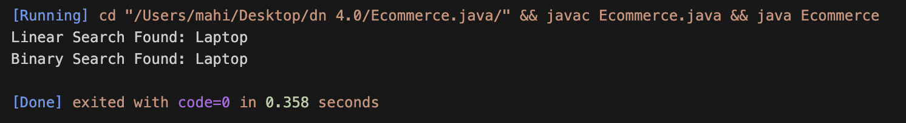

**Comparison :**

* Binary search is more suitable if the array of the product Id’s has already been sorted, in any other case it might be more time consuming to sort the array first.
* But in case of smaller datasets and unsorted arrays, linear search will be more suitable.
* For the current platform, linear search would work fine.