**Recursion :**

Recursion is when a method calls itself to solve smaller cases of the problem. It ca simplify solving problems where the same method needs to be used multiple times.

**Code :**

public class Recursive {

public static void main(String[] args) {

double principal = 1000;

double[] growthPercent= {0.05, 0.10, 2, 0.50};

double future = forecast(principal, growthPercent, 0);

System.out.printf("Future Value: %.2f\n", future);

}

static double forecast(double p, double[] g, int i) {

if (i == g.length)

return p;

return forecast(p * (1 + g[i]), g, i + 1);

}

}

**Output :**

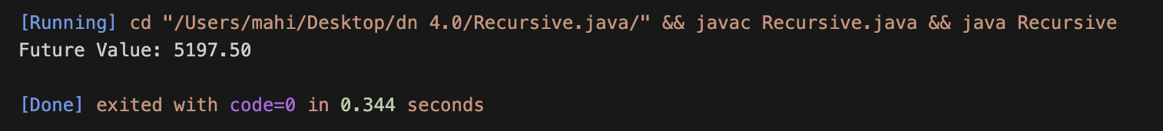

**Time complexity :**

* Since, we are letting the recursion run a number of times “n” the time complexity of this recursion is O(n).
* To optimize this we may use an iterative approach with loops.