**Scenario 1 :**

DECLARE

CURSOR cust_cursor IS

SELECT CustomerID, InterestRate

FROM Customers

WHERE Age > 60;

BEGIN

FOR cust_rec IN cust_cursor LOOP

UPDATE Customers

SET InterestRate = InterestRate - 0.01

WHERE CustomerID = cust_rec.CustomerID;

DBMS_OUTPUT.PUT_LINE('Discount: ' || cust_rec.CustomerID);

END LOOP;

END;

**Output :**

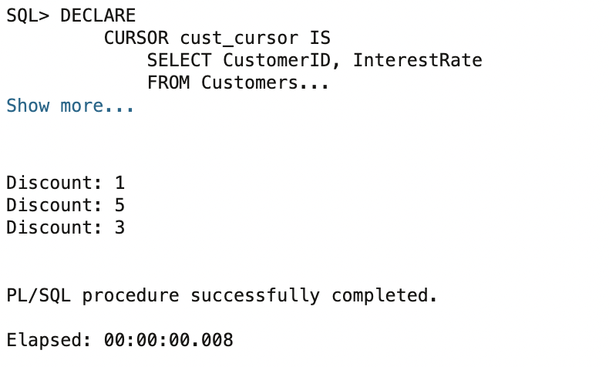

**Scenario 2 :**

DECLARE

CURSOR balance_cursor IS

SELECT CustomerID, Balance

FROM Customers

WHERE Balance > 10000;

BEGIN

FOR cust_rec IN balance_cursor LOOP

UPDATE Customers

SET IsVIP = 'TRUE'

WHERE CustomerID = cust_rec.CustomerID;

DBMS_OUTPUT.PUT_LINE('Customer ID ' || cust_rec.CustomerID || ' promoted.');

END LOOP;

END;

**Output :**

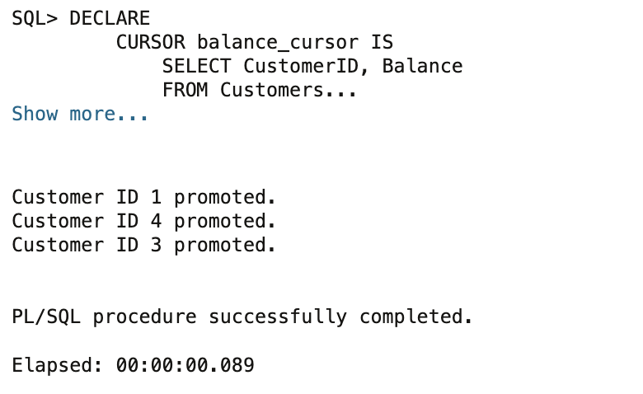

**Scenario 3 :**

DECLARE

CURSOR loan_cursor IS

SELECT LoanID, CustomerID, DueDate

FROM Loans

WHERE DueDate BETWEEN SYSDATE AND SYSDATE + 30;

BEGIN

FOR loan_rec IN loan_cursor LOOP

DBMS_OUTPUT.PUT_LINE('Reminder: Loan ID ' || loan_rec.LoanID ||

' for Customer ID ' || loan_rec.CustomerID ||

' is due on ' || TO_CHAR(loan_rec.DueDate, 'DD-MON-YYYY'));

END LOOP;

END;

**Output :**

