1. Setting up Spring Project :

* Created Maven project in IntelliJ IDE called LibraryManagement.
* Added the necessary SpringCore dependencies in the pom.xml file.

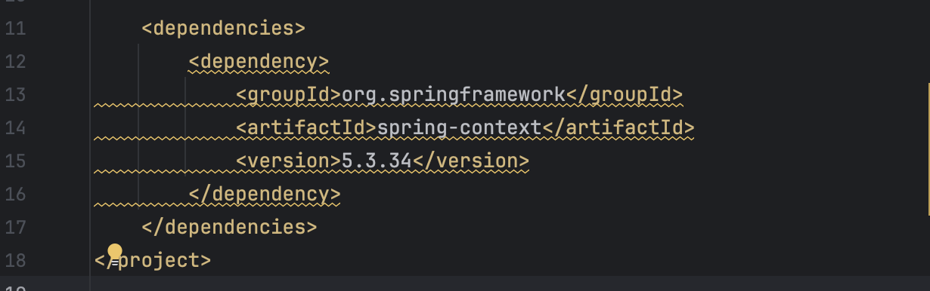

1. Create xml file :

* Created applicationContext.xml :

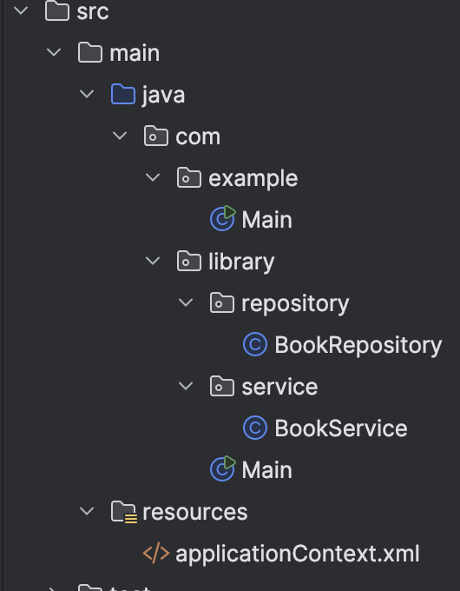

* Used this code to define beans for BookService and BookRepository :
* 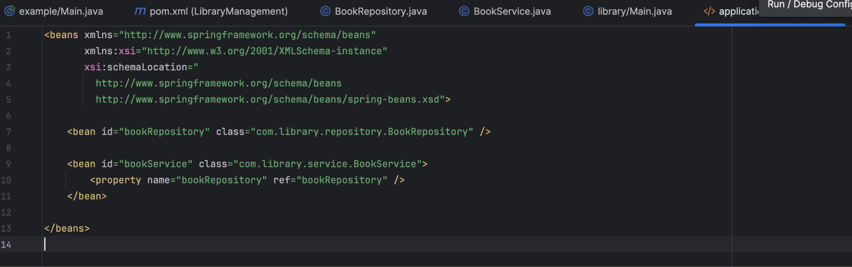

1. Defining Service and Repository classes :

* Creating Repository and Service java classes in their respective packages :

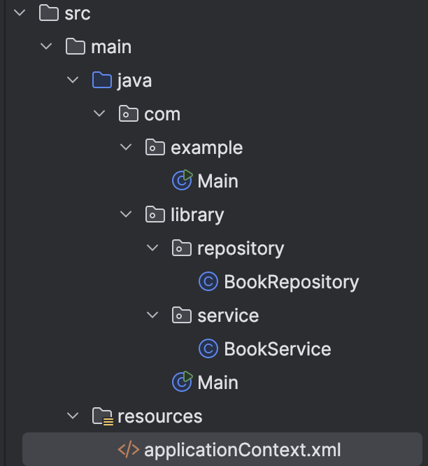

* Used the following codes in the classes :
* BookRepository.java :

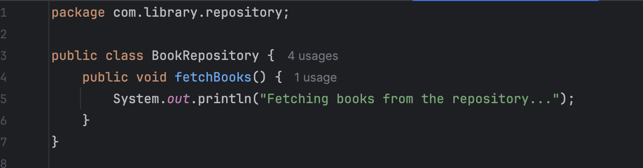

* BookService.java :

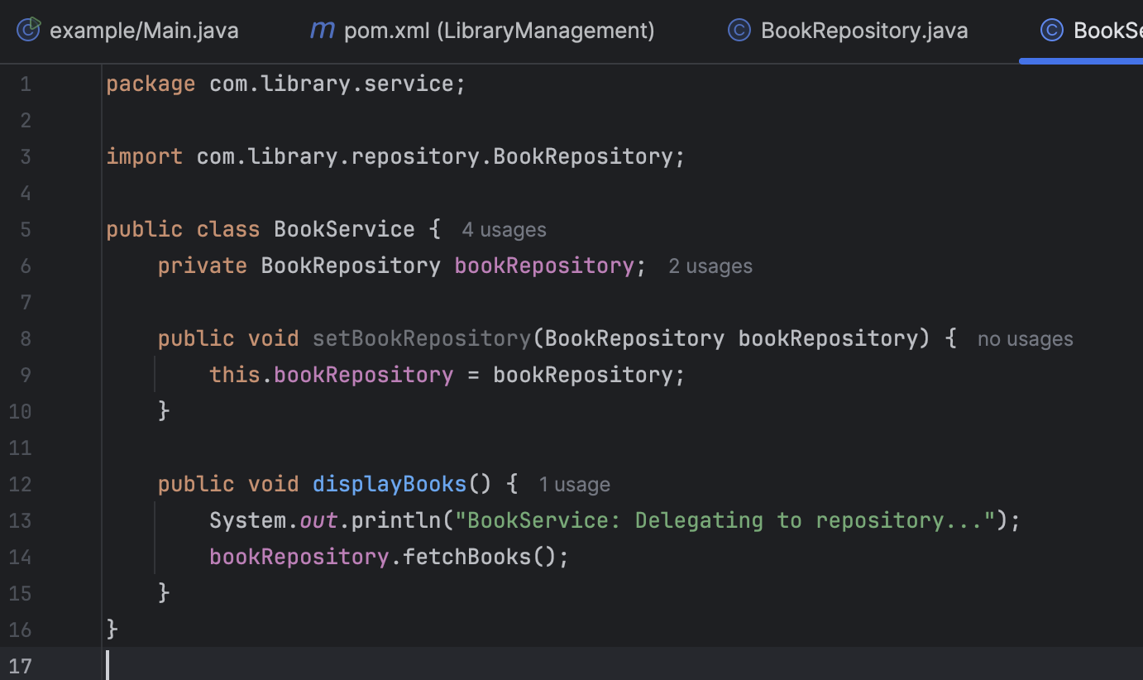

1. Create a main class :

* Created a main class with the following code :

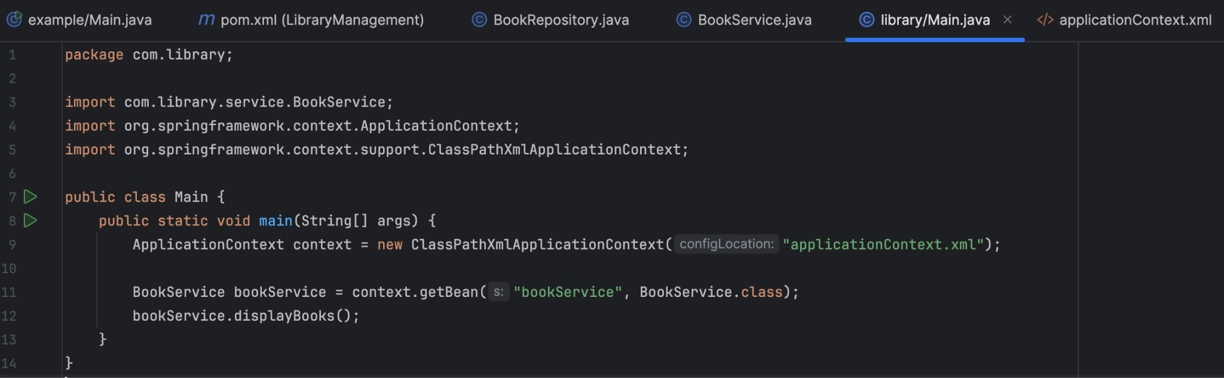

* Final output after running :

