1. Modifying xml document :

* Updating applicationContext.xml to wire between BookRepository and BookService :

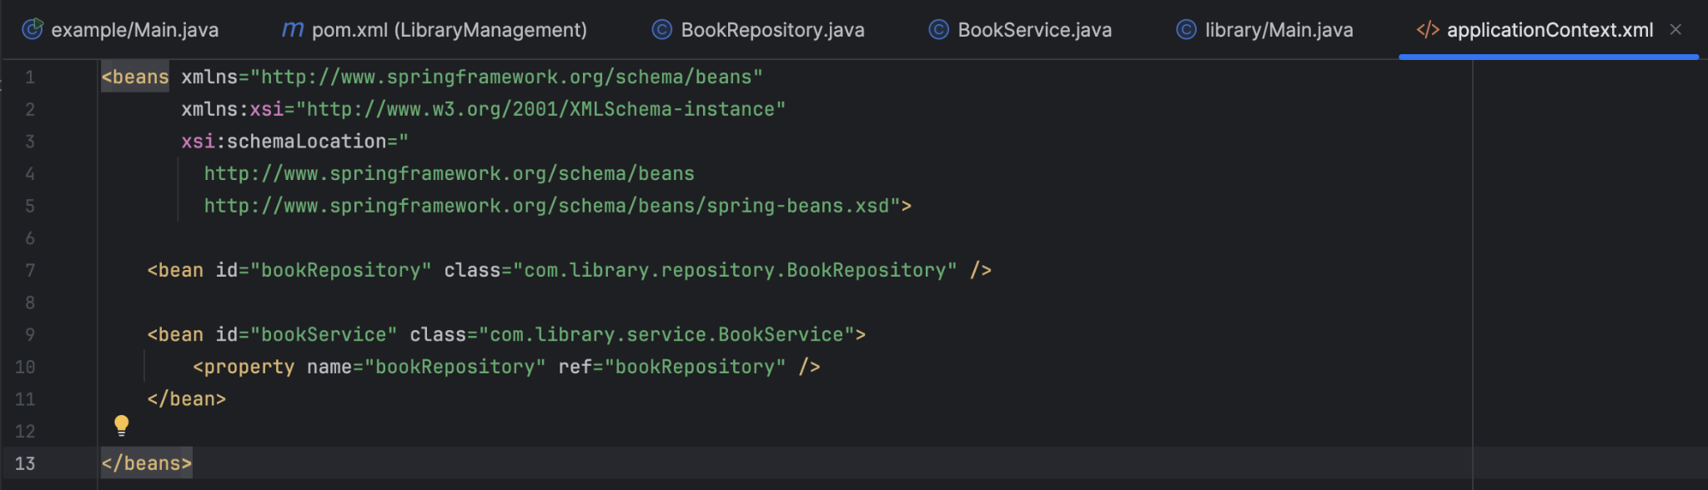

1. Updating BookService class :

* Modifying BookService class to have a setter that we have already linked in the xml document :

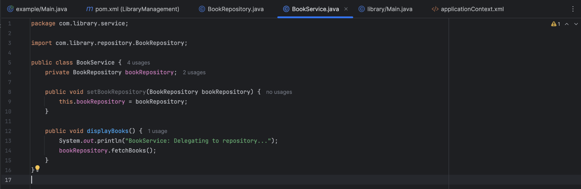

1. Test Main app :

* Modify Main.java to test the setter :

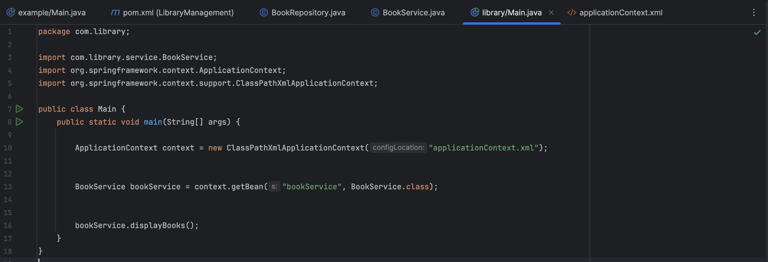

1. Final output :

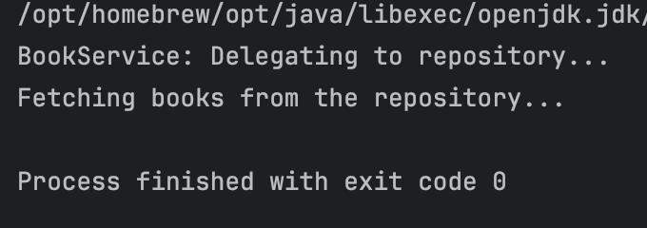

The setter-based injection successfully concluded.