1. **Created a “HelloController.java” class :**

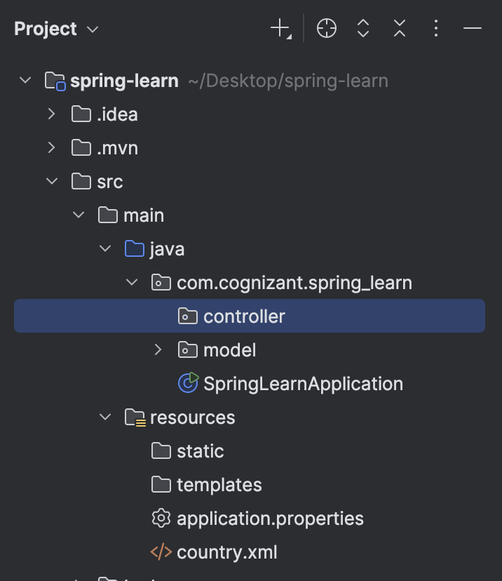

**The code in that class :**

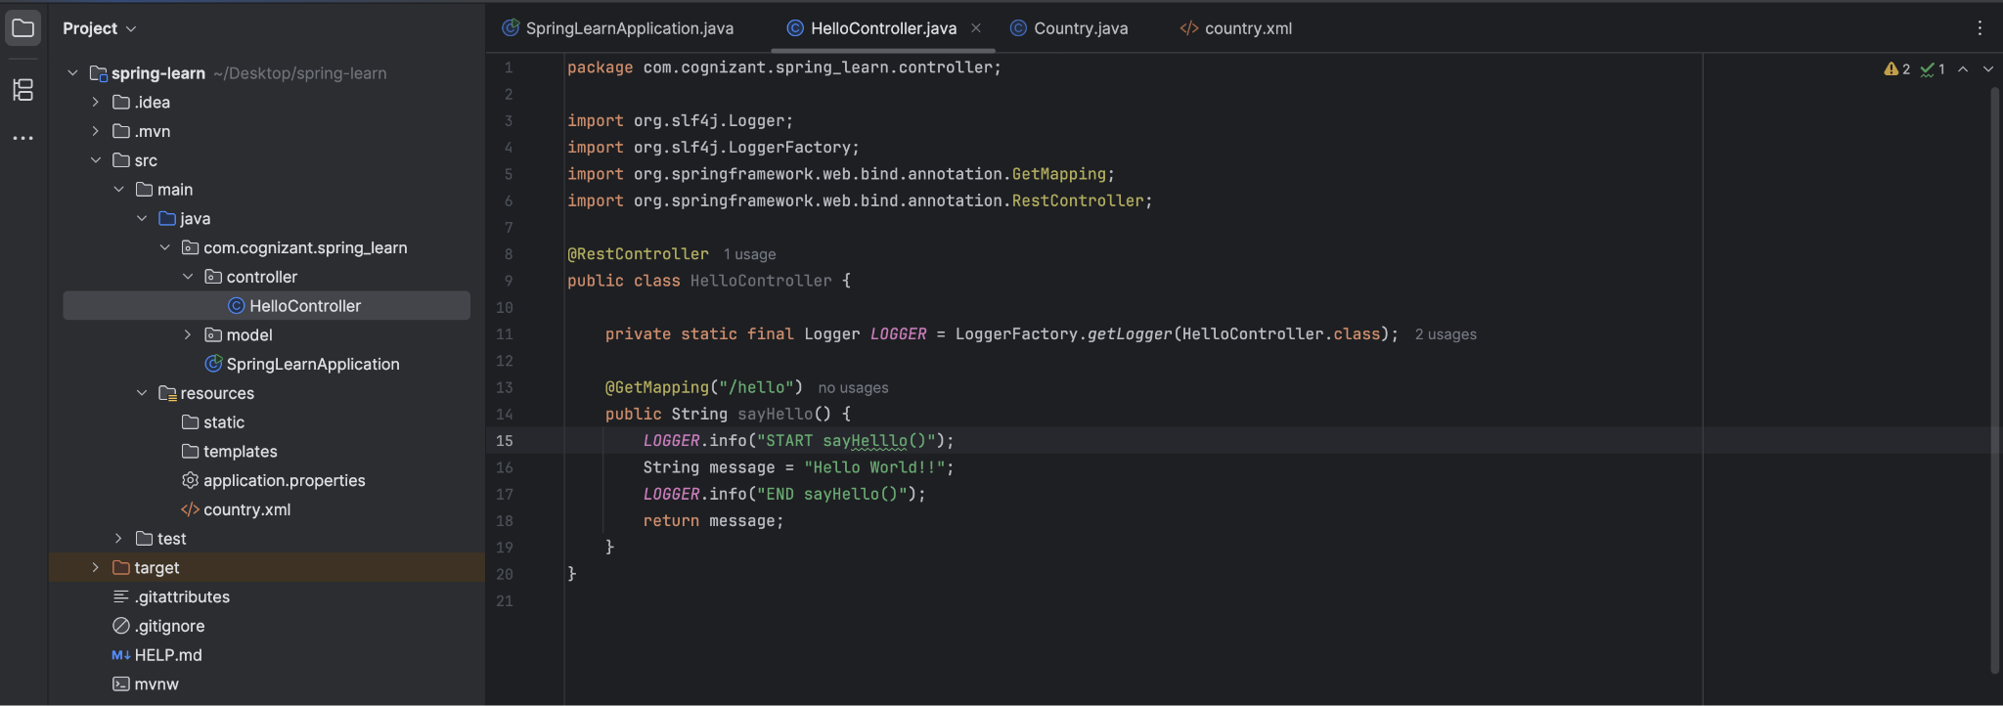

1. **Set server port to 8083 in application properties :**

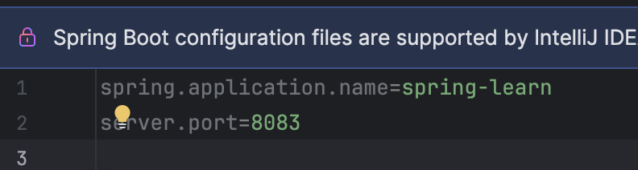

1. **Updated SpringLearnApplication to a simpler code :**

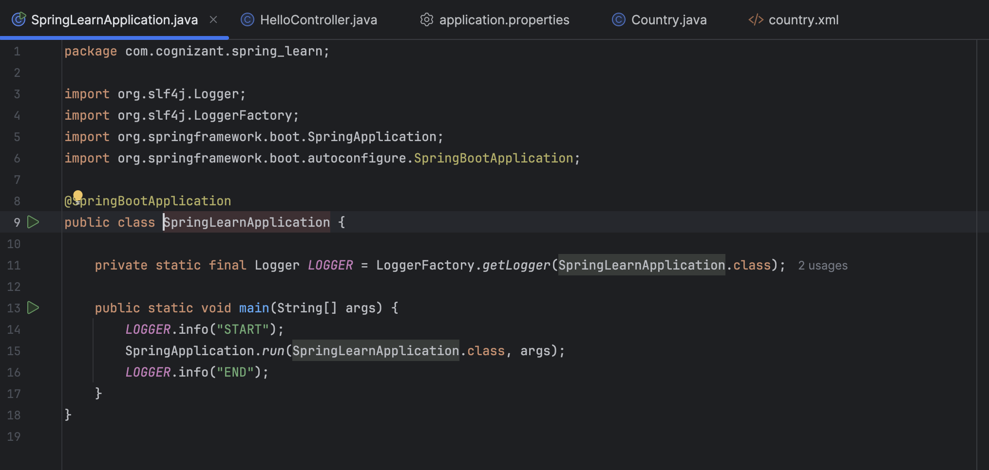

1. **Run “**[**http://localhost:8083/hello**](http://localhost:8083/hello)**” on my local browser to see :**

