1. **I initially ensured that the country “India” was already present in my existing “country.xml” file :**

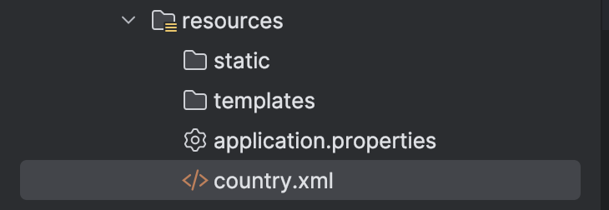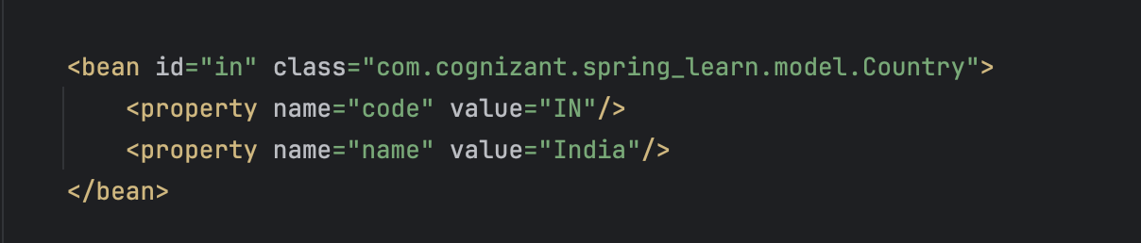

1. **I made sure that the Country.java file was still present :**

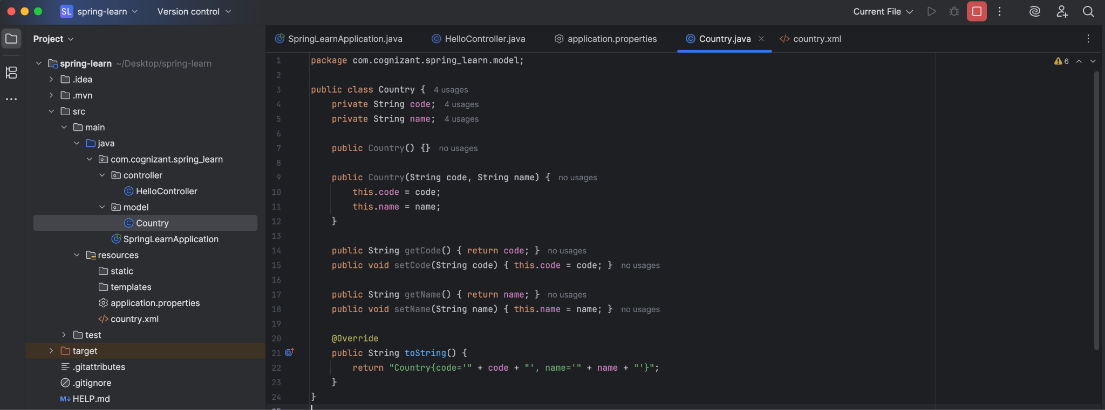

1. **Created the “CountryController.java” file :**

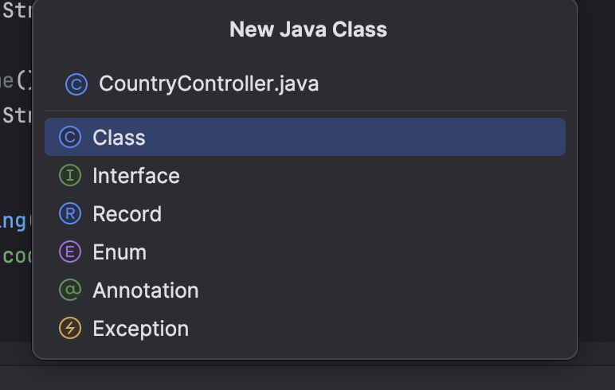

**The code in “Country.Controller.java” :**

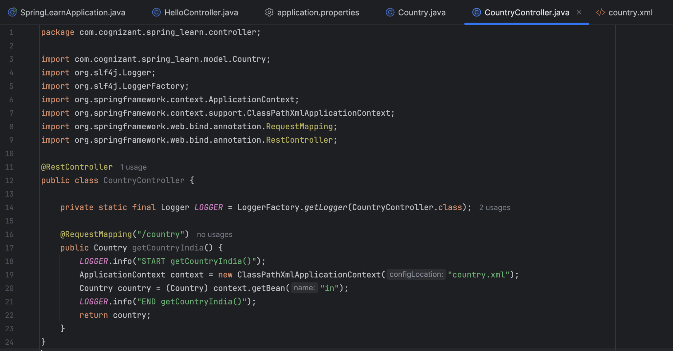

1. **Ran the “SpringJavaApplication” file and went to the url “**[**http://localhost:8083/country**](http://localhost:8083/country)**” to get :**

