1. **Made sure “country.xml” contained various country names and their codes.**
2. **Created a “CountryService.java” class in a “service” package to dynamise everything :**



**The code used :**

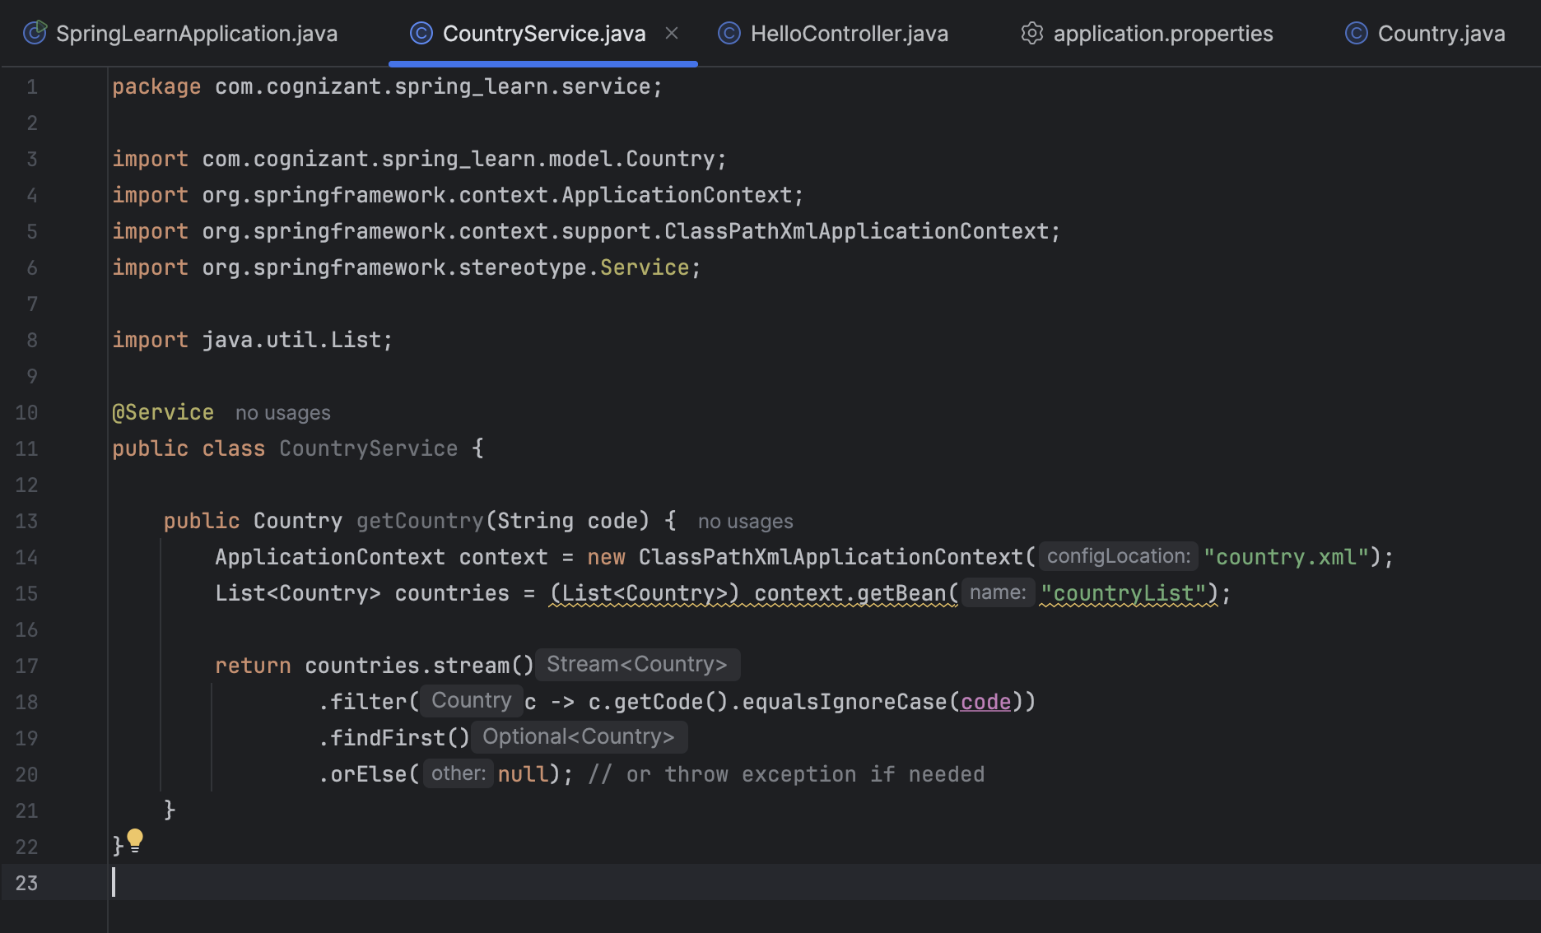

1. **Updates “CountryController.java” to work with the service file :**

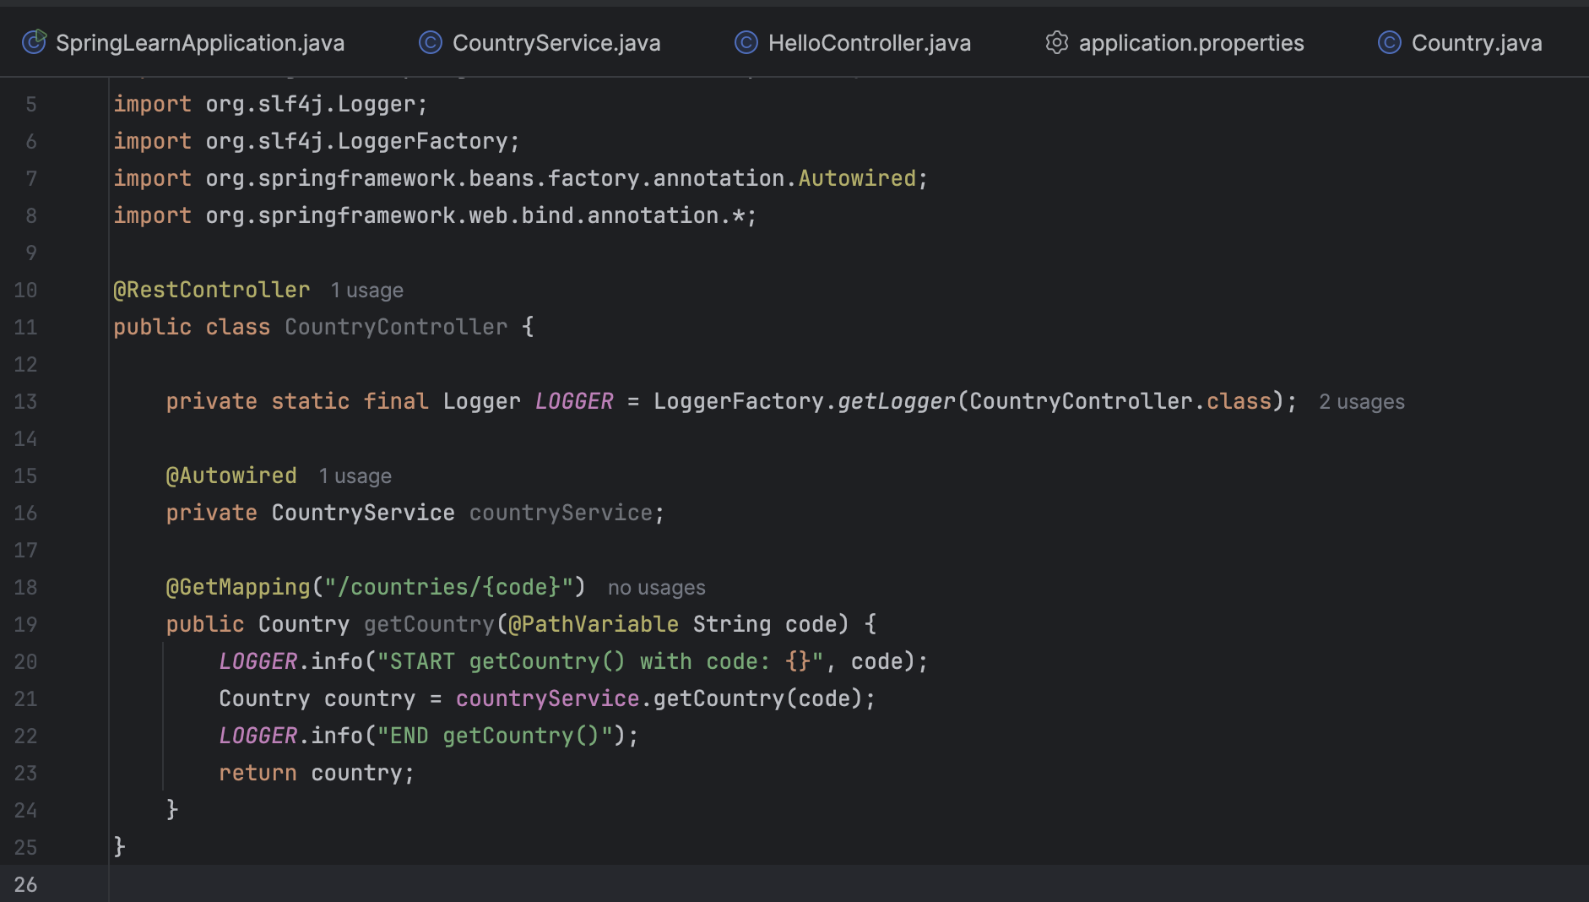

1. **Ran the “SpringJavaApplication” and went to “**[**http://localhost:8083/countries/jp**](http://localhost:8083/countries/jp)**” to find this :**

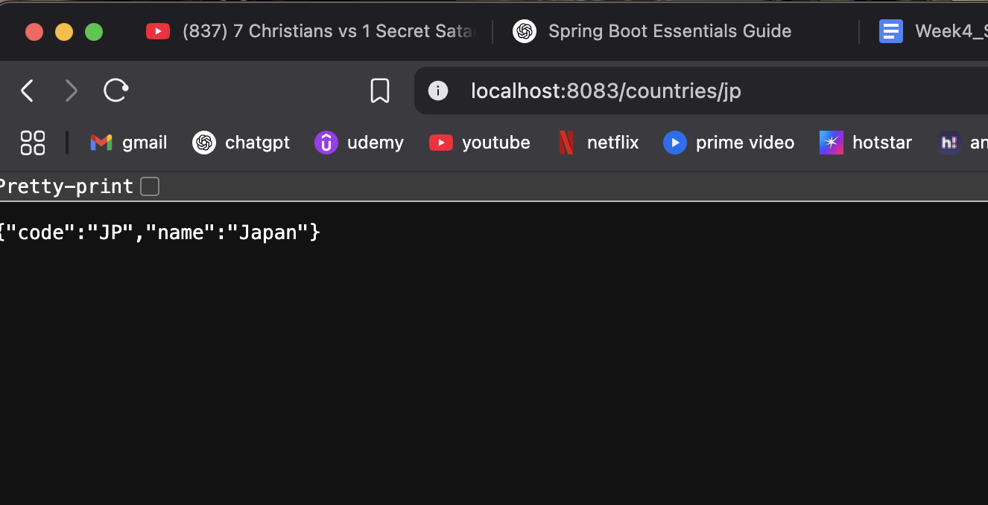

**The application will pull up whatever code is entered in the url.**