1. **Added Jwt dependencies to pom.xml :**

**Code :**

<project xmlns="http://maven.apache.org/POM/4.0.0" xmlns:xsi="http://www.w3.org/2001/XMLSchema-instance"

xsi:schemaLocation="http://maven.apache.org/POM/4.0.0 https://maven.apache.org/xsd/maven-4.0.0.xsd">

<modelVersion>4.0.0</modelVersion>

<parent>

<groupId>org.springframework.boot</groupId>

<artifactId>spring-boot-starter-parent</artifactId>

<version>3.5.3</version>

<relativePath/> <

</parent>

<groupId>com.cognizant</groupId>

<artifactId>spring-learn</artifactId>

<version>0.0.1-SNAPSHOT</version>

<name>spring-learn</name>

<description>Demo project for Spring Boot</description>

<url/>

<licenses>

<license/>

</licenses>

<developers>

<developer/>

</developers>

<scm>

<connection/>

<developerConnection/>

<tag/>

<url/>

</scm>

<properties>

<java.version>17</java.version>

</properties>

<dependencies>

<dependency>

<groupId>org.springframework.boot</groupId>

<artifactId>spring-boot-starter-web</artifactId>

</dependency>

<dependency>

<groupId>javax.servlet</groupId>

<artifactId>javax.servlet-api</artifactId>

<version>4.0.1</version>

<scope>provided</scope>

</dependency>

<dependency>

<groupId>org.springframework.boot</groupId>

<artifactId>spring-boot-devtools</artifactId>

<scope>runtime</scope>

<optional>true</optional>

</dependency>

<dependency>

<groupId>org.springframework.boot</groupId>

<artifactId>spring-boot-starter-test</artifactId>

<scope>test</scope>

</dependency>

<dependency>

<groupId>io.jsonwebtoken</groupId>

<artifactId>jjwt-api</artifactId>

<version>0.11.5</version>

</dependency>

<dependency>

<groupId>io.jsonwebtoken</groupId>

<artifactId>jjwt-impl</artifactId>

<version>0.11.5</version>

<scope>runtime</scope>

</dependency>

<dependency>

<groupId>io.jsonwebtoken</groupId>

<artifactId>jjwt-jackson</artifactId>

<version>0.11.5</version>

<scope>runtime</scope>

</dependency>

<dependency>

<groupId>org.glassfish.jaxb</groupId>

<artifactId>jaxb-runtime</artifactId>

<version>2.3.1</version>

</dependency>

</dependencies>

<build>

<plugins>

<plugin>

<groupId>org.springframework.boot</groupId>

<artifactId>spring-boot-maven-plugin</artifactId>

</plugin>

</plugins>

</build>

</project>

1. **Created a simple Jwt class :** 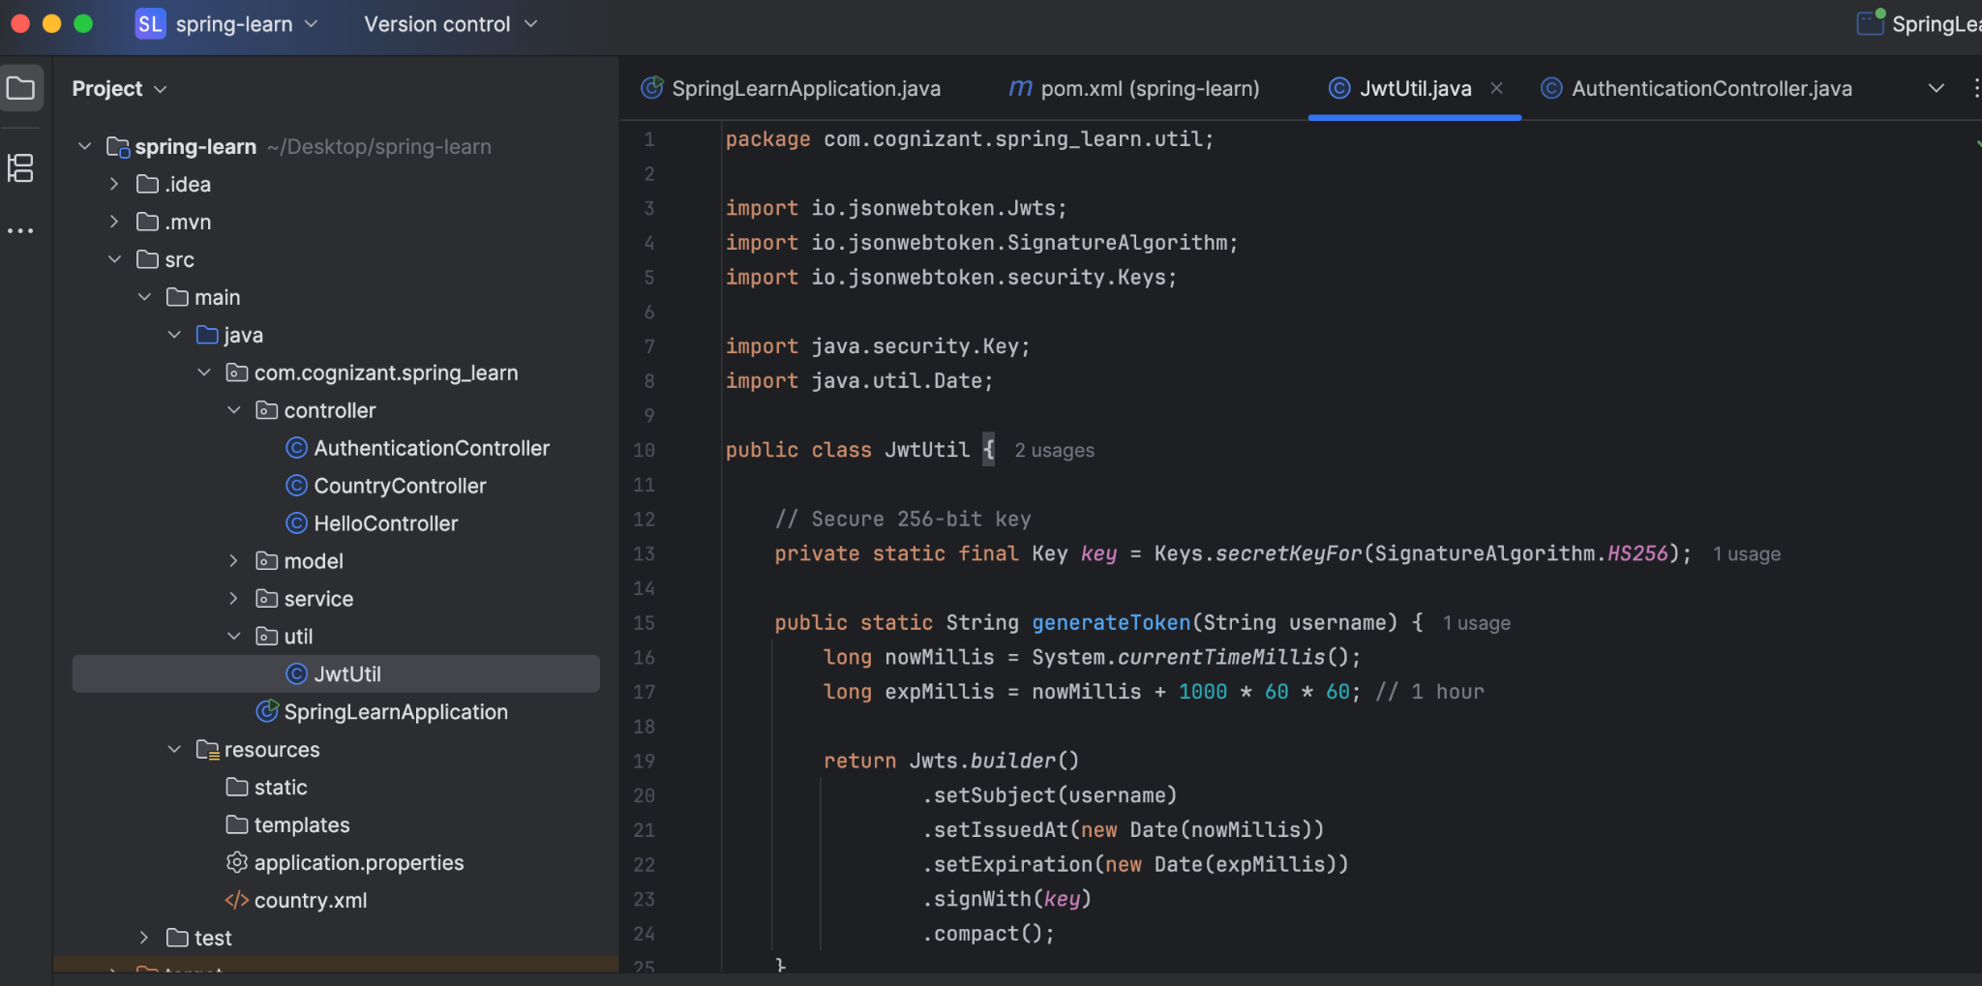
2. **Created Authentication Controller like follows :**

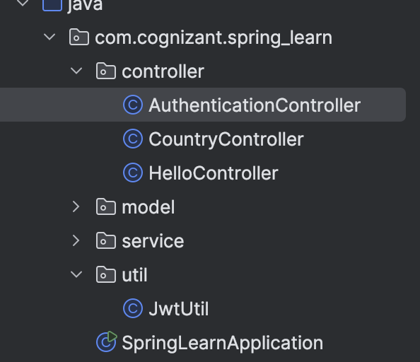

**The code :**

package com.cognizant.spring_learn.controller;

import com.cognizant.spring_learn.util.JwtUtil;

import org.springframework.http.ResponseEntity;

import org.springframework.web.bind.annotation.*;

import java.util.Base64;

import jakarta.servlet.http.HttpServletRequest;

@RestController

public class AuthenticationController {

@GetMapping("/authenticate")

public ResponseEntity<?> authenticate(HttpServletRequest request) {

String authHeader = request.getHeader("Authorization");

if (authHeader == null || !authHeader.startsWith("Basic ")) {

return ResponseEntity.status(401).body("Missing or invalid Authorization header");

}

// Decode username:password

String base64Credentials = authHeader.substring("Basic ".length());

byte[] decodedBytes = Base64.getDecoder().decode(base64Credentials);

String[] credentials = new String(decodedBytes).split(":", 2);

String username = credentials[0];

String password = credentials[1];

System.out.println(">>> Authenticate endpoint hit");

// Dummy check (in real apps, check DB or UserDetailsService)

if ("user".equals(username) && "pwd".equals(password)) {

String token = JwtUtil.generateToken(username);

return ResponseEntity.ok().body("{\"token\":\"" + token + "\"}");

} else {

return ResponseEntity.status(403).body("Invalid credentials");

}

}

}

1. **Changed the port to 8090**
2. **Tested with curl in the terminal.**

Used the command : curl -s -u user:pwd http://localhost:8090/authenticate

And got this as output :

