1. **In the existing Maven project, I created a “County” java class with codename fields :**

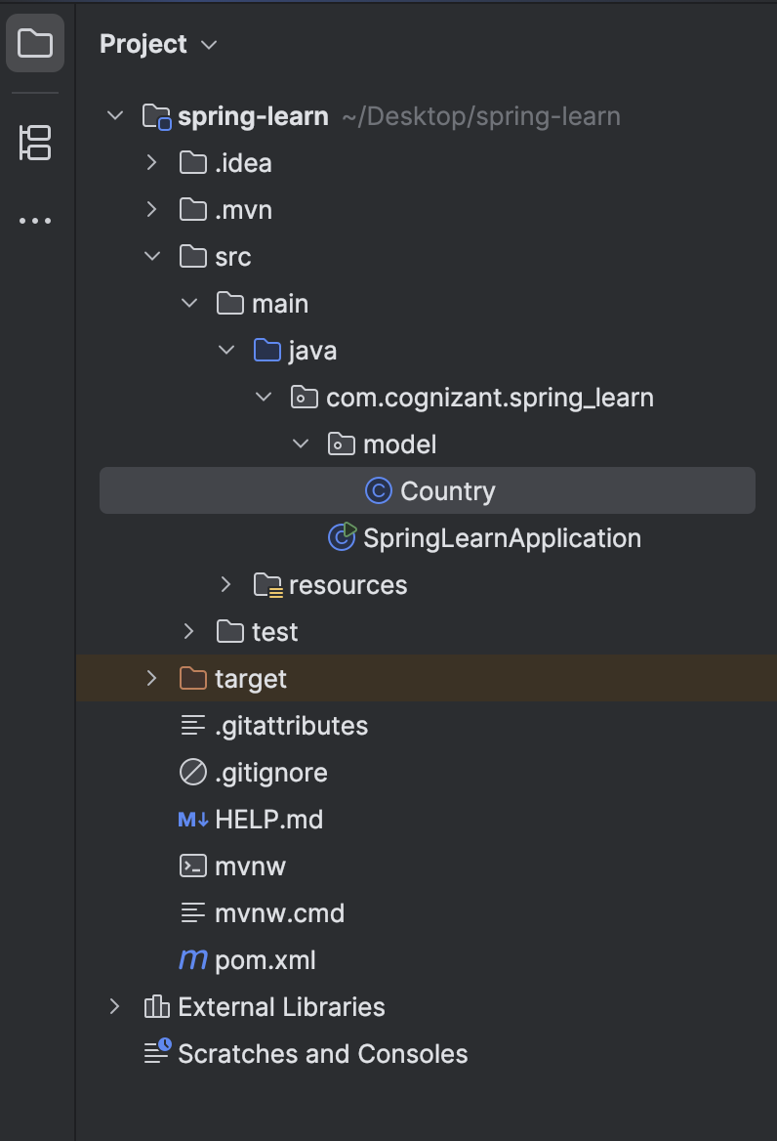

**The code in the “Country.java” file :**

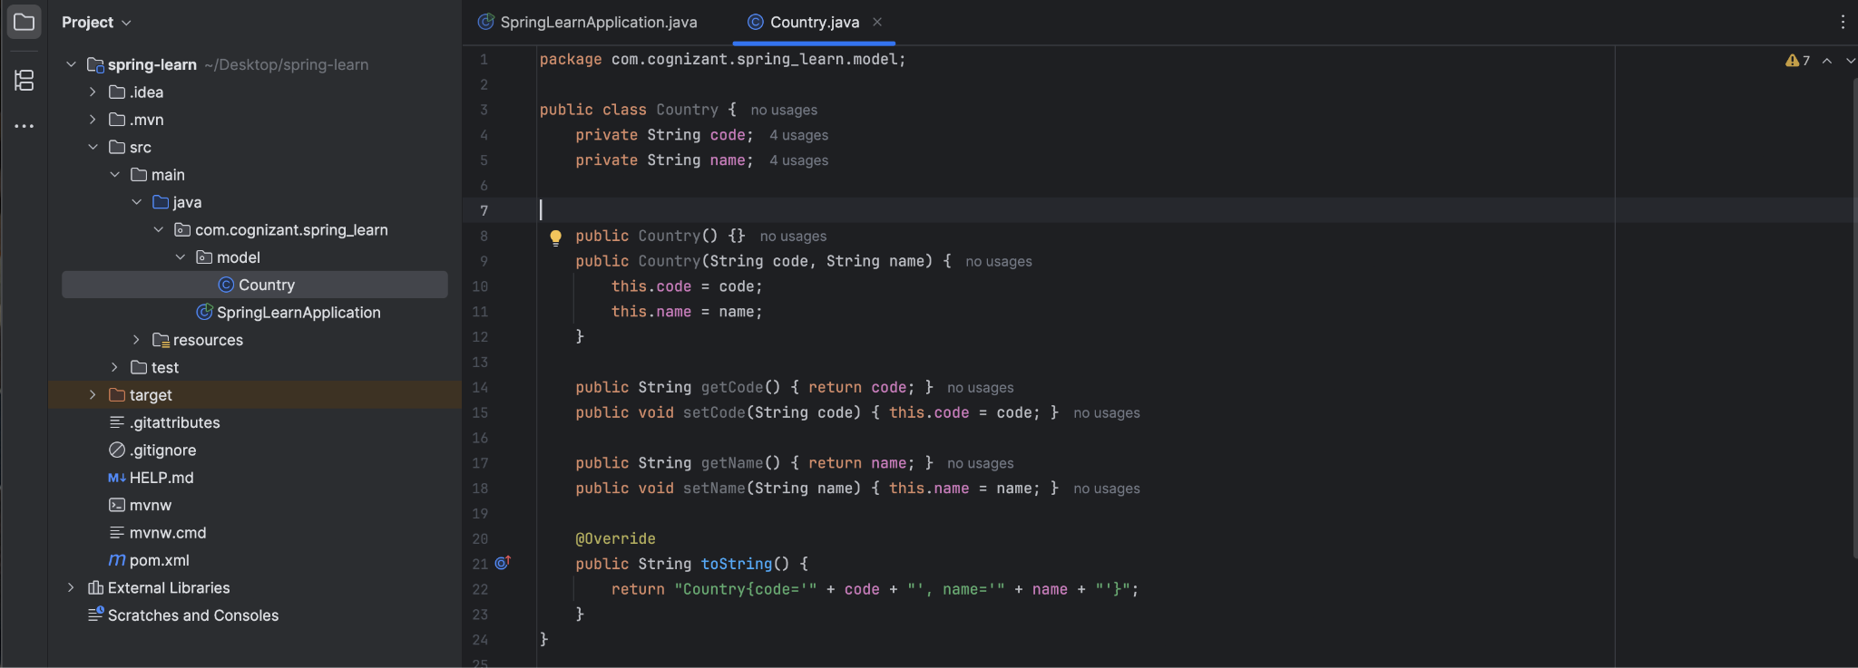

1. **Created a “country.xml” file in the resources package to define the beans :**

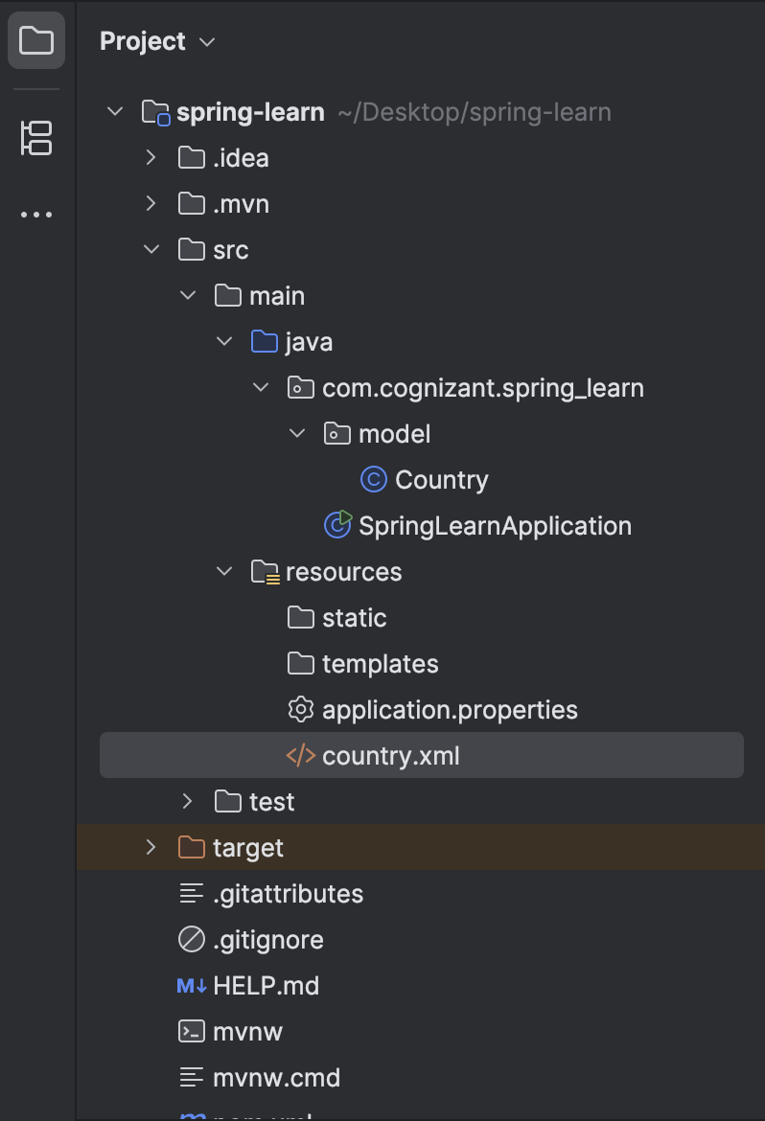

**The code in “country.xml” :**

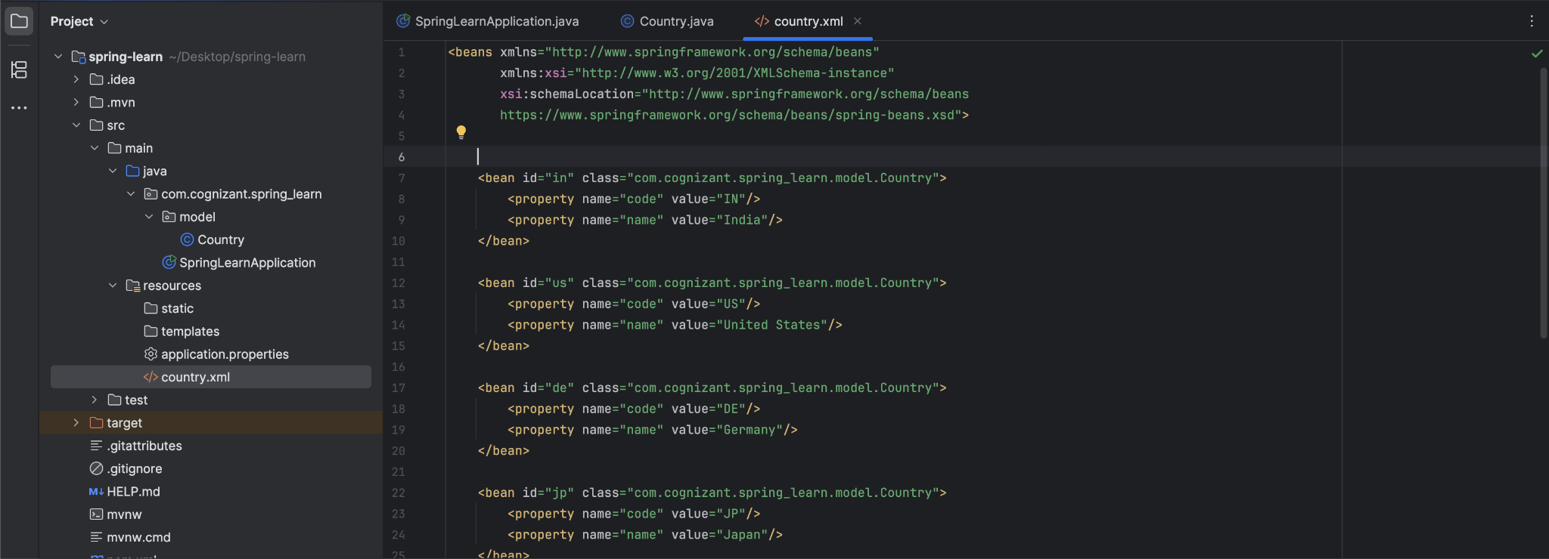

1. **Updated the “SpringLearnApplication” file with the following code :**

package com.cognizant.spring_learn;

import org.slf4j.Logger;

import org.slf4j.LoggerFactory;

import org.springframework.context.ApplicationContext;

import org.springframework.context.support.ClassPathXmlApplicationContext;

import java.util.List;

public class SpringLearnApplication {

private static final Logger LOGGER = LoggerFactory.getLogger(SpringLearnApplication.class);

public static void main(String[] args) {

LOGGER.info("START");

displayCountries();

LOGGER.info("END");

}

public static void displayCountries() {

LOGGER.debug("START displayCountries()");

ApplicationContext context = new ClassPathXmlApplicationContext("country.xml");

List<?> countryList = (List<?>) context.getBean("countryList");

for (Object country : countryList) {

LOGGER.debug(country.toString());

}

LOGGER.debug("END displayCountries()");

}

}

1. **Output :** 