1. **Generated Spring Boot file :**

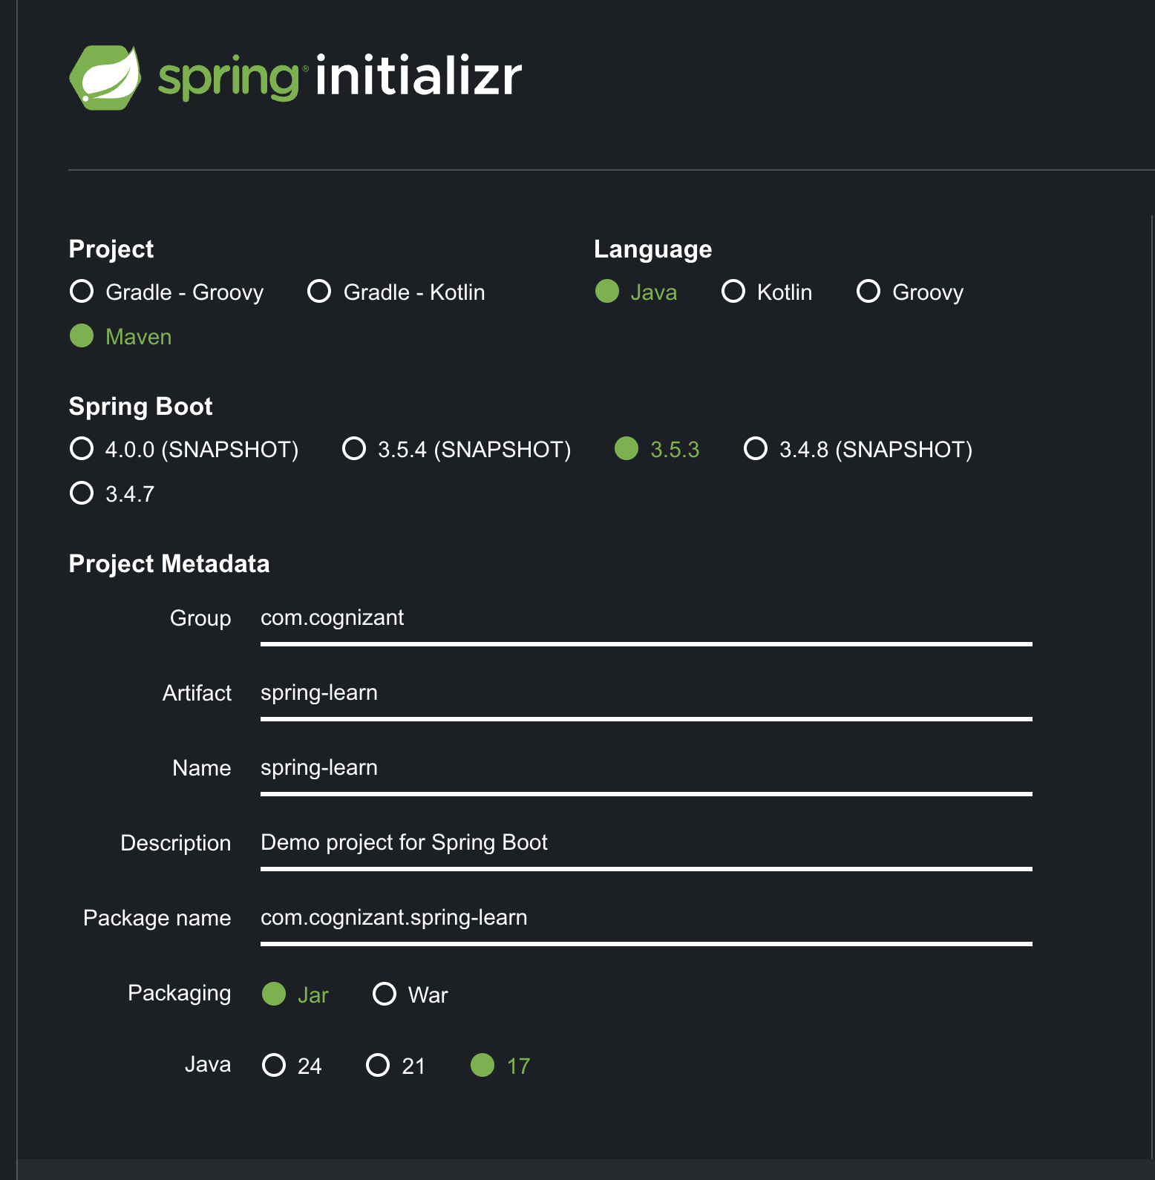

1. **Added appropriate dependencies before generating project :**

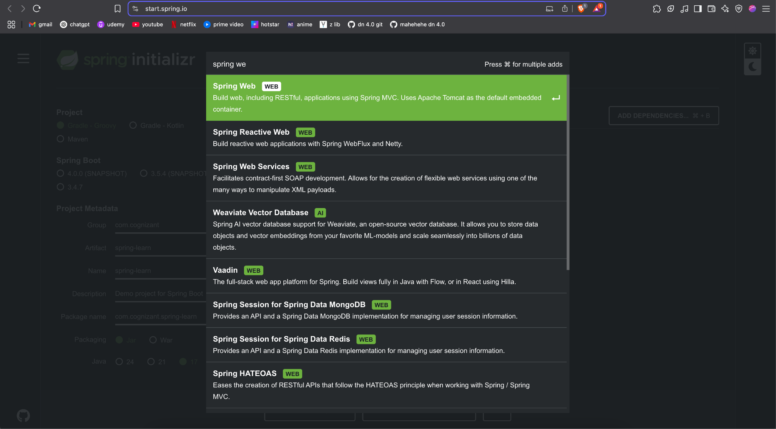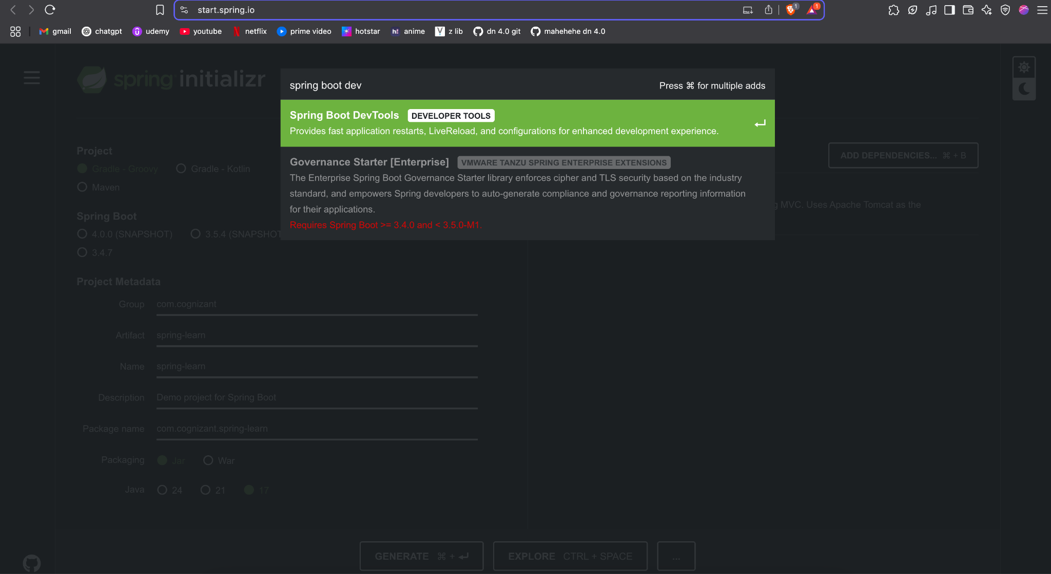

1. **Extracted the folder :**

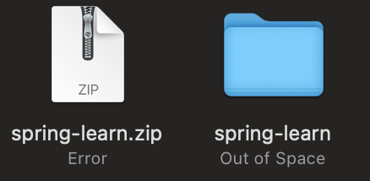

1. **Building the project :**

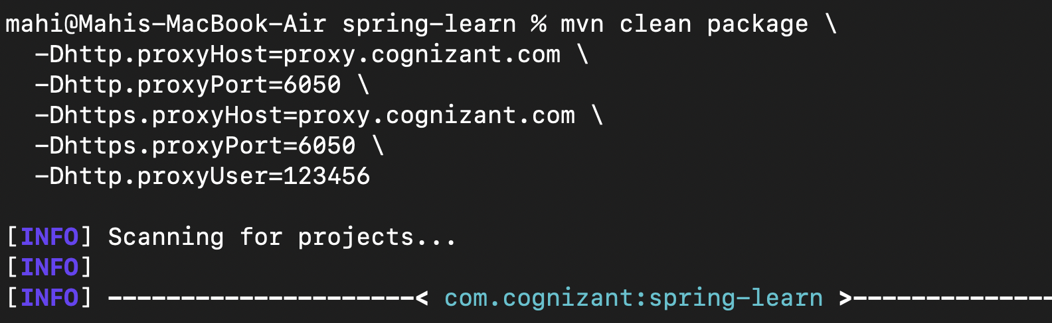

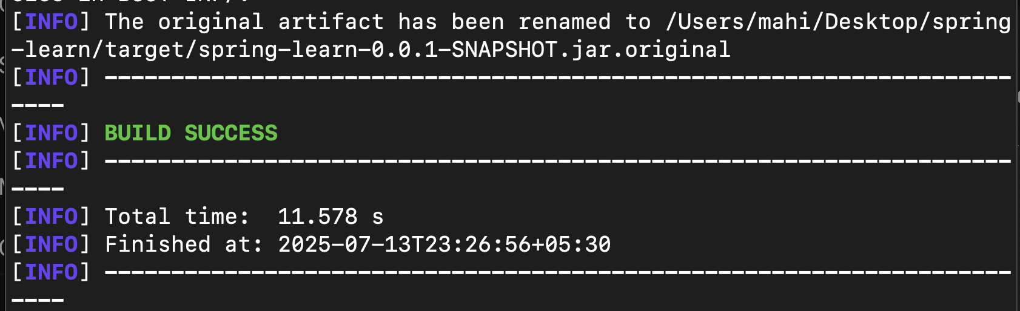

1. **Importing into IntelliJ (The software that I use) :**

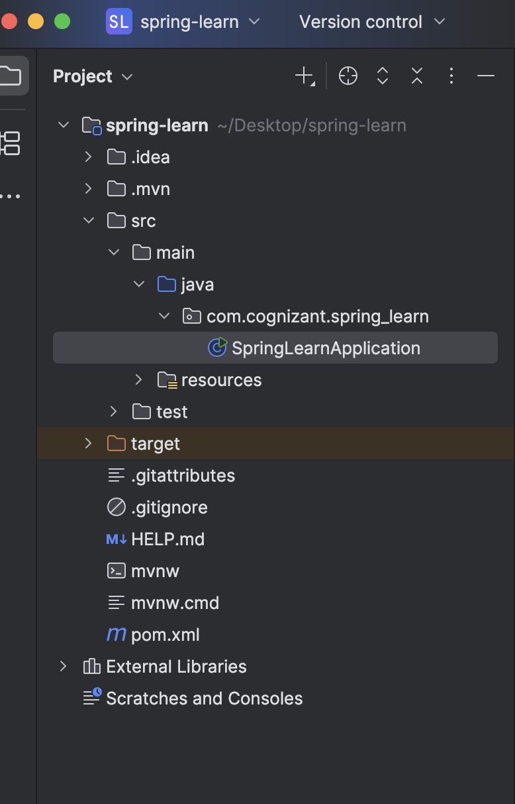

1. **Included logs to verify main method in SpringLearnApplication :**

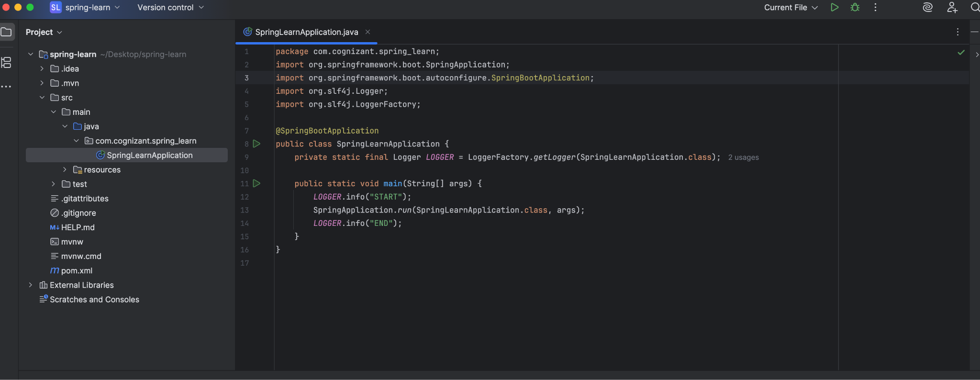

1. **Output after the project is run :** 