1. **Created a folder for account and loan :**

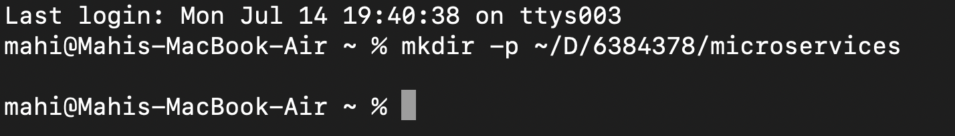

1. **Generated SpringInitializr zip folder for “Account” with the necessary dependencies :**

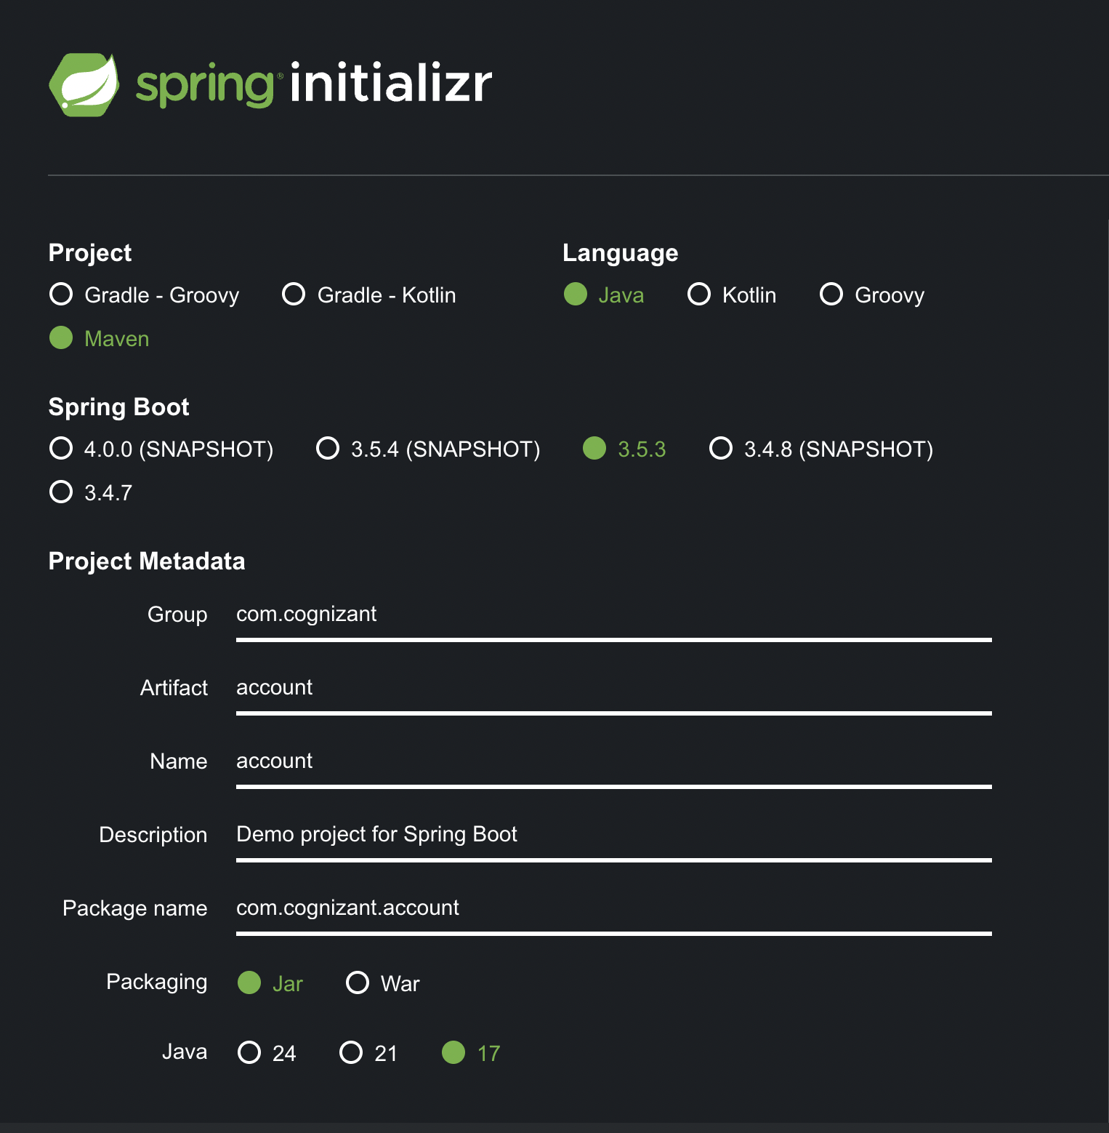

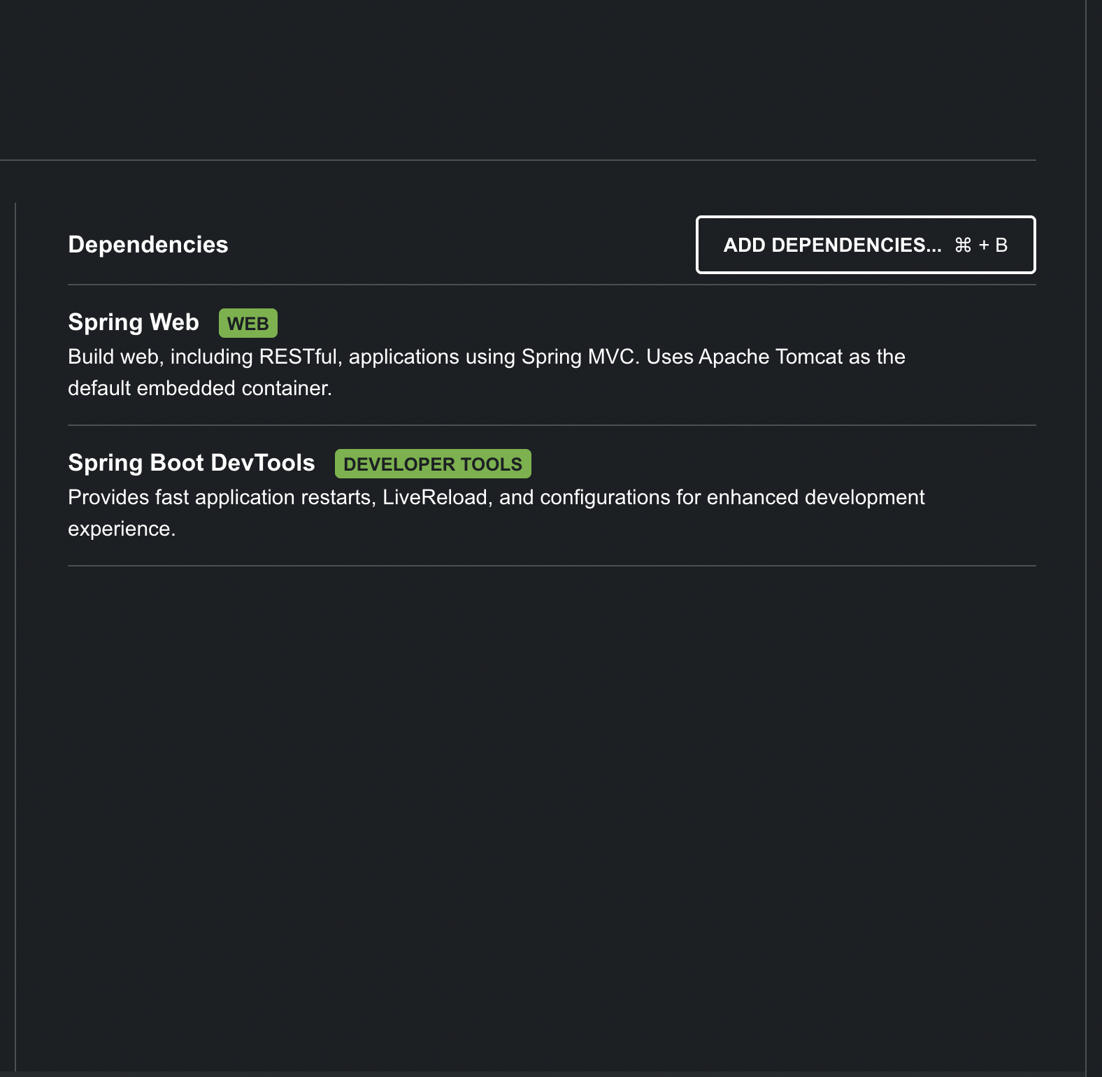

1. **Created “AccountController.java” class in the “controller” package after importing the project into IntelliJ (after moving the file to appropriate folder) :**

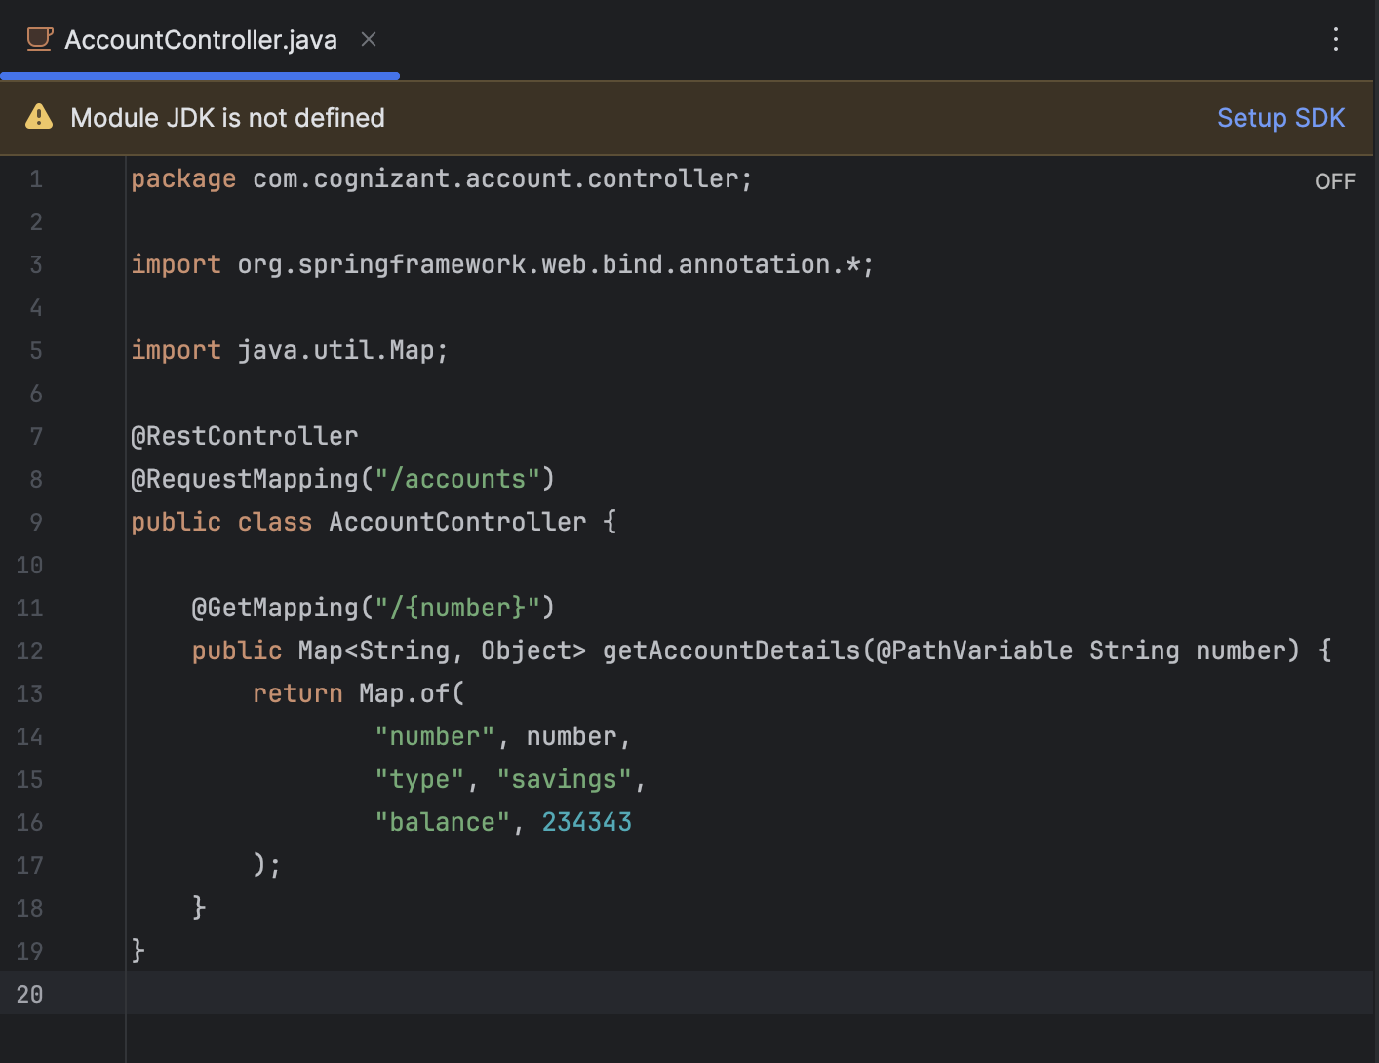

1. **Ran the “**[**http://localhost:8080/accounts/00987987973432**](http://localhost:8080/accounts/00987987973432)**” and got the following output :**

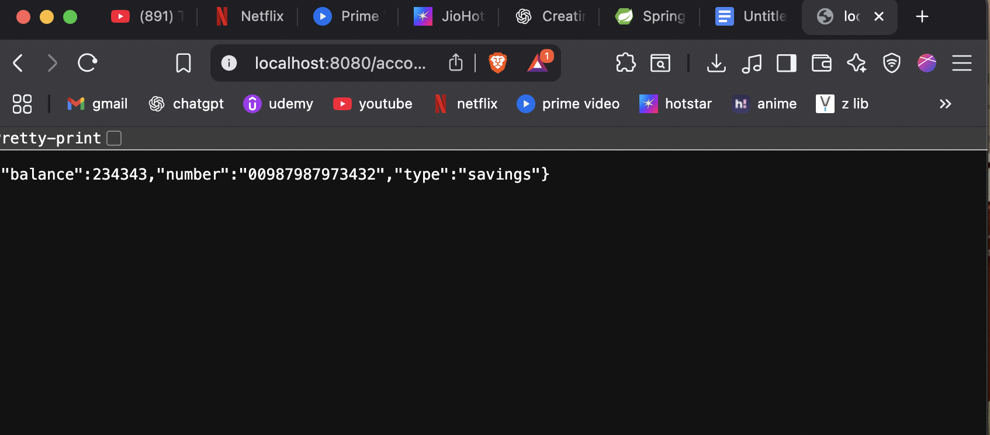

1. **Created a similar project for “loan” from SpringIntializr :**

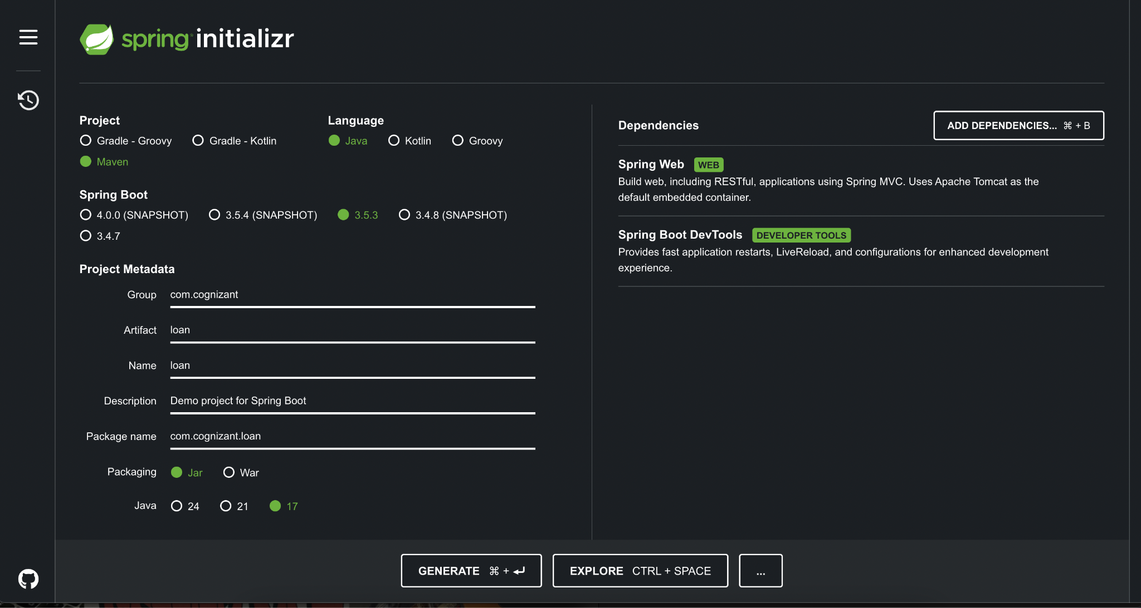

1. **Imported it into IntelliJ after moving it to initial folder.**
2. **Created a “LoanController.java” class in “controller” package using the following code :**

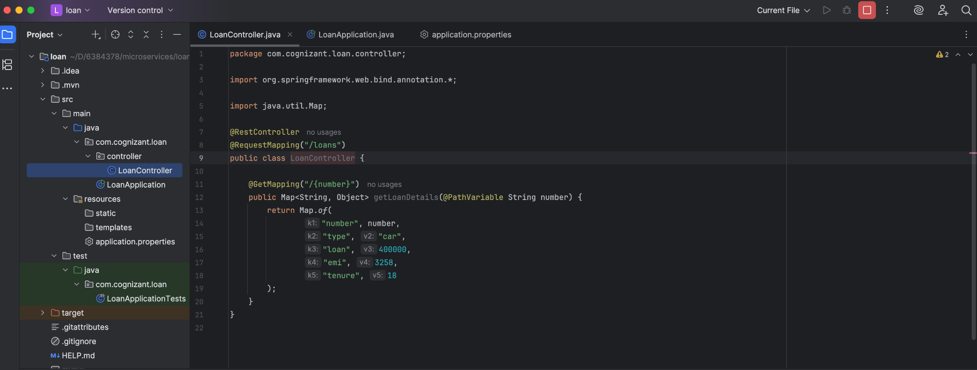

1. **Changed the port to “8081” to avoid conflicts.**
2. **Ran “**[**http://localhost:8081/loans/H00987987972342**](http://localhost:8081/loans/H00987987972342)**” to get the following output :**

