1. **Downloaded node.js for macos onto my system :**

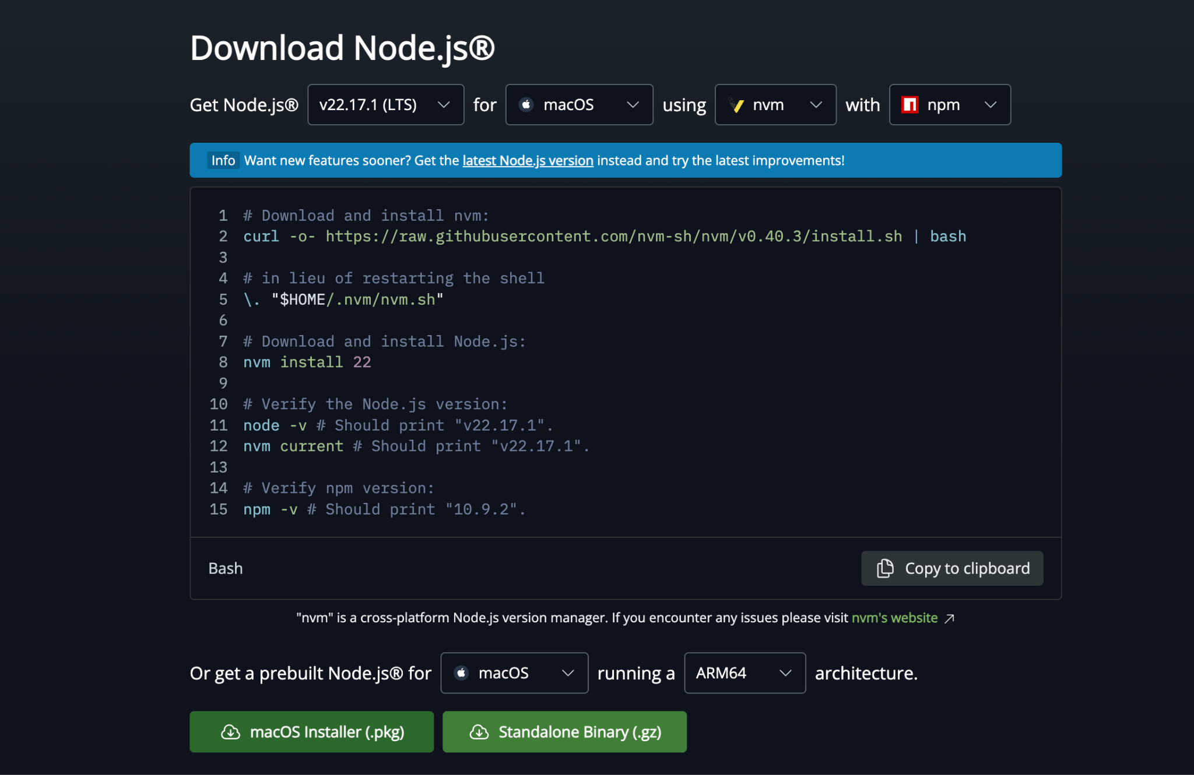

1. **Opened the .pkg file and followed all the installation steps**
2. **Verified installation :**

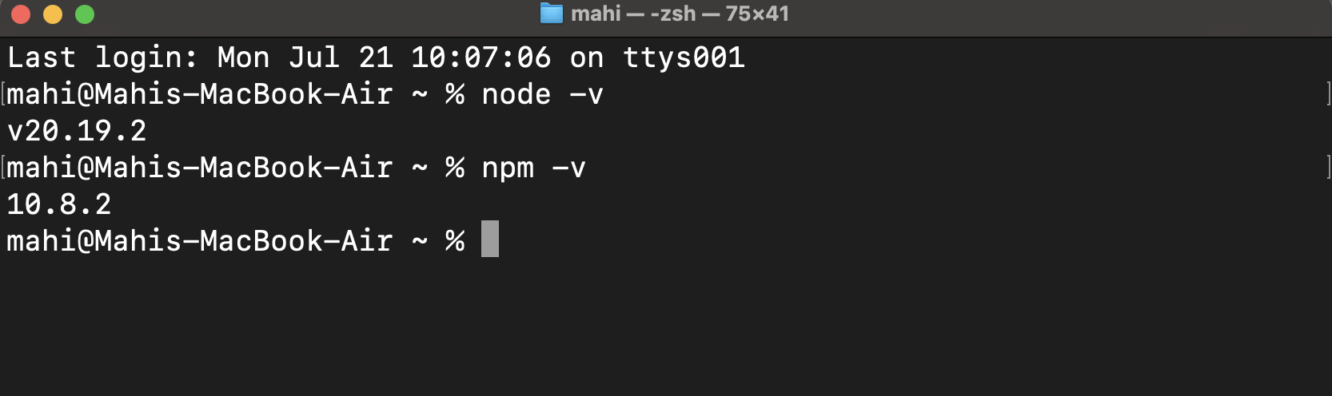

1. **Downloaded create-react-app :   
     
   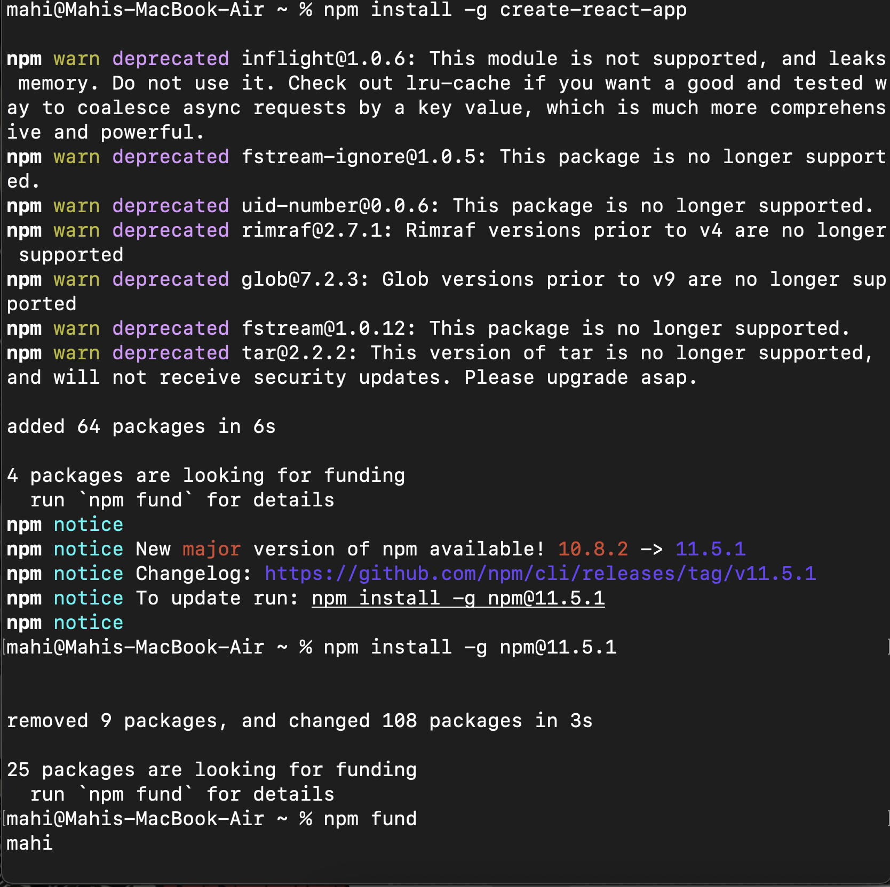**
2. **Created my first react :**



1. **Navigated to the folder and opened it on vs code :**

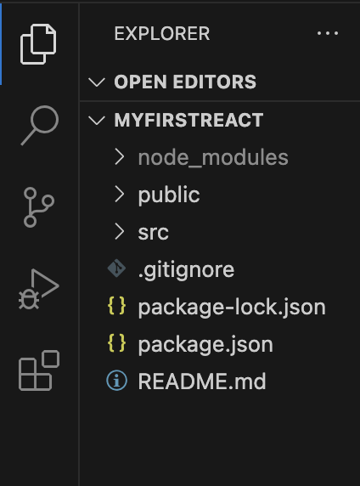

1. **Modified the “**[**App.js**](http://app.js)**” file to display “Welcome to the first session of react” :   
     
     
   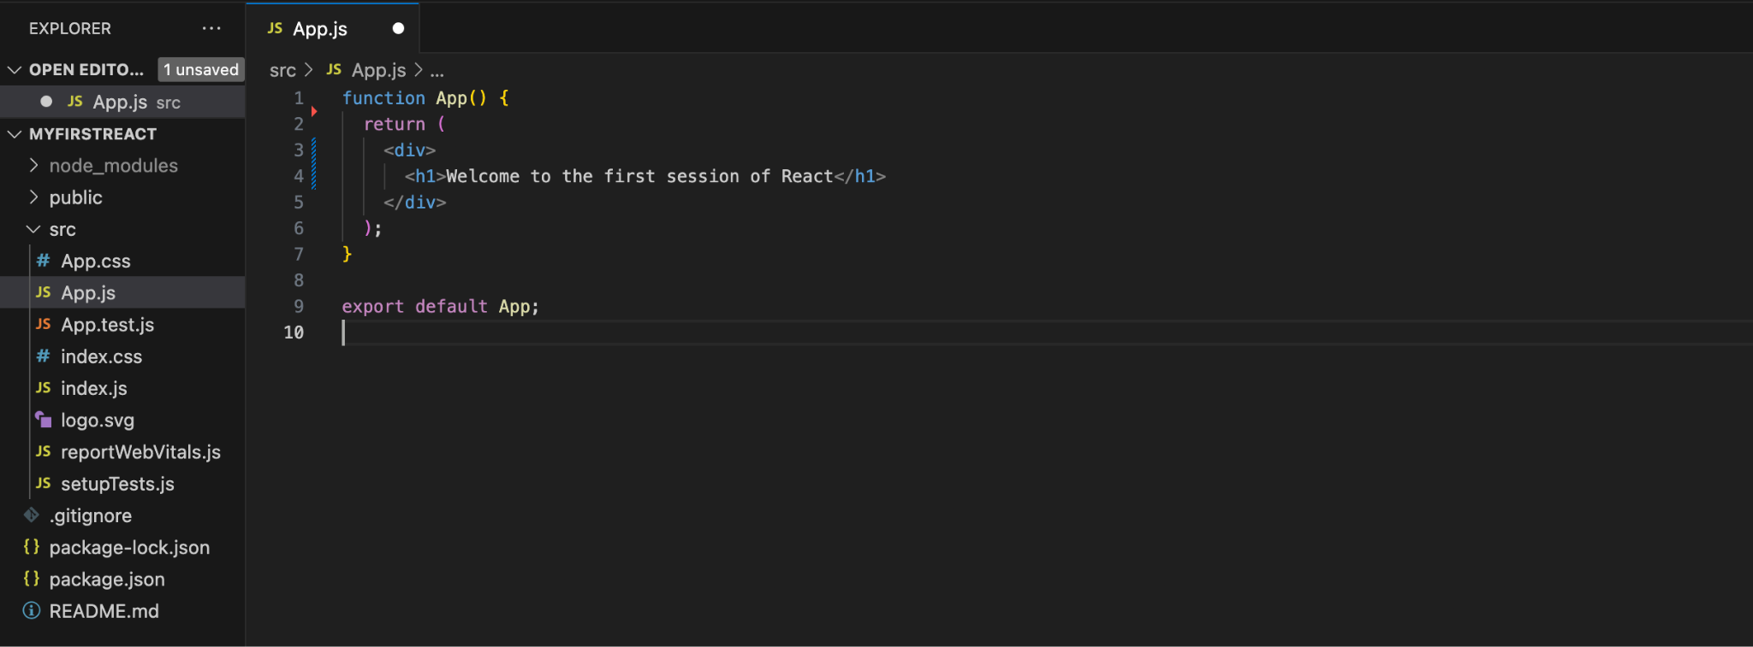**
2. **Ran npm start on the terminal :   
     
     
   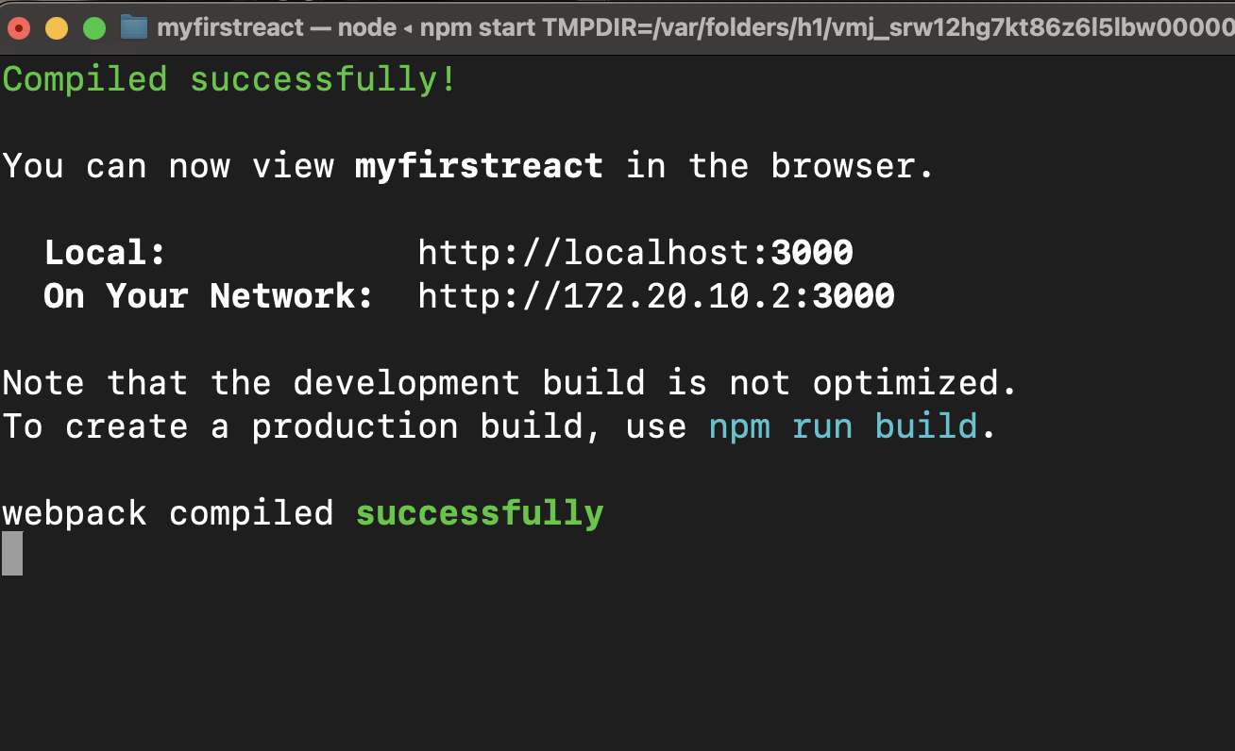**
3. **Automatically saved as given and opens to :   
     
   