1. **Created “studentapp” :   
     
   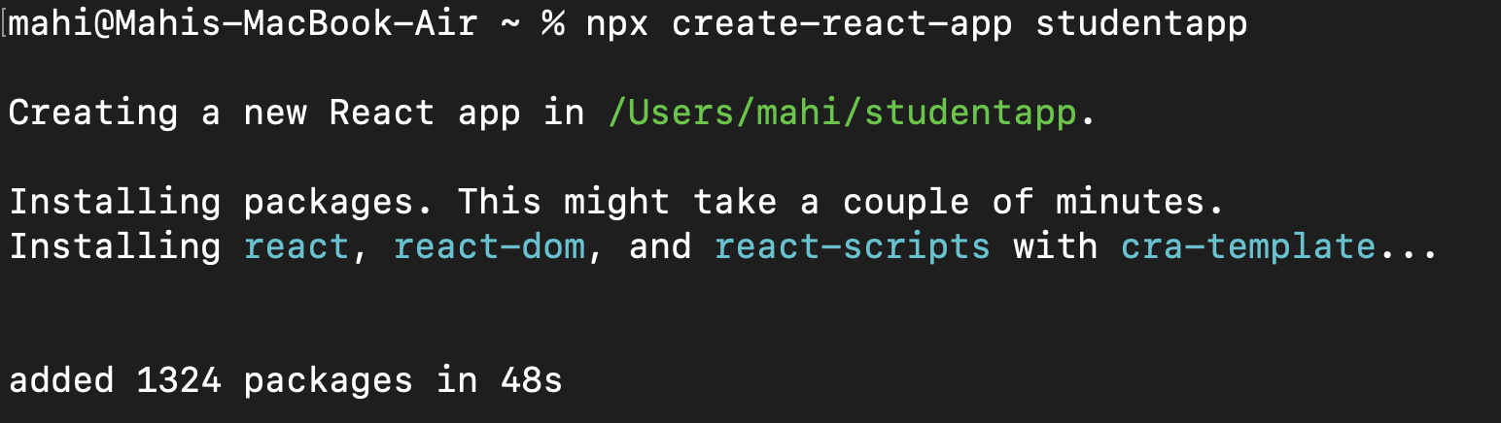**
2. **Navigated to studentapp on v s code.**
3. **Created a folder “Components” and also created a file “**[**Home.js**](http://home.js)**” within that :   
     
   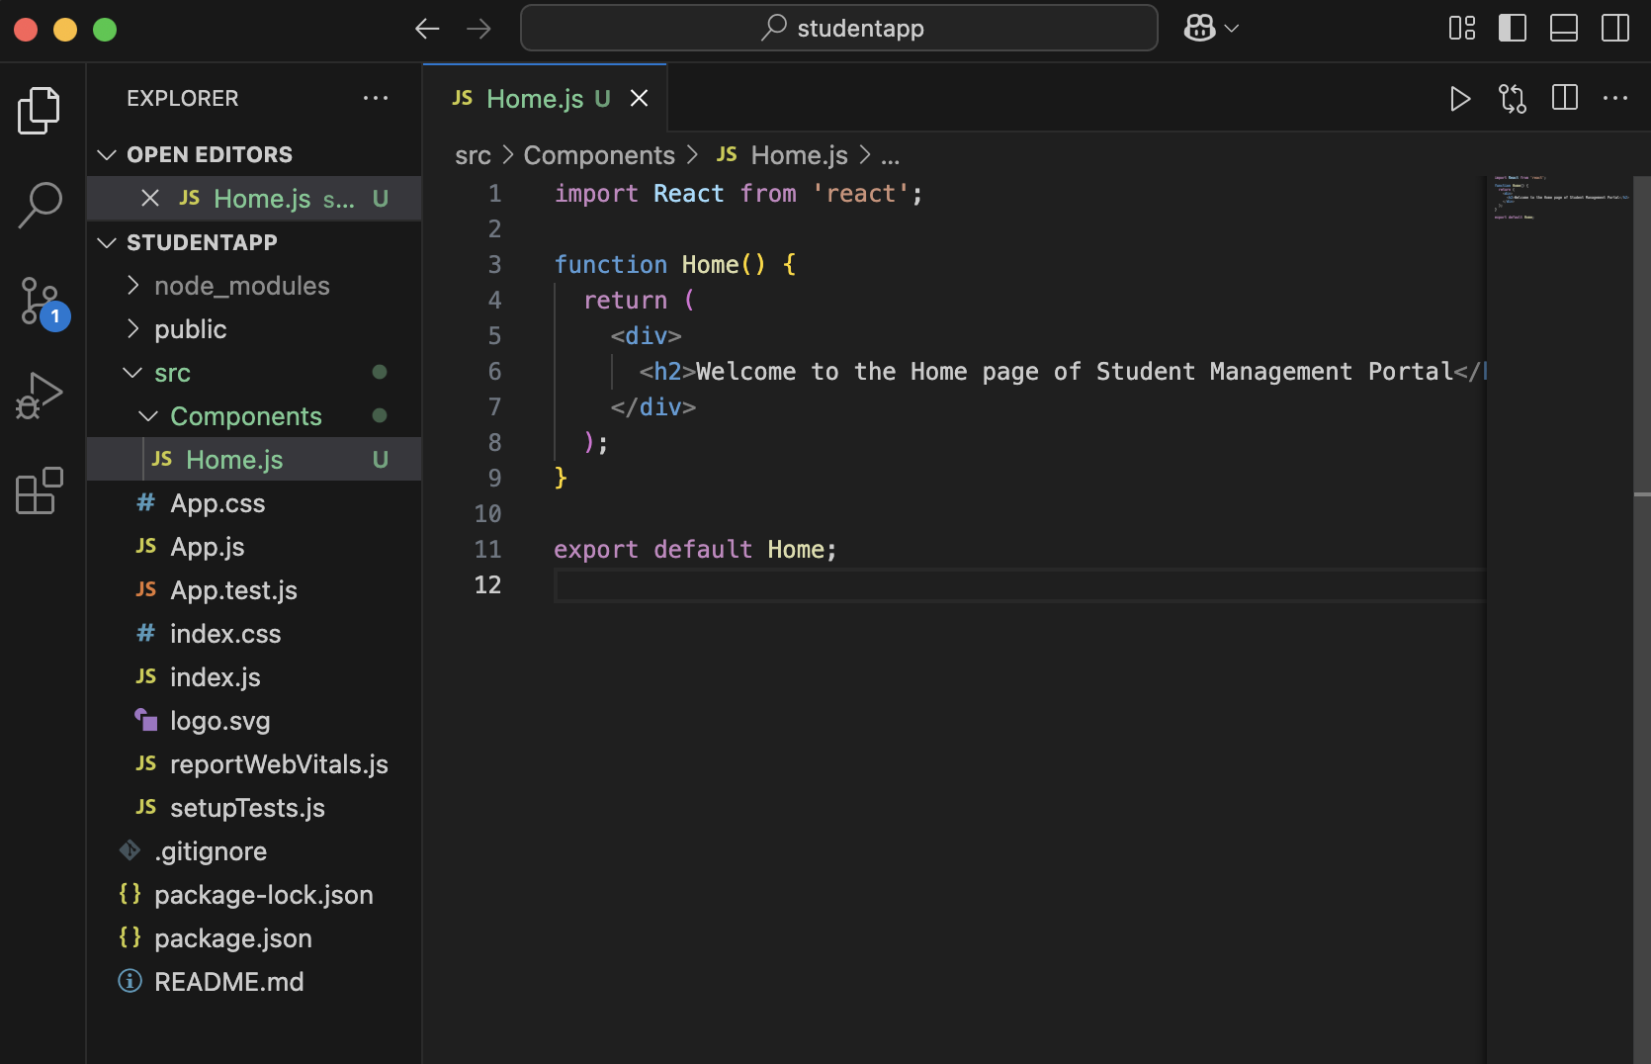**
4. **Also created “**[**About.js**](http://about.js)**” :   
     
   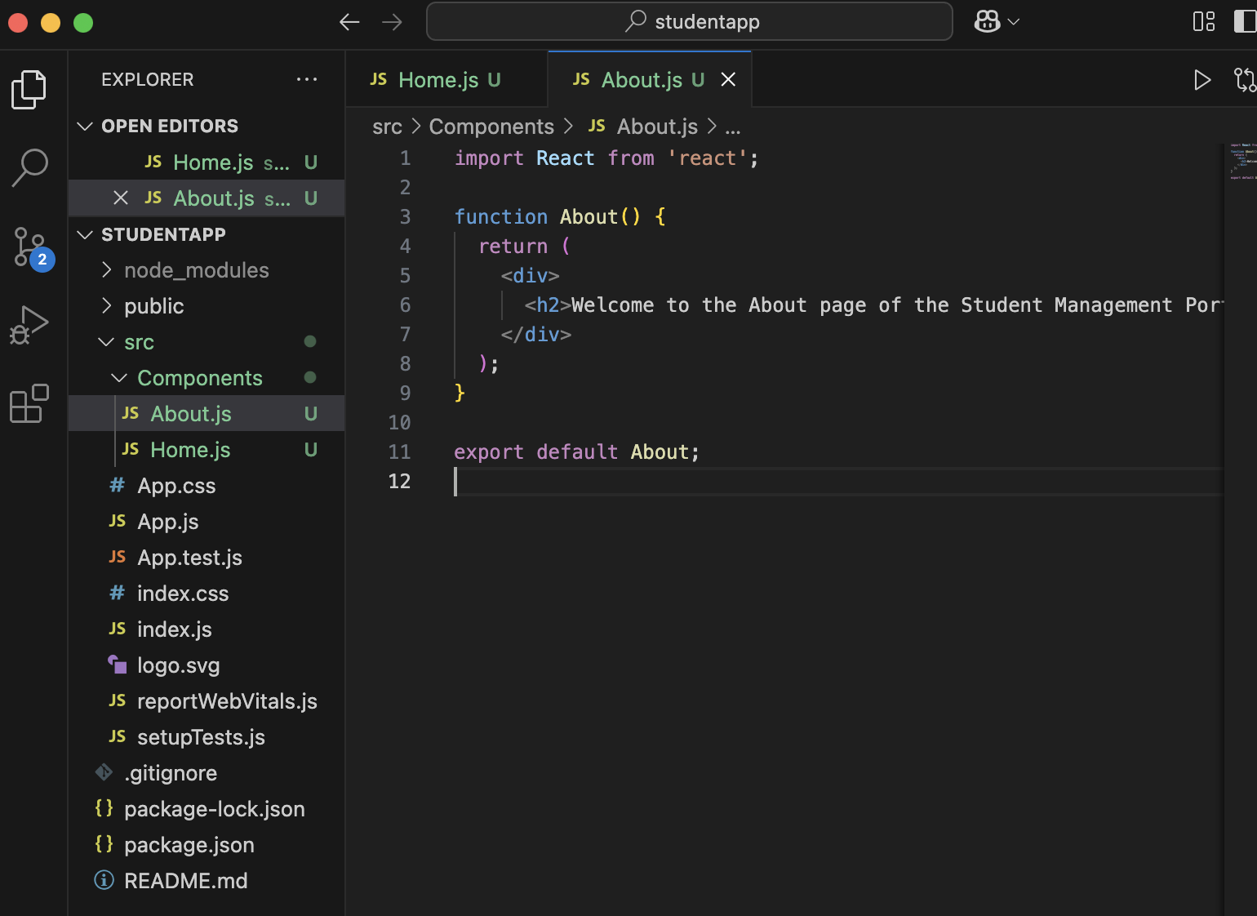**
5. **Created “**[**Contact.js**](http://contact.js)**” :   
     
   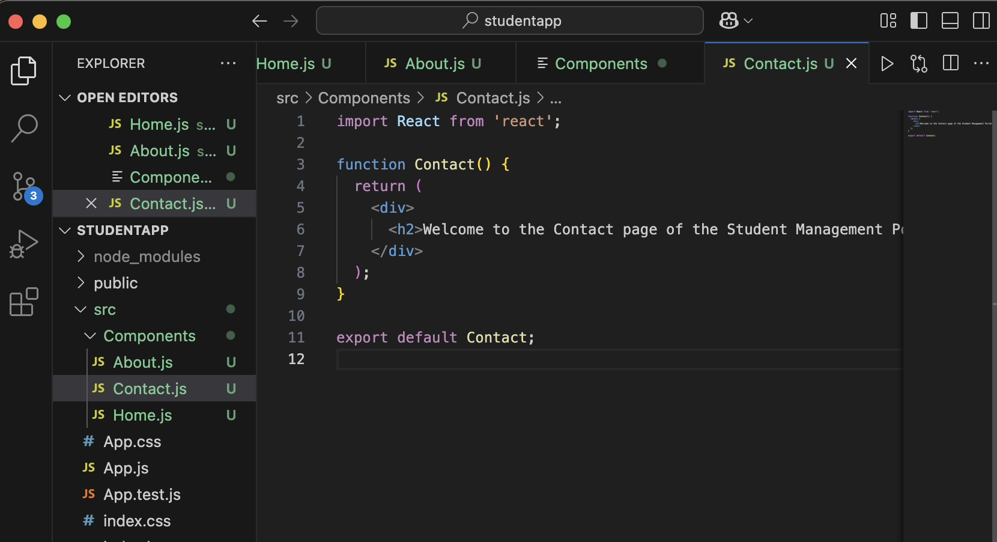**
6. **Updated “**[**App.js**](http://app.js)**” :   
     
   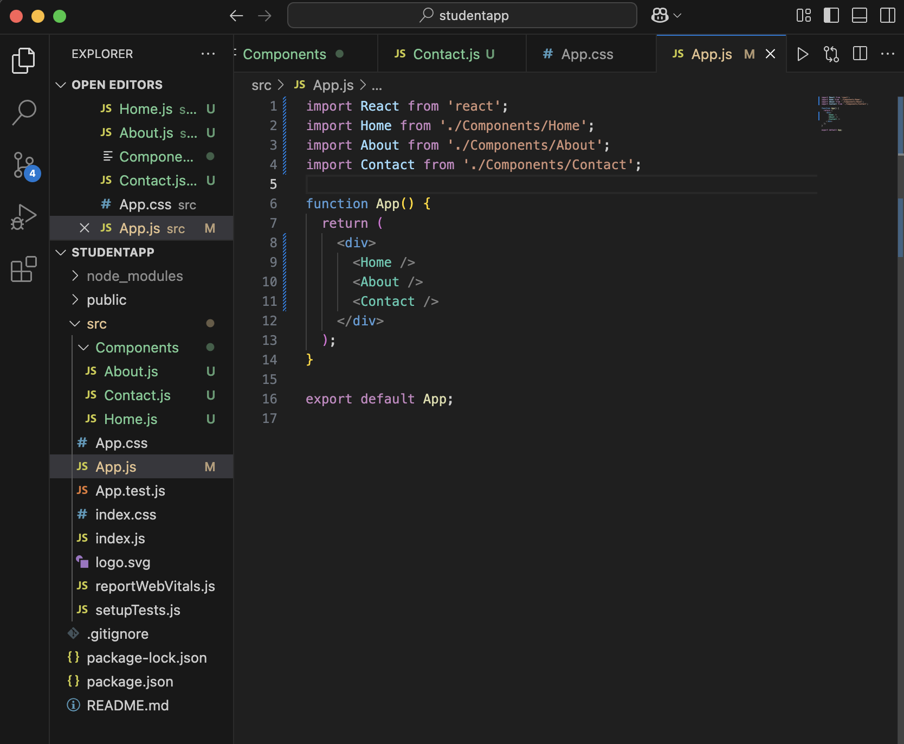**
7. **Ran npm start :**

