1. **Created react app “scorecalculatorapp” :   
     
   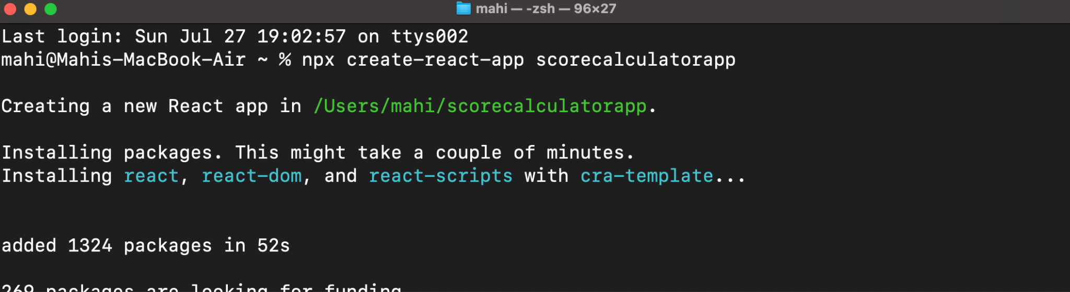**
2. **Created “**[**CalculateScore.js**](http://calculatescore.js)**” inside Components folder :   
     
   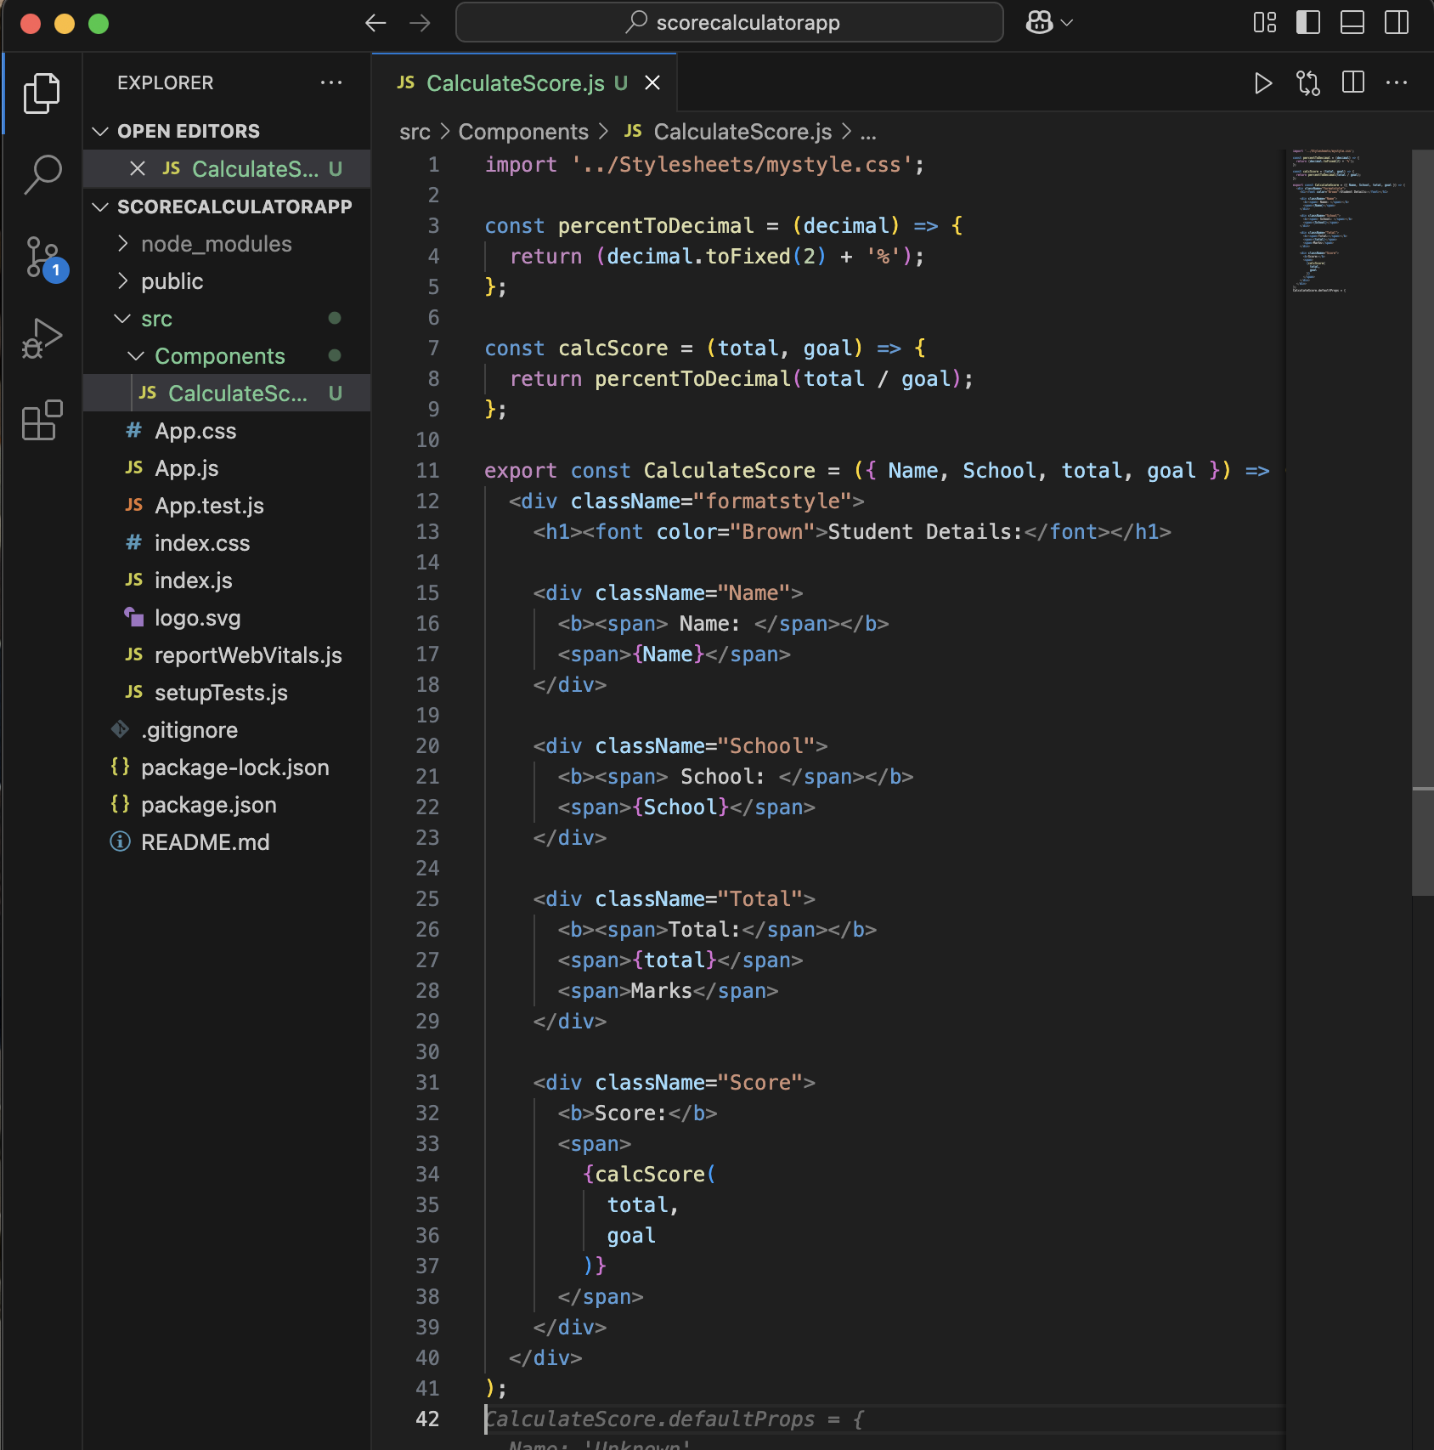**
3. **Created ‘Stylesheets’ folder and added this :   
     
   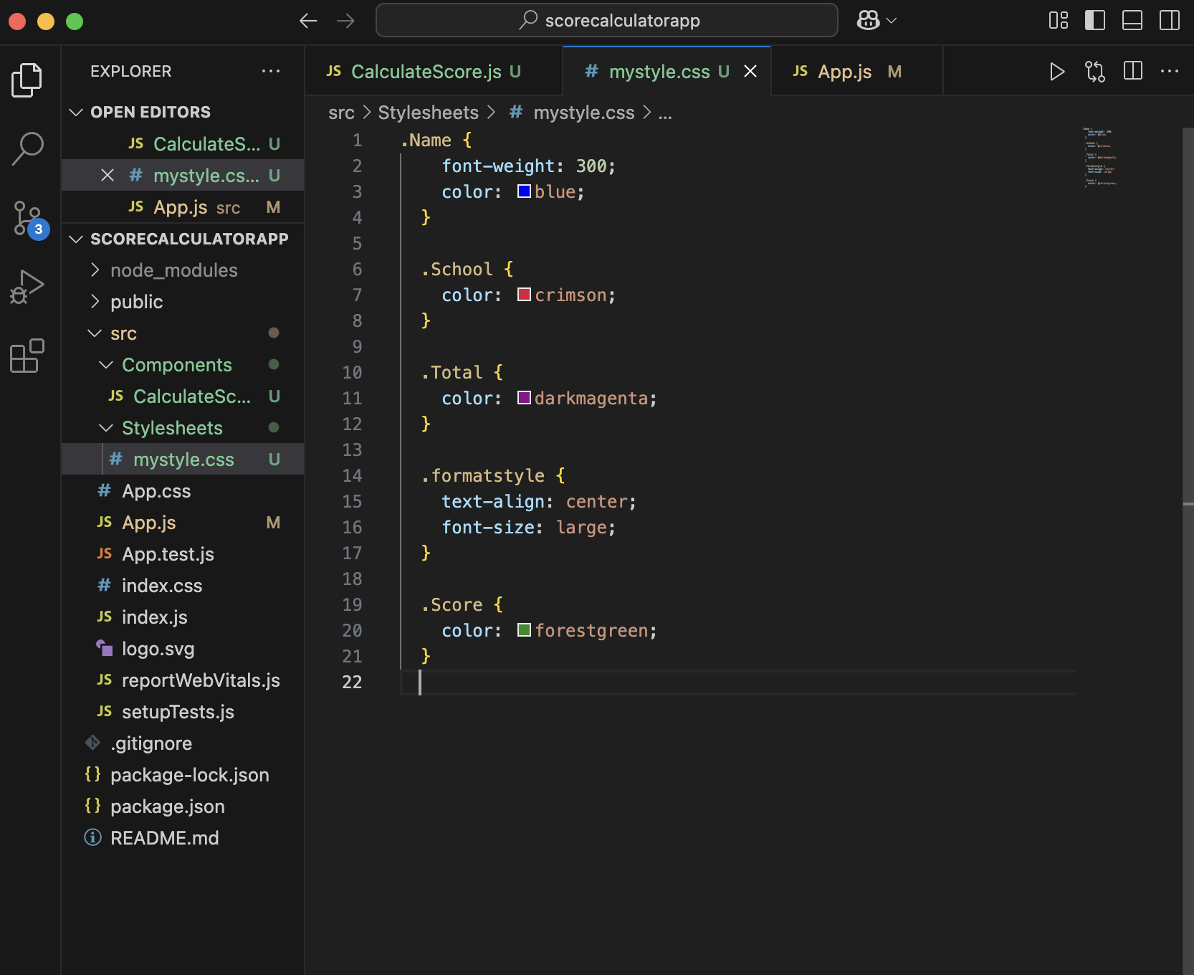**
4. **Updates “**[**App.js**](http://app.js)**” to look like this :   
     
     
   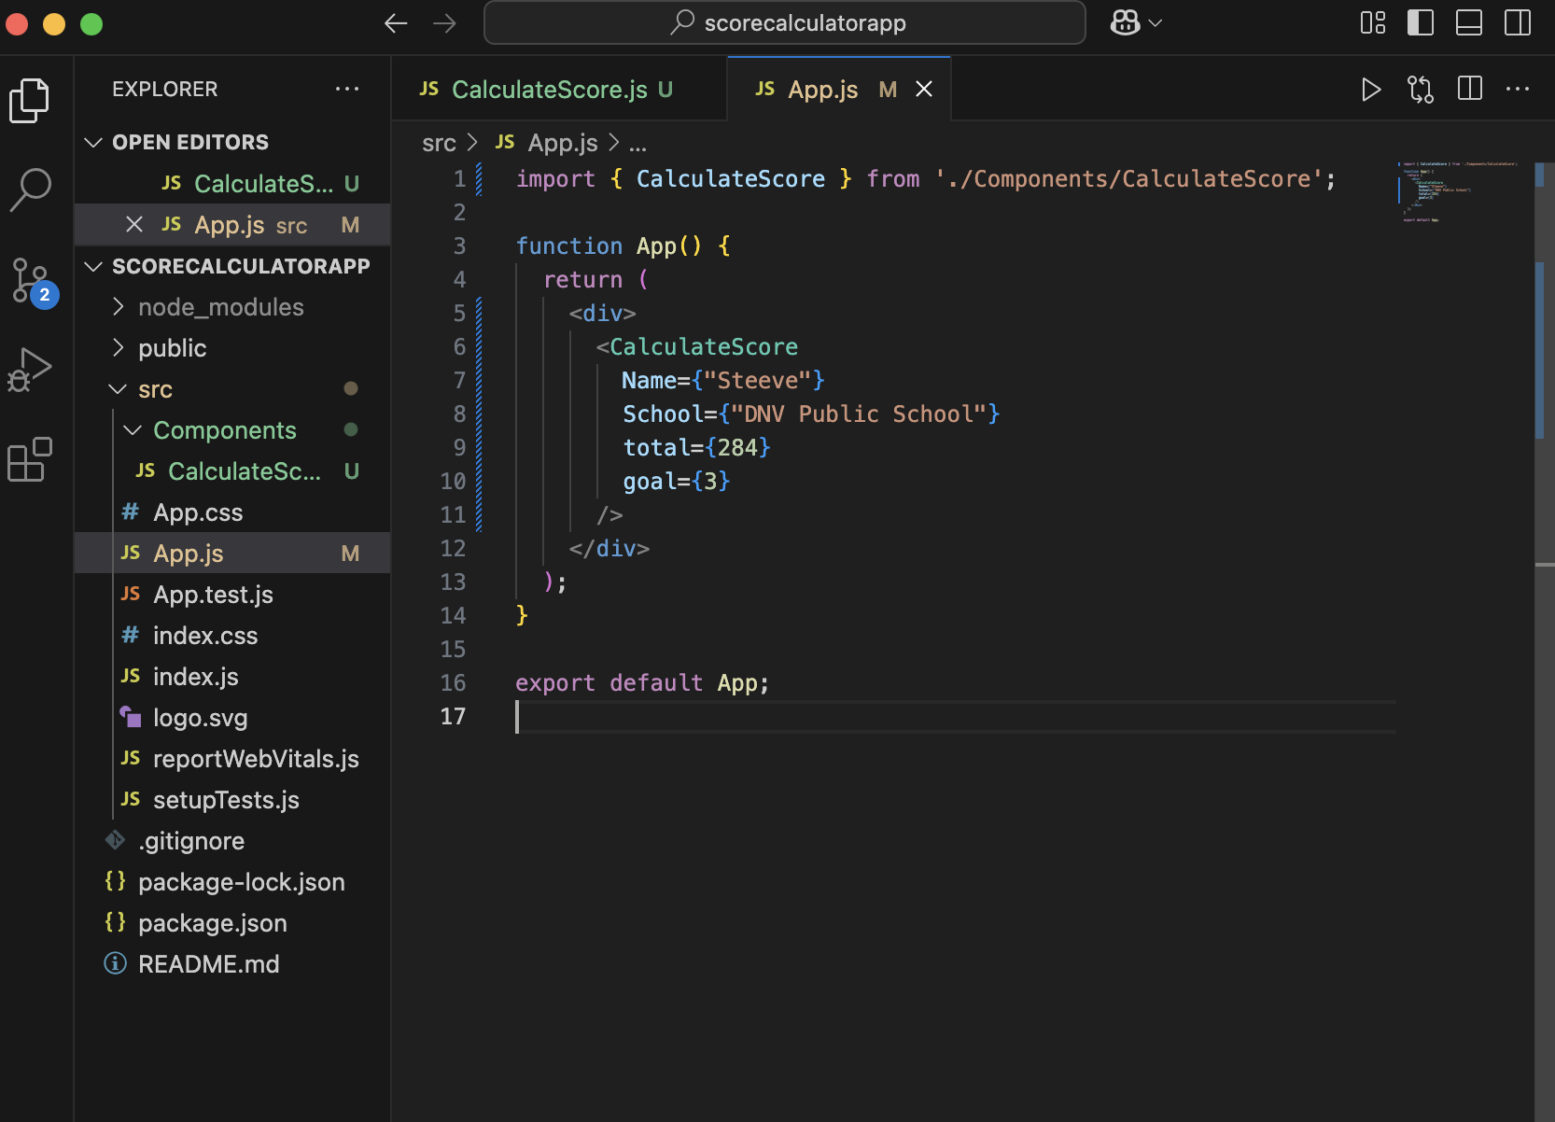**
5. **Ran npm start on terminal.**
6. **Output looks like :   
     
   