1. **Created “blogapp” react-app :   
     
   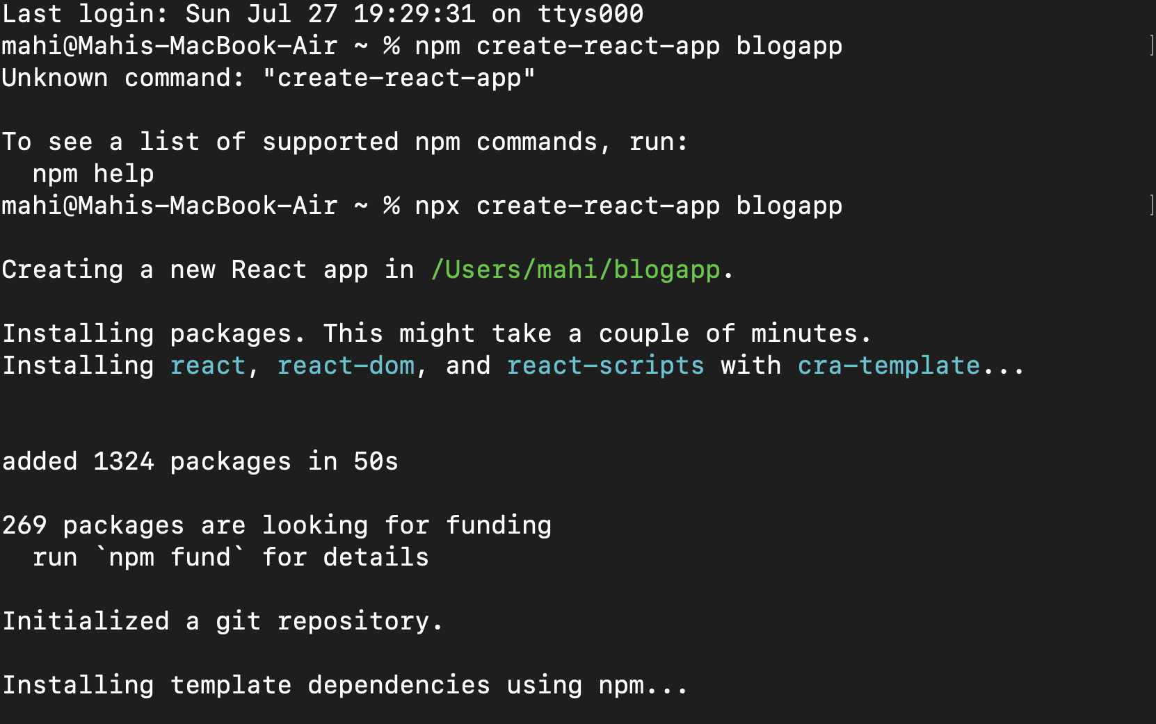**
2. **Navigated to the folder and opened it in v s code**
3. **Created a “**[**Post.js**](http://post.js)**” file in src :   
     
   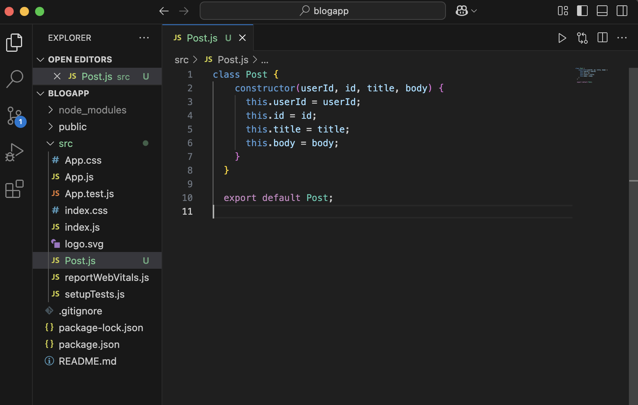**
4. **Created a “**[**Posts.js**](http://posts.js)**” file to show various blogposts :   
     
   Code used :**

mport React, { Component } from 'react';

import Post from './Post';

class Posts extends Component {

constructor(props) {

super(props);

this.state = {

posts: [],

hasError: false

};

}

loadPosts() {

const data = [

{

userId: 1,

id: 1,

title: "The Power of Consistency",

body: "Consistency beats talent when talent doesn't show up. Whether it's building habits, learning a skill, or creating content—staying consistent is the real secret to progress."

},

{

userId: 1,

id: 2,

title: "Why Reading Books Will Never Go Out of Style",

body: "In a digital age, books continue to offer something unique—deep focus, mental clarity, and timeless knowledge. Every book is a doorway to a new world."

},

{

userId: 2,

id: 3,

title: "How to Stay Focused in a Distracted World",

body: "Turn off notifications, set short goals, and give yourself breaks. Focus isn’t about discipline alone—it’s about managing your environment."

},

{

userId: 3,

id: 4,

title: "The Joy of Writing for Yourself",

body: "You don’t need an audience to start writing. Write to understand your thoughts, your emotions, and your world. It's therapeutic and transformative."

},

{

userId: 3,

id: 5,

title: "3 Lessons I Learned from Failing",

body: "Failure teaches you more than success ever can. I learned how to be resilient, how to ask for help, and most importantly—how to start again."

}

];

const postList = data.map(p => new Post(p.userId, p.id, p.title, p.body));

this.setState({ posts: postList });

}

componentDidMount() {

this.loadPosts();

}

componentDidCatch(error, info) {

alert("An error occurred in the component.");

console.error(error, info);

}

render() {

if (this.state.hasError) {

return <h2>Something went wrong.</h2>;

}

return (

<div>

<h1>Blog Posts</h1>

{this.state.posts.map(post => (

<div key={post.id}>

<h3>{post.title}</h3>

<p>{post.body}</p>

<hr />

</div>

))}

</div>

);

}

}

export default Posts;

**5. Ran npm start to show :   
  
