1. **Created “trainersapp” react-app :   
     
   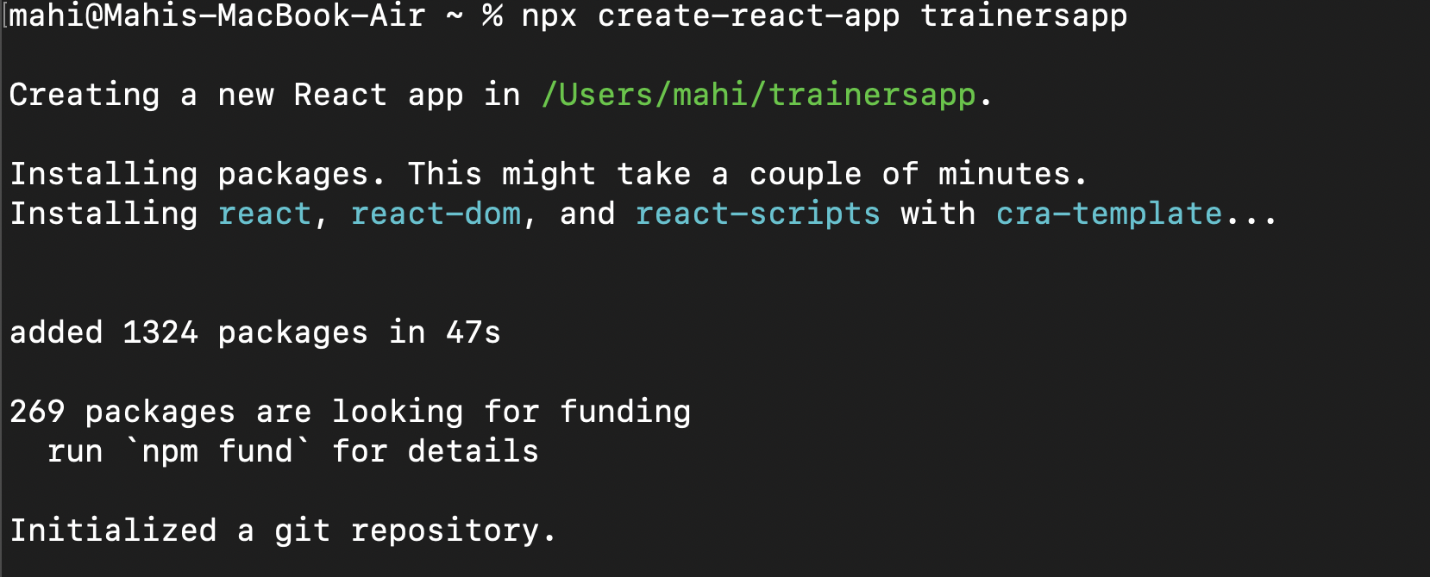**
2. **Navigated to it and opened it in V S Code.**
3. **Created “**[**Trainer.js**](http://trainer.js)**” in src :   
     
     
   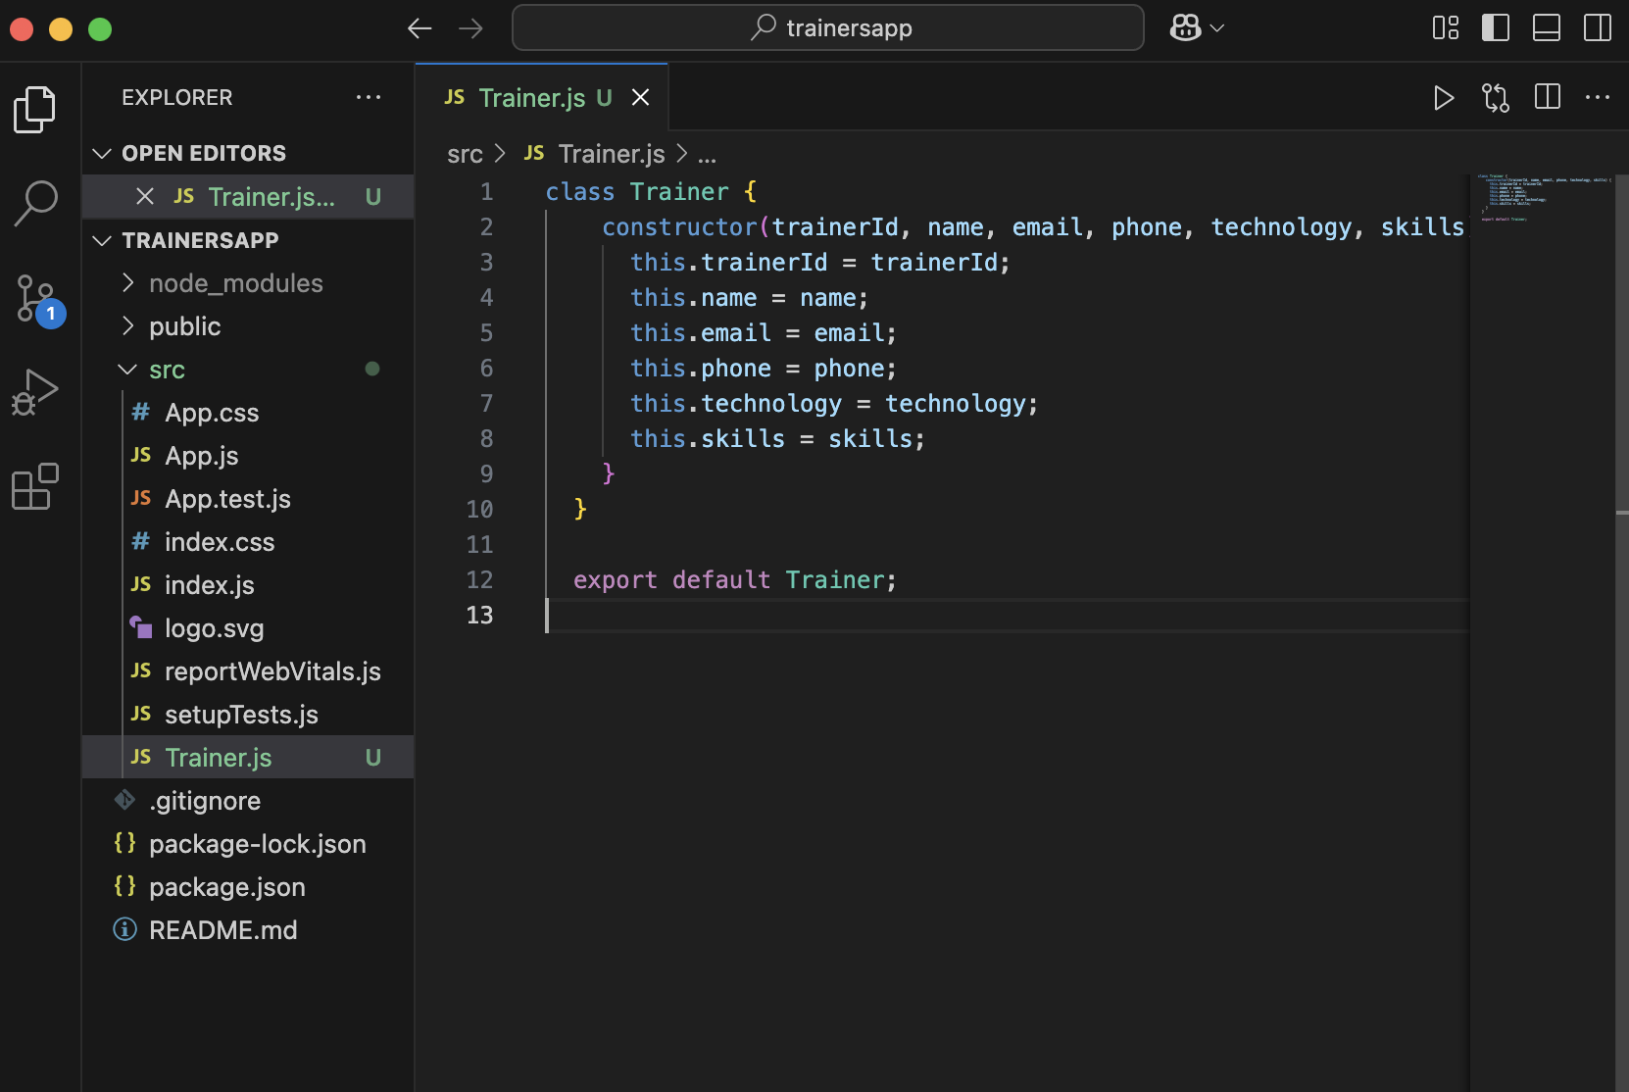**
4. **Created “**[**TrainerMock.js**](http://trainermock.js)**” :   
     
     
   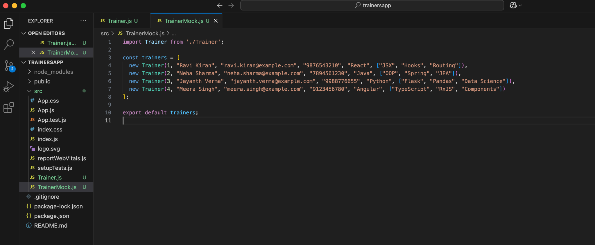**
5. **Installed react router for routing purposes :   
     
   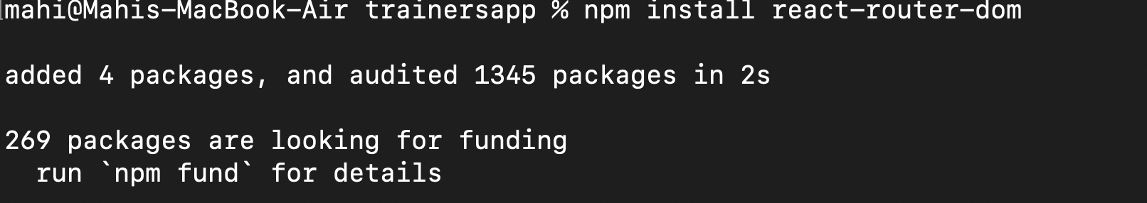**
6. **Created** [**Trainerslist.js**](http://trainerslist.js) **:   
     
   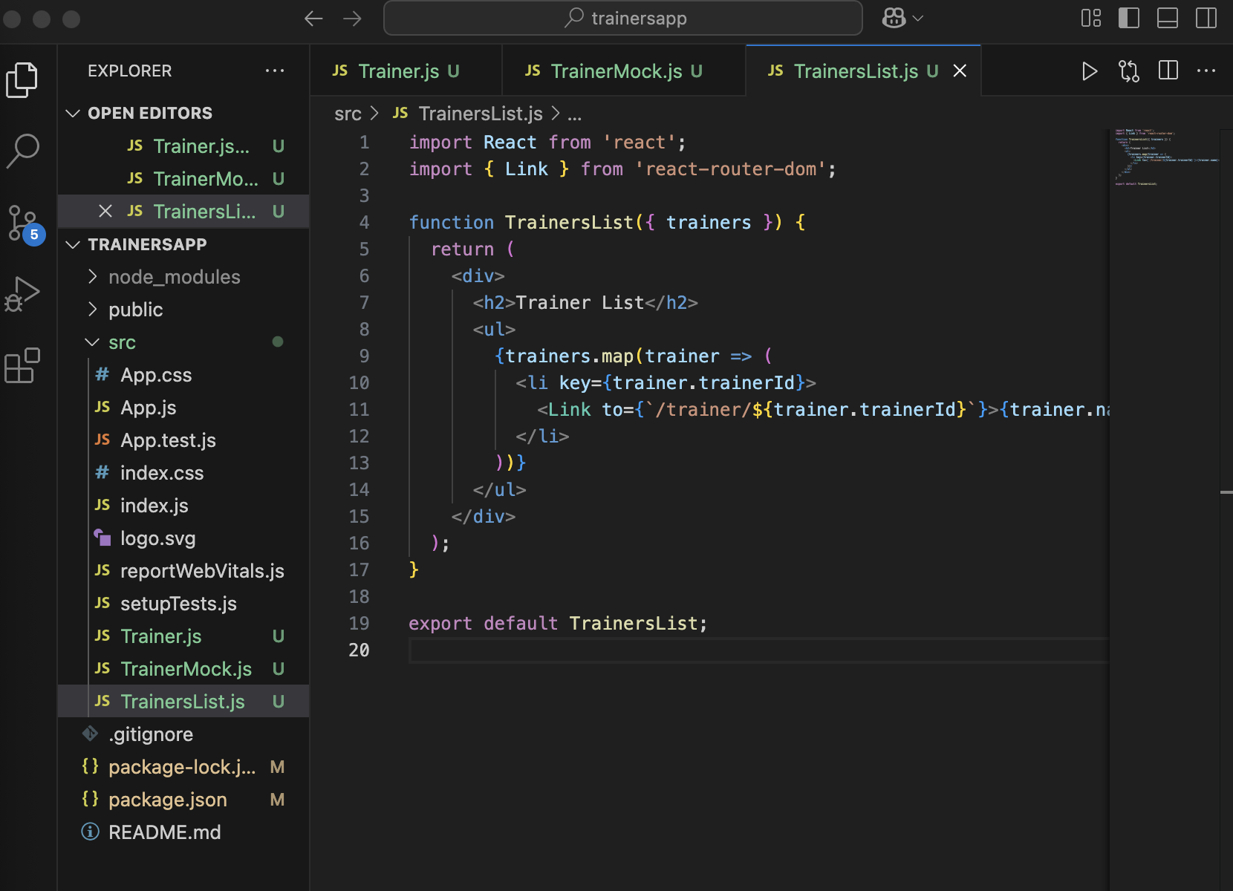**
7. **Created “**[**Home.js**](http://home.js)**” for the home page :   
     
   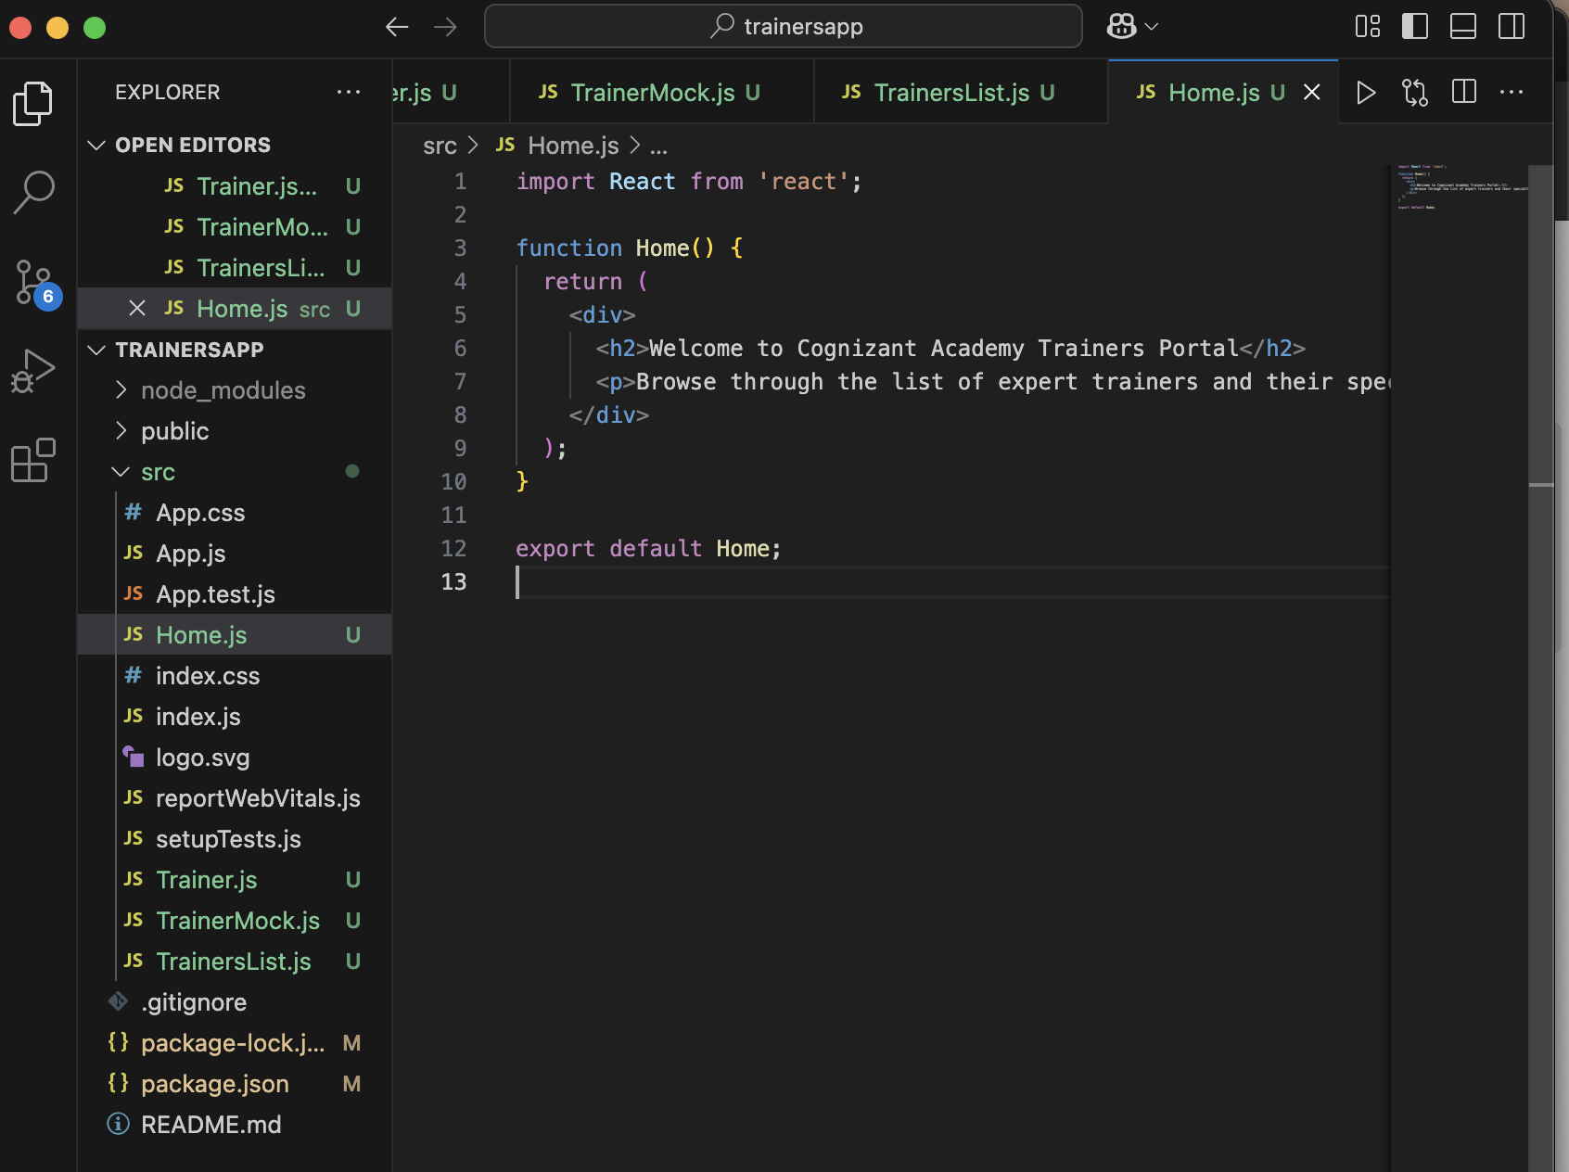**
8. **Created “**[**TrainerDetails.js**](http://trainerdetails.js)**” :   
     
   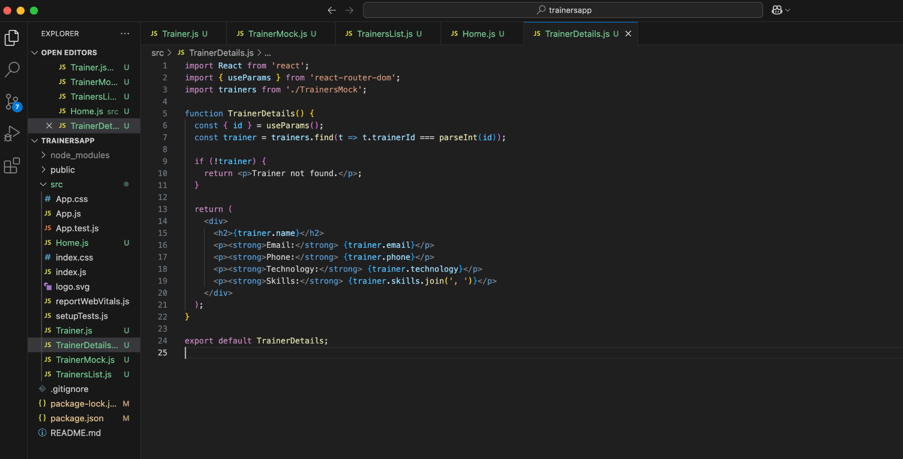**
9. **Updated “**[**App.js**](http://app.js)**” to this :   
     
     
   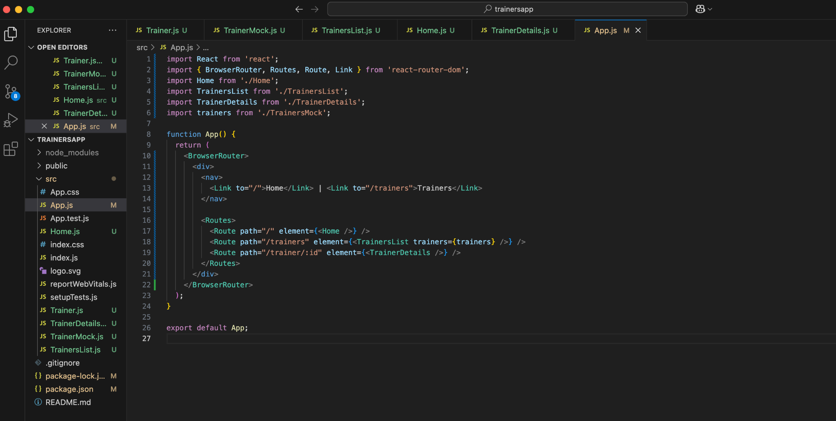**
10. **Displayed the following when npm start was run :   
      
    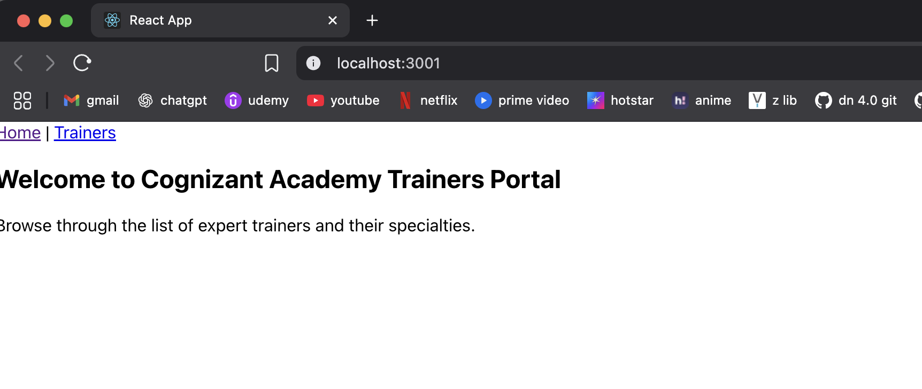**

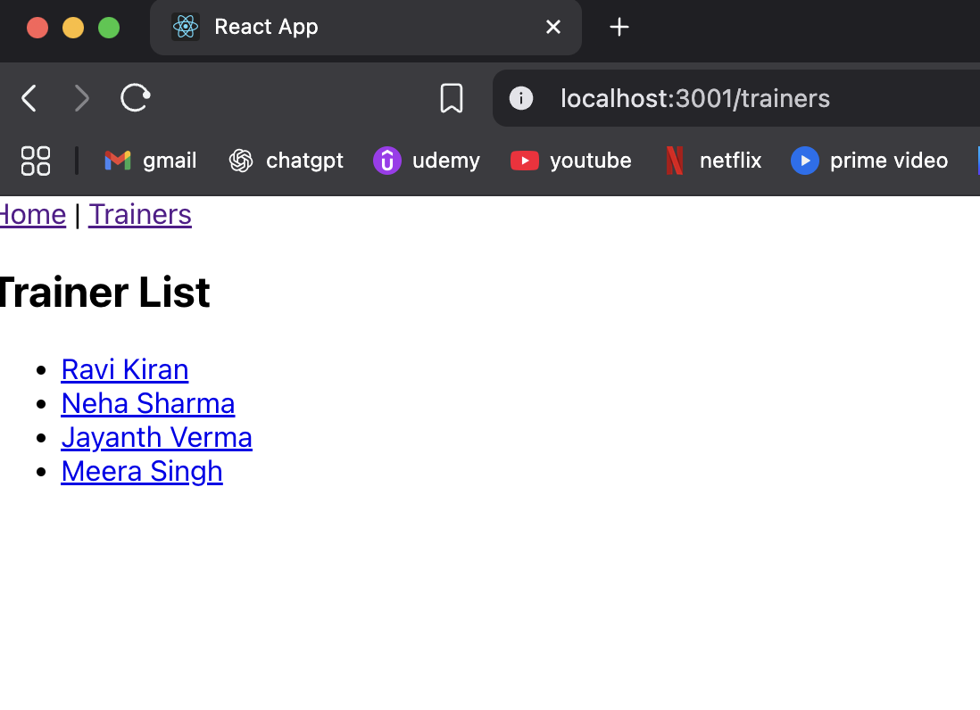

**Displays something like this for each individual trainer :**

