1. **Create the react app :   
     
   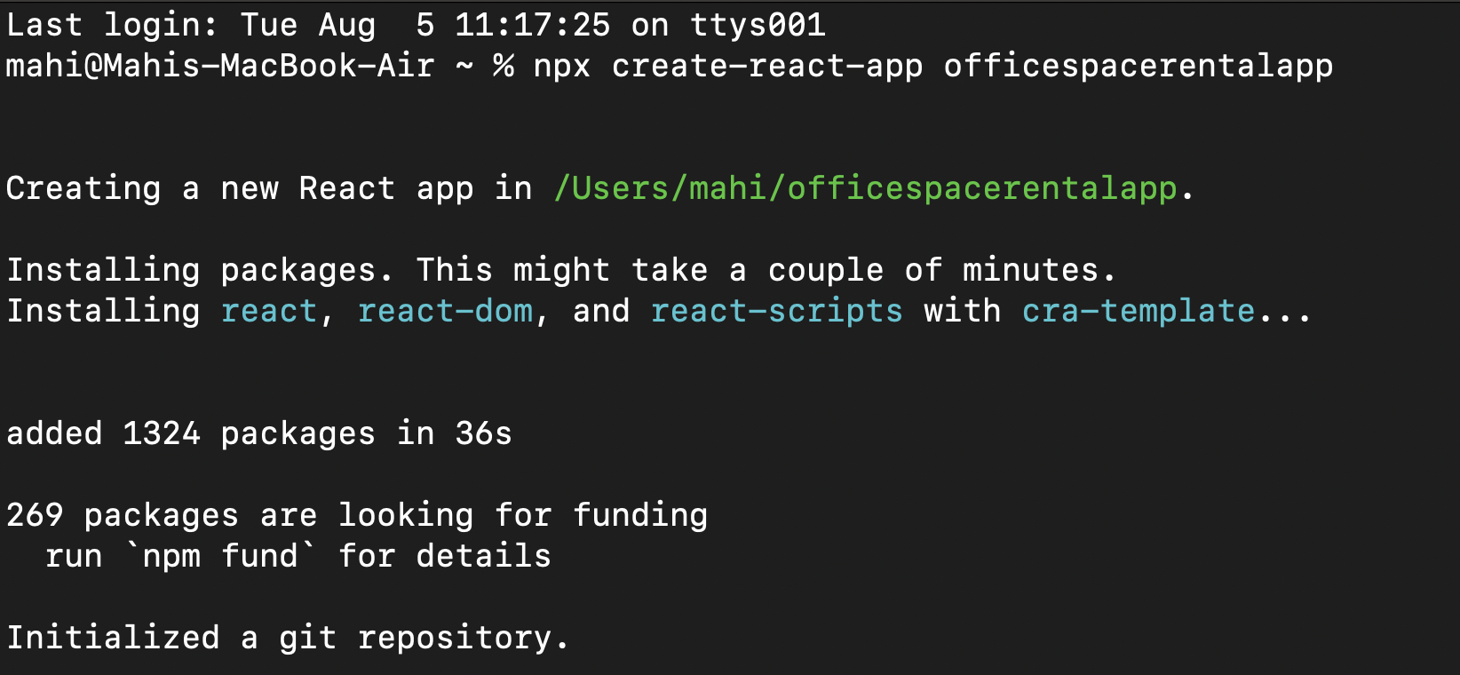**
2. **Navigated to the app and opened it in vs code.**
3. **Updated the** [**App.js**](http://app.js) **file with this code :**import React from 'react';

import './App.css';

function App() {

const offices = [

{

Name: "DBS",

Rent: 50000,

Address: "Chennai",

Image: "https://cdn.officechai.com/wp-content/uploads/2016/03/DBS-office.jpg"

},

{

Name: "WeWork",

Rent: 75000,

Address: "Bangalore",

Image: "https://media.wired.com/photos/5bb770c3d3f7502d042ad4a7/master/pass/WeWork_HQ_6.jpg"

},

{

Name: "Regus",

Rent: 60000,

Address: "Mumbai",

Image: "https://assets.regus.com/image/upload/f_auto,q_auto/v1684934410/website_v2/office-space.jpg"

}

];

const heading = "Office Space";

return (

<div className="App">

<h1>{heading} , at Affordable Range</h1>

{offices.map((item, index) => {

const rentClass = item.Rent <= 60000 ? 'textRed' : 'textGreen';

return (

<div key={index}>

<img src={item.Image} width="25%" height="25%" alt="Office Space" />

<h1>Name: {item.Name}</h1>

<h3 className={rentClass}>Rent: Rs. {item.Rent}</h3>

<h3>Address: {item.Address}</h3>

<hr />

</div>

);

})}

</div>

);

}

1. **Updated App.css to look like this :   
     
   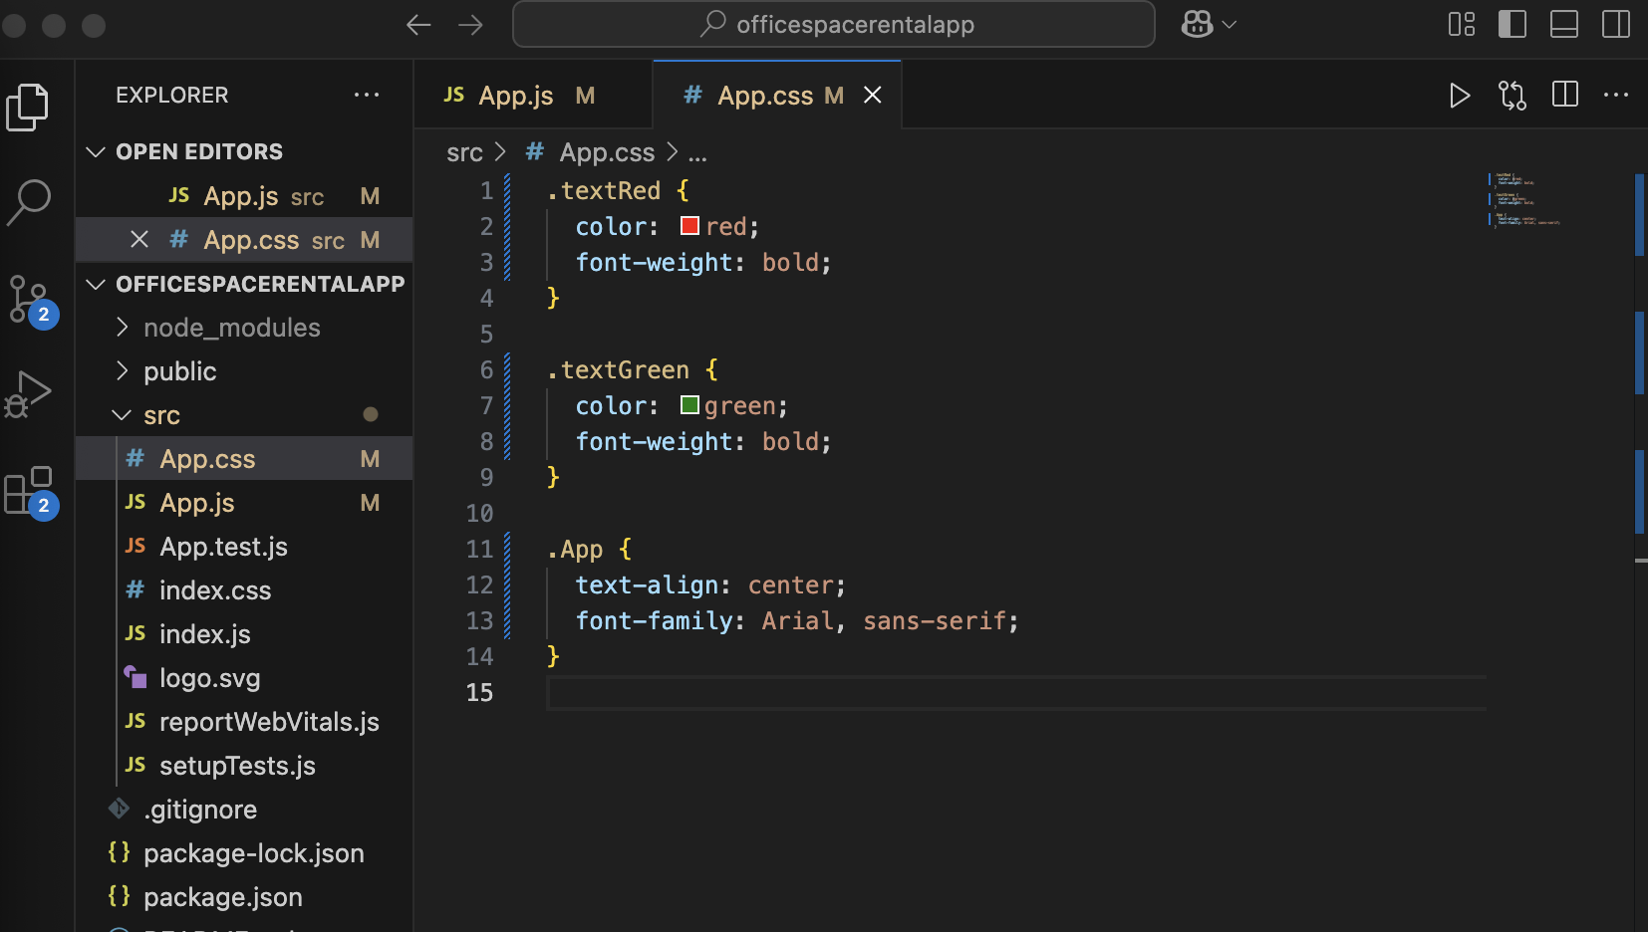**
2. **Made sure the** [**index.js**](http://index.js) **looks like this :   
     
   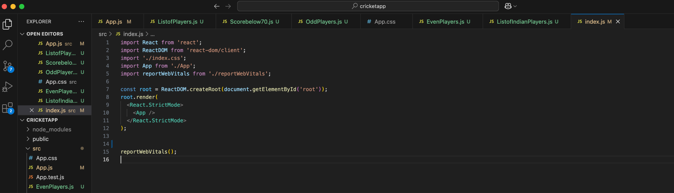**
3. **After running npm start it looks like :   
     
   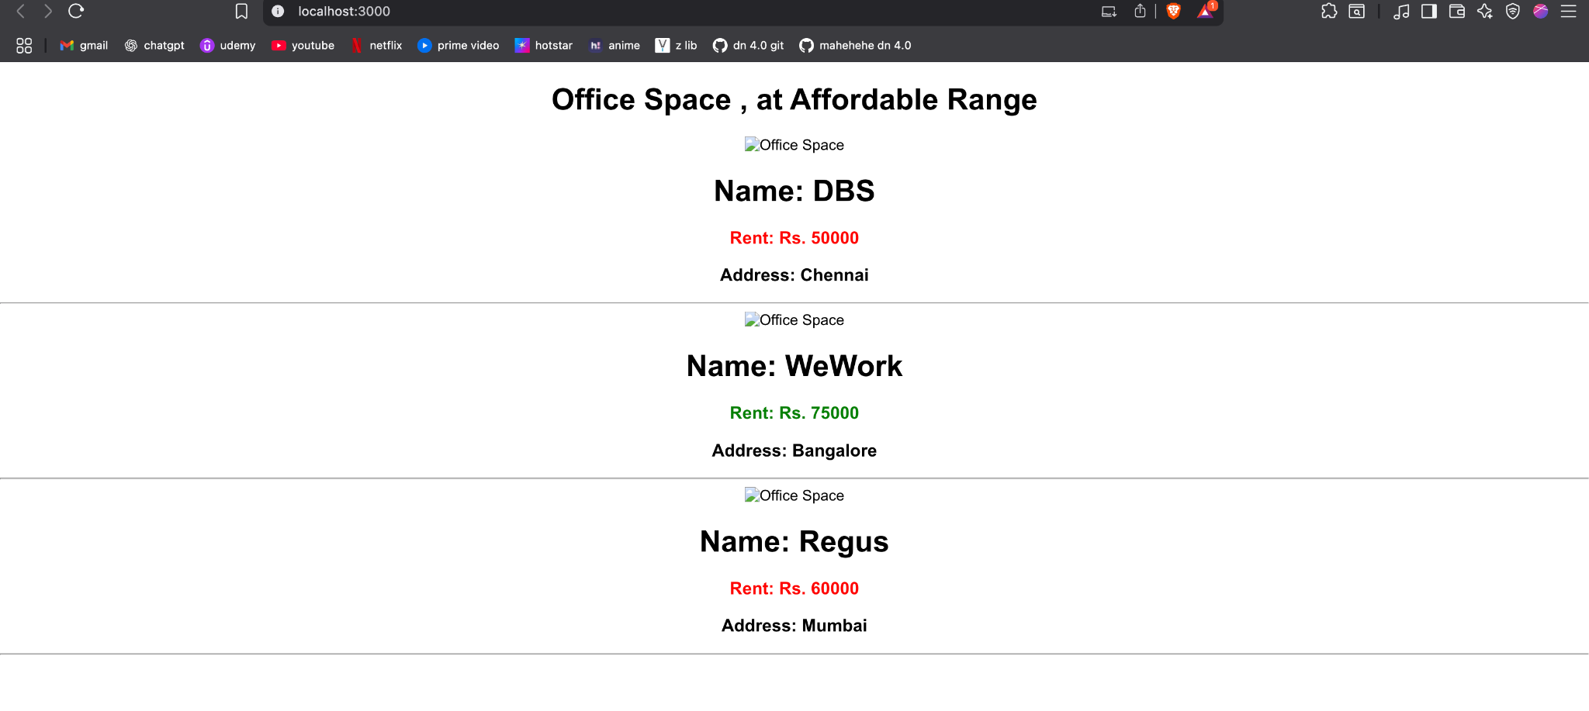  
     
   (The images couldn't be displayed due to a network glitch)**