1. **Create eventexamplesapp react app :   
     
   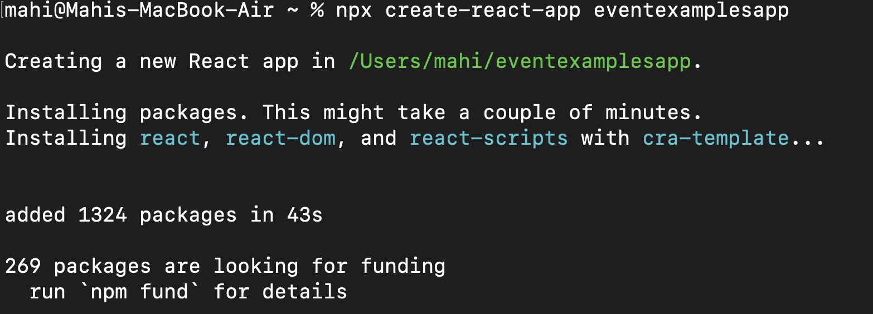**
2. **Navigate to that folder and open it in vs code using the “code .” command.**
3. **Update** [**App.js**](http://app.js) **with the following code :**

import React, { useState } from 'react';

import './App.css';

function App() {

const [count, setCount] = useState(5);

const [amount, setAmount] = useState('');

const [currency, setCurrency] = useState('');

const increment = () => {

setCount(count + 1);

sayHello(); // calling multiple methods

};

const decrement = () => {

setCount(count - 1);

};

const sayHello = () => {

alert("Hello! Member1");

};

const sayWelcome = (msg) => {

alert(msg);

};

const handleClick = (e) => {

alert("I was clicked");

};

const handleSubmit = (e) => {

e.preventDefault();

const euro = parseFloat(amount) / 90; // Sample rate: ₹90 = €1

alert(⁠ ₹${amount} is approximately €${euro.toFixed(2)} ⁠);

};

return (

<div className="App" style={{ margin: '20px' }}>

<div>

<p>{count}</p>

<button onClick={increment}>Increment</button>

<br /><br />

<button onClick={decrement}>Decrement</button>

<br /><br />

<button onClick={() => sayWelcome("welcome")}>Say welcome</button>

<br /><br />

<button onClick={handleClick}>Click on me</button>

</div>

<h1 style={{ color: 'green' }}>Currency Convertor!!!</h1>

<form onSubmit={handleSubmit}>

<label>

Amount:

<input

type="text"

value={amount}

onChange={(e) => setAmount(e.target.value)}

/>

</label>

<br /><br />

<label>

Currency:

<textarea

value={currency}

onChange={(e) => setCurrency(e.target.value)}

/>

</label>

<br /><br />

<button type="submit">Submit</button>

</form>

</div>

);

}

export default App;

1. **Updated App.css to look like this :**

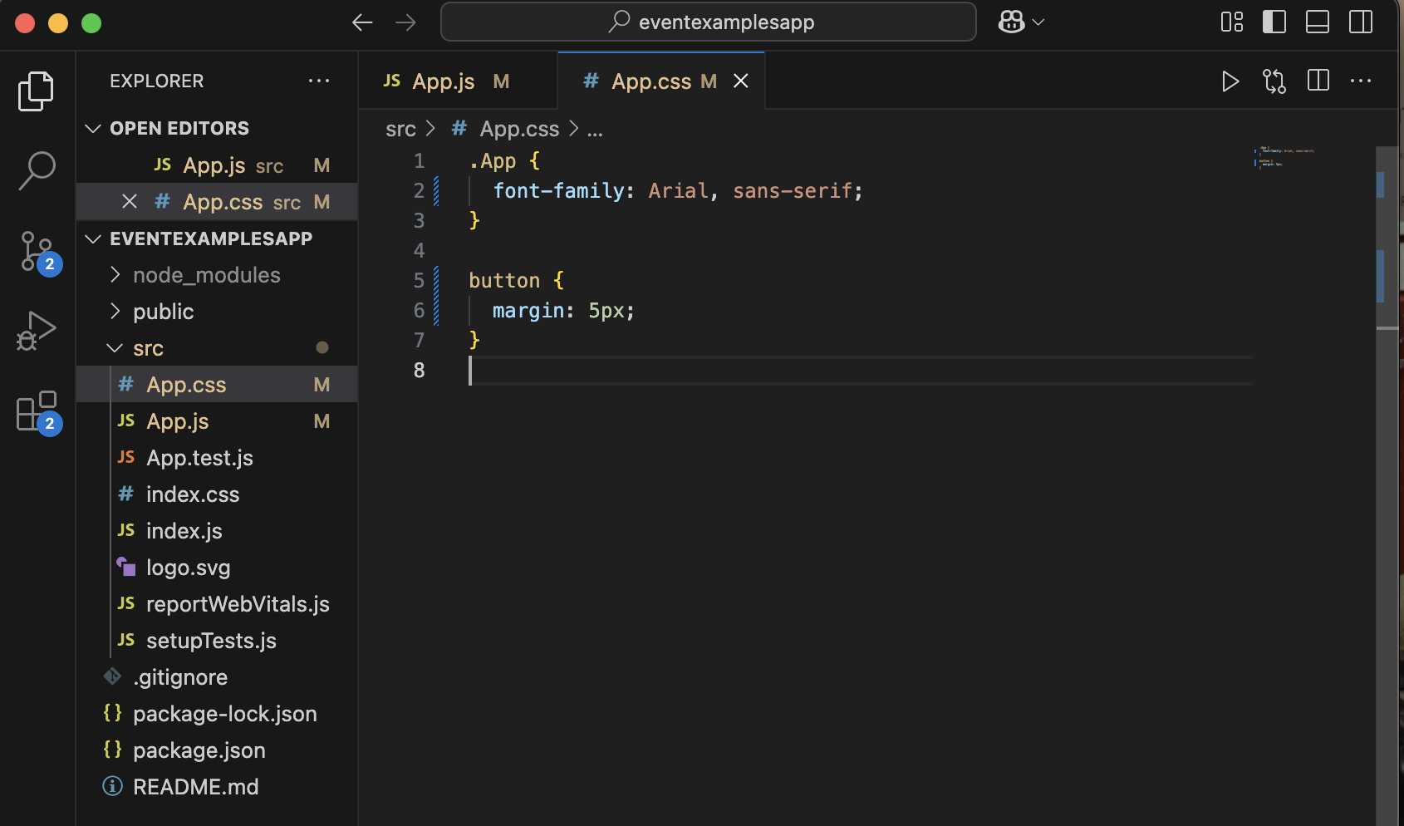

1. **Saved everything and ran npm start.**
2. **The output looked like :   
     
     
   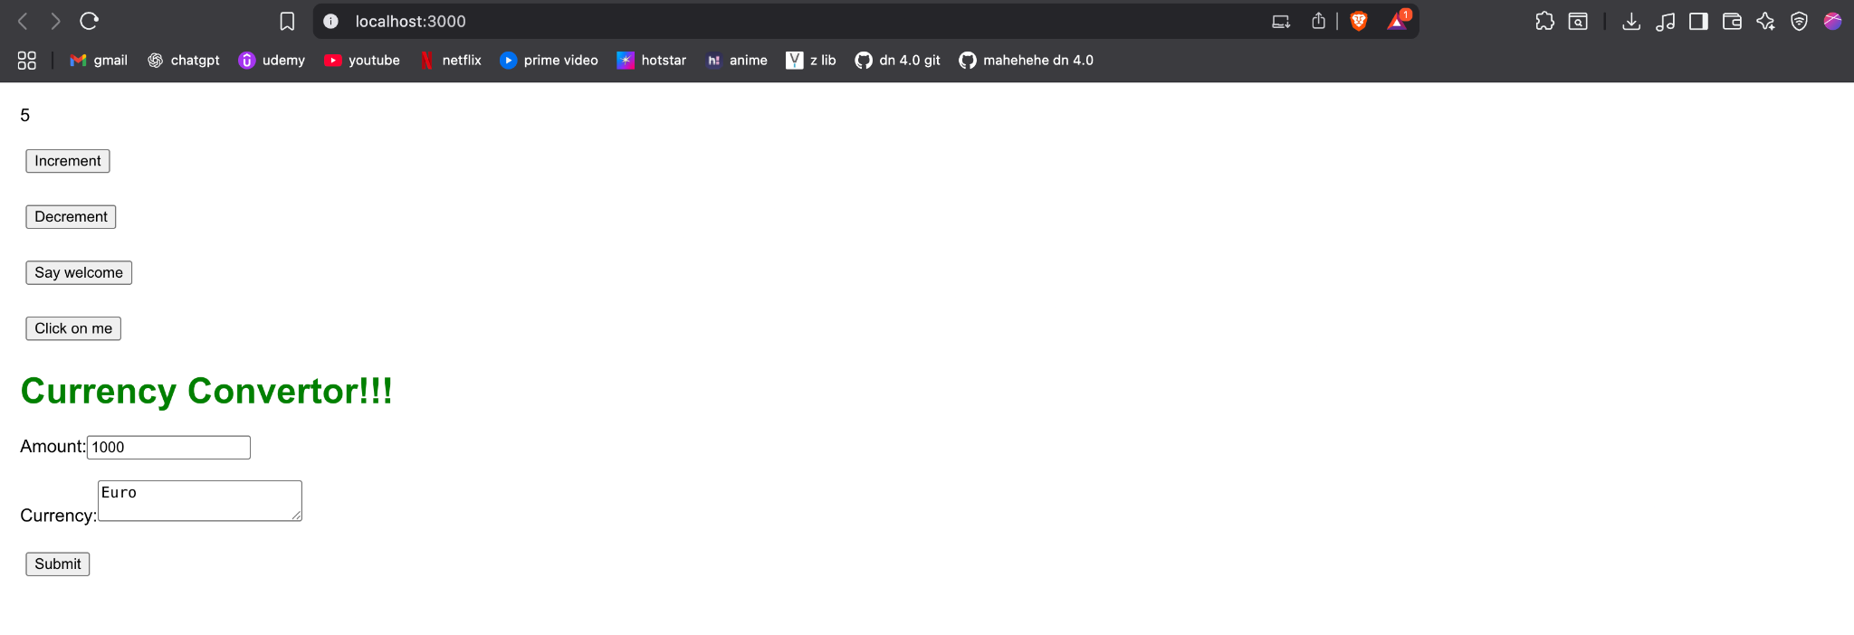**

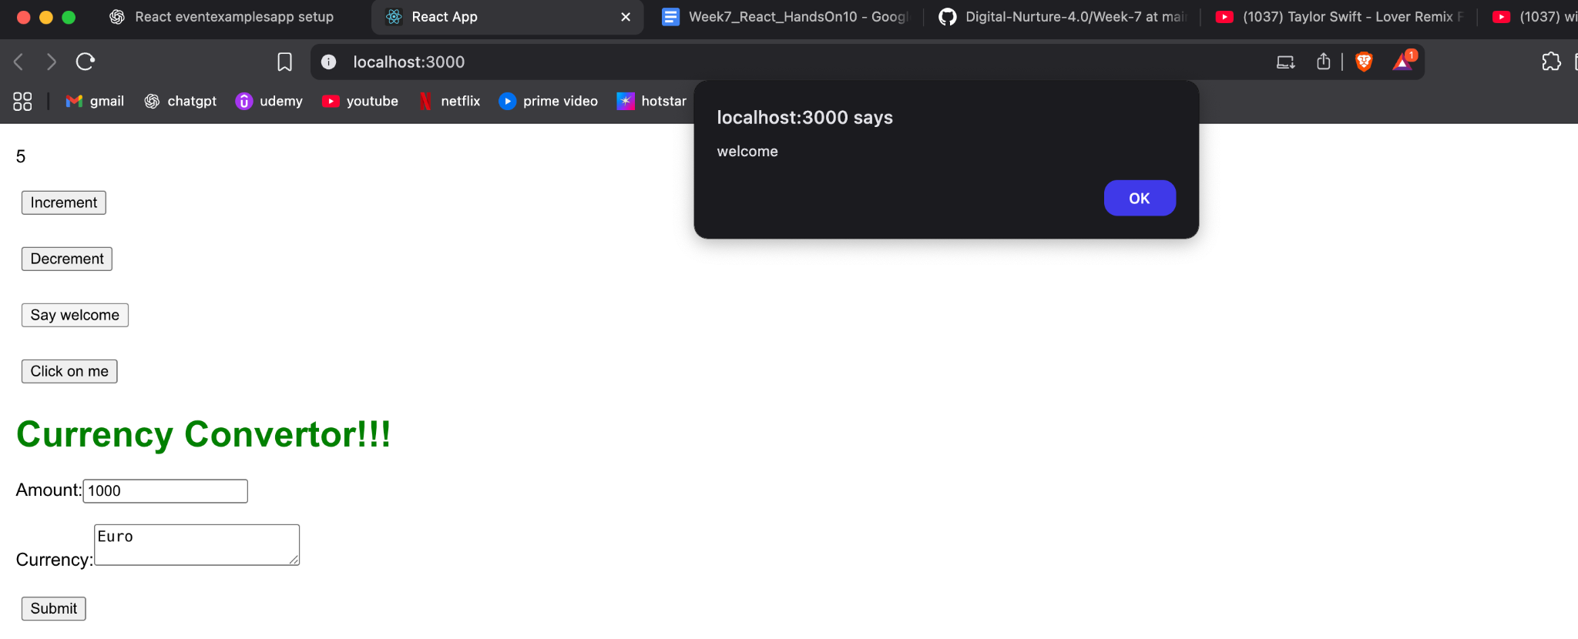

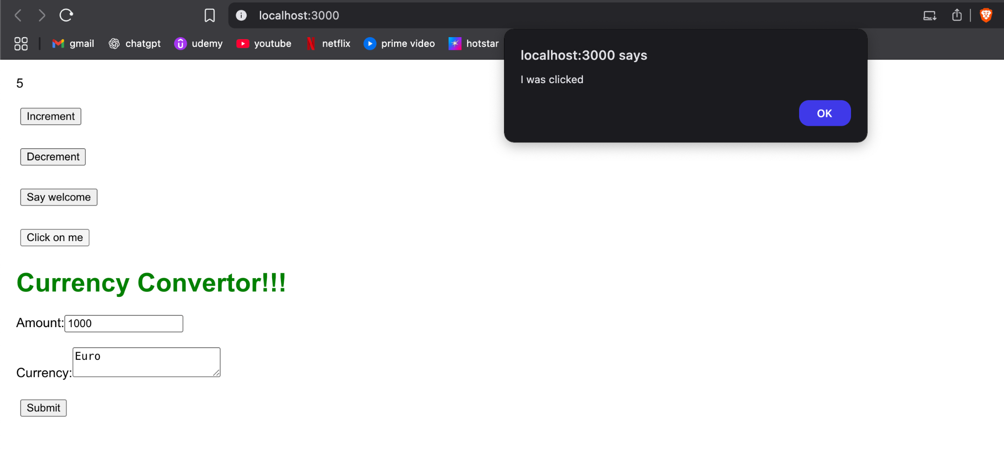

**On clicking submit :   
  
