1. **Create a react app “ticketbookingsapp” :   
     
   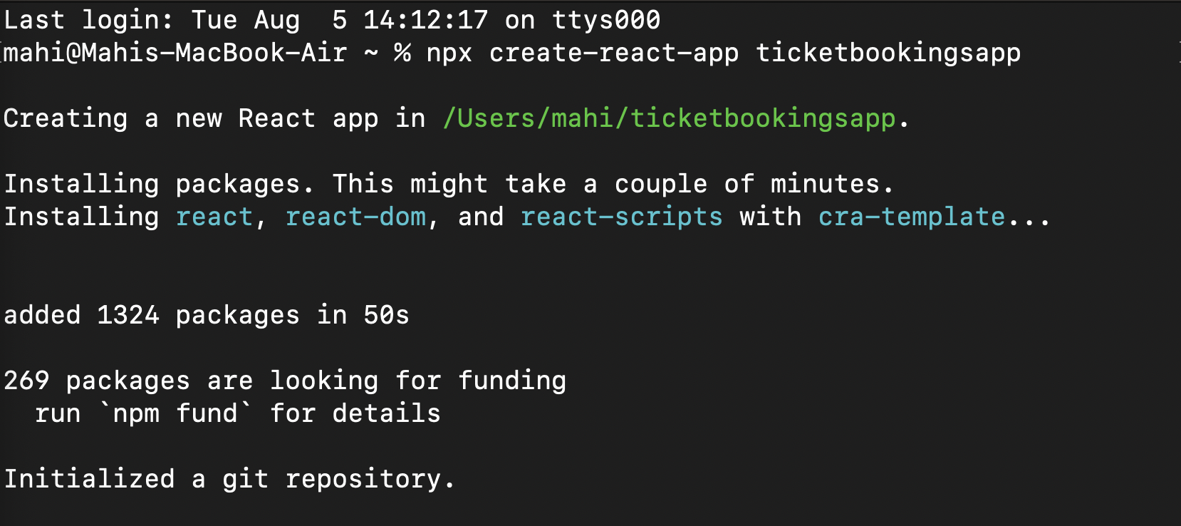**
2. **Make sure that the router dom is installed .**
3. **Navigated to that folder and opened it in vs code.**
4. **Updated** [**index.js**](http://index.js) **:   
     
   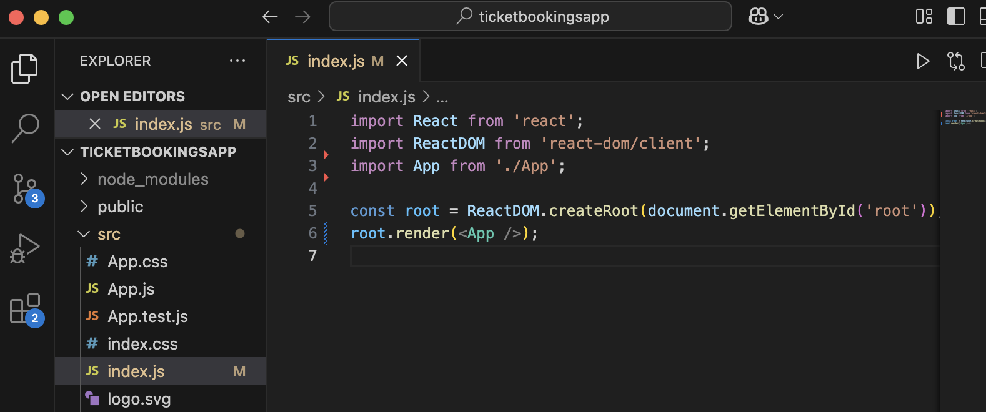**
5. **Updated** [**App.js**](http://app.js) **to look like this :   
     
   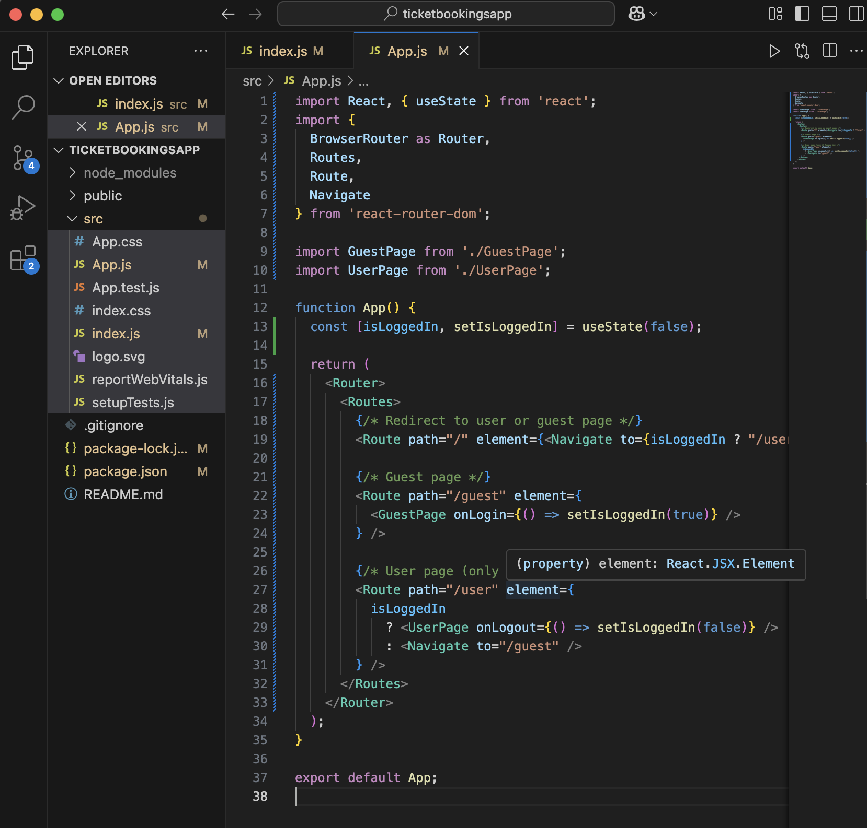**
6. **Created** [**GuestPage.js**](http://guestpage.js) **:   
     
   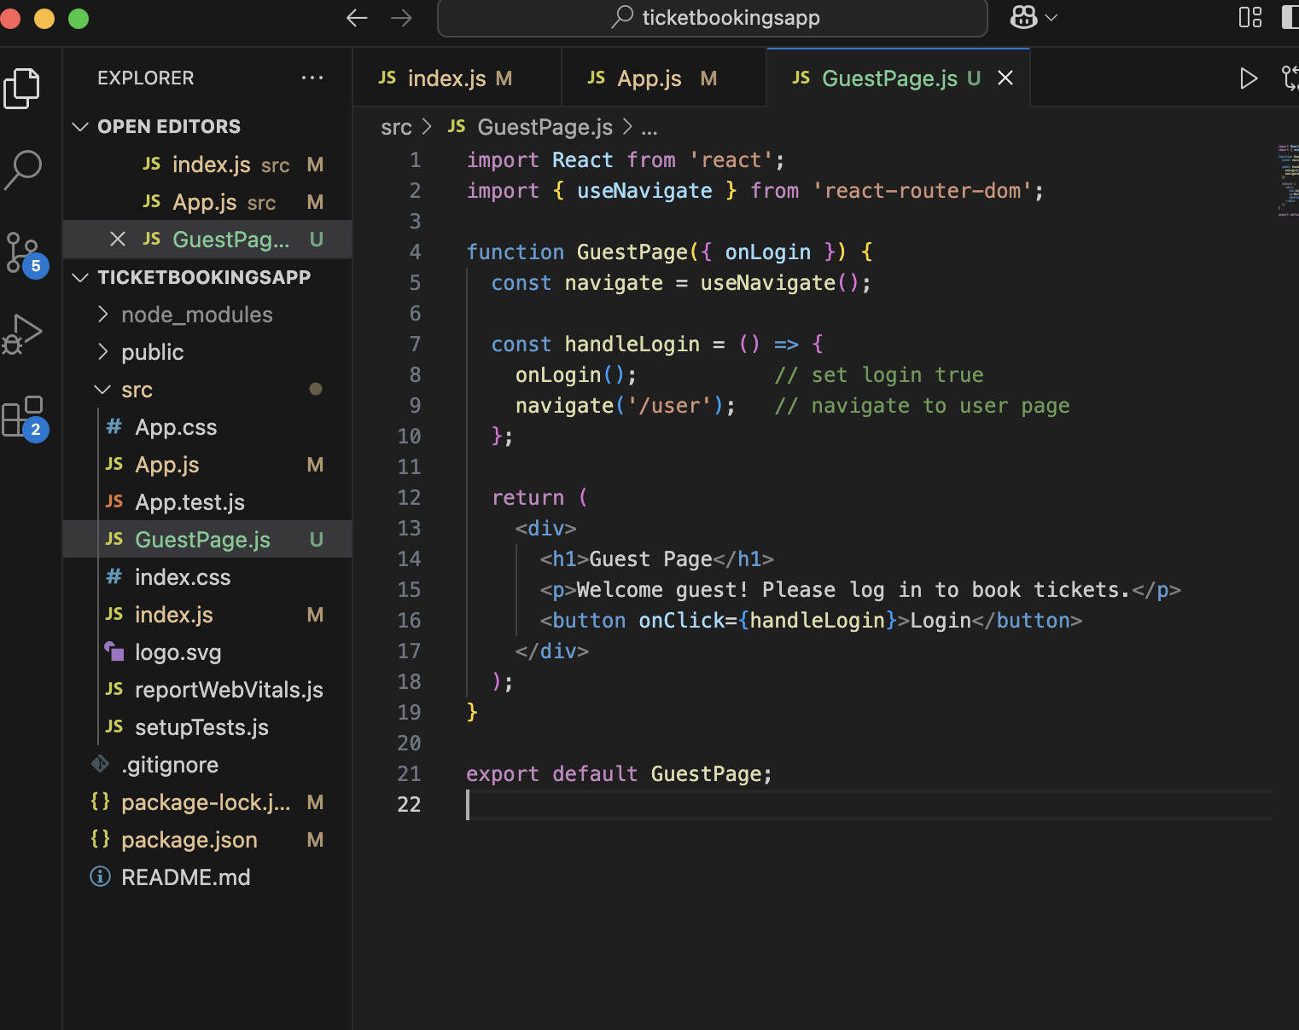**
7. **Created** [**UserPage.js**](http://userpage.js) **:   
     
   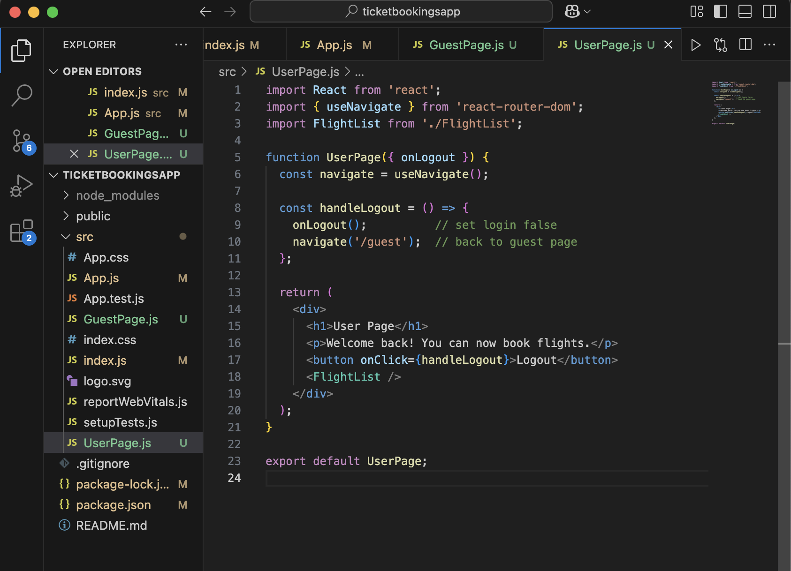**
8. **Created** [**FlightList.js**](http://flightlist.js) **:   
     
   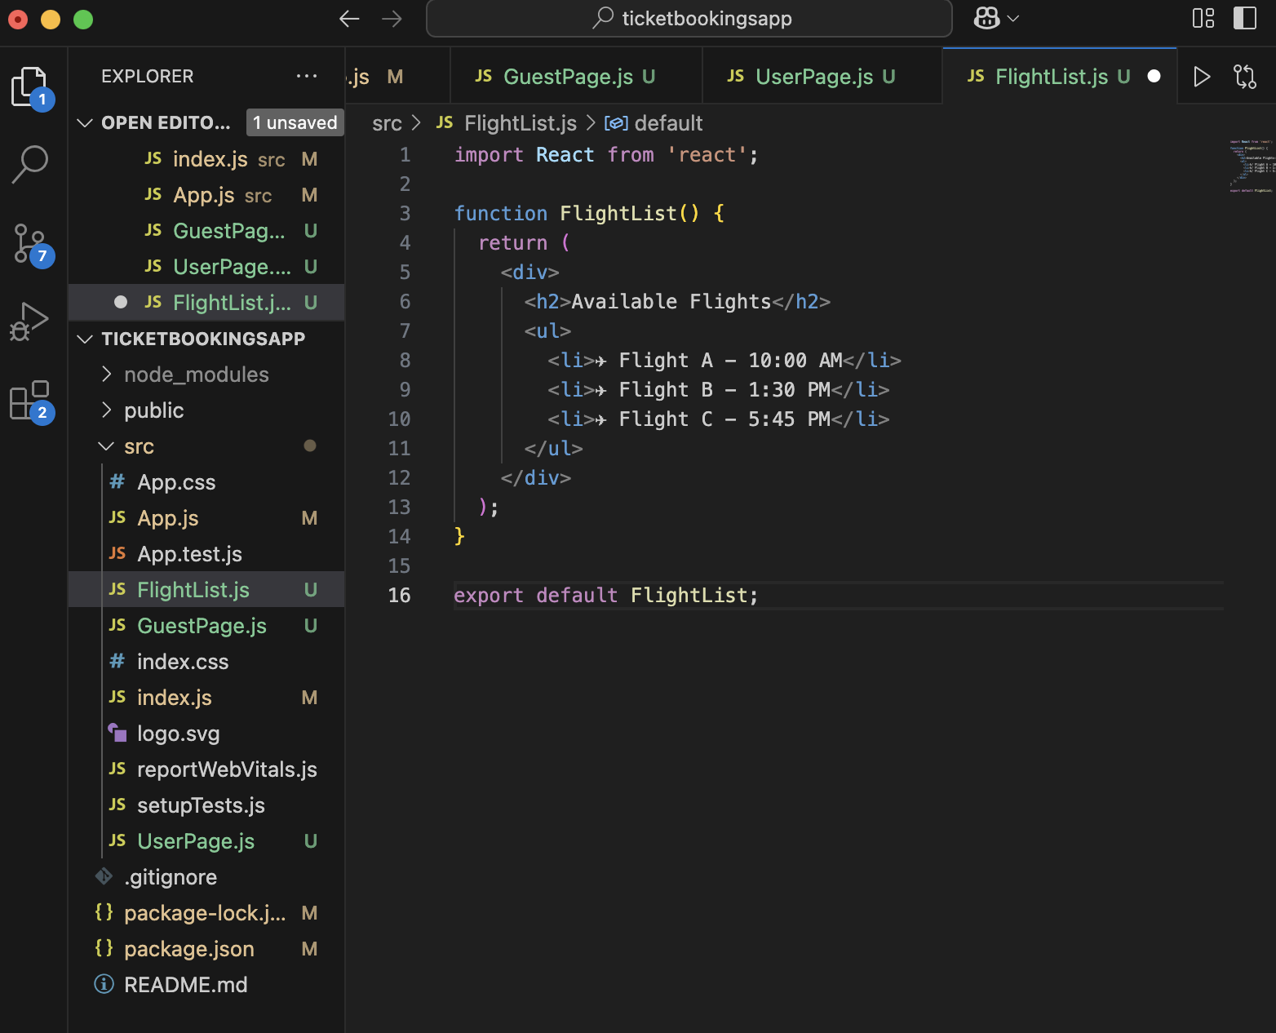**
9. **The output for both pages :   
     
     
   