1. **Create react app bloggerapp :   
     
   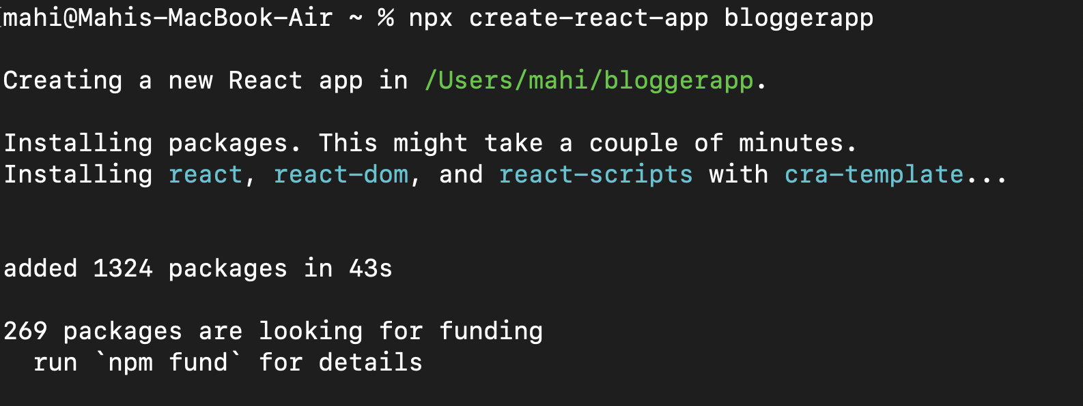**
2. **Navigate to the folder and open it on vs code.**
3. **Create** [**data.js**](http://data.js) **:   
     
   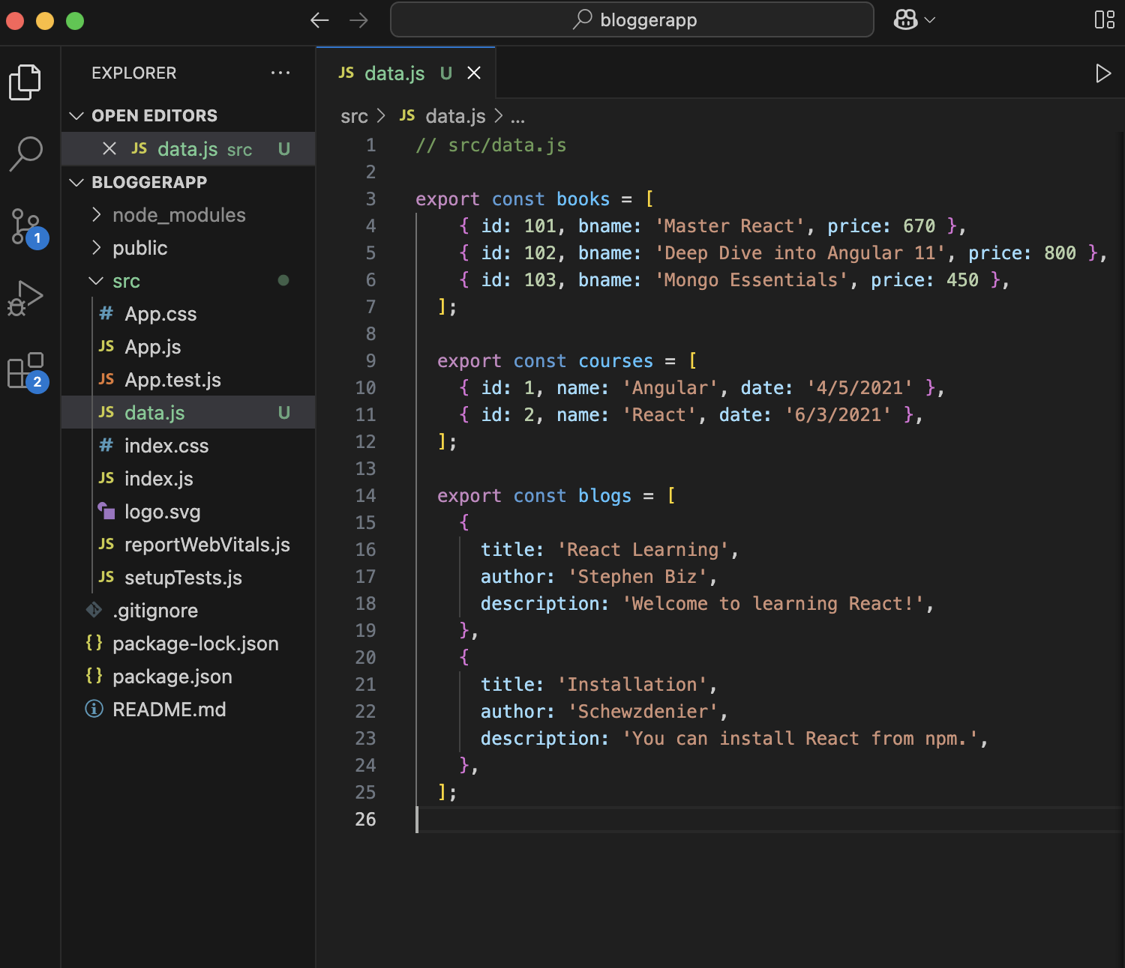**
4. **Create** [**BookDetails.js**](http://blogdetails.js) **:   
     
     
   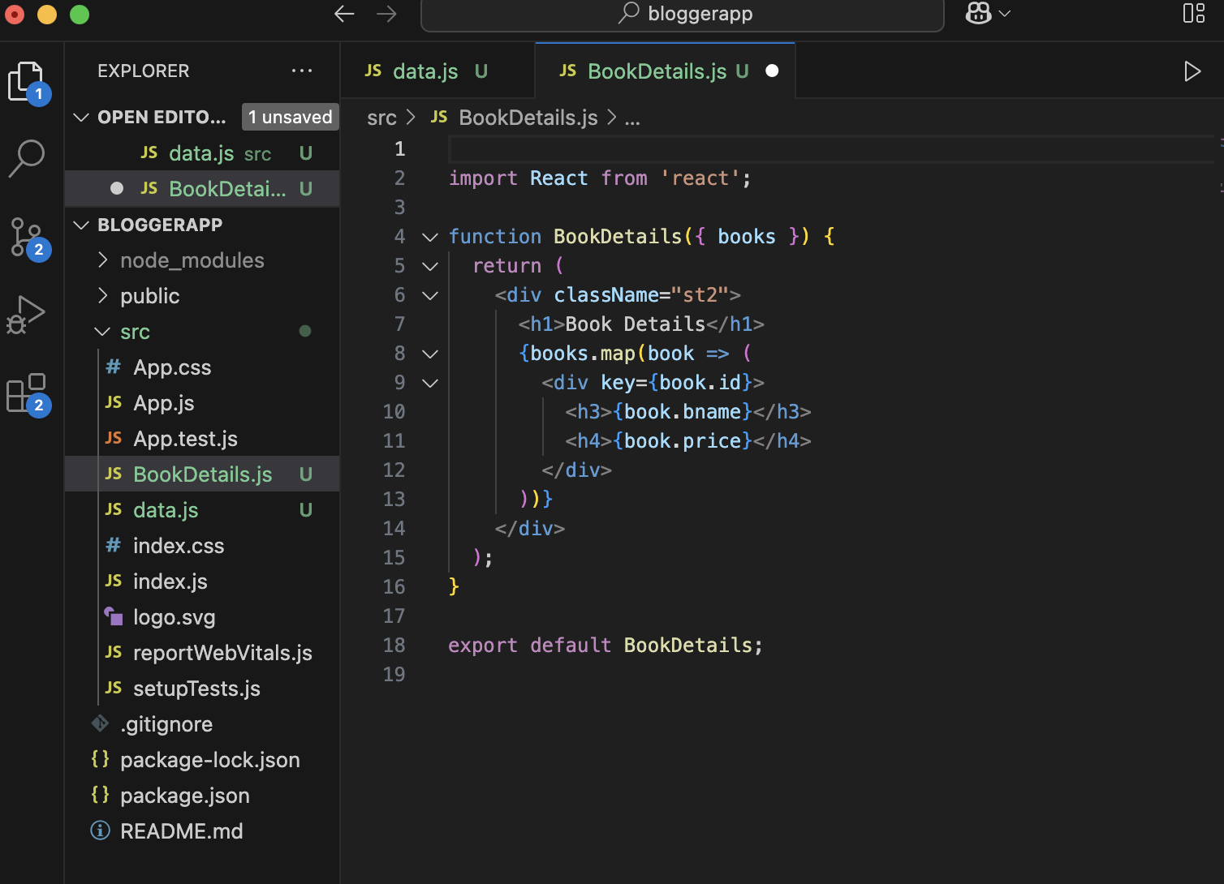**
5. **Create** [**CourseDetails.js**](http://coursedetails.js) **:   
     
     
   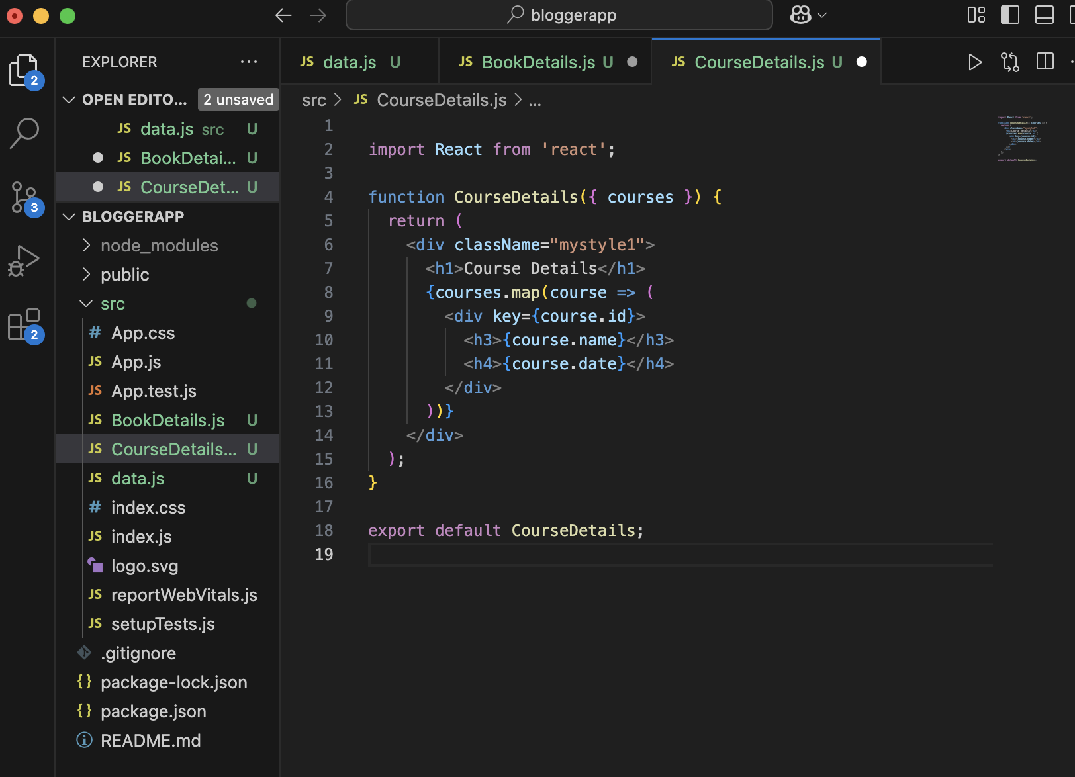**
6. **Create** [**BlogDetails.js**](http://blogdetails.js) **:   
     
   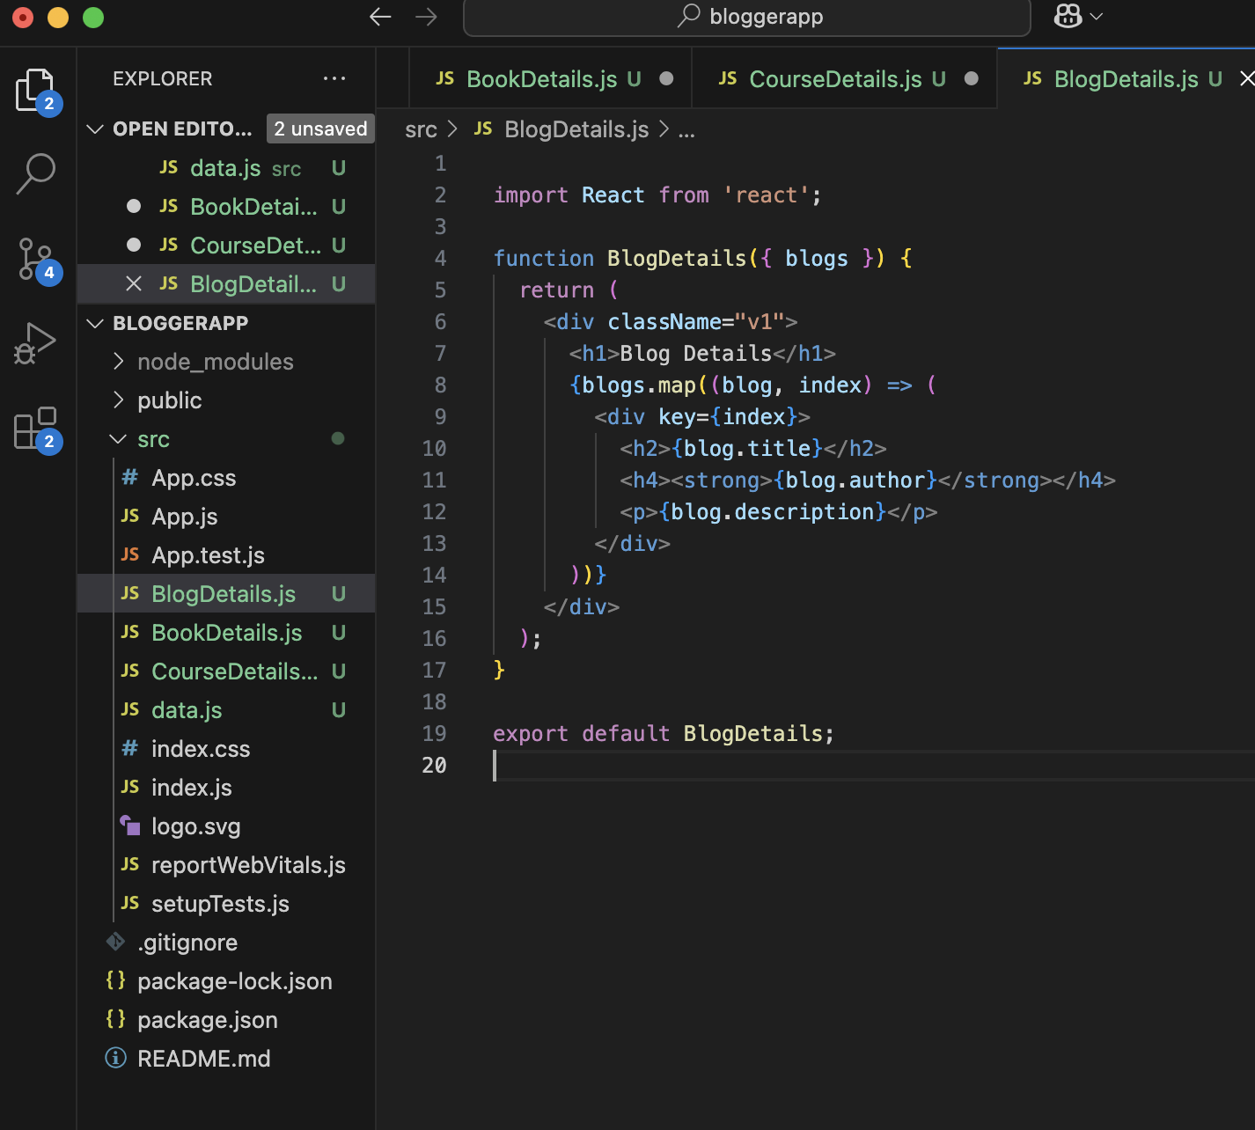**
7. **Update** [**App.js**](http://app.js) **:   
     
     
   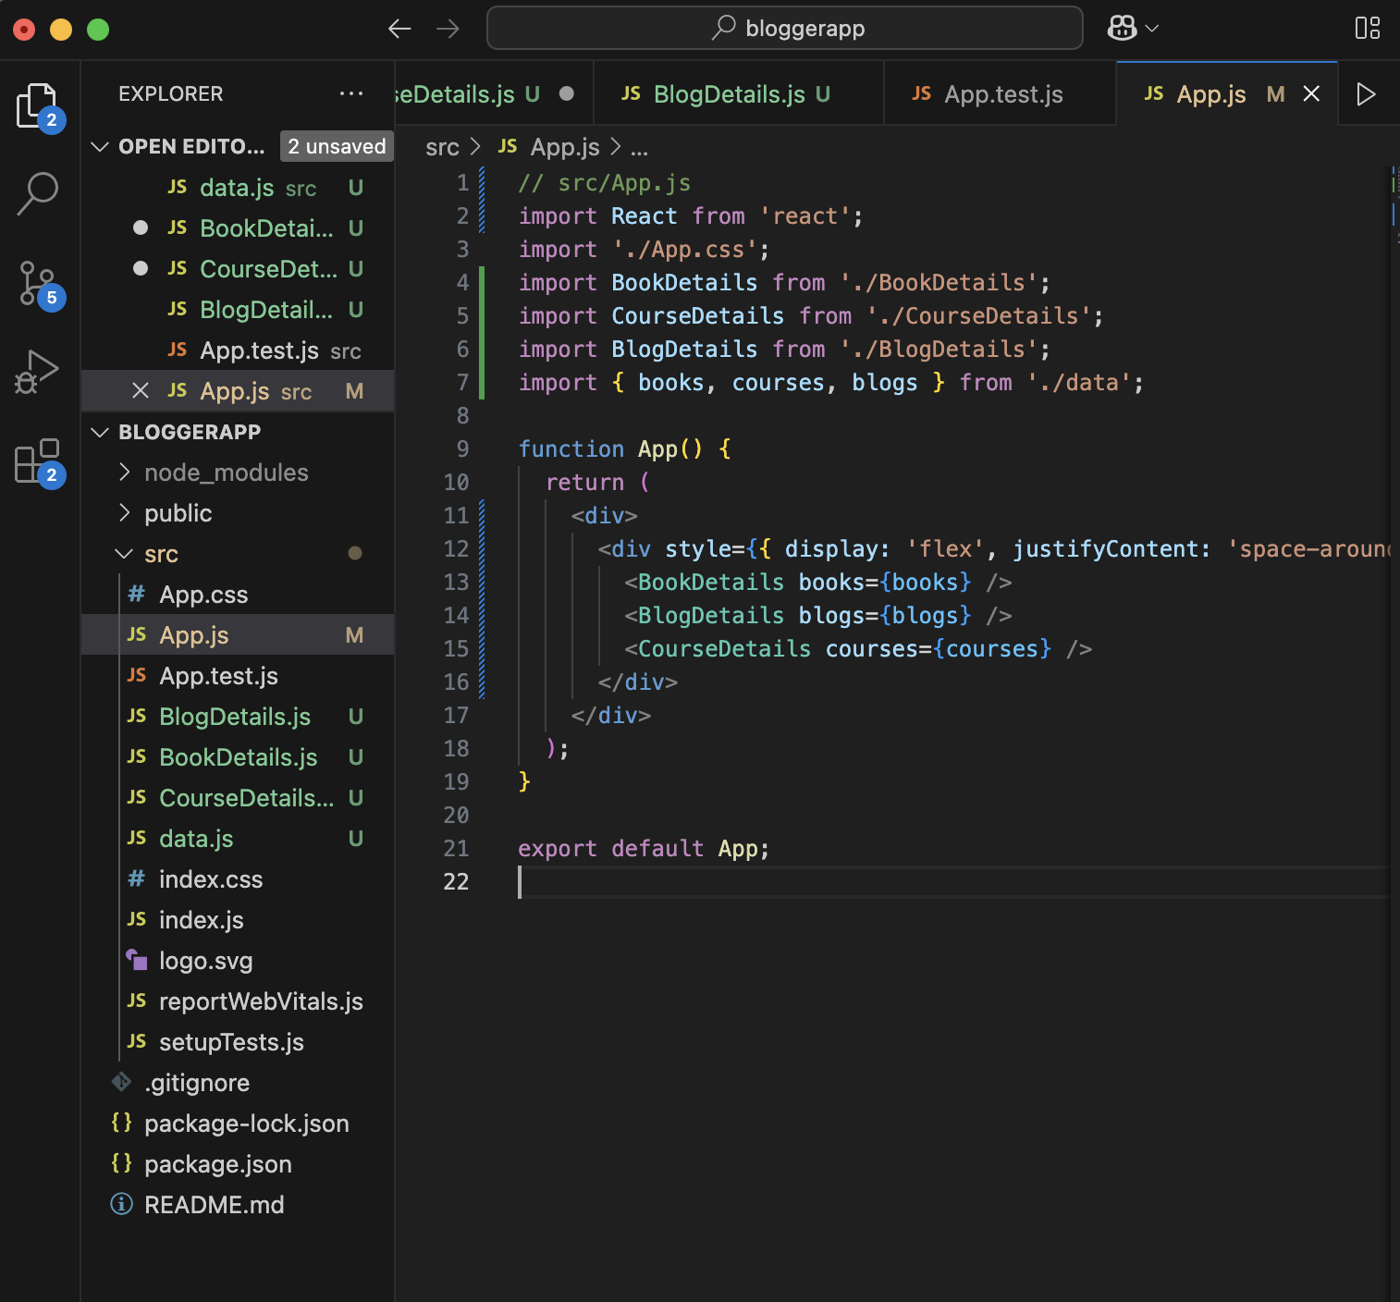**
8. **Update App.css for the style :   
     
   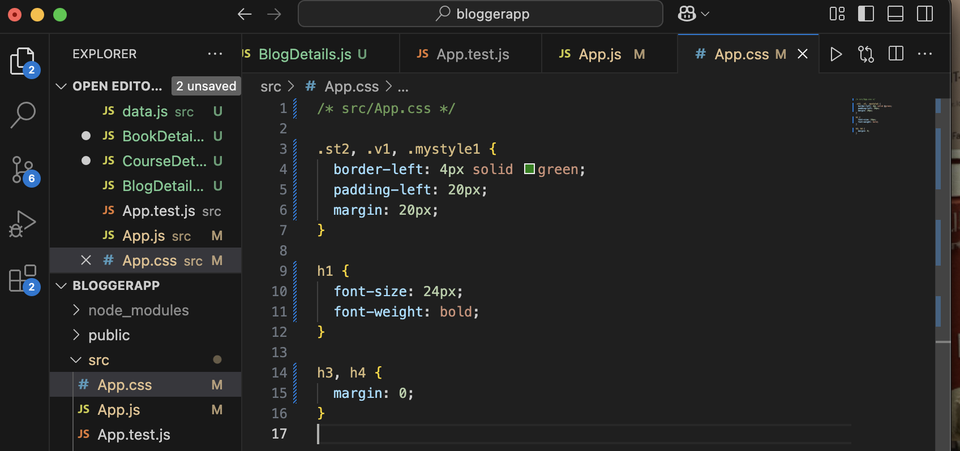**
9. **The output looks like :   
     
   