1. **Create “cricketapp” react app :**

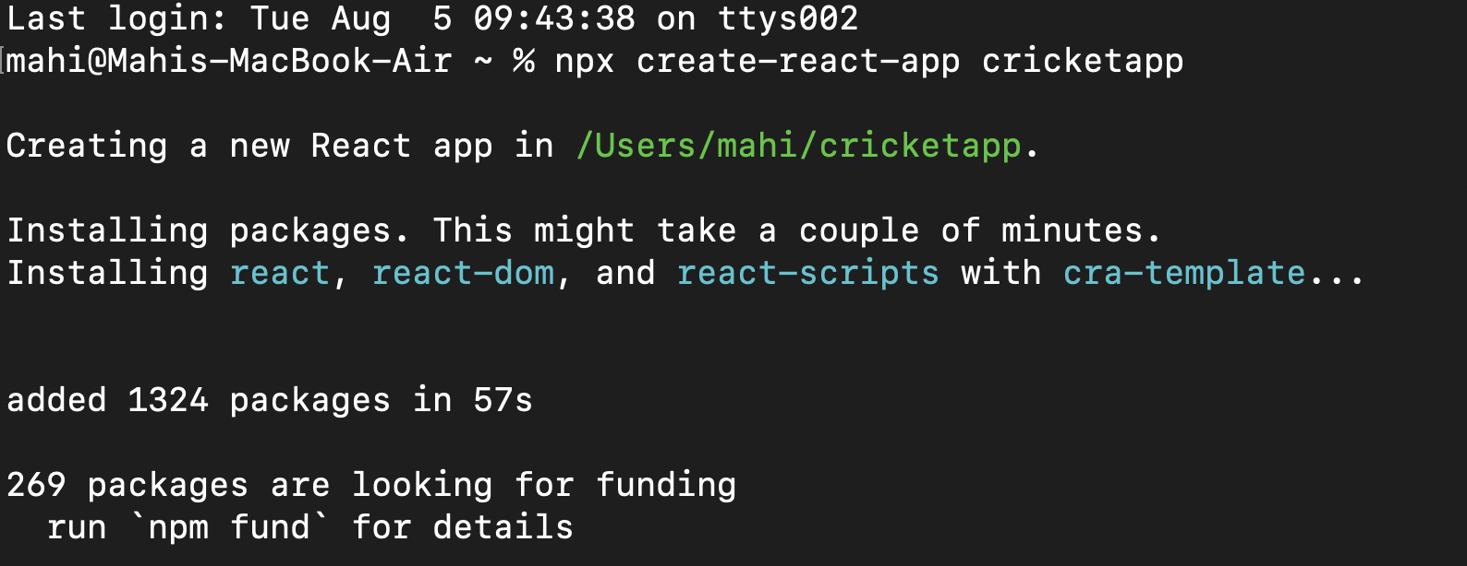

1. **Navigated to that folder and opened it in vs code.**
2. **Updated A**[**pp.js**](http://spp.js) **to have the array of players :**

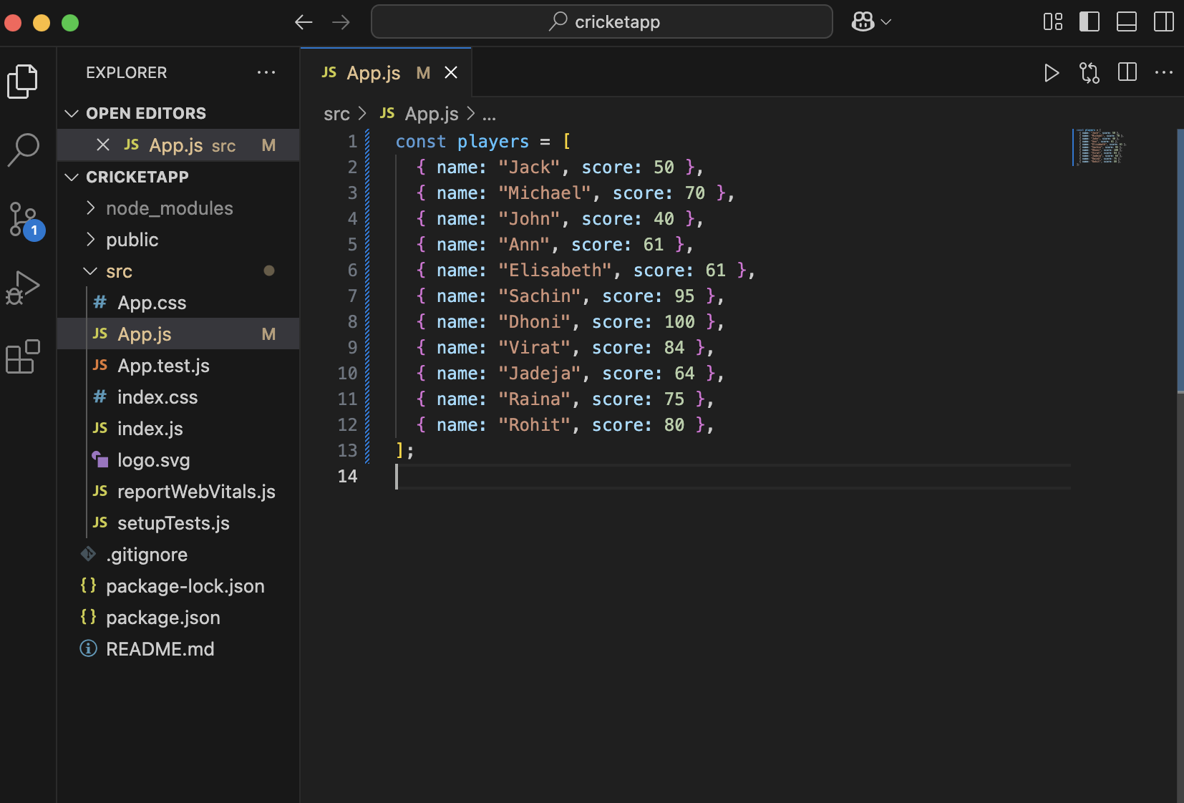

1. **Created** [**ListofPlayers.js**](http://listofplayers.js) **:**

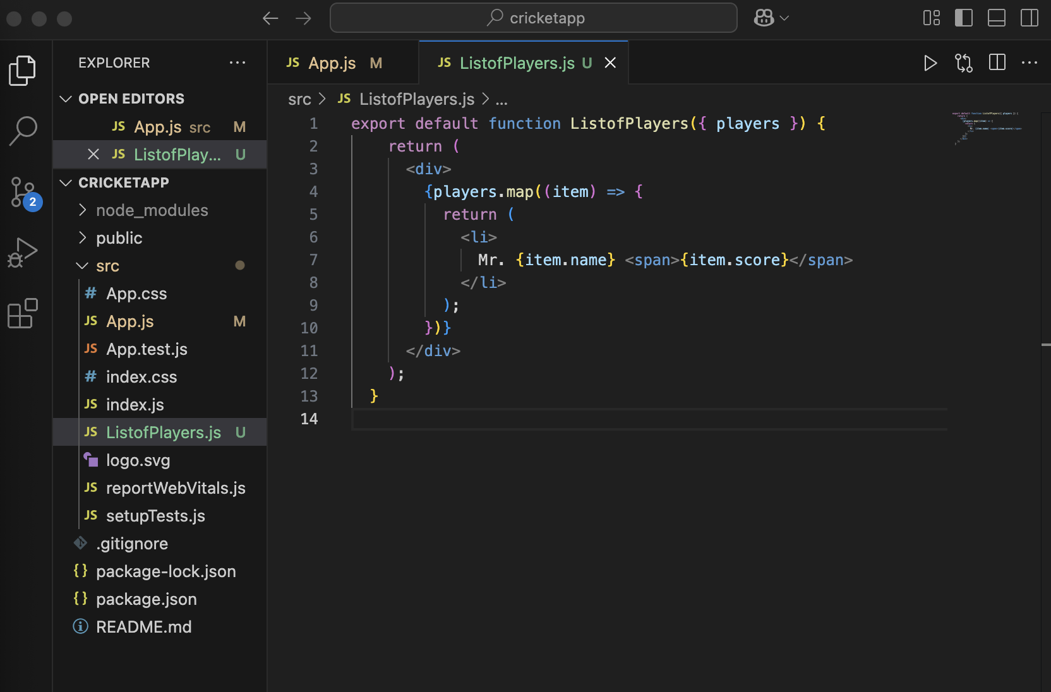

1. **Create** **Scorebelow7-.js** **:   
     
   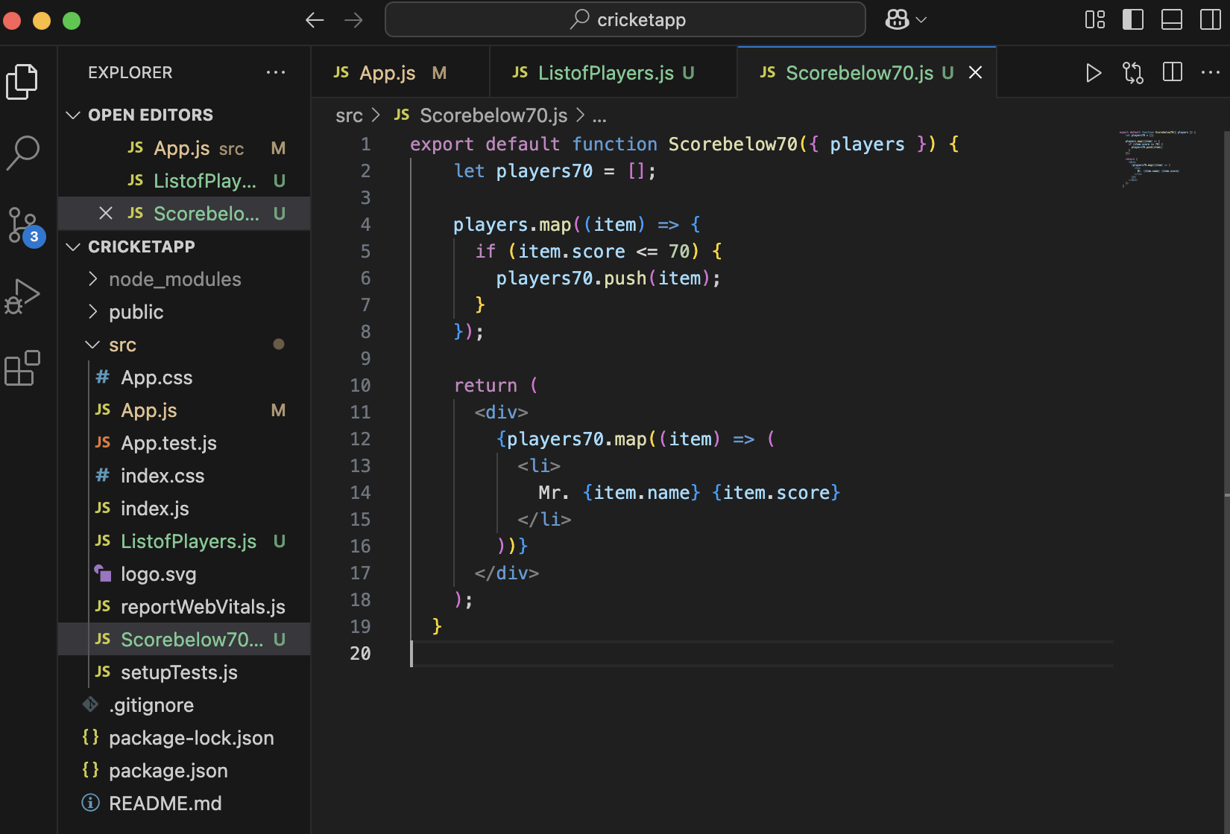**
2. **Create** [**OddPlayers.js**](http://oddplayers.js) **:   
     
   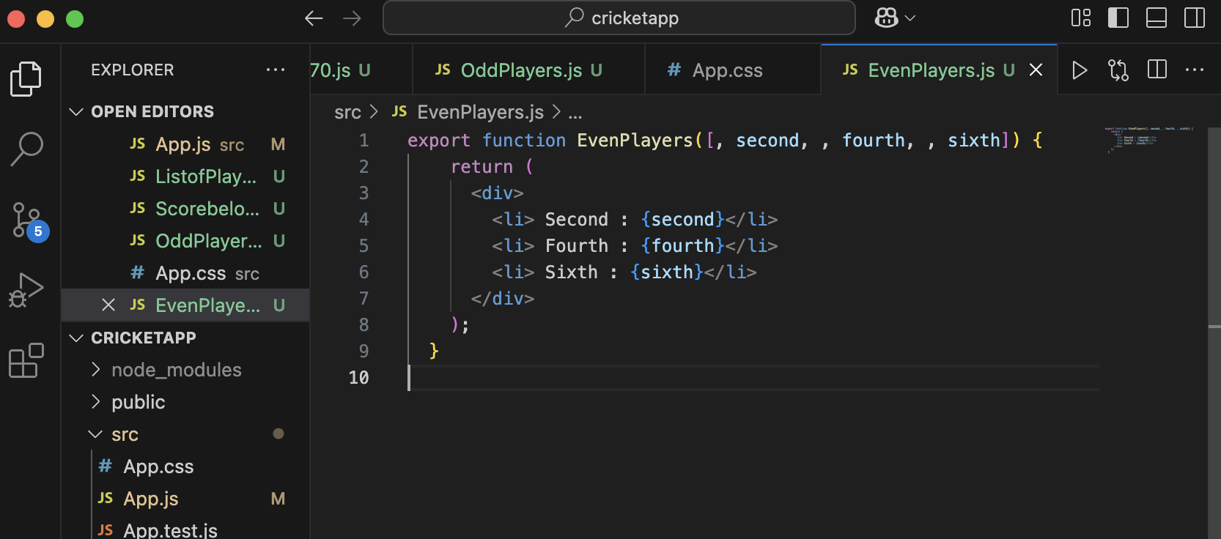**
3. **Create** [**EvenPlayers.js**](http://evenplayers.js) **:   
     
   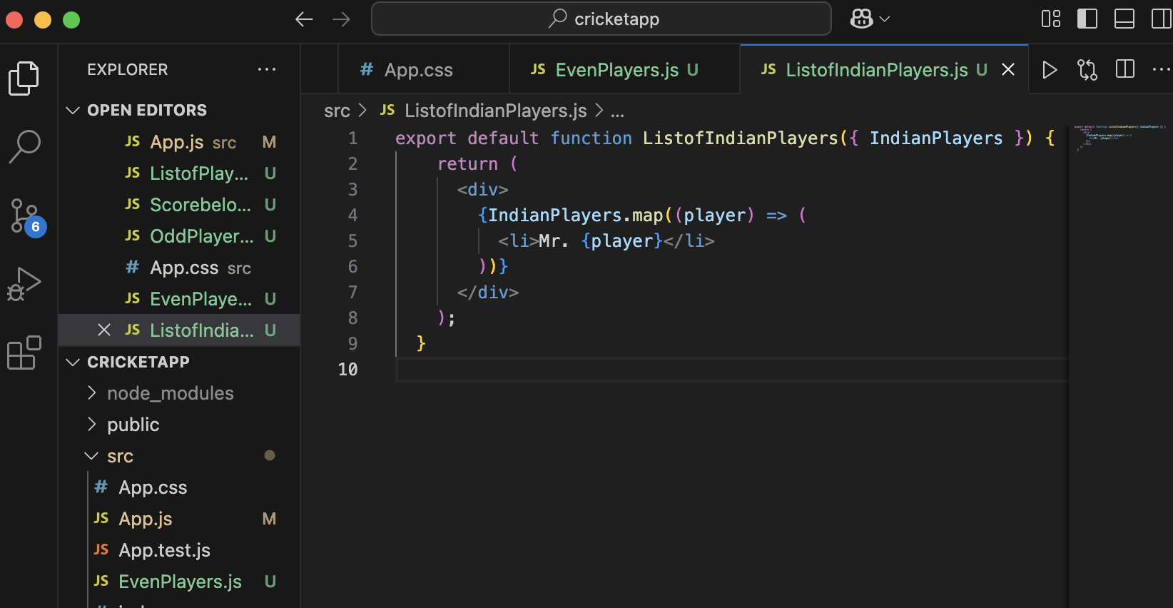**
4. **Create** [**ListofIndianPlayers.js**](http://listofindianplayers.js) **:   
     
   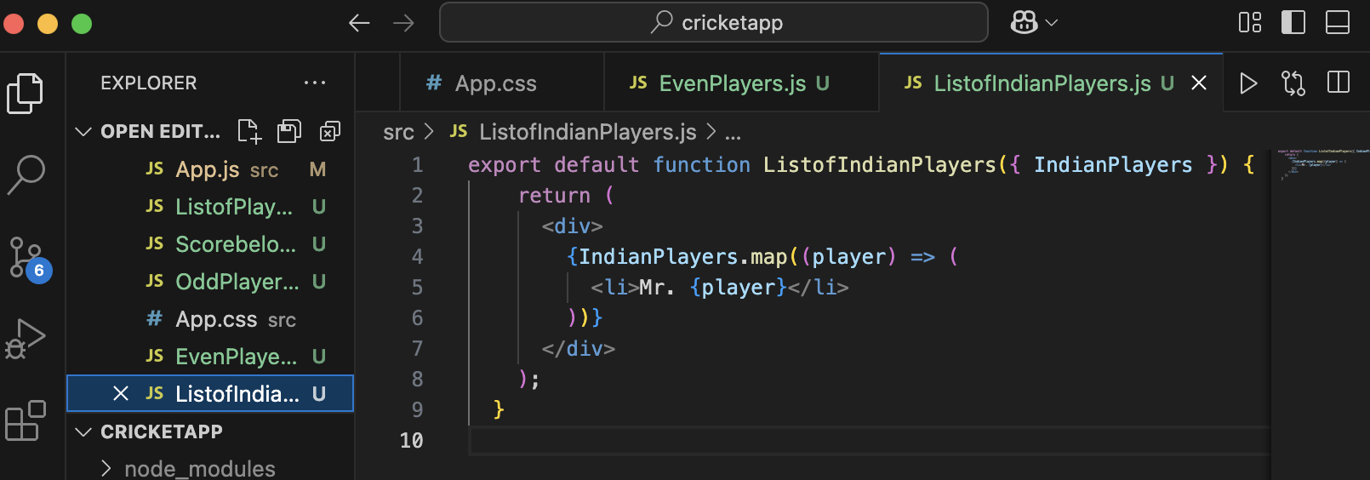**

**9. Updated** [**App.js**](http://app.js) **to have the following code :**iimport ListofPlayers from "./ListofPlayers";

import Scorebelow70 from "./Scorebelow70";

import { OddPlayers } from "./OddPlayers";

import { EvenPlayers } from "./EvenPlayers";

import ListofIndianPlayers from "./ListofIndianPlayers";

const players = [

{ name: "Jack", score: 50 },

{ name: "Michael", score: 70 },

{ name: "John", score: 40 },

{ name: "Ann", score: 61 },

{ name: "Elisabeth", score: 61 },

{ name: "Sachin", score: 95 },

{ name: "Dhoni", score: 100 },

{ name: "Virat", score: 84 },

{ name: "Jadeja", score: 64 },

{ name: "Raina", score: 75 },

{ name: "Rohit", score: 80 },

];

const IndianTeam = ["Sachin1", "Dhoni2", "Virat3", "Rohit4", "Yuvaraj5", "Raina6"];

const T20Players = ["First Player", "Second Player", "Third Player"];

const RanjiTrophyPlayers = ["Fourth Player", "Fifth Player", "Sixth Player"];

const IndianPlayers = [...T20Players, ...RanjiTrophyPlayers];

function App() {

var flag = true;

if (flag === true) {

return (

<div>

<h1>List of Players</h1>

<ListofPlayers players={players} />

<hr />

<h1>List of Players having Scores Less than 70 </h1>

<Scorebelow70 players={players} />

</div>

);

} else {

return (

<div>

<div>

<h1>Indian Team</h1>

<h1>Odd Players</h1>

<OddPlayers IndianTeam={IndianTeam} />

<hr />

<h1>Even Players</h1>

<EvenPlayers IndianTeam={IndianTeam} />

</div>

<hr />

<div>

<h1>List of Indian Players Merged:</h1>

<ListofIndianPlayers IndianPlayers={IndianPlayers} />

</div>

</div>

);

}

}

export default App;

**10. When flag=true the output after running npm start looks like :   
  
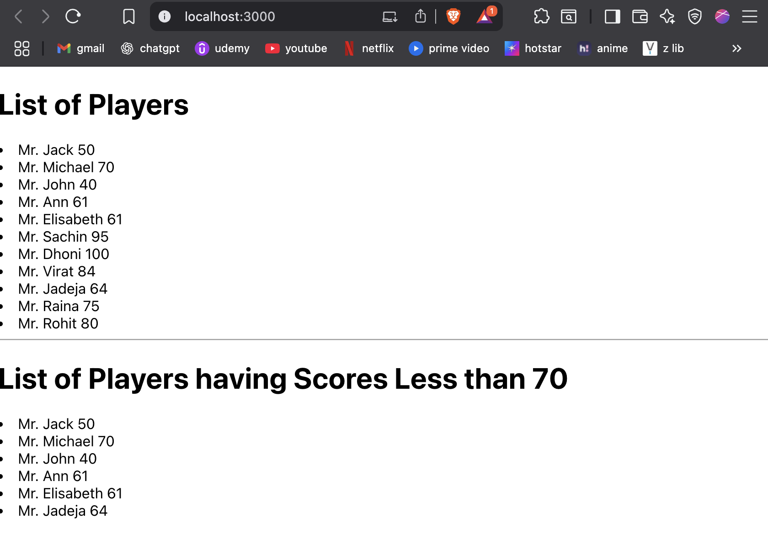**

**When flag = false :   
  
