1. **Created a log file into the already existing repo :   
     
   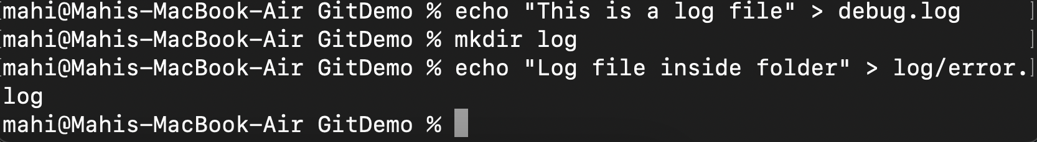**
2. **Opened gitignore on bbedit and added files to ignore :   
     
   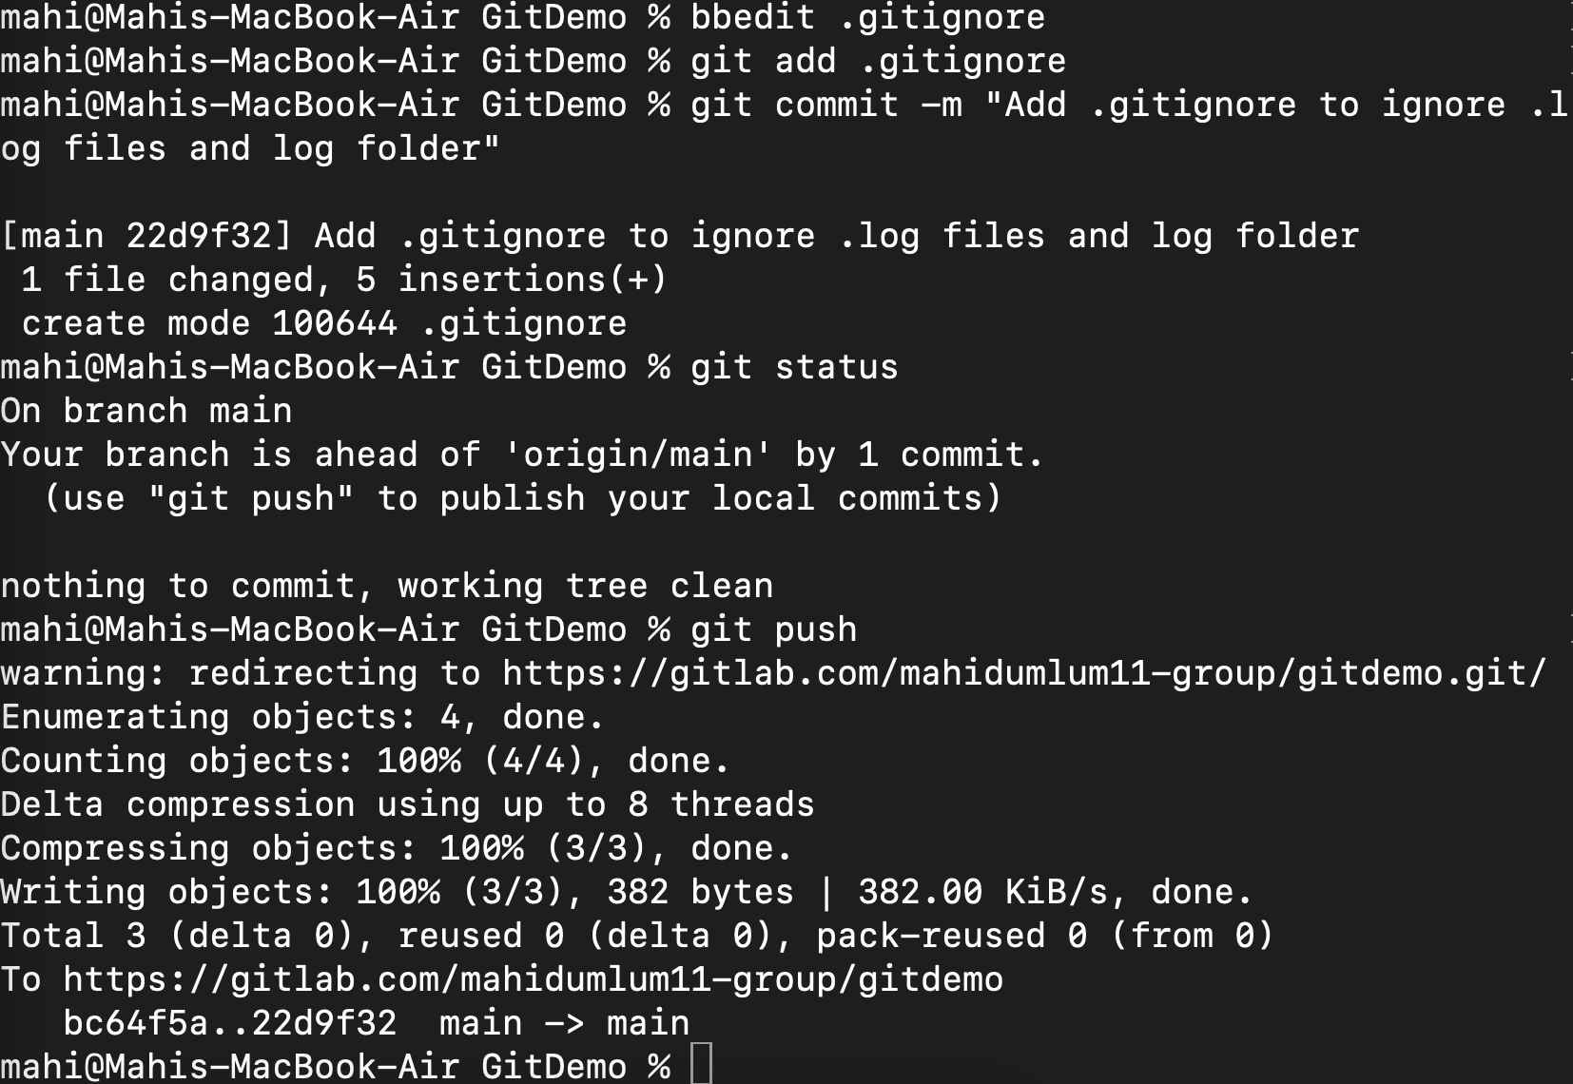**

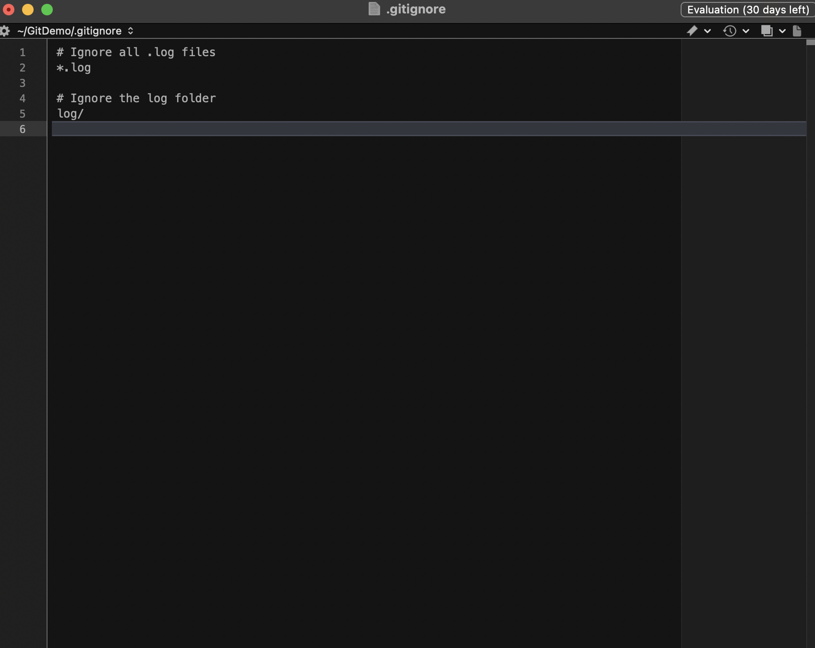

1. **Added the commit and verified if it was showing up :**



1. **Verified local repository log :   
     
   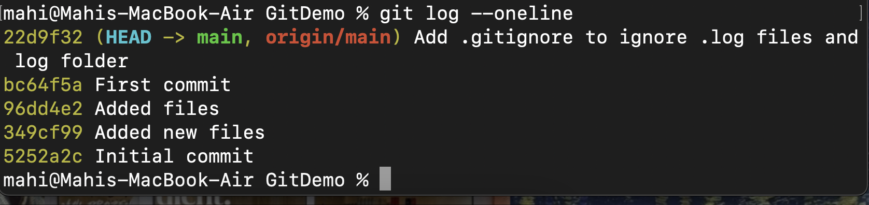**
2. **Checked remote repository online :   
     
   