1. **Created a new branch and switched to that branch from main branch :   
     
   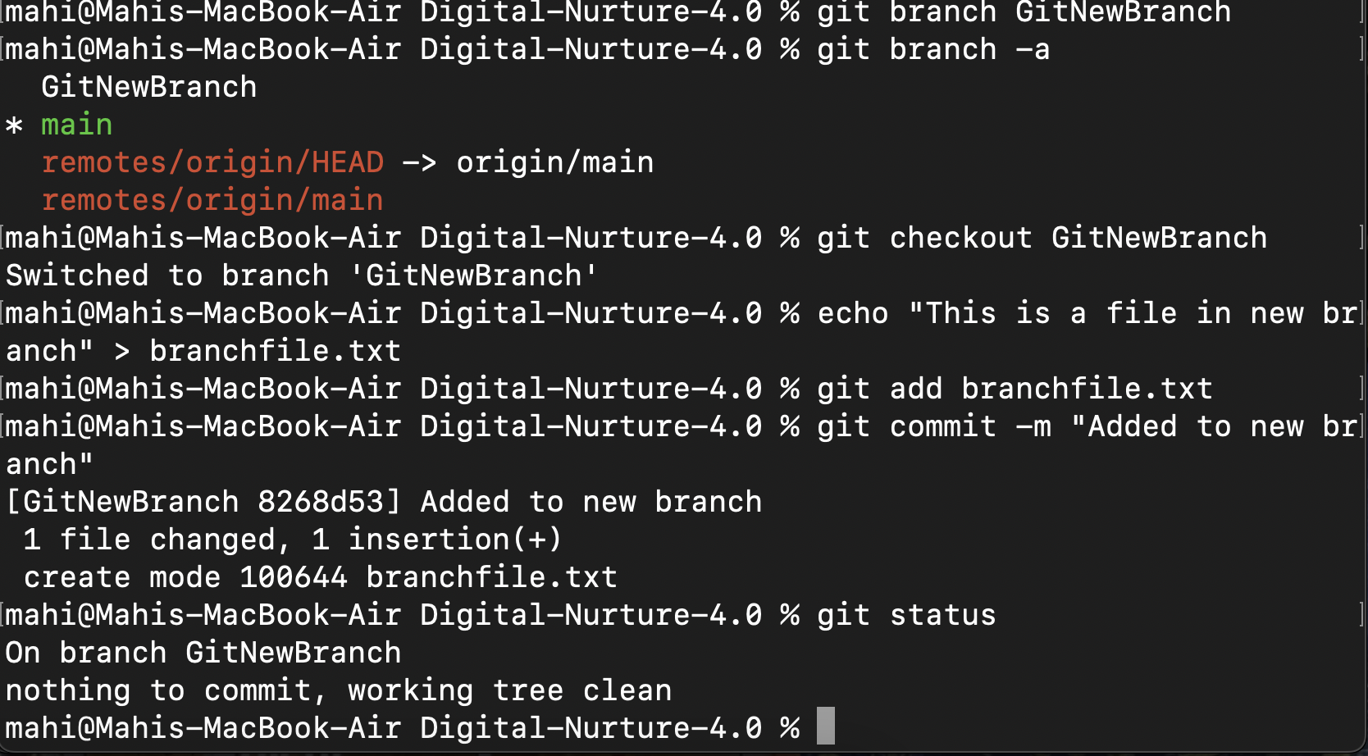**
2. **Switched to main branch again and listed the differences and visual differences between the two :   
     
   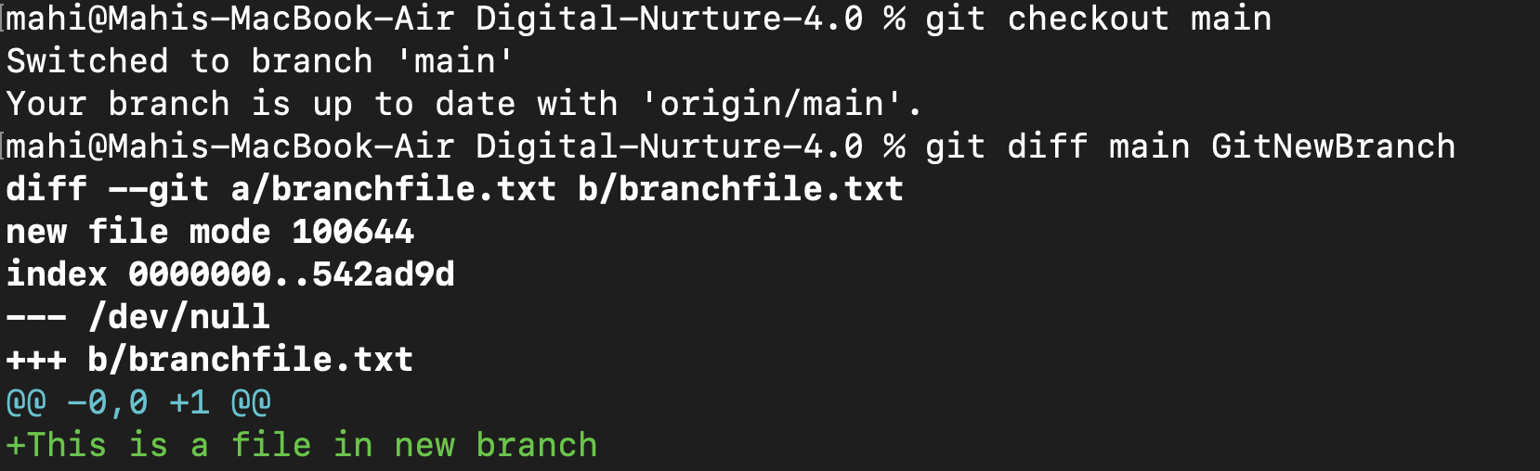**

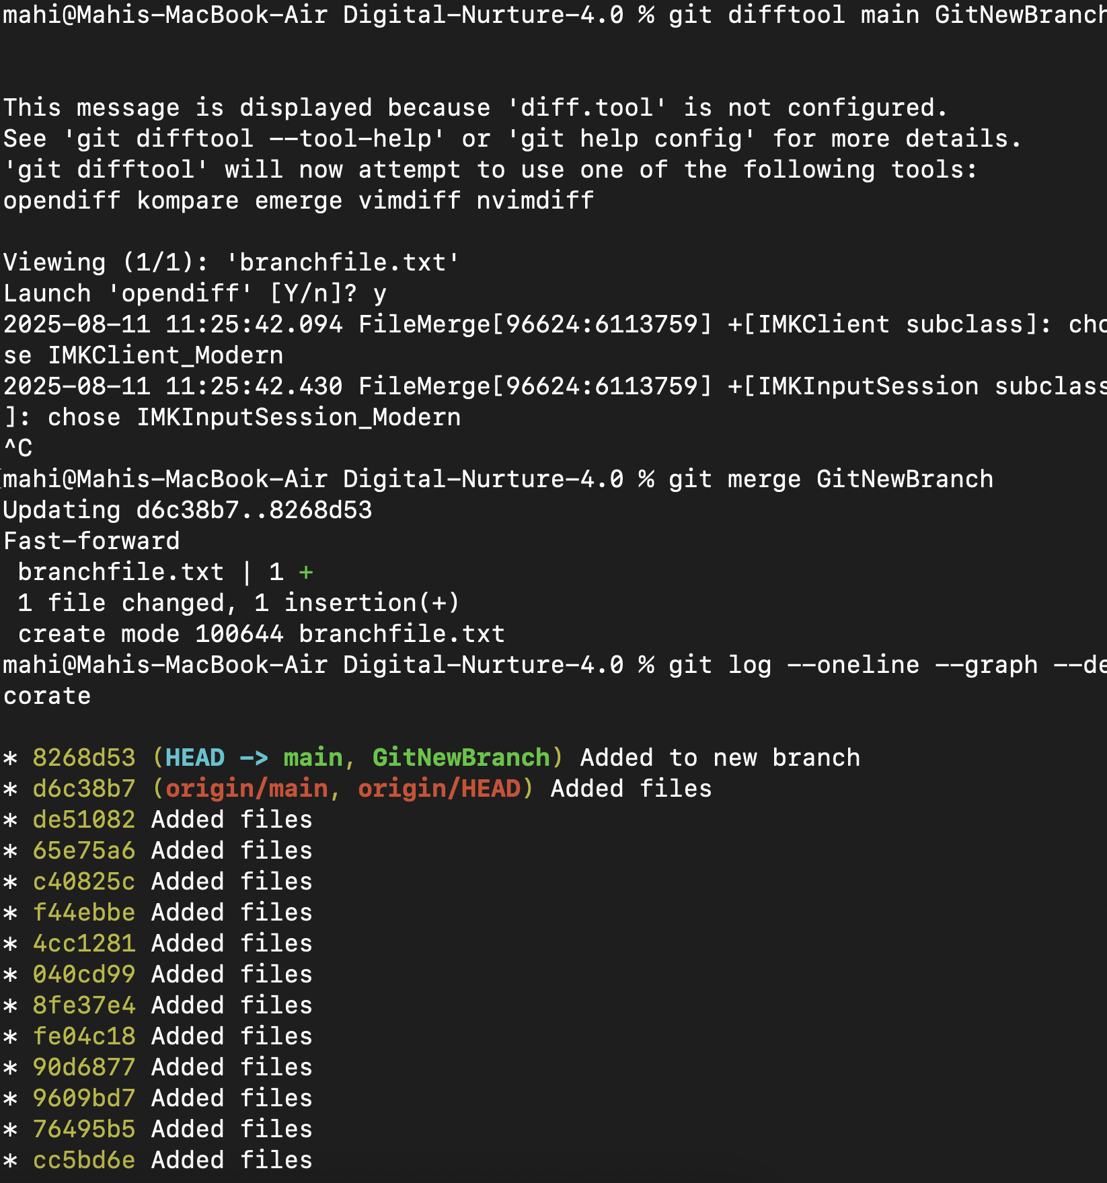

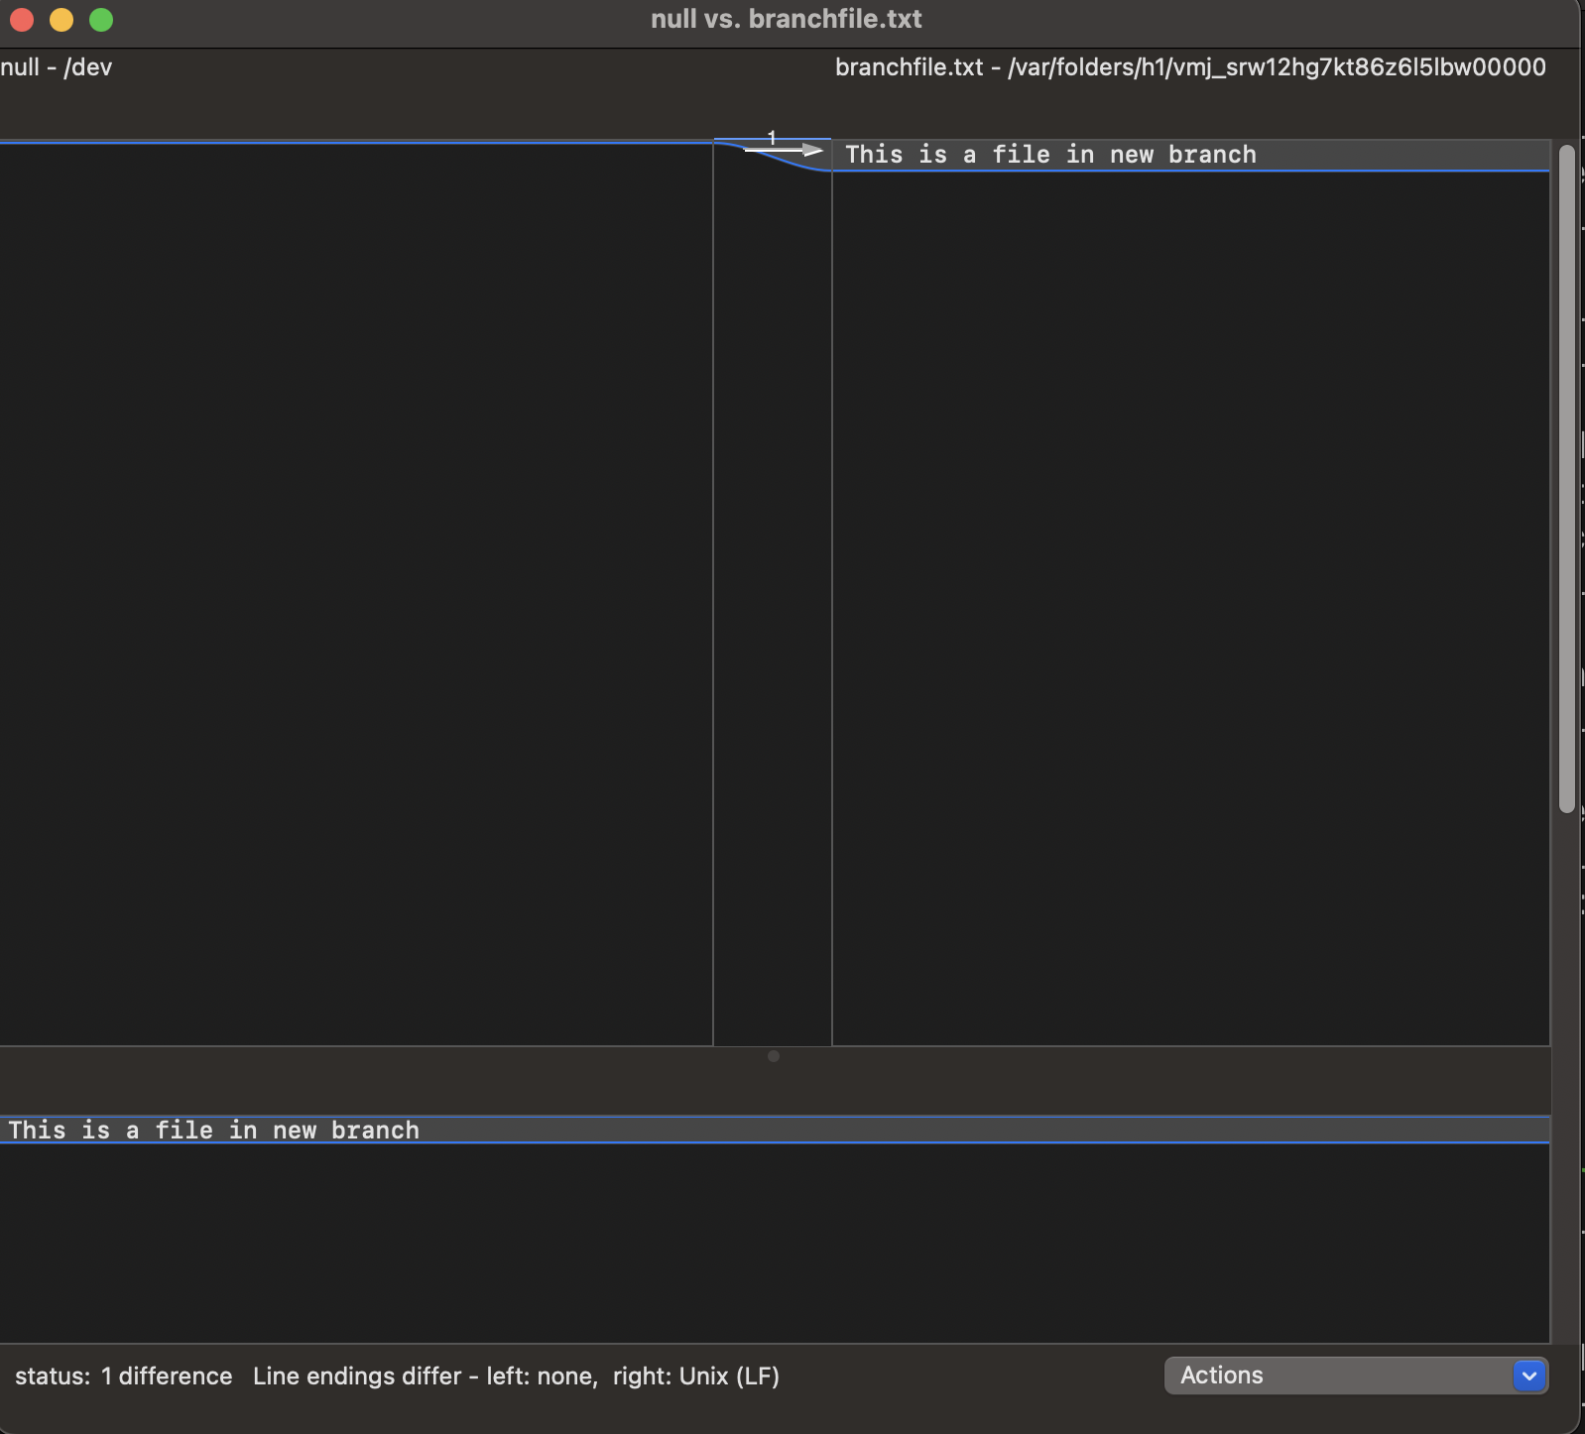

1. **Merged both branches and viewed committed history :**



1. **Deleted the branch after merging and viewed status :   
     
   