1. **Checked out main branch and verified if it was clean also created branch GitWork and added “hello.xml” to that branch :   
     
   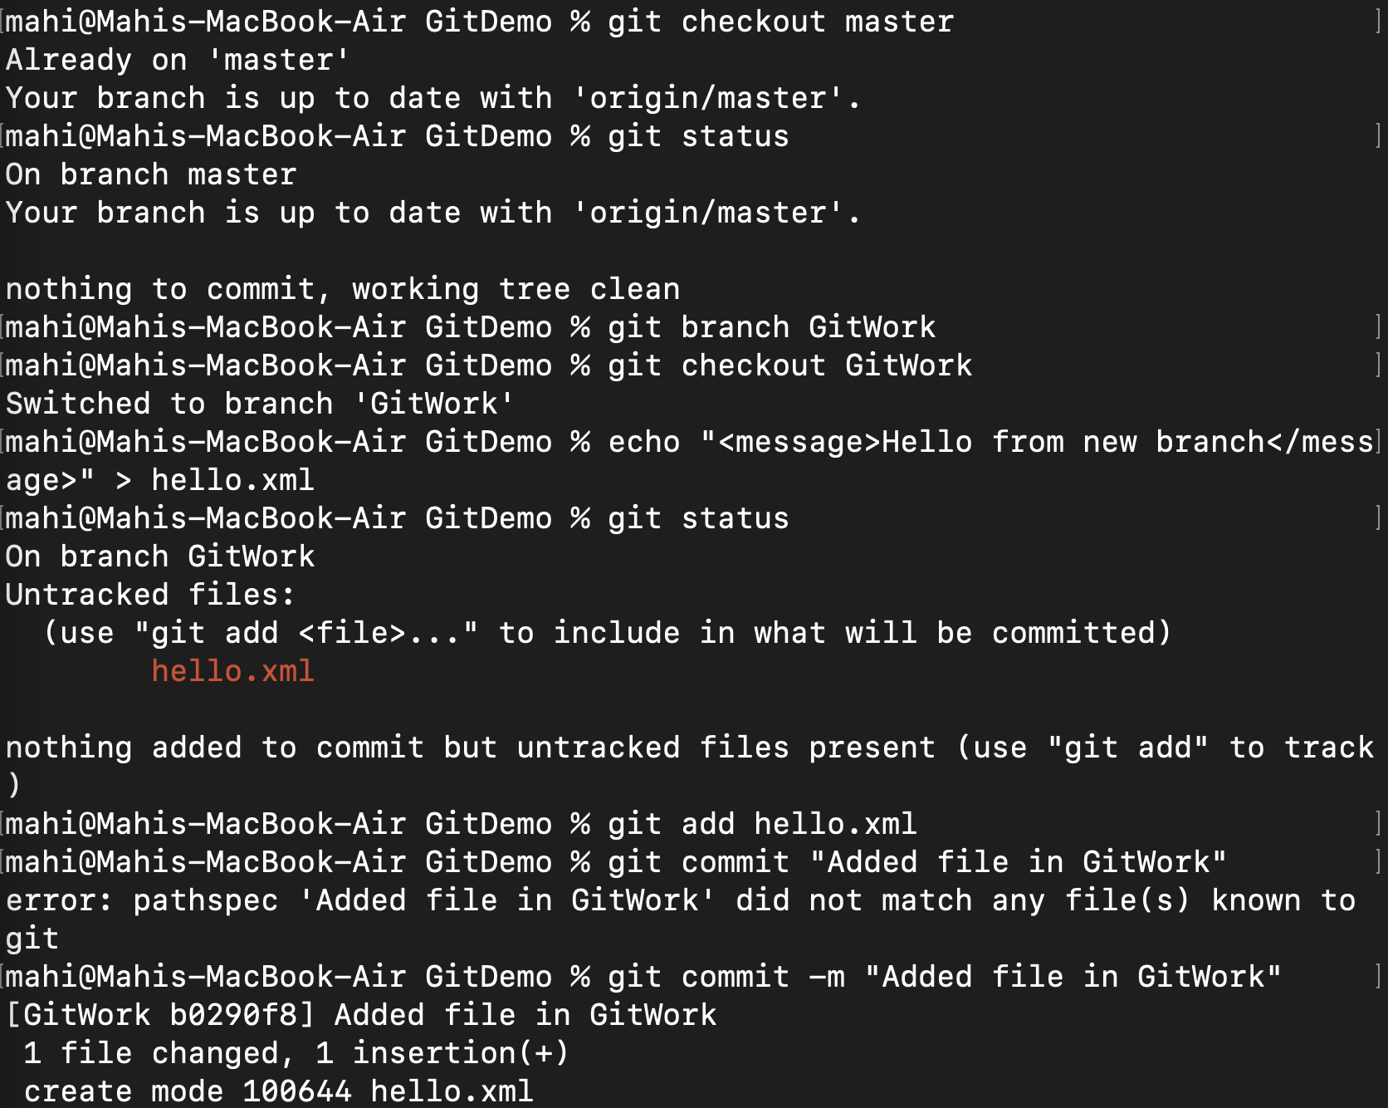**
2. **Added new “hello.xml” file onto master branch after switching to it :   
     
   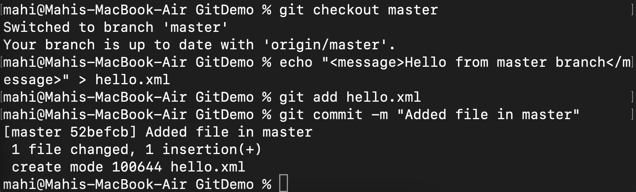**
3. **Visualised and noted the differences between the two branches :   
     
   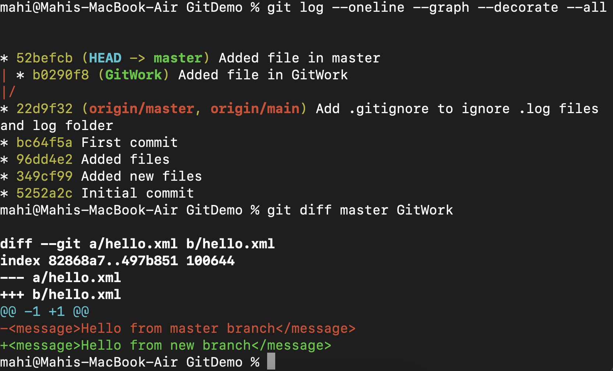**

****

1. **Merged both branches and resolved the conflict using git mergetool :   
     
     
     
     
     
     
   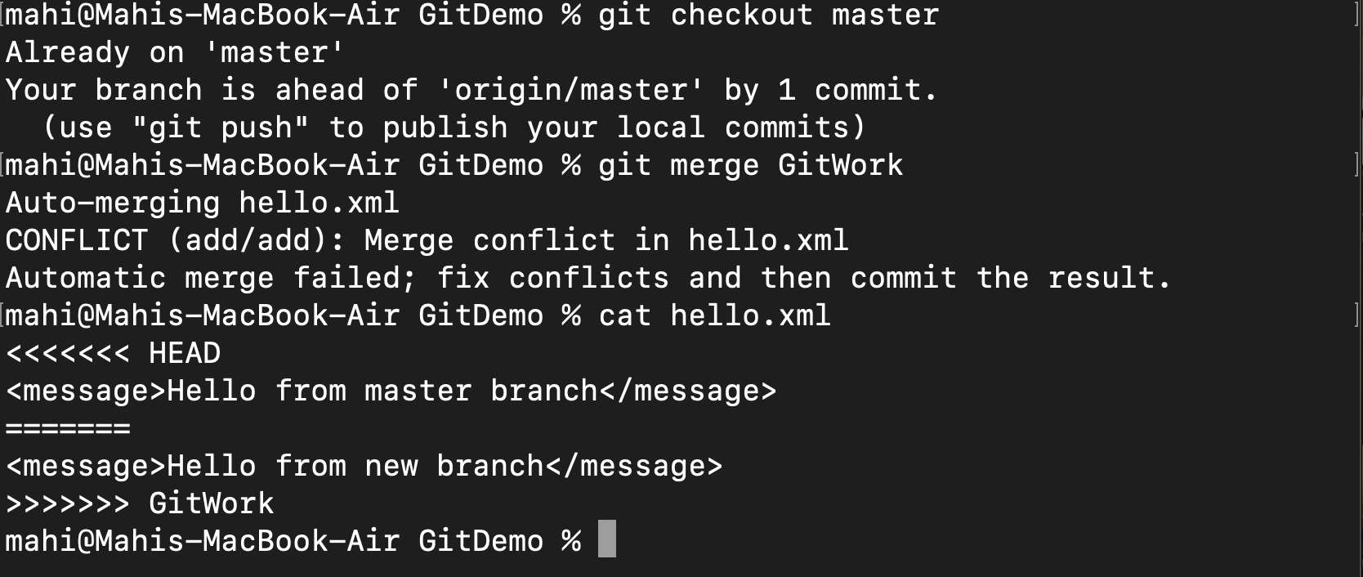  
   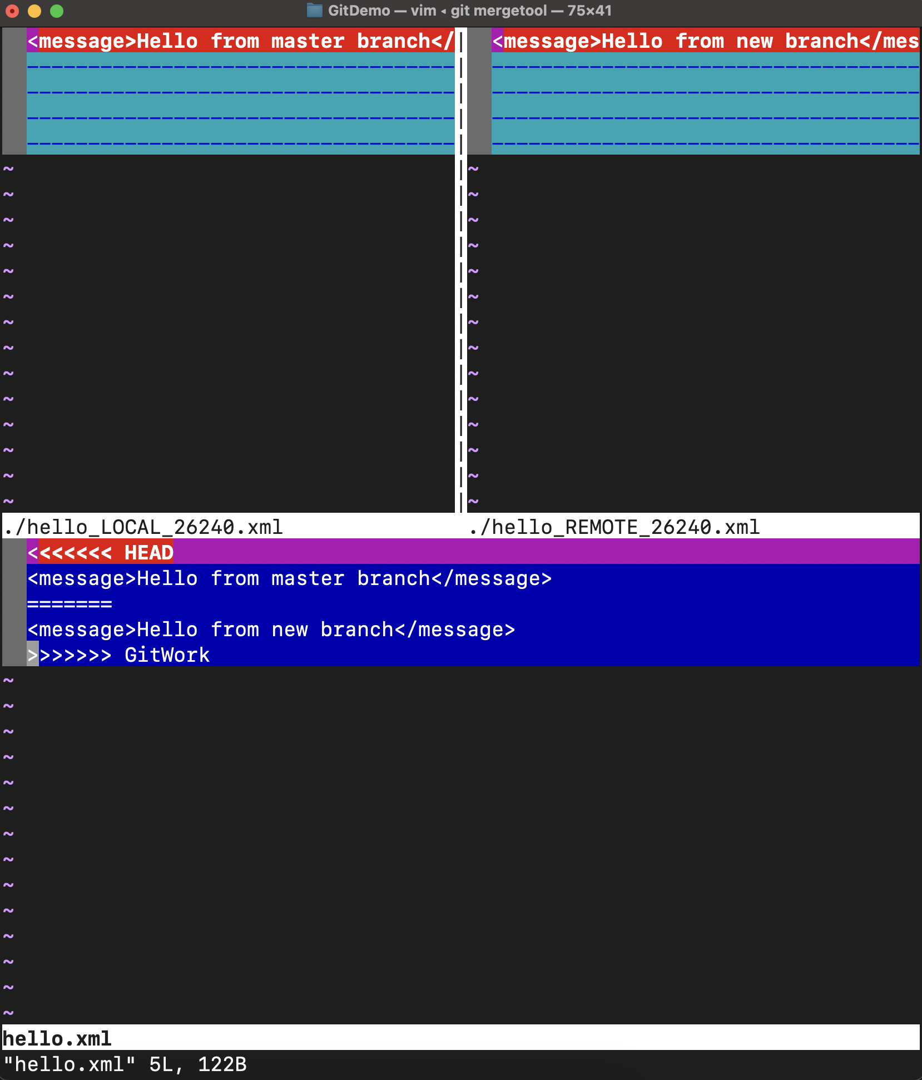**
2. **Added backup files to gitignore, checked the logs and deleted the GitWork branch after the merge :   
     
     
     
     
     
     
     
     
   