1. **Checkout if main branch was clean and displayed all branches :   
     
   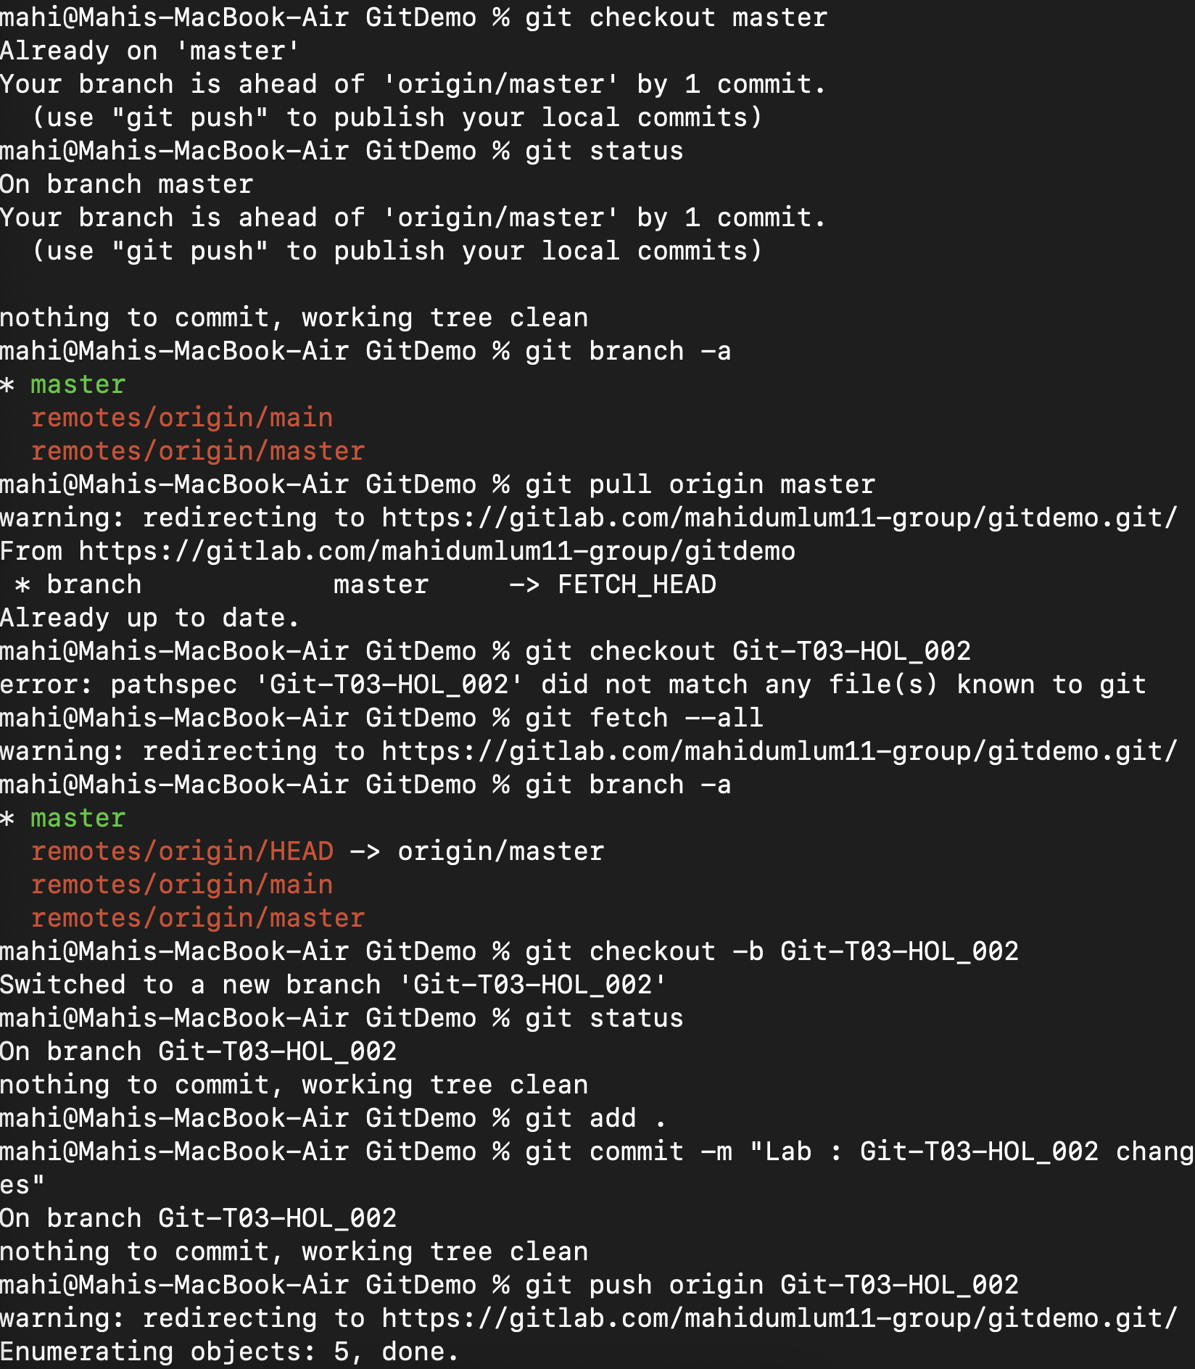**
2. **Pulled to origin master and created and switched to a new branch verified it was present in the repo :   
     
     
   