REPUBLIC OF RWANDA



MINISTRY OF INFRASTRUCTURE

ENERGY SECTOR STRATEGIC PLAN

2018/19 - 2023/24

**September 2018**

TABLE OF CONTENTS

LIST OF FIGURES

LIST OF TABLES

Chapter 1: Introduction

1.1 Purpose of the ESSP

Energy is central to Rwanda’s economy and development plans. It supports all other sectors, including housing and urbanization, manufacturing, agro-processing, mining, tourism and IT services. As such, a well-functioning, efficient energy sector is a prerequisite of achieving the country’s national goals. The Energy Sector Strategic Plan (ESSP) is vital in delivering this.

This ESSP follows on from the earlier 2013/14 – 2017/18 ESSP. This new ESSP reviews the current status of the sector and outlines high-level target objectives (HLTOs). These have been determined on the basis of political ambitions and rigorous technical analysis. The HLTOs apply to all subsectors and serve to translate the policy goals laid out in the REP and NST-1 into tangible outcome indicators achievable by the end of the NST-1 period (2018/19 to 2023/24).

1.2 Methodology

A detailed process has been undertaken to finalize the ESSP. This process has been led by MININFRA, with support and inputs from all sector stakeholders.

The ESSP reflects the current status of the sector and outlines plans for future development. As such, a number of important supporting activities have been undertaken, the results of which have been reflected in the ESSP:

Analysis of medium-term supply and demand balance

Assessment of policy gaps in the sector

Development of a Least Cost Development Plan

Development of Electrification Plan

Development of Biomass Energy Strategy

Development of Energy Efficiency Strategy

The results of the above activities have been incorporated into the ESSP, which has been developed through:

CHAPTER 2: OVERVIEW OF THE ENERGY SECTOR

2.1 Policy Context

The ESSP exists in a policy context which includes international, national and sectoral strategies, policies and goals. It is these policy documents which provide the main orientations for the sector. The ESSP collates these documents, prioritises key targets and presents plans to ensure their delivery.

2.1.1 International

The Sustainable Development Goals (SDGs), otherwise known as the Global Goals, are a universal call to action to end poverty, protect the planet and ensure that all people enjoy peace and prosperity. The 17 Goals build on the Millennium Development Goals, while including new areas such as climate change, economic inequality, innovation, sustainable consumption, peace and justice, among other priorities.

This ESSP supports achievement of the above goals: universal energy access will be achieved by 2024; the Energy Efficiency Strategy will be implemented and supply-side solutions to delivering reliable, affordable electricity will be prioritised; and the generation mix is projected to be made up of around 52% renewable sources by 2024 – above the SE4ALL minimum and far above the international average.

2.1.2 National

Energy policies and strategies interact closely with wider, national policies. High-level national objectives are set by Vision 2050 and NST-1 (both 2018).

NST-1 replaces EDPRS II. It sets sectoral targets to be achieved by 2024. These link sectoral achievements and progress to national development. As a result, progress towards targets that appear in both the ESSP and NST-1 will be monitored by both MININFRA and MINECOFIN. Table 4 outlines how NST-1 pillars and priority areas link to the HLTOs set out in the ESSP.

2.1.3 Sector specific

2.1.4 The National Energy Policy (REP) (2015) is the high-level policy document which guides and influences decisions on the extraction, development and use of Rwanda’s energy resources in a transparent and sustainable manner. It sets out governing laws and regulations and strategic Sector specific priorities.

Below these sector-wide documents, a number of policies and strategies cover specific subsectors and topics. The previous ESSP set as an objective the development, adoption and implementation of relevant strategies and policies. Prior to 2015, some papers were either not progressed from draft form, adopted or implemented. A summary of all energy sector documents which have influenced this ESSP is presented in Table 5.

2.2 National Context

2.2.1 Socio-economic indicators

Rwanda has a total area of 26,338 km2 and a population of more 12 million people. Therefore, it is one of the most densely populated countries in Africa. The economy has seen significant, sustained growth, with an annual average growth rate of 8.3% since 2000. GDP in 2015 was RWF 4,864 billion, or $743 per capita. Agriculture contributes 33% of GDP. Great progress has been made in attracting investment and encouraging entrepreneurship. In 2017, the country ranked 42 amongst 190 world economies in the World Bank Doing Business indicators. Sustained economic growth is targeted in coming years. Overall national objectives are in place to achieve upper middle-income status by 2035 and highincome status by 2050.

2.2.2 Climatic conditions

Rwanda is situated between 1° and 3° latitude south of the equator and has a subequatorial climate. The average annual temperature is 18° for the whole country. Recorded annual average rainfall is 989 mm.

2.3 Energy Consumption

The energy sector is made up of three subsectors: electricity, biomass and petroleum. Each of these is then divided into focus areas. This structure is presented in Figure 1.

Electricity is increasingly used and will drive Rwanda’s growth, but currently it accounts for only 2% of all energy consumed, as shown in Figure 2. Electricity is generated from a range of technologies and resources and the grid is being developed to expand access. The rise of off-grid technologies in recent years has been a major innovation, and they are now a major contributor to expanding access. Efficiency across generation and transmission, as well as consumption, is increasingly important, with significant economic and environmental benefits possible.



**Biomass**

**85**

**%**

**Petroleum**

**13**

**%**

**Electricity**

**2**

**%**

**ENERGY CONSUMPTION BY SUBSECTOR**

**(2016)**

Households are the largest category of energy consumer, at 82%, with transport at 8%, industries at 6% and others at 4%. This is illustrated in Figure 3.

2.4 Achievements

The major achievements of the energy sector are now set out by subsector, starting with those of the electricity subsector. 2.4.1 Electricity achievements

2.4.1.1 Generation achievements

Generation capacity increased from 160 MW to 218 MW

Generation capacity has been increased by 43.5 MW since the previous ESSP was published (and has tripled since 2010). The EDPRS II target of 563 MW was based on an overoptimistic assessment of demand growth, and therefore has not been met, but capacity is sufficient to meet all household and industrial demand. No load shedding has occurred since January 2015. By investing in generation to meet increasing demand, the energy sector has supported Rwanda’s economic growth. Further, a pipeline of projects to be delivered in the medium term has been established. These projects can potentially increase capacity to around 446.8 MW.

2.4.2 Biomass achievements

MININFRA, MINIRENA and REMA, along with other Government institutions, worked with consultants through 2017 to develop a comprehensive Biomass Energy Strategy (BEST). This was a key requirement for the subsector, with the previous Strategy having been developed in 2009. BEST presents detailed analysis of the current status of the subsector. Detailed modelling was completed to assess supply and demand under different scenarios in the medium term. The identified biomass deficit (more wood being used than is grown), along with concerns for the health and economic well-being of citizens, makes clear the requirement for change.

2.4.3 Petroleum achievements

Petroleum reserves have been increased significantly since the last ESSP was published, from 30 million litres to 74 million litres. New storage facilities have been opened in Rusororo Sector, Gasabo District (22 million litres) and Jabana (21 million litres). A further 40 million litres of capacity is due online in 2018, part of a 60 million litre storage facility in Kigali. Further development of storage facilities remains a key objective for the petroleum subsector.

2.5 Challenges

The major challenges of the energy sector are now set out by subsector, starting with those of the electricity subsector.

2.5.1 Electricity challenges

2.5.1.1 Generation challenges

Rwanda’s economy has grown at an average rate of 7.2% over the past five years. As a result, demand for electricity is increasing at a rate of almost 8% per year. New generation capacity must be added to the system to meet this demand. However, the majority of the costs of new power stations are fixed, and payable whether or not the available electricity purchased is consumed. Therefore, a surplus of capacity will be a costly burden on the sector, but a lack of capacity may constrain economic growth. This balance is complicated by the long lead times of large-scale generation projects (5-10 years) and the uncertainty around future demand in a high-growth economy. As a result, investment decisions must be based on sound planning, projects must be delivered to agreed timelines and flexibility must be built into commercial arrangements.

2.5.2 Biomass challenges

Maintaining wood supplies in the medium term

Analysis prepared for the Biomass Energy Strategy shows that there is currently a deficit in the supply and demand of wood. Under current trends, wood stocks will be depleted in the medium term. Interventions will be needed to bridge this supply gap and this is a major driver of reducing the use of firewood for cooking. Further analysis is required to improve the accuracy of projections and model the impact of interventions.

2.5.3 Petroleum challenges

Rwanda has very low security over petroleum-based energy products and the global market for petroleum products can be volatile. Although international oil prices have been exceptionally low in in recent years compared to other periods of time, price volatility and shocks are a cause of concern due to Rwanda’s extremely high vulnerability.

2.6 Energy Sector Status

2.6.1 Electricity Subsector Status

Electricity is an essential driver of modern technology and socio-economic development. It powers small appliances, such as lights and mobile phones, which improve the lives of citizens, as well as industrial processing activities, which contribute to economic valueadded products and job creation.



86

96

101

112

131

164

164

192

218

0

50

100

150

200

250

2009

2010

2011

2012

2013

2014

2015

2016

2017

MW

Generation Installed Capacity History

Rwanda has a range of indigenous resources that complement each other in the energy mix. Table 6 summarises these resources.

|  |  |
| --- | --- |
| Resource Summary of current and potential contribution potential | |
| Hydropower  313-400 MW | Hydropower has generated the bulk of electricity in Rwanda since 1960s. Its overall potential is estimated at up to 400 M W, with the current installed hydro capacity is 98.5 MW. As a result of extremely low operational costs however, hydro is still one of the cheapest forms of generation in the long run. |
| Methane  140-180 MW | Kivuwatt, a 27 MW generation facility, has demonstrated the commercial and technical viability of extracting methane from Lake Kivu. Further utilisation of methane resources is planned, with significant investor interest. |
| Peat  121-161 MW | A Peat master plan was first developed in 1993. Estimates of potential capacity have since been revised downwards from the initial 700 MW to 121 MW-161 MW in 2016. About 77% of peat reserves are near Akanyaru and Nyabarongo rivers and the Rwabusoro Plains. |
| Geothermal  (TBD) | Rwanda’s geothermal resource is yet to be proven. However, studies have identified Karisimbi, Kinigi, Gisenyi and Bugarama as promising areas, with potentially 47.3 MW of generation available from five promising sites. Further studies, exploration and test sites are required to confirm this. |
| Solar Energy  (TBD) | Rwanda’s solar radiation varies between 4.3 and 5.2 kWh per m2 per day over all regions.. There is high interest from the private sector in on-grid solar power development. However, penetration is limited by the technical capacity of the grid. |
| Biomass  (TBD) | Small-scale power generation using agricultural residues (such as bagasse or rice husks) or biomass briquettes (from compacted waste residues or charcoal dust) is feasible at low levels of capacity.. |
| Wind Energy  (TBD) | Commercialy wind power resources are not expected to be significant based on past resource assessments and modeling work. However, MININFRA will continue to assess the potential for wind to contribute to the generation mix. |

2.6.1.1.1 Hydro Power

Studies suggest that Rwanda’s topography is most suitable for medium- to high-head pico- and micro-hydro run-of-river schemes. Rwanda’s overall technical hydropower potential has been estimated at up to 400 MW, although this varies by study. An assessment of the energy sector undertaken by the African Development Bank in 2013 estimated Rwanda’s domestic hydropower potential at 313 MW, broken down into 130 MW of domestic and 183 MW of regional hydro resources.

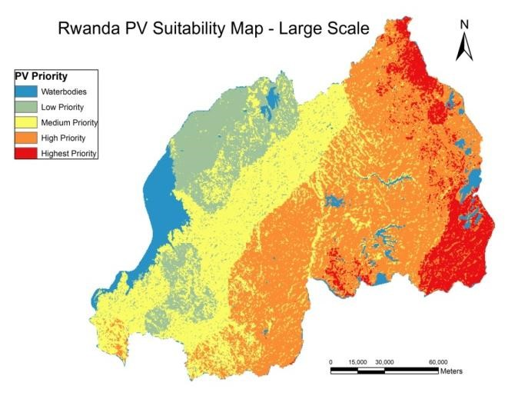

Significant investment has been made in expanding and strengthening the transmission network. By the end of June 2017, 744 km of high voltage (HV) transmission lines had been laid, up from 462 km in 2014. These lines evacuate power from various points of generation across the country, as well as facilitating regional interconnectivity. These are mainly 110 kV (470.5) and 220 kV transmission lines (273.5 km).

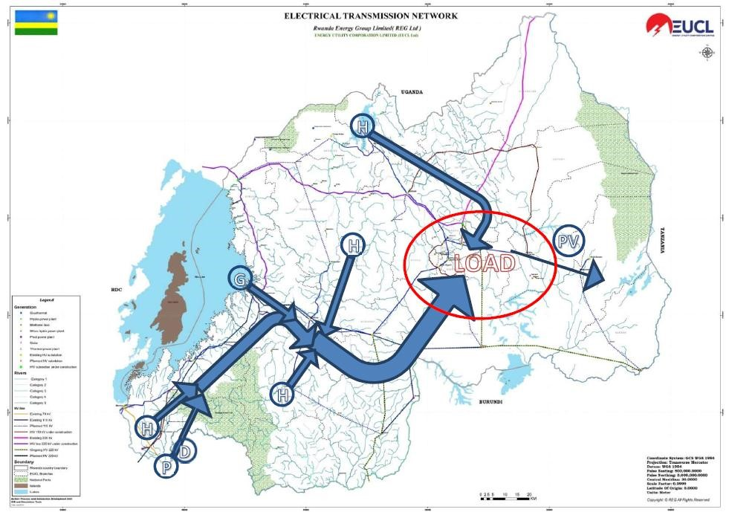

The current performance of the distribution network (medium voltage (MV) and low voltage (LV)) across the country and within Kigali is below the standards required. This will be strengthened to ensure a reliable electricity supply, as set in RURA regulations and ESSP and NST-1 targets.

2.6.1.2.1 Regional integration

Currently, the only major inter-country power flow in the region is the export from Ethiopia to Sudan. However, a number of transmission lines are under construction between countries in the region and it is expected that by 2022 East Africa should be almost fully integrated. Further, the region will be connected to the South Africa Power Pool (SAPP) via the Tanzania-Zambia line. Figure 7 shows planned HV lines expected to be built by 2022.

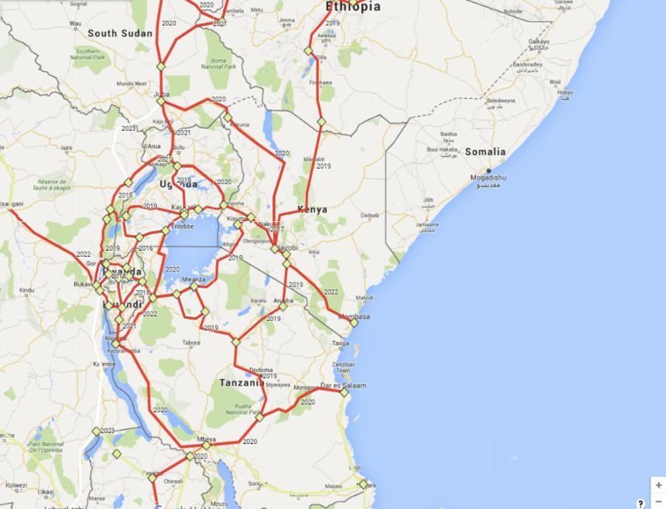

Rwanda is developing connections with the DRC, Burundi, Uganda and Tanzania. These connections will support network stability and enable regional trading of power.

2.6.1.2.2 Losses

All electricity systems incur losses. Losses refers to electricity injected into the transmission and distribution grids that is not paid for by users. Total losses consist of two components:

Even if losses are held at current levels, the financial cost to REG will increase significantly as demand grows. Figure 8 shows that if losses remain at 22%, the annual cost will increase to $102 million by 2030. The cumulative cost from 2016-2030 will be $826 million. By reducing losses by 1% each year (to 9% in 2030) the annual cost will reach $36 million in 2027 and then decline. Cumulative losses over the period will be $470 million. This is a saving of $356 million.

Annual cost of losses under improving and steady scenarios

Consumption of electricity in Rwanda is low, at 10 kWH for rural grid-connected households and 29 kWh for urban grid-connected households. On-grid electricity access to households has increased significantly in recent years, from 364,000 in June 2012 to 696,952 in June 2017. This is 27.8% of all households. The low level of electricity access reflects both the previous unaffordability of electricity for many Rwandans, which has been addressed to some extent through the introduction of the life-line tariff, and the geo-spatial realities of the country. Settlements are dispersed and the mountainous geography render the infrastructure costs of grid extension projects expensive.

2.6.1.3.2 Off-grid access

The challenges associated with expanding on-grid access outlined above mean that off-grid electricity access is now recognised as the primary means by which access will be expanded across Africa in the short-to-medium term. In Rwanda, the development of off-grid electricity has been one of the key achievements for the electricity subsector in recent years. Off-grid access for households has grown from around 0% to 11%, with appropriately 300,000 households connected as of end June 2018.

Under Programme 4, the EARP continues to be rolled out. Coordinating the expansion of on- and off-grid connections is a key challenge.

2.6.1.4 Productive user access

Productive use of electricity involves the utilisation of electricity for activities that enhance economic and social welfare. These activities cover a range of sectors, as summarised in Table 7. Beyond supporting economic and social development, connecting productive users increases the financial sustainability of the sector, as they use electricity away from the evening peak (when it is cheaper to supply) and use sufficient electricity to more than cover the cost of their connection (unlike households which may use little electricity). infrastructure

Out of 8,855 productive users identified, 2,733 (31%) do not have an electricity connection. Of the 69% that are connected, 6,100 have on-grid connections and only 22 off-grid. A summary of these results is presented in Table 8.

|  |  |  |
| --- | --- | --- |
|  | Total | Proportion of total |
| Productive users | 8,855 |  |
| Non-electrified productive users | 2,421 | 27.4% |
| Grid-connected | 6,412 | 72.6% |
| Off-grid (solar) connected | 22 | 0% |
| Total connected | 6,434 | 72.6% |

2.6.1.5 Energy Efficiency

2.6.1.5.1 Programmes undertaken

A small number of energy efficiency programs have been continued or undertaken since 2014. These include:

Compact Fluorescent Lights (CFL): Supported by Government subsidy, REG distributed 800,000 CFLs in place of incandescent light bulbs between 2007 and 2014. To further support this initiative, an exemption of VAT on energy saving lamps was introduced in 2013. Benefits of this included a reduction in annual energy demand of 54 GWh and $11 million in savings for consumers.

The network is being expanded and strengthened. Significant investment is being made to upgrade the network around Kigali, which serves over half of Rwanda’s demand. Improving the reliability and performance of the network will reduce the use of expensive, polluting diesel generators.

2.6.1.5.2 Energy Efficiency Strategy

An Energy Efficiency Strategy was developed and approved. This assesses the potential for energy efficiency in Rwanda across the electricity value chain, from generation, through transmission and distribution to end-user demand. The Strategy proposes a number of initiatives to be implemented, and these will be taken forward over the coming years.

2.7 Biomass energy subsector

2.7.1 Land use

Rwanda has a forested area of approximately 600,000 hectares which is about 22% of the country’s land area, as shown in Error! Reference source not found.. These forest resources omprise of 260,000 ha of natural forests and 340,000 ha public and private plantations (productive forests). Natural forests are mainly composed of protected forest areas consisting of Nyungwe National Park in the southwest and Volcano National Park in the northwest. Other national reserves include the forests of Gishwati and Mukura, the savannah and gallery forest of the Akagera National Park and remnants of gallery forests and savannas of Bugesera, Gisaka and Umutara.

|  |  |  |
| --- | --- | --- |
| Land use | Area (ha) | % |
| Forest | 600,000 | 22 |
| Agriculture | 1,612,068 | 58 |
| Built up areas | 100,000 | 4 |
| Water bodies | 176,050 | 6 |
| Wetlands | 278,536 | 10 |
| Total | 2,766,000 | 100 |

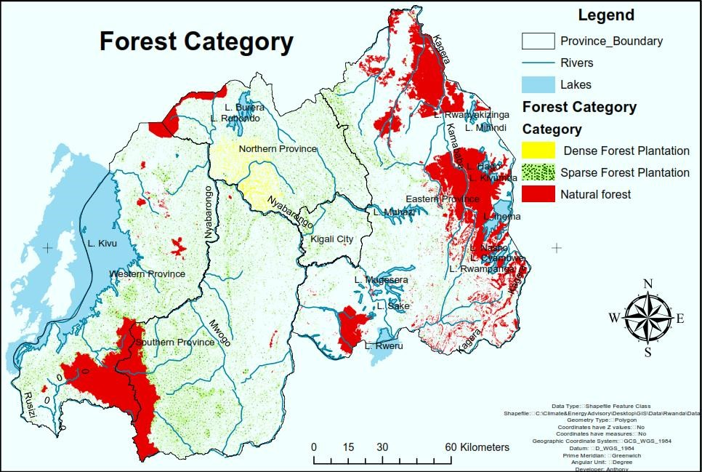

In 2015, the Rwanda Natural Resources Authority (RNRA) commissioned a National Forest Inventory (NFI) to provide quantitative and qualitative information on the wood resources of Rwanda. According to the NFI data, the country has 2,102,508 hectares of forest resources. Most of the forest resources are located in the Eastern, South and Western provinces. At a national level, the following the total amount of forest resources available for energy wood use according to the NFI (2015) is 8.9 million m3 as shown in the table below.

|  |  |  |  |
| --- | --- | --- | --- |
| Category | Area | Volume of energy wood per hectare (cc/ha) | Total volume available for energy wood  (m3) |
| Trees Inside Forest (TIF) in Productive Forests | 257,624 | 11.57 | 2,980,710 |
| Trees Outside Forest (TOFs) in Shrubland (incl. Wooded Savannah) | 142,730 | 4.99 | 712,224 |
| Trees Outside Forest (TOFo) on Agroforestry (incl. Agriculture) | 1,503,377 | 3.52 | 5,291,887 |
| Total |  |  | 8,984,822 |

There is additional biomass resources available in form of total harvestable residue amounting to about 1,375,000 m³ and 1,117,000 MT from agricultural residues.

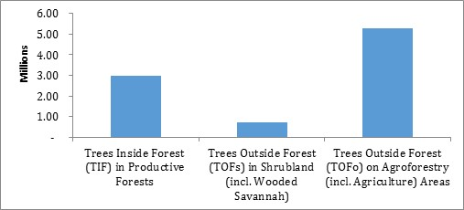

2.7.2 Consumption of biomass

At 85%, biomass energy is the most important source of energy in Rwanda. Households use 91% of biomass, with the remaining consumption shared between industry (4%), nonenergy usage (2%) and commercial and the public sector (both 1%). Industrial use is largely in tea industries and small-scale brick making, with biomass used for drying.

Based on a review of recent data, five key market segments have been defined for biomass energy usage for cooking, heating and drying processes in Rwanda: Household sector (Rural and Urban), Commercial food industry, Public institutions and Processing and Production sectors.

Reducing reliance on firewood, and in doing so improving health, developing economic opportunities by reducing the time spent collecting wood, and preserving the country’s forests is a priority for Government.

2.7.3 Improved cooking technologies

As well as the fuel used, the type of stove has a significant impact on the amount of fuel required and health of households. Most households (66%) use three-stone cookstoves (the most simple cookstove, made by placing a pot on three stones, which are positioned around a fire) or traditional cooking stoves. These are normally used with firewood. The average household uses around 1.8 tonnes of firewood each year to satisfy its cooking needs with this type of cookstove. The average monthly consumption per household on firewood is RWF 1,930 ($2.27).

A simple comparison of cookstove types is presented in Figure 14.

Chapter 3: The Strategic Framework

3.1 Vision, Mission and Objectives

3.1.1 Vision of the sector

The vision of the energy sector is to contribute effectively to the growth of the national economy and thereby improve the standard of living for the entire nation in a sustainable and environmentally sound manner.

3.1.2 Mission of the sector

The mission of the Rwanda energy sector is to create conditions for the provision of sufficient, safe, reliable, efficient, cost-effective and environmentally appropriate energy services to households and to all economic sectors on a sustainable basis.

3.1.3 Overall objectives of the sector

|  |  |  |
| --- | --- | --- |
|  | Priority | HLTOs |
| 1 | Support continued economic development and growth in household electricity access through least-cost expansion of electricity generation capacity. | Generation capacity increased to ensure that all demand is met and a 15% reserve margin is maintained. |
| 2 | Improve industrial competitiveness through increased reliability of electricity supply. | Reliability of electricity supply improved: average number of power interruptions per year reduced to 91.7 and average number of hours without power to 14.2. |
| 3 | Improve the health, well-being and economic opportunities available to Rwandans through increased household access to electricity. | Household access to electricity increased to 100%. |
| 4 | Improve public service provision and support economic development through increased productive user access to electricity. | Productive user access to electricity increased to 100%. |
| 5 | Increase safety of communities and support 24hour service delivery through expansion of street lighting. | Street lighting expanded to all populated areas and main roads. |
| 6 | Reduce sector costs and environmental impacts through improved efficiency in the use of resources. | Losses in the transmission and distribution networks reduced to 15%. |
| 7 | Improve the health of Rwandans and promote the efficient use of forests through reduced reliance on inefficient cooking fuels and technologies. | Halve the number of HH using traditional cooking technologies to achieve a sustainable balance between supply and demand of biomass through promotion of most energy efficient technologies |
| 8 | Safeguard continued economic development through the security of supply of petroleum. | Petroleum strategic reserves increased to cover three months’ supply. |

The overall goal of the sector, as set out in the REP, is to ensure that all residents and industries can access energy products and services that are sufficient, reliable, affordable, and sustainable. Specific core global objectives of the REP include:

ensuring the availability of sufficient, reliable and affordable energy supplies for all Rwandans;

creating an enabling environment for increased private sector participation in energy supply and service provision;

encouraging and incentivizing more rational, efficient use of energy in public institutions, and amongst industrial and household end-users;

ensuring the sustainability of energy exploration, extraction, supply, and consumption so as to prevent damage to the environment and habitats;

promoting safe, efficient, and competitive production, procurement, transportation, and distribution of energy; and

3.2 Energy Sector Priorities and Targets for National Strategy

The starting point for deciding the HLTOs included in this ESSP were the sector priorities. Table 13 maps the HLTOs presented in this ESSP against the sector priorities.

Independent Power Producers (IPPs) will continue to be encouraged to finance and deliver generation projects through Power Purchase Agreements (PPAs). This will reduce the pressure on Government resources, attract internationally state-of-the-art technologies and reduce costs through competition. However, the inclusion of capacity payments (fixed costs) in PPAs necessitates that underutilisation is minimised, with tight alignment between supply and demand.

Maximise exploitation of indigenous resources: Rwanda has limited resources and so these will be used efficiently to meet demand in the medium term.

|  |  |  |  |  |  |  |
| --- | --- | --- | --- | --- | --- | --- |
| Connections | 2018/19 | 2019/20 | 2020/21 | 2021/22 | 2022/23 | 2023/24 |
| New on-grid connections | 163,914 | 148,201 | 160,466 | 173,624 | 187,472 | 202,734 |
| On-grid access | 34.5% | 38% | 41.5% | 45% | 48.5% | 52% |
| New off-grid connections | 283,507 | 220,262 | 271,266 | 255,706 | 274,286 | 293,938 |
| Off-grid access | 17% | 23% | 30% | 36% | 42% | 48% |
| Households connected (m) | 1.5 | 1.8 | 2.3 | 2.7 | 3.2 | 3.7 |
| Households connected (%) | 51.5% | 61% | 71.5% | 81% | 90.5% | 100% |

REG is finalising a National Electrification Plan which will set out exactly how the access targets will be achieved. The EARP will continue to drive grid connections. Given the high cost per on-grid new connection, at roughly $700, development partners’ support will be leveraged. Further, gird connections give social benefits not captured in a cost/benefit analysis. However, this presents a considerable technical and financial challenge.

Delivering access to 100% of the population will require significant investment, with costs estimated at $510 million for on-grid and $78 million for off-grid.

|  |  |  |  |
| --- | --- | --- | --- |
| User category | Number | User category | Number |
| Beverages and Tobacco | 14  843  109  41  104  35  1  13  111  15 | Mining facility | 80  214  700  281  25  2  14  97  1  33 |
| Cell Office | Pre-primary school |
| Coffee Washing Station | Primary school |
| Food Processing | Secondary school |
| Health Facility | Sector office |
| IDP Model Villages | Tea factory |
| Industry park | Technical school |
| Irrigation pumping facility | Telecom tower |
| Market | University and Institutes |
| Milk Collection centre | Water pumping facility |
| Total |  |  | 2,733 |

REG has designed and will implement a plan to connect all of these users by 2021. Productive users within 800 metres of a distribution transformer will be directly connected to the grid as the connection cost is relatively low. Those further away from the grid will be connected via either on- or off-grid solutions based on analysis of their consumption patterns and exact location.

3.2.1 Economic Transformation Pillar

This ESSP strongly supports the Economic Transformation Pillar of NST-1. Energy underpins the continued economic growth of Rwanda. Ensuring all households and productive users have access to electricity will boost economic activity across all sectors and all provinces. Further, the electricity supply will be of high quality, something especially important to commercial and industrial consumers. Therefore, combined with the January 2017 tariff review, which lowered the price of electricity for industrial users, this ESSP will ensure the availability of reliable, competitively priced electricity. This will help attract investment into

3.2.2 Social Transformation Pillar

Energy’s central contribution to this pillar will be the delivery of 100% energy access for households and productive users. On and off-grid access will be delivered across the country. Low-income, rural households will be supported in accessing off-grid solutions such as solar home systems. Productive users include health centres and education facilities. Connecting these to electricity will ensure that modern, high quality services can be offered. In the case of education, electricity access will allow the uptake of ICT use, a pre-requisite to Rwanda becoming a knowledge-based economy.

3.2.3 Transformation Governance Pillar

Achieving 100% electricity access for social infrastructures such as health centres, schools, sectors offices and street lights will ease service delivery and enable the use of ICT. This will improve service delivery in, and the efficiency of, Government institutions. Delivering electricity access to all Rwandans will support peace, unity and the engagement of all citizens in society.

3.3 Mainstreaming of Cross-cutting Areas

3.3.1 Capacity building

A range of traditional and new skills are required if the sector’s objectives are to be met. Traditional skills such as planning, project management and commercial, as well as specific mechanical and electrical engineering knowledge, are required at operational and management levels. Further, there is a requirement to build up capacity in newer areas, such as off-grid electrification and energy efficiency. Qualified staff must be put in place through hiring and training at MININFRA, REG and related institutions. Further, capacity building must equip the private sector with skilled employees. For example, a recent study found that 53% of private sector off-grid organisations do not have critical skills for off-grid energy.

3.3.2 Regional integration

The energy sector will play a key role in developing regional integration. This ESSP fully supports the deepening of regional cooperation and integration in the energy sector and the sector vision foresees a fully integrated regional exchange of power resources in the longterm. In particular, Rwanda is committed to participating actively in regional initiatives.

3.3.3 Gender and Family

Gender equality promotion is a key aim of Government. It has been prioritised in national documents, such as Vision 2020 and EDPRS 2, and the National Gender Policy was published in 2010. MININFRA developed the Infrastructure Gender Mainstreaming Strategy in 2017. This recognises gender mainstreaming as a pathway to poverty reduction and sets out five strategic objectives:

Enhance institutional and human resource capacity for gender equality promotion in the infrastructure sector.

Reducing the use of firewood, as set out in the HLTOs, will have a significant positive impact on the lives of women and girls across Rwanda.

3.3.4 Environment and climate change

Rwanda is embarking on a low-carbon development pathway as reflected in its National Strategy on Green Growth and Climate Resilience. Further, Rwanda hosted the update to the Montreal Protocol in 2016. Globally, energy is one of the most environmentally impactful sectors. The ESSP prioritises improved efficiency through the reduction of losses and the Energy Efficiency Strategy will deliver significant improvements to generation and end-user efficiency. This will be increasingly important as Rwanda’s economy grows and consumption increases.

3.3.5 Disaster management

MININFRA is responsible for mainstreaming disaster prevention guidelines into its operational policies as well as environment, health, and safety (EHS) guidelines to be followed by its implementation agents. International EHS standards shall be applied in all energy infrastructures both public and private owned so as to ensure the safety of both personnel and equipment as well as the conservation of the environment. This shall be especially applicable in tendering of PPPs and IPPs and in the activities of REG.

3.3.6 Disability and social inclusion

Achieving 100% access to electricity will improve the lives of all citizens, including those with disabilities. This will apply to the provision of clean cooking technologies. Connecting all productive users to electricity will ensure that health centres and other social buildings can operate outside of daylight hours and provide modern services.

3.3.7 HIV/AIDS and non-communicable diseases

Achieving 100% access to electricity will improve the lives of all citizens, including those with

HIV/AIDS and non-communicable

Chapter 4: Implementation of the ESSP

4.1 Background and implementation plan

Past experience has shown that policies and strategies must be followed by timely, effective implementation. A high-level plan is in place to ensure the targets of the ESSP are met and the key initiatives delivered. More detailed plans will be drawn up by the implementing agencies for specific initiatives as required. Further, the implementation of the ESSP will retain some flexibility. The energy sector is complex and it interacts with a range of other sectors and the economic growth of Rwanda more generally. In particular, growth in demand for electricity is directly linked to growth in GDP and access rates are influenced by wider urbanisation and resettlement policies. The successful implementation of the ESSP will require cooperation with a number of Government ministries and institutions, development partners and the private sector.

4.2 Communication plan

Clear communication between lead and supporting stakeholders will be important in ensuring effective implementation. Issues and challenges will be dealt with as they arise and new opportunities will be identified and, where appropriate, adopted. MININFRA will lead communication. Regular progress reports will be provided on specific projects and the sector more generally. The SWG will provide a forum to discuss progress and raise concerns. REG will provide updates on all areas of its work, including electrification, capacity installed and demand projections. RURA will monitor and report on the performance of implementing agencies and ensure that tariffs are clear, including the methodology and assumptions behind them. Specifically, communication will be maintained through:

4.3 Data Sharing

An energy sector database will be developed and implemented. This will be scaled up over time, eventually connecting all sector stakeholders and acting as a repository for data and documents. Data will be required across all subsectors and areas. This data will be shared effectively between MININFRA and REG and across Government and the NIS, in particular. The SWG, TWGs and Energy Steering Committee will facilitate data sharing. Appropriate investment will be made in IT hardware and software, and training, to ensure that data is stored and made available. Transparency will become central to the energy sector, with all stakeholders able to access accurate, up-to-date information. MININFRA will also develop the capacity to carry out regular reporting, bulletins and policy briefs.

4.4 Risk Analysis

The Rwanda energy sector is exposed to significant risks. There is therefore a need to integrate risk screening into planning, particularly at the sectorial level. Some especially critical risks worth highlighting include:

Environmental and climatic shocks: These pose a significant challenge. Extraordinary events such as volcanic eruptions could destroy energy investments and disrupt service provision. Oils spills or methane gas explosions can be catastrophic to humanity and the surroundings. The long-term impact of climate change on rainfall and available hydropower generation capacity could also be detrimental to meeting the country’s long-term energy plans. A Disaster Recovery Plan therefore needs to be integrated into energy sector planning.

Chapter 5: Monitoring and Evaluation

5.1 M&E Approach

Monitoring and evaluation will be vital in supporting the effective implementation of the ESSP. Further, effective M&E contributes to a variety of core principles outlined in the REP, including: increased accountability and transparency to the Treasury and DPs on the use of public funds; enabling a timely resolution of implementation issues that can build investor confidence, and uncovering lessons on the effectiveness of activities so as to justify scalingup and alternative procurement mechanisms or market-based approaches.

5.2 Targeted Areas

The HLTOs presented in this ESSP represent the key indicators to be measured. These cover vital sector issues such as generation capacity, access, efficiency and security of supply. These are not new metrics. Many of these targets have been developed from the previous ESSP and other sector policies and strategies. However, monitoring and evaluation has not previously been sufficient and so improvement is required. This will involve the development of new systems and significant improvements to existing systems.

5.3 Monitoring and reporting systems

The Sector Working Group acts as the main coordination forum for the sector, providing information and evaluating progress against targets set during the bi-annual Joint Sector Reviews. Below this, Technical Working Groups exist to deal with specific sub-sectors/issues. Recently, TWGs have developed approaches to off-grid access implementation and energy efficiency. The Sector-Wide Approach (SWAP) team within MININFRA lead on disseminating information to stakeholders. REG and MININFRA are improving Management Information Systems to ensure that accurate data is collected, stored and accessed to support project management and planning.

5.4 Evaluation

Beyond project tracking, all activities will need to be evaluated. This will allow lessons to be learnt to improve strategy formation and project delivery, and also increase the accountability of MININFRA. Led by MININFRA, standard evaluation and reporting formats will be drawn up and agreed upon between Districts and central Government. Regular sector reviews will be organized internally and with other partners, particularly in the NST-1 Pillar working groups to evaluate sector performance in line with commitments reflected herein. The expansion of the M&E unit in the Ministry will receive the required external expertise and training in various evaluation methodologies to be able to carry out internal evaluation projects. Additionally, the ministry will explore how best to engage with external evaluators, when final evaluations are not part of project packages, and seek support to do so.

**References (put here automatic references in APA)**