**Develop an application and use Google Firebase service to store your data.**

**Theory:** (Ref. https://firebase.google.com/docs/firestore)

**What is Firebase?**

Cloud Firestore is a flexible, scalable database for mobile, web, and server development from Firebase and Google Cloud. Like Firebase Realtime Database, it keeps your data in sync across client apps through realtime listeners and offers offline support for mobile and web so you can build responsive apps that work regardless of network latency or Internet connectivity. Cloud Firestore also offers seamless integration with other Firebase and Google Cloud products, including Cloud Functions.

**How to use Firebase :**

1. Go to the firebase Console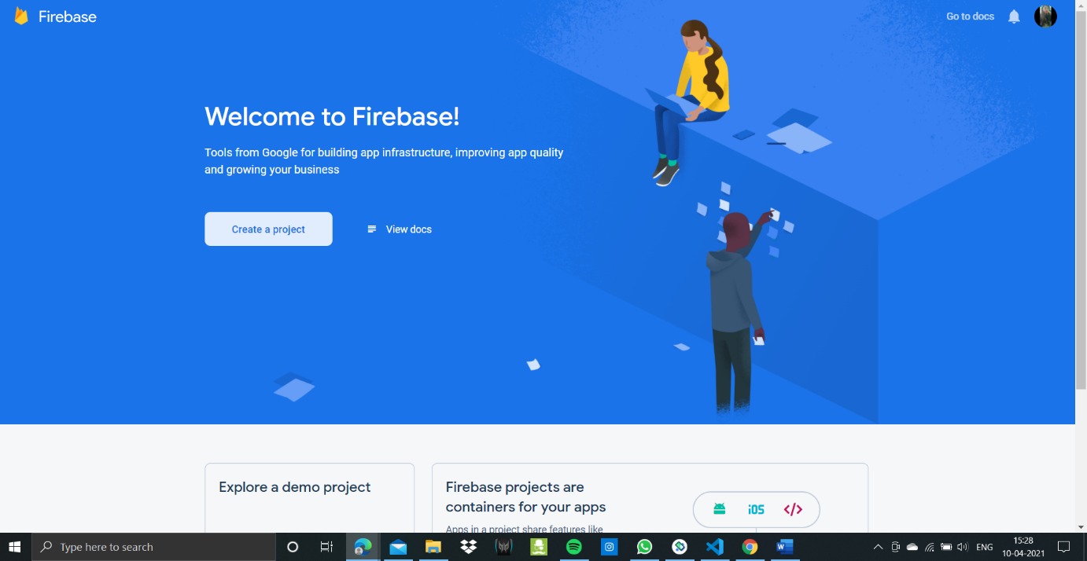
2. Start your new firebase project, give it a name. Click Continue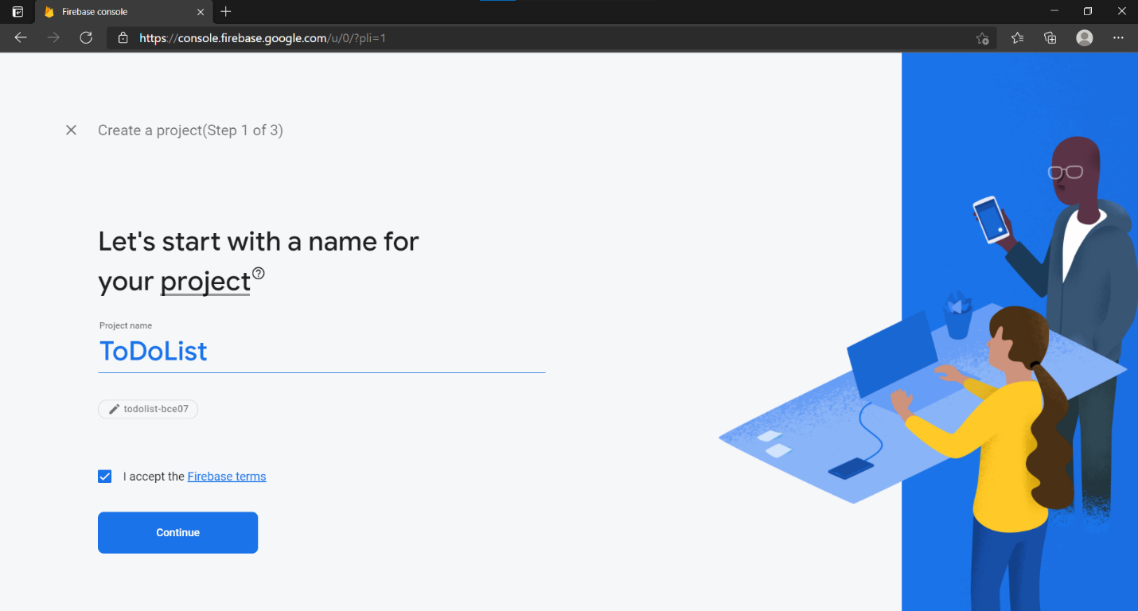
3. Enable google analytics for your project and Click continue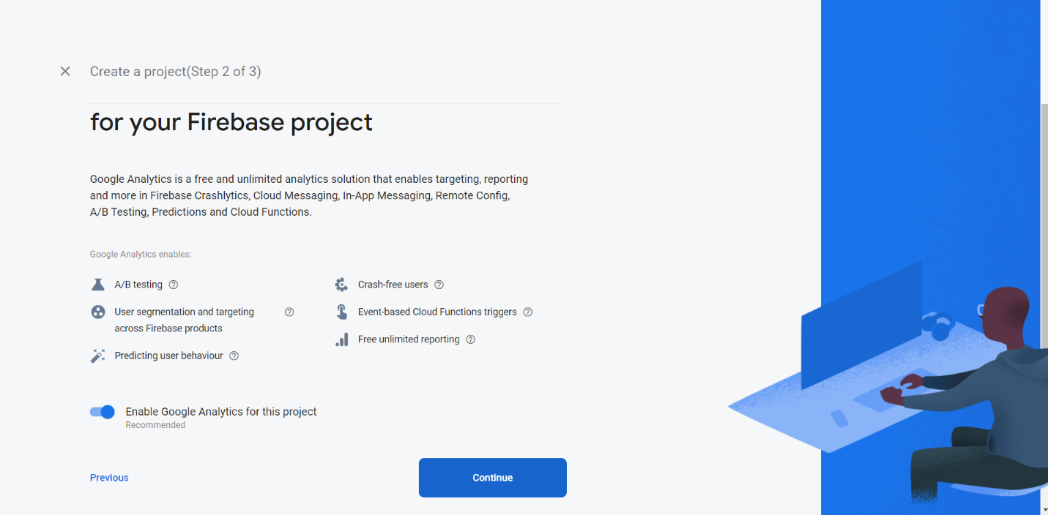
4. Accept the terms and conditions. Click Continue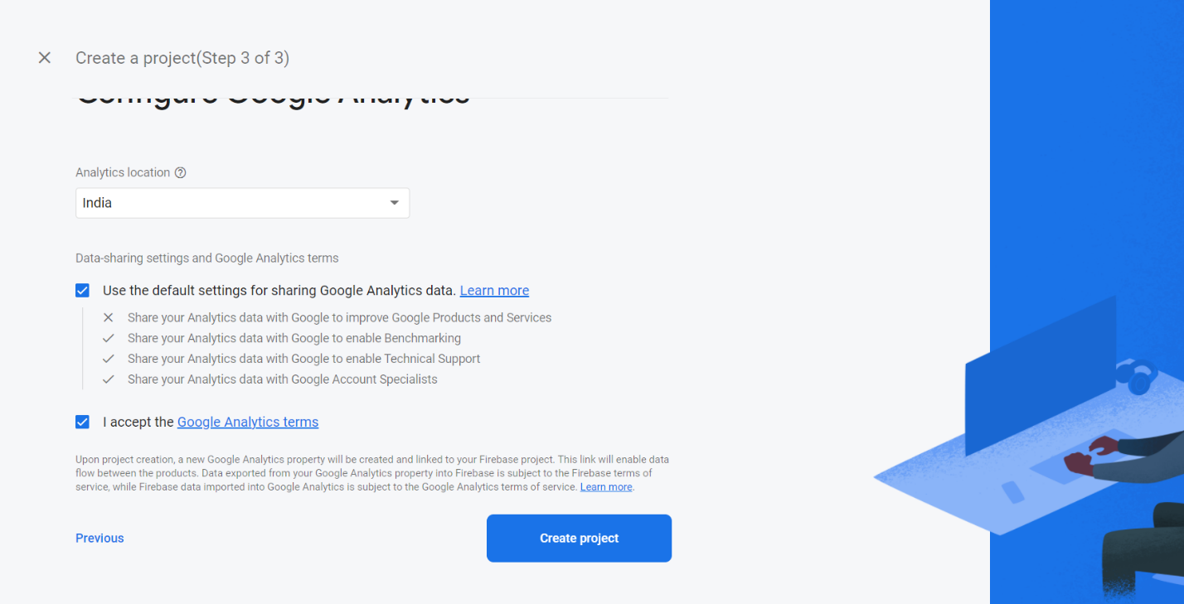
5. Next step is to add Firebase to your android / ios app. Copy the android package name from your flutter program and fill up the column in firebase. Click on Register App. 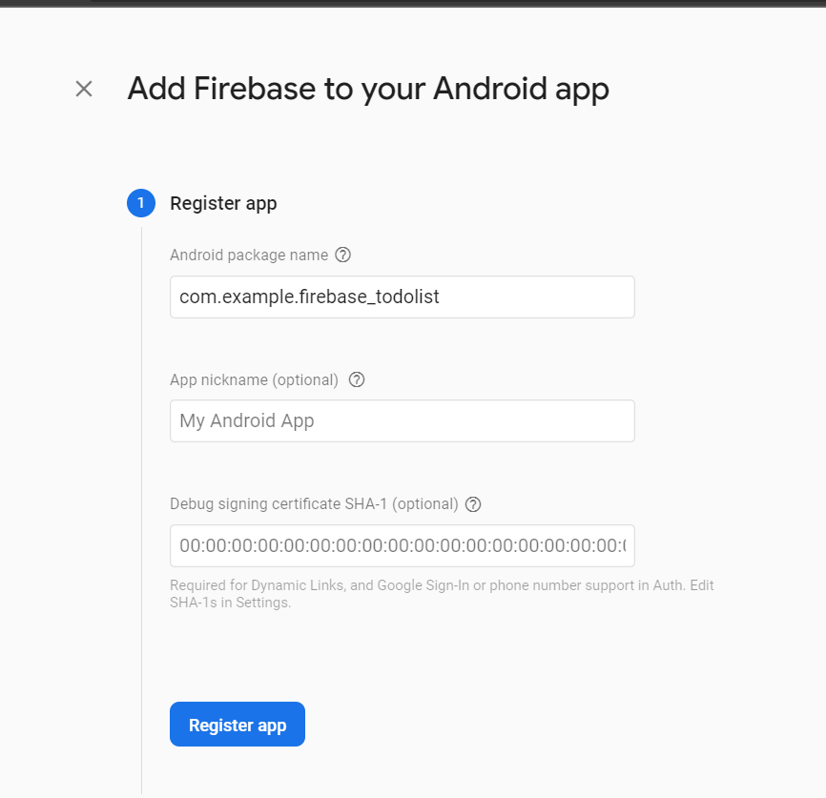
6. Add the configuration Json file to specififed location of your android app. 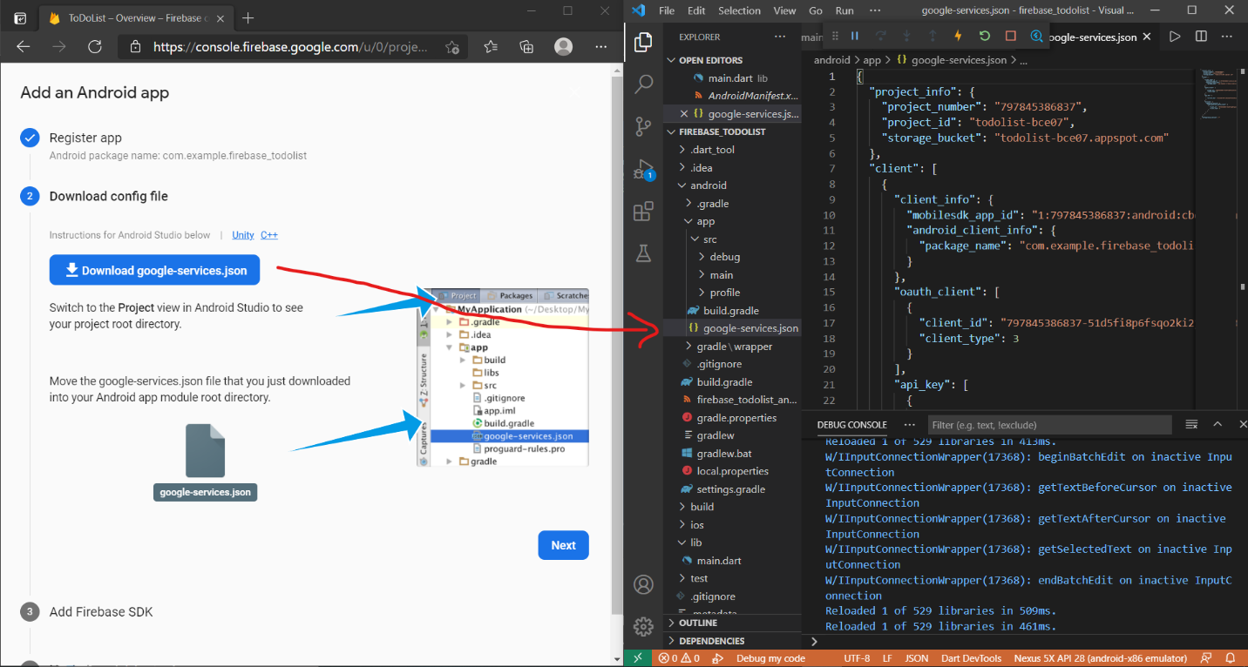
7. Add Firebase SDK and necessary plugins to your app program. 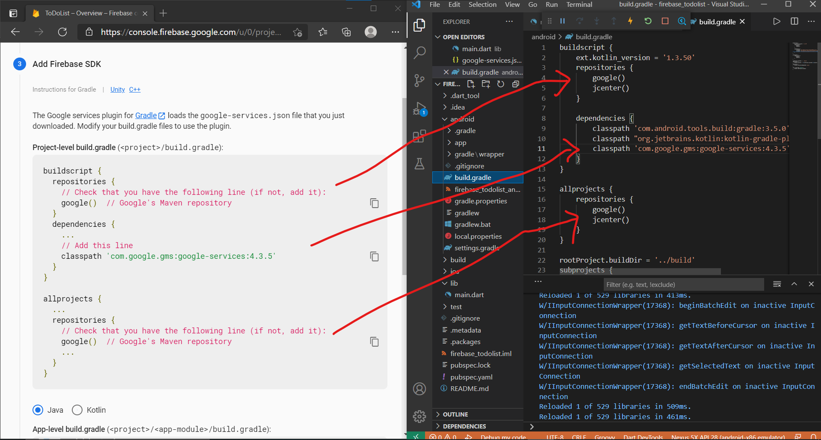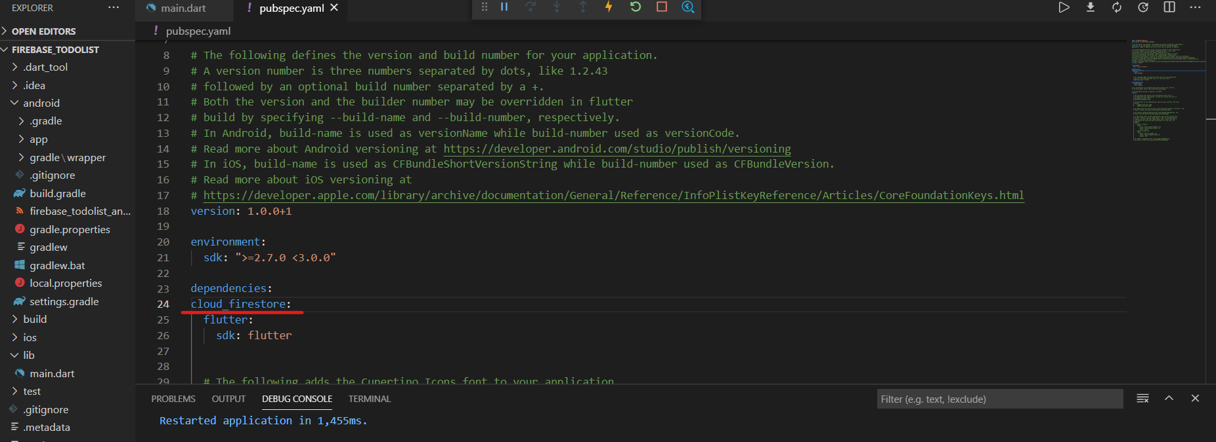
8. Create database in cloud Firestore and start in test mode. 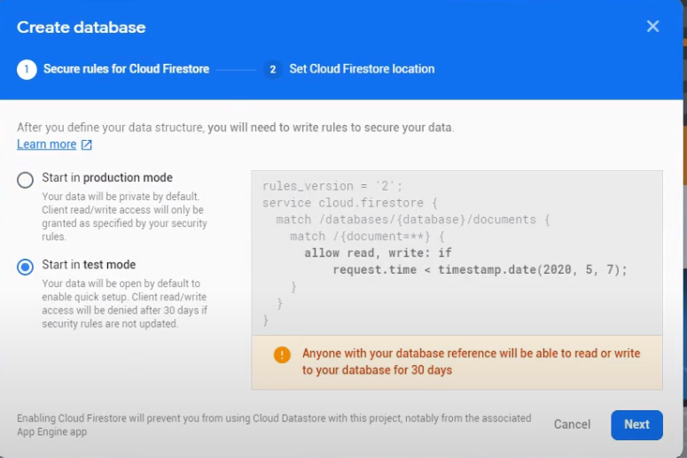
9. Import all the necessary packages to the fultter build. 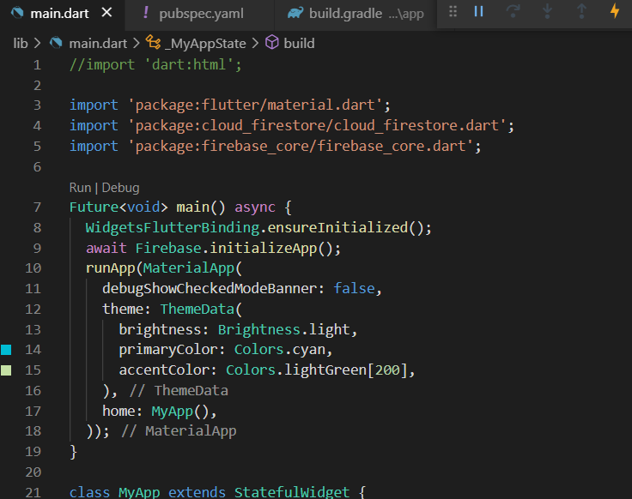
10. After running the app, a new collection is produced with the entries from the app interface.

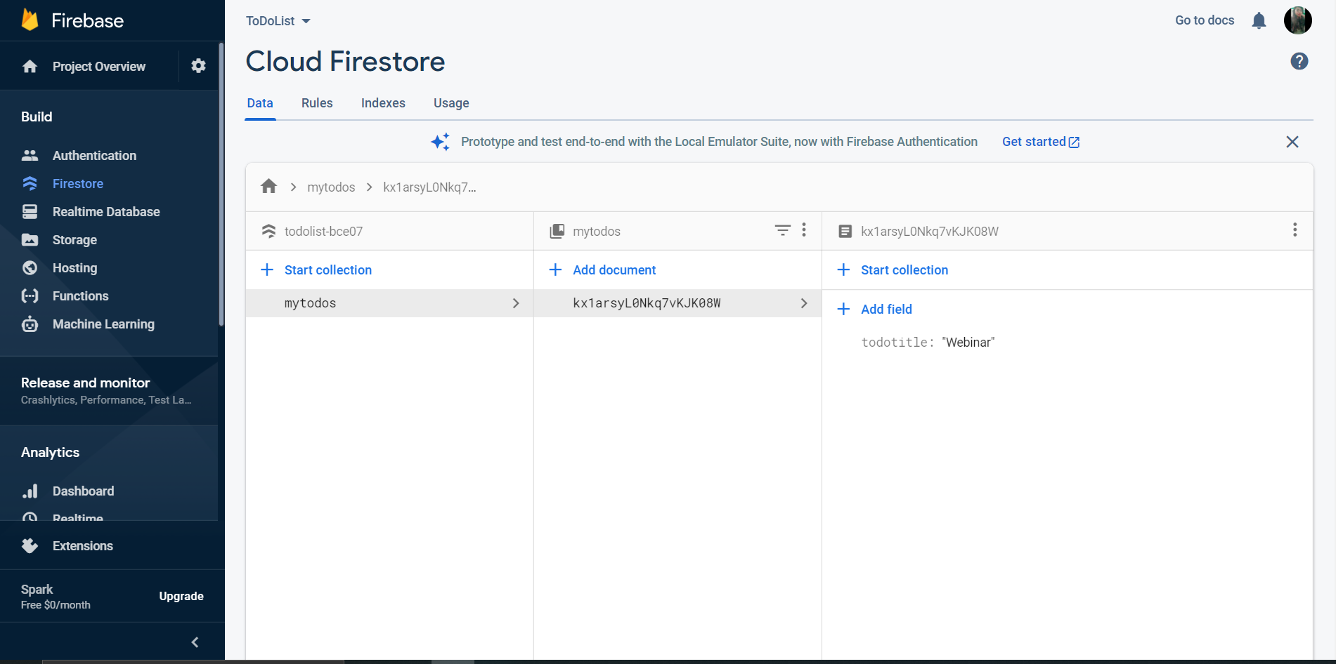

**Running Application : A Todolist app with add and delete operations**