Experiment- 10

Aim: To study YACC and implement YACC

**Steps:**

1. Get root access: $ sudo su root

$ Enter the password

2. Install the package: apt-get install bison

**Programs:**

Program 1: To check whether entered identifier is valid or not

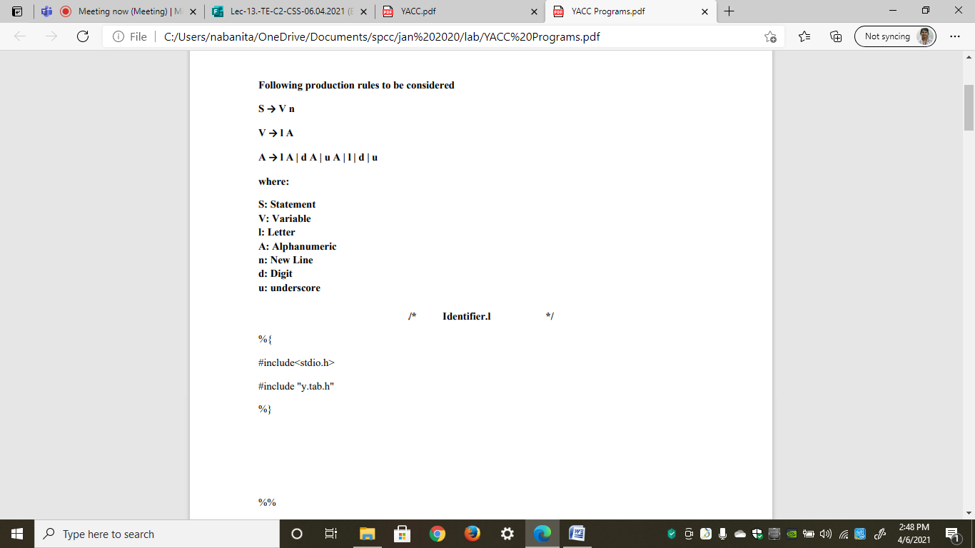

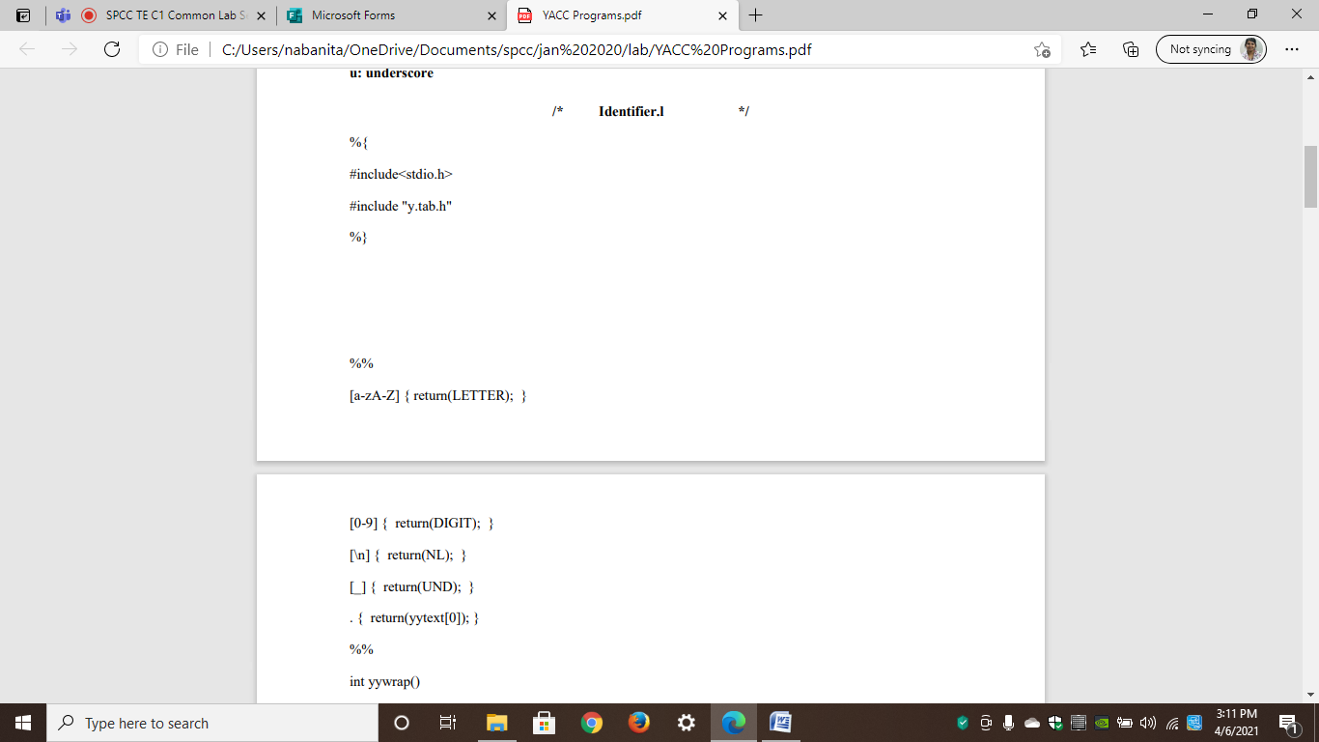

%%

[a-zA-Z] { return(LETTER); }



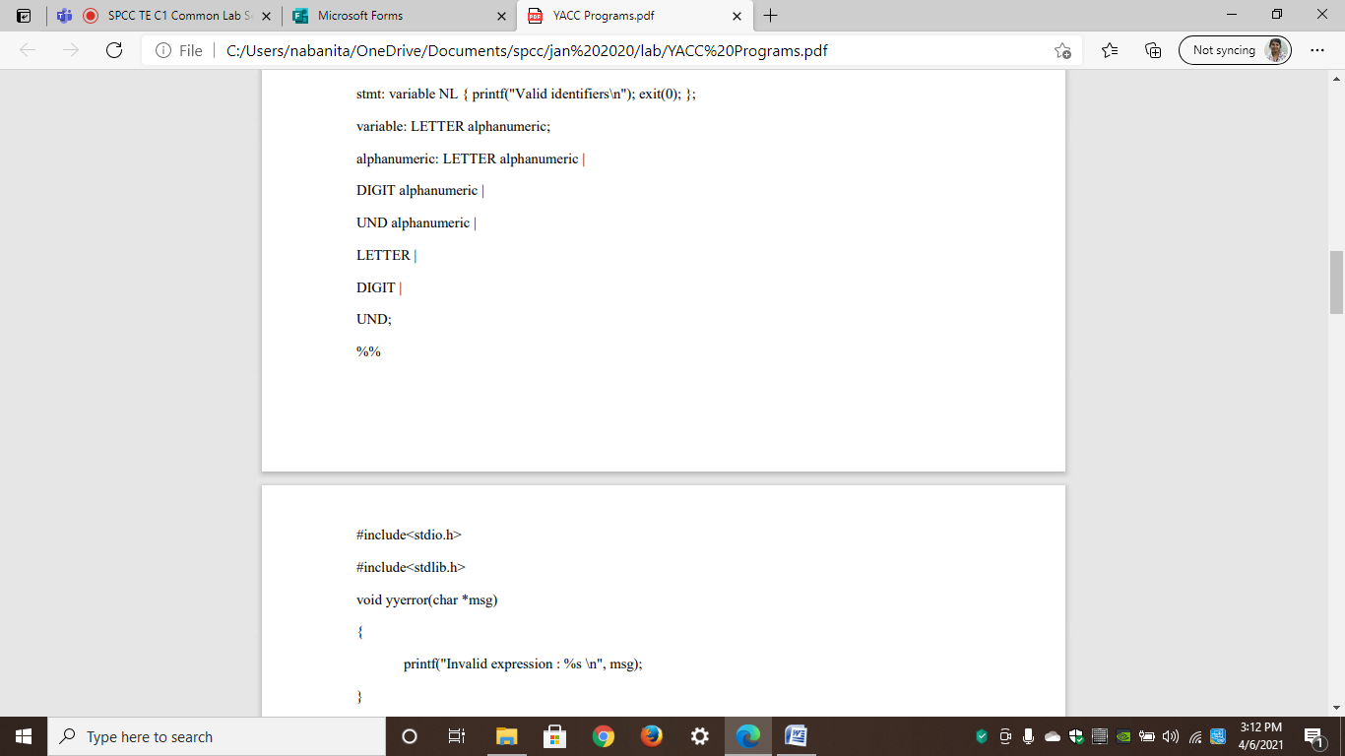

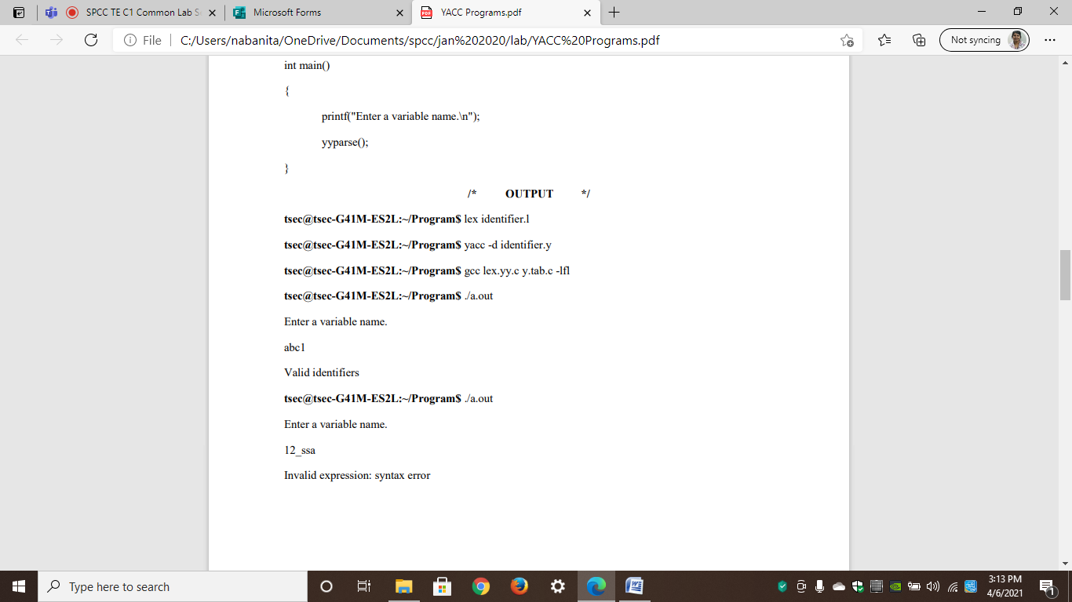

Program 2: Calculator