**Experiment- 9**

Aim: Write a program to implement Single Pass Macroprocessor

A MACRO consists of Macro Definition and Macro Call

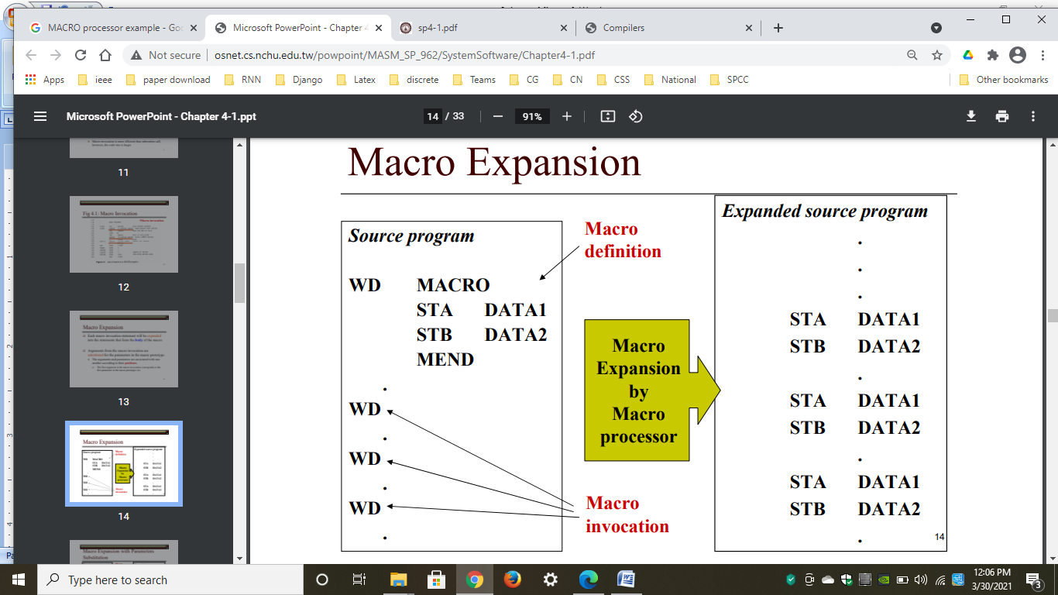

**Input: Sample Program containing a MACRO**

|  |
| --- |
| **Sample Program** |
| PRG START 0 |
| . |
| . |
| MACRO |
| INCR |
| A 1 DATA |
| A 2 DATA |
| A 3 DATA |
| MEND |
| . |
| . |
| INCR |
| . |
| . |
| INCR |
| . |
| . |
| END |

**OUTPUT:**

|  |  |  |  |  |  |
| --- | --- | --- | --- | --- | --- |
| **MNT** | | |  | **MDT** | |
| **Index** | **Name** | **MDT Index** |  | **Index** | **Entries** |
| 1 | INCR | 1 |  | 1 | INCR |
|  |  |  |  | 2 | A 1 DATA |
|  |  |  |  | 3 | A 2 DATA |
|  |  |  |  | 4 | A 3 DATA |
|  |  |  |  | 5 | MEND |