**Easy**

**Deploy a static website on AWS S3 bucket using GitHub action. when developer is making some changes in website code. New changes should be reflected on my website**

**Step 1: Create a bucket**

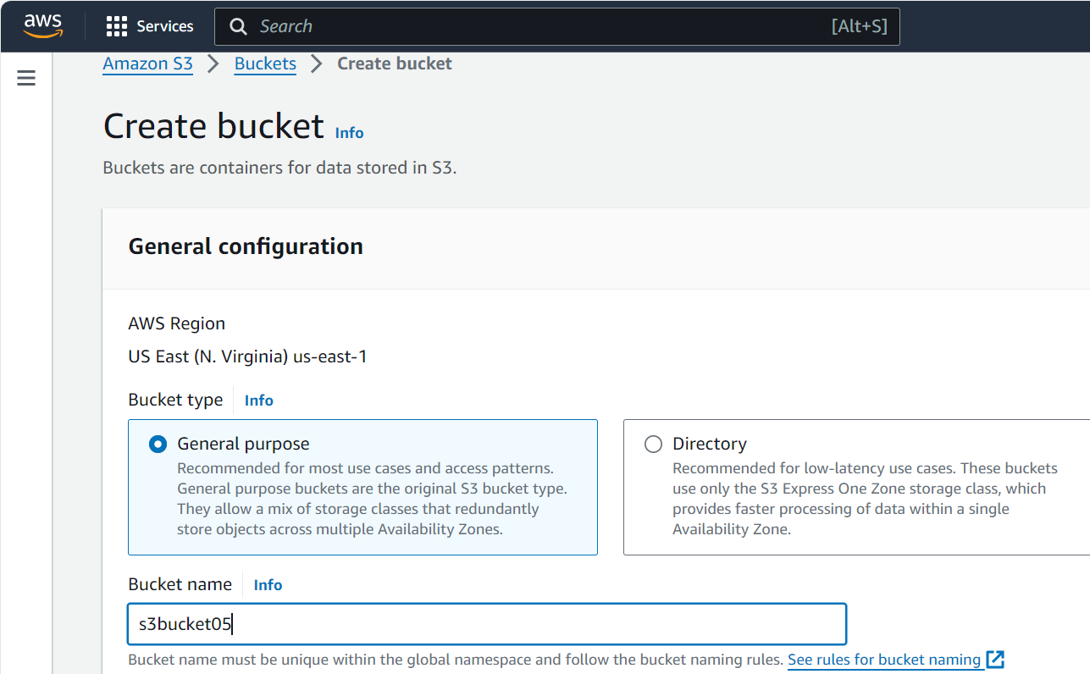

**Uncheck the check box for block all public access**

**Click on the acknowledge checkbox**

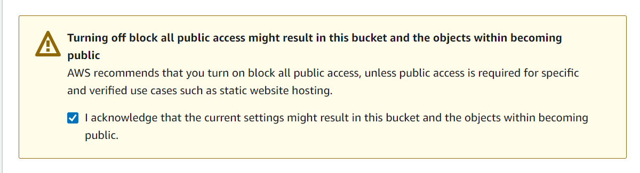

**Step 2: Enable static website hosting**

1. **In the Buckets list, choose the name of the bucket that you want to enable static website hosting for.**
2. Choose **Properties**.
3. **Under Static website hosting, choose Edit.**

1. **Under Buckets, choose the name of your bucket.**
2. **Choose Permissions.**
3. **Under Bucket Policy, choose Edit.**

**STEP 3: Create a new repository in your GitHub account**

**Go to settings >> secrets and variables >> actions >> add new repository secret  
  
Here add access key and secret key**

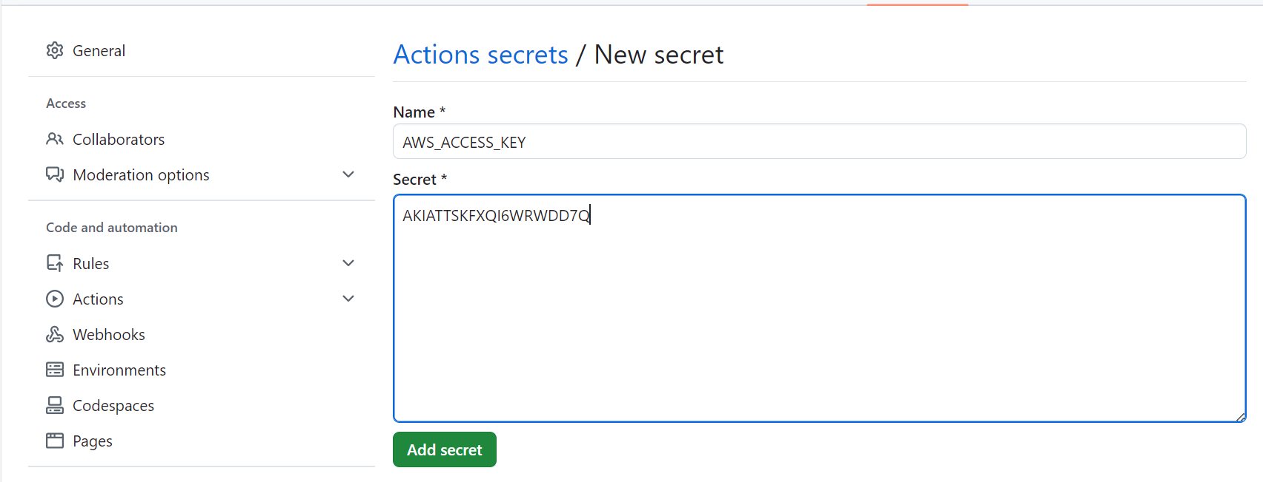

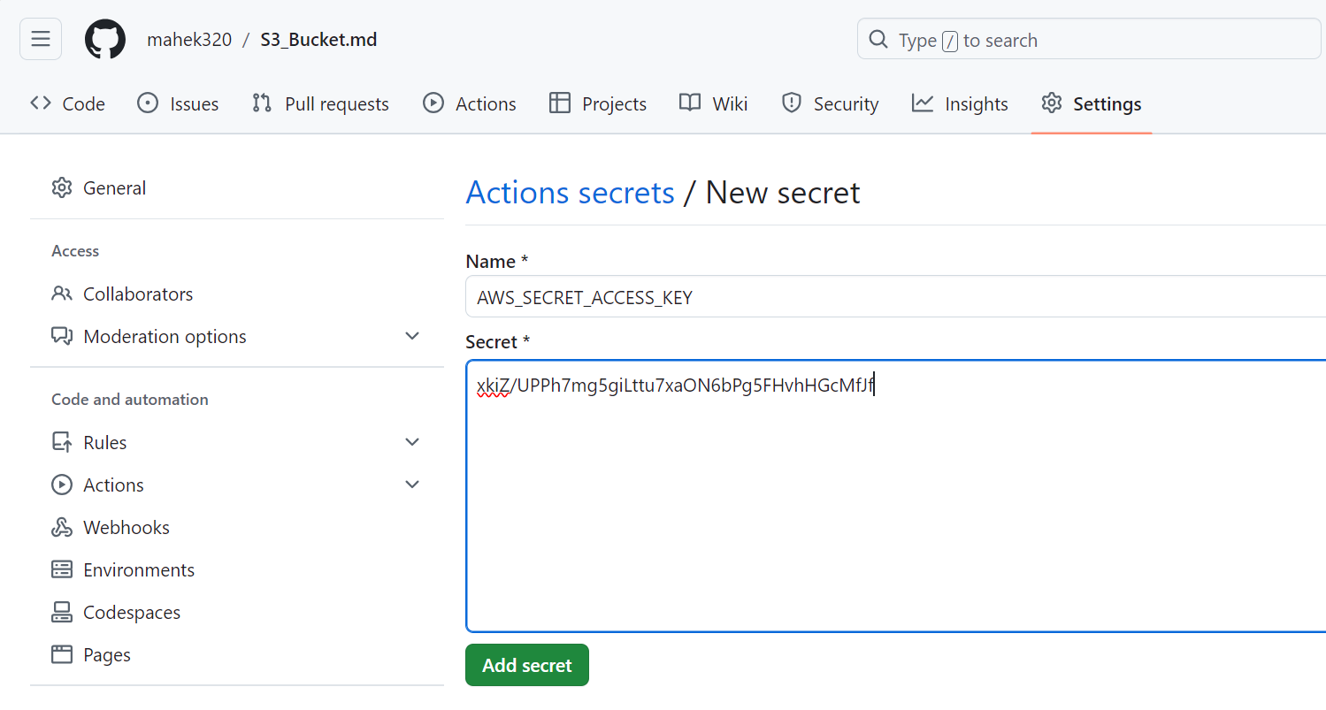

**Change the bucket name and region and remove public**

**Create an index file in the same repository**

**Click on actions in the git repository**

**Under Static website hosting, click on the Endpoint URL.**

**Copy paste the endpoint url**

Easy 1

Pull the Ubuntu image from Docker hub and launch a web application in the container on port no. 8080 and this application should be reachable globally.

Launch an EC2 instance for docker and connect it on the terminal

Add port 8080 in the security group of the instance

Set the hostname

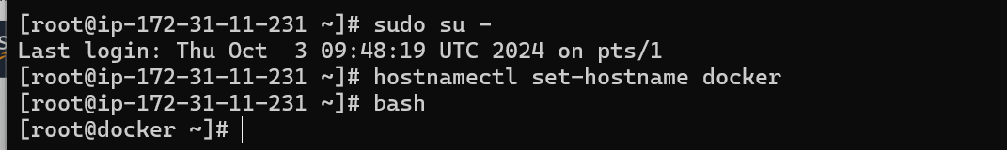

Run the docker commands on the terminal to install docker



We will now use the start docker command to start docker



We will pull the ubuntu image

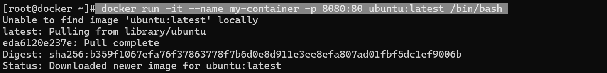

We will install all the packages and update them

We will create a html file



We will start the start the apache

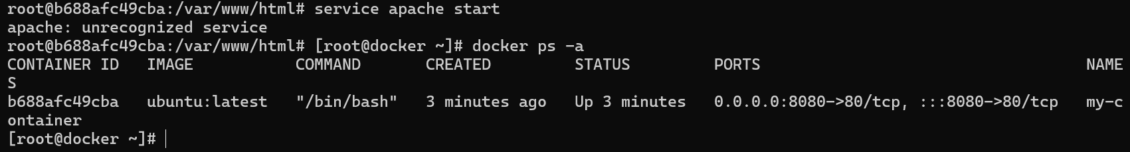

The image has been successfully hosted on 8080

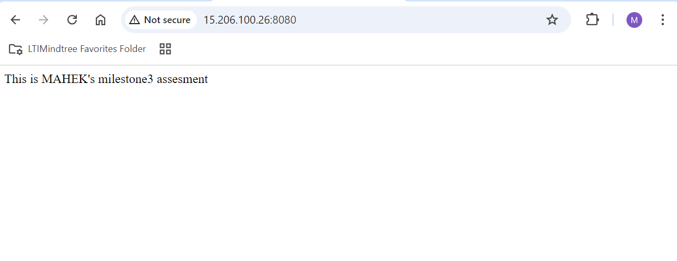

Medium

Create a custom VPC and create two subnets like public and private in that subnet you need to deploy one web server and another is database server using IAC tool terraform

Created an ec2 instance and connected to terminal



We have configured aws and install aws cli

We created a vim vpc.tf file

We have then validated the terraform

We have now used the terraform plan command

We have applied all the changes

As we can see that all the changes have been successfully implemented

Medium 1

Deploy a web application in the Kubernetes pod. And create a replica set. In any case load is going to increase on your replica set. increase the number of replicas of the pods.

Create an instance

Create a role

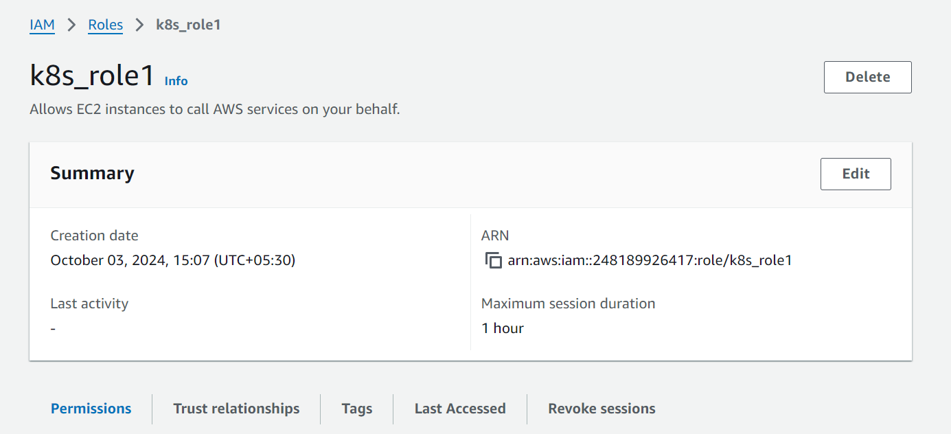

Connect to the terminal

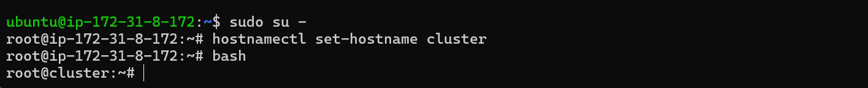

Unzip the necessary files for installation

Install aws



Configure aws



Install EKS tool



Install Kubectl



Create a cluster

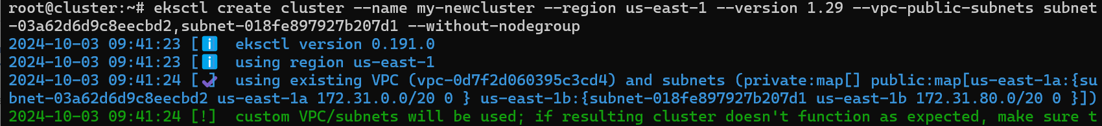

Creating node group

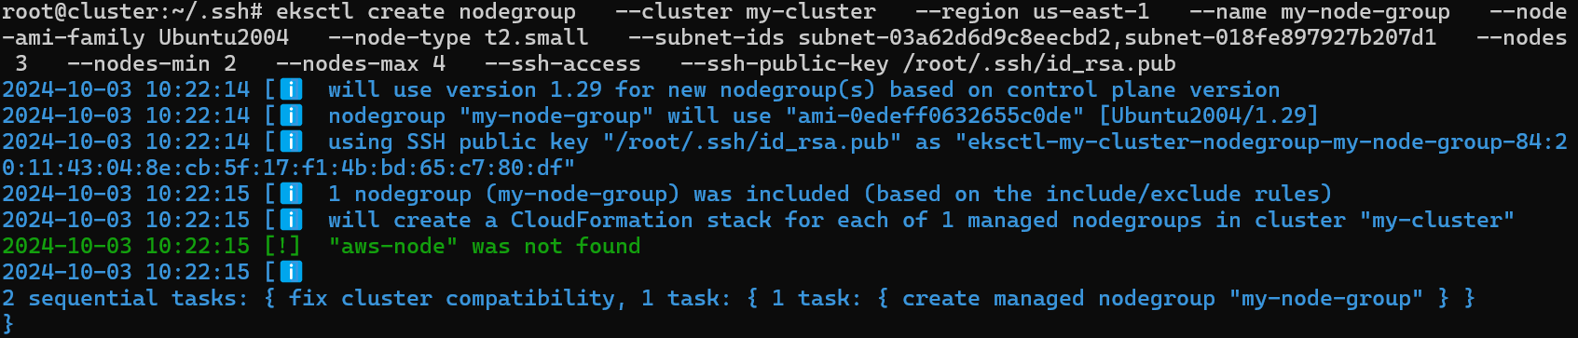

Create a vim replicaset.yml

Here we see that the pods are created

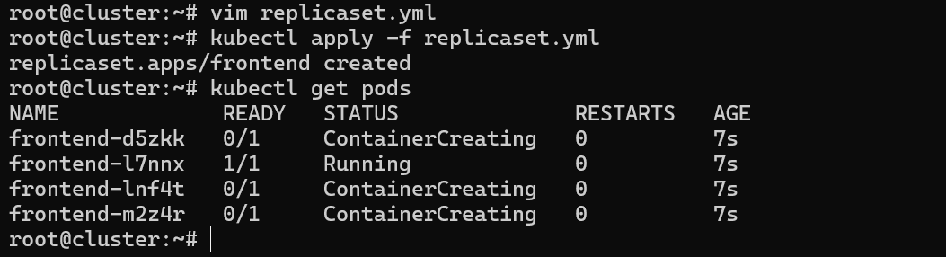

We can increase or decrease the number of replicaset by the below command automatically



Inorder to increase it manually

