**DATABASE AND MANAGEMENT SYSTEMS PROJECT**

**CAR RENTAL SYSTEM**

**Submitted by:**

**MAHEK AGARWAL (RA1911003010893)**

**AYUSH KUMAR SINGH (RA1911003010907)**

**INDEX**

1. Project detail------------------------------------------- 3
2. Customer Requirements--------------------------- 4
3. Module Specification ---------------------------------5
4. Entities----------------------------------------------------6
5. Relations--------------------------------------------------8
6. ER Diagram---------------------------------------------- 9
7. Sequence Diagram-------------------------------------11
8. Use Case Diagram--------------------------------------12
9. SQL Statements-----------------------------------------13
10. SQL Queries-------------------------------------------- 21
11. Conclusion-----------------------------------------------23

**Description of the Project:**

A car rental company wants to develop a relation database to monitor customers, rentals, pickup date, maintenance, and employees.

CRC's fleet consists of cars of different types. A car is described via a unique code (VIN), a description, color, brand, and model. CRC should also store in this database its customers. A customer is described by a unique ID, SSN, Name (First, Last), email, mobile phone number and lives in a state and country. A rental is described by a unique reservation number, it has an amount and contains the pickup date and the return date. Entity-Relationship Diagram (ERD) Use the Entity-Relationship Diagram (ERD) to model entities, relationships, attributes, cardinalities, and all necessary constraints. Use any tool you like to draw the ERD.

**Mission**

Our mission is to satisfy our customer’s rental-car needs while delivering the best quality, service and value; we believe the ideal system is a human-centered user-experience modeled according to a consistent object-oriented model from the front-end of the application to the back-end of the database.  Concordantly, we believe both the entity relationship diagram and relational database-model specifications required by the rental-car management inventory system will seek to:

1. Proactively maintain and monitor the database system to prevent any potential issues.
2. Accurately diagnose and forecast the database system health and capacity to maximize return on investment for the rental-car inventory management system and promptly respond to the stakeholder’s support request(s) to remove any work bottleneck on DBA side.
3. Persistently seek innovative ways to improve DBA work efficiently yet effectively.

**CUSTOMER REQUIREMENTS**

1. Car rental agency should have collection of cars
2. Each car should belong to a car category
3. Customer based on car category preference, rents a car
4. Customer will select a car from the suggestions and should be able to reserve it for rent.
5. Car rental rate will be calculated based on the selected make and model
6. Which is the most preferable rental office location for customers.
7. Car model with the highest mileage and reservations

### **Module specification:**

**Add/remove Car**: The Admin can add or remove car so that the user can see the available cars with their feedbacks given by users.

**Add/remove Drivers**: The Admin can add or remove drivers so that the user can see the available drivers with their feedback given by users.

**View Available Cars:** According to the category user can view cars with the price for the ride.

**Booking Car:** The user can book a car with or without a driver as per his/her necessity.

**Car on rent:** The Customer can easily get the car whenever they need to on the rent with the use of this system.

**Feedback:** The customer can give feedback on the ride.

**Manage Rent**: The Admin can manage the rent and discount as per a user’s points.

**View Feedback**: The admin can reply to the given feedbacks.

**Payment details**: The rent and the payment details of the car with the discount (if redeemed) will be available to the user.

# **ENTITIES**

### Customer:

Customer will be the one who is using car rental system for reserving a car. He can be a member of the system or a non-member of the system. Customer entity will store details like customer driving license number, email, address, name, and phone number.

### Vehicle:

Vehicle entity will have list of Vehicle available in the system. Each Vehicle will be associated with a make and model. Vehicle will have attributes like make, model, mileage and license plate, release year and color.

### Employee:

Every person working for wonderland car rental system, position at employee work in the company, employee’s SSN. Their first and last name with their employee ID in the company associated with that employee.

### Reservation

Each car booking will be monitored in the entity called reservation. Reservation will have attributes like reservation ID, which is primary key. Rental office ID, date of reservation, Rate for specific car and customer ID will be including in this entity.

### Rental Office Location

### Every car is rented from specific location and depends on the customer booking car from that location. Office is accompanied with its city name state code and zip code which takes in reservations from customer and assign the preferable car to clients

### Maintenance Log

### This entity will take car of different cars and its maintenance log book. Vehicle requiring the repair and type of procedure followed for each vehicle. The car will have date on which it is repaired and employeeID who took the responsibility to repair it.

# **RELATIONS**

### Vehicle to Reservation :

Every Vehicle is associated with a VIN. VIN and reservation ID is associated with customer who is making reservation for that vehicle. Here it has one to one relation. The relation name is ‘Reserves’.

### Reservation to Accesory:

Once customer . There can be case like booking is cancelled in that case no bill will be associated with the booking. The relation name is ‘Includes.

### Maintenance to Employee:

The employee is responsible for maintiang a vehicle repair who will manage the procedure of vehicle repair so here employee manages the maintenance hence the relation name is ‘manages’.

### Reservation to Customer:

Customer makes reservation for vehicle rental . The relation name is ‘Makes’.

### Employee to Rental Office location

### Employee working at the office location from where the car is booked is mange by the employee table and rental office will keep details of that office. The relation name here is ‘Employs’.

ER DIAGRAM:

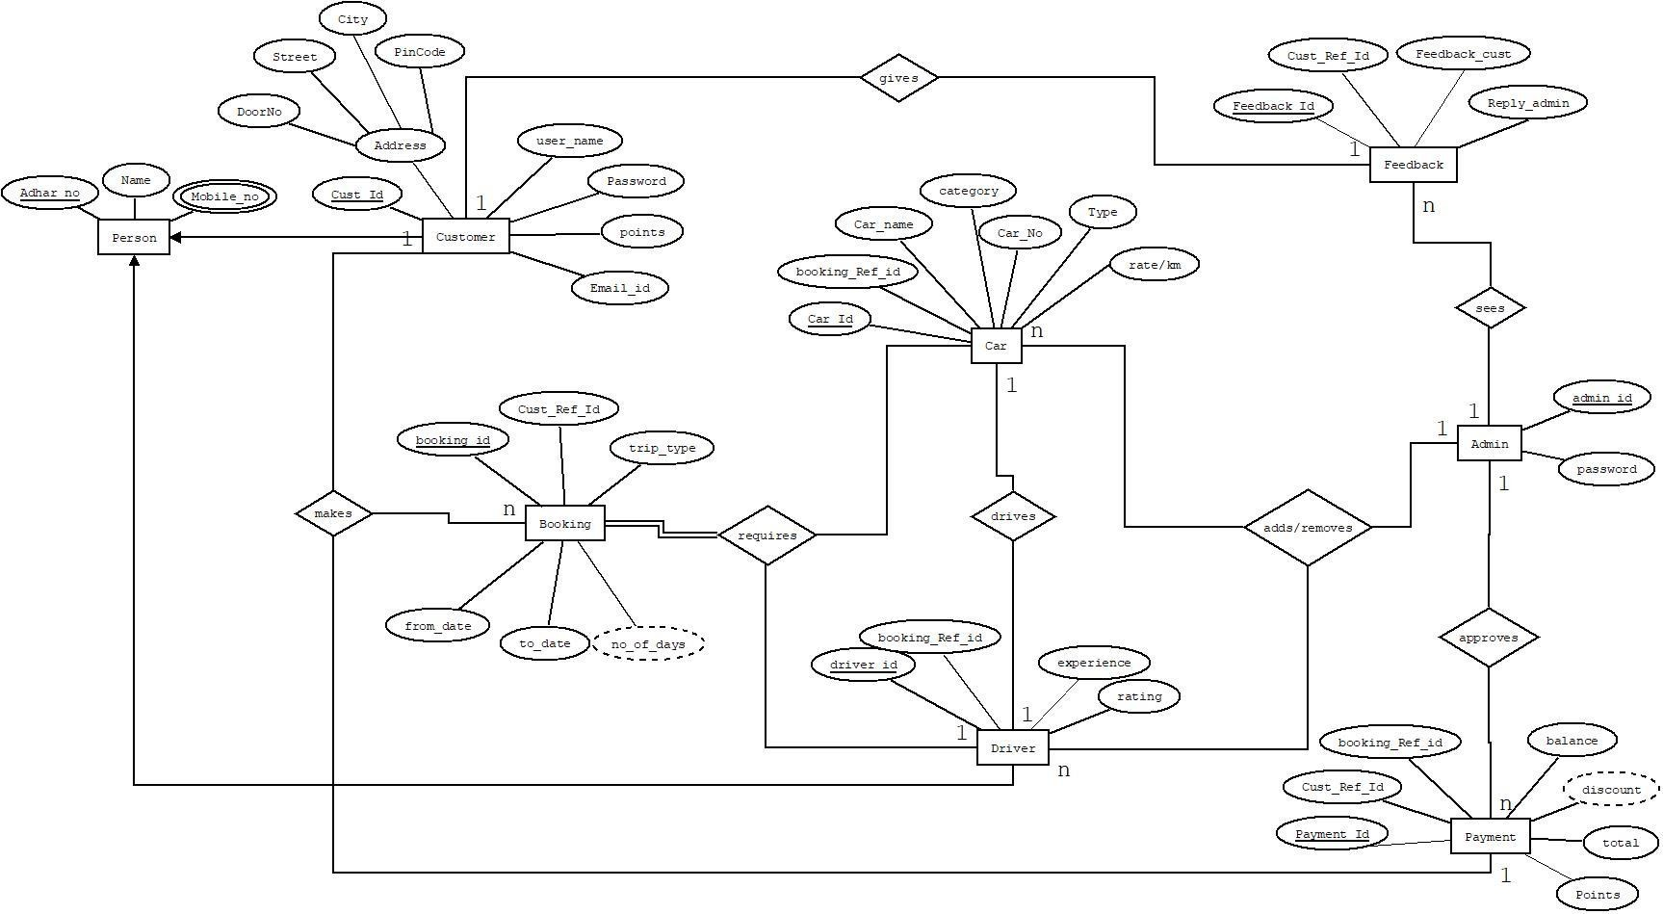

ER to relational schema mapping

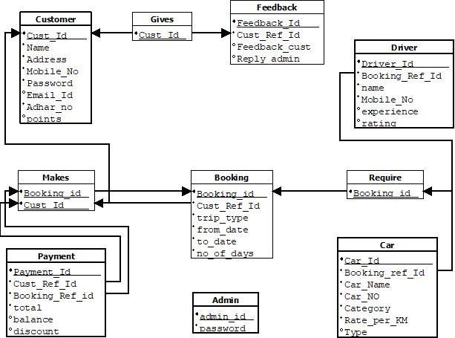

**SEQUENCE:**

A sequence diagram is a type of interaction diagram because it describes how—and in what order—a group of objects works together. A sequence diagram specifically focuses on lifelines, or the processes and objects that live simultaneously, and the messages exchanged between them to perform a function before the lifeline ends.

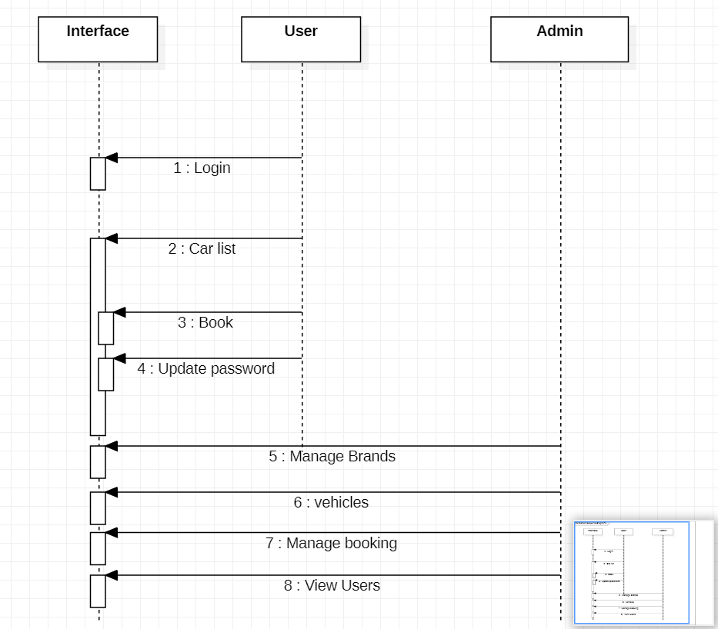

**USE CASE:**

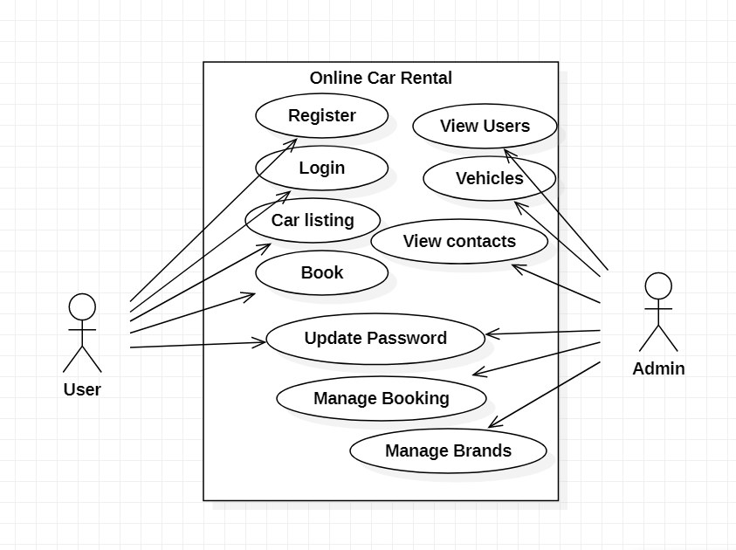

# **SQL STATEMENTS**

**Create table Statements**

SQL> CREATE TABLE VEHICLE

(

VIN VARCHAR(30) NOT NULL,

Make VARCHAR(30) NOT NULL,

Model VARCHAR(30) NOT NULL,

Year INT NOT NULL,

Color CHAR(30) NOT NULL,

LicensePlate VARCHAR(20) NOT NULL,

Mileage INT NOT NULL,

PRIMARY KEY (VIN),

UNIQUE (LicensePlate)

);

Table created.

SQL> CREATE TABLE EMPLOYEE

(

EmployeeFName VARCHAR(100) NOT NULL,

EmployeeID INT NOT NULL,

EmployeeLName VARCHAR(100) NOT NULL,

Title VARCHAR(100) NOT NULL,

SSN INT NOT NULL,

PRIMARY KEY (EmployeeID),

UNIQUE (SSN)

);

Table created.

SQL> CREATE TABLE ACCESSORY

(

SerialNumber INT NOT NULL,

Type VARCHAR(50) NOT NULL,

Cost DECIMAL(20,2) NOT NULL,

Quantity INT NOT NULL,

PRIMARY KEY (SerialNumber)

);

Table created.

SQL> CREATE TABLE CUSTOMER

(

CustomerID INT NOT NULL,

CustomerFName VARCHAR(100) NOT NULL,

CustomerLName VARCHAR(100) NOT NULL,

CustomerEmail VARCHAR(200) NOT NULL,

DriversLicense VARCHAR(50) NOT NULL,

RewardNumber INT,

PRIMARY KEY (CustomerID),

UNIQUE (DriversLicense)

);

Table created.

SQL> CREATE TABLE RENTAL_OFFICE_LOCATION

(

RentalOfficeID INT NOT NULL,

StreetAddress VARCHAR(200) NOT NULL,

City VARCHAR(100) NOT NULL,

State VARCHAR(100) NOT NULL,

ZipCode INT NOT NULL,

PRIMARY KEY (RentalOfficeID)

);

Table created.

SQL> CREATE TABLE MAINTENANCE_LOG

(

Maintenance_ID INT NOT NULL,

EmployeeID INT NOT NULL,

VIN VARCHAR(30) NOT NULL,

Maintenance_Date DATE NOT NULL,

Maintenance_Procedure VARCHAR(200) NOT NULL,

PRIMARY KEY (Maintenance_ID),

FOREIGN KEY (VIN) REFERENCES VEHICLE(VIN),

FOREIGN KEY (EmployeeID) REFERENCES EMPLOYEE(EmployeeID)

);

Table created.

SQL> CREATE TABLE RESERVATION

(

ReservationID INT NOT NULL,

Pick_Up_Date DATE NOT NULL,

Return_Date DATE NOT NULL,

Daily_Rate DECIMAL(20,2) NOT NULL,

Total DECIMAL(20,2) NOT NULL,

CustomerID INT NOT NULL,

RentalOfficeID INT NOT NULL,

PRIMARY KEY (ReservationID),

FOREIGN KEY (CustomerID) REFERENCES CUSTOMER(CustomerID),

FOREIGN KEY (RentalOfficeID) REFERENCES RENTAL_OFFICE_LOCATION(RentalOfficeID)

);

Table created.

SQL>

SQL> CREATE TABLE EMPLOYING

(

RentalOfficeID INT NOT NULL,

EmployeeID INT NOT NULL,

PRIMARY KEY (RentalOfficeID, EmployeeID),

FOREIGN KEY (RentalOfficeID) REFERENCES RENTAL_OFFICE_LOCATION(RentalOfficeID),

FOREIGN KEY (EmployeeID) REFERENCES EMPLOYEE(EmployeeID)

);

Table created.

SQL> CREATE TABLE RESERVES

(

VIN VARCHAR(30) NOT NULL,

ReservationID INT NOT NULL,

PRIMARY KEY (VIN, ReservationID),

FOREIGN KEY (VIN) REFERENCES VEHICLE(VIN),

FOREIGN KEY (ReservationID) REFERENCES RESERVATION(ReservationID)

);

Table created.

SQL> CREATE TABLE INCLUDES

(

SerialNumber INT NOT NULL,

ReservationID INT NOT NULL,

PRIMARY KEY (SerialNumber, ReservationID),

FOREIGN KEY (SerialNumber) REFERENCES ACCESSORY(SerialNumber),

FOREIGN KEY (ReservationID) REFERENCES RESERVATION(ReservationID)

);

Table created.

AFTER INSERTING SOME RANDOM VALUES, CHECKING FOR CERTAIN QUERIES,

**SQL QUERIES**

1. This query will count all records within the model column using the count-function returning the number of records within a table grouped by MODEL from the VEHICLE-table, which will then be displayed as an alias-table entitled, “Highest mileage”.

**SYNTAX**

**SELECT** MODEL, COUNT (*) AS "HIGHEST MILEAGE"

**FROM** VEHICLE

**WHERE** MILEAGE > 300

**GROUP** **BY** MODEL;

1. Query to find the oldest reservation done for any car is by using the select minimum function where pick_up_date is the earliest date among all of them.

**SYNTAX**

**SELECT** * **FROM** RESERVATION

**WHERE** Pick_Up_Date = (SELECT MIN(Pick_Up_Date) FROM RESERVATION);

1. This query will count all records withing the daily rates column using between function returning the Daily_rate between 100-120 within a table

**SYNTAX**

**SELECT** * **FROM** RESERVATION

**WHERE** DAILY_RATE BETWEEN 100 AND 120;

CONCLUSION:

The goal of this project is to automate vehicle rental and reservation so that customers do not need to walk-in or call in order to reserve a vehicle. They can go online and reserve any kind of vehicle they want from the inventory of available vehicles. Even when a customer chooses to walk-in, computers are available for him to go online and perform his reservation. When he choose to reserve by phone, any of the customer service representatives can help him reserve the vehicle speedily and issue him a reservation number.