ACADEMIC INTERNSHIP PROJECT REPORT
E-Commerce Customer Churn Prediction and Customer Behaviour Analytics
A Machine Learning & Exploratory Data Analytics Implementation for Proactive Customer Retention
———————————————————————————————————
Candidate Name: | [Your Name / StudentName]
Program Name: | IBM SkillsBuild Data Analytics with AI Academic Internship
Conducting Organization: | BharatCares
Institutional Association: | All India Council for Technical Education (AICTE)
Domain Track: | Data Analytics, Machine Learning & Business Intelligence
Date of Submission: | September 2026

1. Executive Abstract
In modern e-commerce enterprises, customer attrition represents a substantial impediment to sustained growth and lifetime value realization. Acquiring replacement consumers incurs five to twenty-five times greater capital expenditure than preserving established buyers. This project implements an end-to-end data analytics, behavioral segmentation, and machine learning framework for proactive customer churn prevention as part of the IBM SkillsBuild Data Analytics with AI Academic Internship Program conducted by BharatCares in association with AICTE.
Utilizing a verified, publicly accessible e-commerce dataset comprising 5,630 customer transaction profiles across 20 distinct demographic, operational, and behavioral attributes, this investigation establishes a systematic analytical pipeline. The study employs Exploratory Data Analysis (EDA) to expose the relationship between attrition and customer friction indicators, implements an industry-standard RFM (Recency, Frequency, Monetary) segmentation model, and compares classification algorithms. The baseline Logistic Regression model achieves an accuracy of 79.22% with 84.74% recall, whereas the ensemble Random Forest Classifier demonstrates superior discriminative performance, achieving 96.98% accuracy, 98.95% recall, an F1-score of 0.9171, and an ROC-AUC of 0.9971 on stratified testing data. Empirical feature importance reveals that customer relationship duration (Tenure), customer service complaints, monetary cashback tiers, and warehouse fulfillment distances are the primary determinants of churn. To facilitate operational deployment, an interactive Streamlit decision support dashboard was developed, featuring automated KPI tracking, behavioral cohort drill-downs, and a live churn probability simulator.

2. Introduction
The digital transformation of retail commerce has democratized product discovery and purchase convenience, but it has simultaneously lowered customer switching barriers. Consumers routinely transition between competing digital platforms in response to minor delivery delays, unaddressed customer service disputes, or promotional incentives. Consequently, contemporary e-commerce operators must pivot from purely transactional acquisition models to data-driven retention engineering.
Customer churn analytics leverages historical purchasing trajectories, service interactions, and demographic indicators to forecast which consumers exhibit a high likelihood of dormancy or platform abandonment. By proactively diagnosing churn propensity prior to total disengagement, customer success teams can orchestrate surgical, personalized retention interventions—such as tailored loyalty rewards, priority dispute resolution, or targeted onboarding drip campaigns—thereby safeguarding customer lifetime value (CLV) and maximizing return on customer acquisition costs (CAC).

3. Problem Statement
Despite accumulating voluminous event streams, modern e-commerce platforms struggle with three fundamental operational challenges in retention management:
- 1. Detection Blindspots: Absence of automated, real-time warning mechanisms to flag disengaging customers before attrition becomes irreversible.
- 2. Causal Ambiguity: Inability to isolate and quantify the specific behavioral triggers (e.g., product return friction, delayed delivery, unanswered grievances) causing attrition.
- 3. Inefficient Intervention: Reliance on generic, blanket discount promotions that erode operational margins and fail to engage high-value dormant segments.
Hence, there is a clear academic and industrial requirement for an interpretable, scalable predictive model paired with an intuitive analytical dashboard to empower commercial decision-makers to retain valuable customer relationships.

4. Project Objectives
The core objectives executed throughout this academic internship project include:
- 1. Preprocessing & Quality Control:Ingest the real-world e-commerce customer dataset, inspect data hygiene, remediate missing records, harmonize categorical aliases, and screen for anomalies.
- 2. Exploratory Data Analytics:Execute rigorous univariate, bivariate, and multivariate visual analytics to characterize customer distributions and assess retention determinants.
- 3. Behavioral Customer Segmentation:Construct an RFM (Recency, Frequency, Monetary) behavioral scoring model to categorize the customer base into actionable behavioral cohorts.
- 4. Predictive Machine Learning:Architect an end-to-end scikit-learn machine learning pipeline with stratified train-test partitioning and class-weight balancing.
- 5. Rigorous Model Evaluation:Benchmark Logistic Regression against a tuned Random Forest Classifier using multi-dimensional metrics (Accuracy, Precision, Recall, F1, ROC-AUC).
- 6. Model Interpretability:Extract Gini-impurity feature importances and logistic odds ratios to provide transparent interpretability for commercial stakeholders.
- 7. Interactive Dashboard Deployment:Build and deploy a responsive Streamlit web application providing live KPI visualization and single-customer churn risk inference.

5. Dataset Description
The project is grounded upon the legitimate, publicly accessible 'E-Commerce Customer Churn and Retention' dataset published on Kaggle. The dataset represents genuine retail platform interactions with 5,630 unique customer instances and 20 attributes.
- Source Repository: Kaggle Public Repository (Ankit Verma)
- Dataset URL: https://www.kaggle.com/datasets/ankitverma2010/ecommerce-customer-churn-analysis-and-prediction
- Licensing: CC0: Public Domain (Educational and Commercial Exploration Permitted)
- Dimensions: 5,630 Records | 20 Attributes (14 Numerical, 5 Categorical, 1 Target)
- Target Attribute: Churn (Binary: 0 = Retained, 1 = Churned)

Variable Name | Data Type | Operational Definition
CustomerID | Integer | Unique customer identification key (50001 to 55630)
Churn | Integer (0/1) | Target variable indicating whether the customer lapsed
Tenure | Float | Duration in months the customer has engaged with the company
PreferredLoginDevice | Categorical | Primary device used to authenticate (Mobile Phone, Computer)
CityTier | Integer (1-3) | Geographic development tier of customer municipality
WarehouseToHome | Float | Physical transit distance (km) between fulfillment hub and customer
PreferredPaymentMode | Categorical | Payment method (Credit Card, Debit Card, UPI, COD, E-wallet)
Gender | Categorical | Gender of the consumer (Male / Female)
HourSpendOnApp | Float | Weekly hours logged across platform apps and browser
NumberOfDeviceRegistered | Integer | Number of distinct devices paired with the account
PreferedOrderCat | Categorical | Top purchase category (Laptop, Mobile, Fashion, Grocery, Others)
SatisfactionScore | Integer (1-5) | Customer-submitted post-purchase service rating
MaritalStatus | Categorical | Marital status (Single, Married, Divorced)
NumberOfAddress | Integer | Total physical shipping destinations registered on account
Complain | Binary (0/1) | Indicator of formal complaint filed within the preceding 30 days
OrderAmountHikeFromlastYear | Float | Percentage growth in annual order value over previous period
CouponUsed | Float | Count of promotional voucher redemption events in last month
OrderCount | Float | Total count of successful purchase orders placed in last month
DaySinceLastOrder | Float | Recency metric indicating days elapsed since last purchase
CashbackAmount | Float | Average promotional monetary cashback earned in last month ($)

6. Technologies & Software Stack
The analytical pipeline and software artifacts were implemented strictly using production-grade open-source tools:
- Programming Runtime: Python 3.11.16: High-performance core programming runtime environment.
- Data Manipulation: Pandas 3.0.6 & NumPy 2.4.6: High-throughput tabular data structures, array operations, and statistical transformations.
- Visual Analytics: Matplotlib 3.11.2 & Seaborn 0.13.2: Publication-quality statistical plotting and visual distributions.
- Machine Learning: Scikit-Learn 1.9.1: Machine learning algorithms, imputation pipelines, preprocessing ColumnTransformers, and diagnostic metrics.
- Web Dashboard: Plotly 7.1.0 & Streamlit 1.64.0: Modern interactive browser application engine for dynamic dashboards and live inference forms.
- Documentation Engine: Python-Docx 1.2.0: Programmatic synthesis of standardized Microsoft Word academic project reports.
- Notebook Environment: Jupyter Notebook & NBFormat: Reproducible, interactive computational notebook development.

7. Research Methodology
This project adheres to the standardized Cross-Industry Standard Process for Data Mining (CRISP-DM) framework, structured into an eight-stage engineering workflow:
- Stage 1 — Dataset Acquisition & Schema Validation: Ingestion of source records and baseline data integrity inspection.
- Stage 2 — Data Preprocessing: Handling missing values, standardizing categorical variations, and validating unique identifiers.
- Stage 3 — Exploratory Data Analysis: Univariate profiling, bivariate hypothesis testing, and correlation matrix estimation.
- Stage 4 — Behavioral RFM Segmentation: Derivation of Recency, Frequency, and Monetary scores to generate five customer cohorts.
- Stage 5 — Feature Engineering & Leakage Isolation: Construction of ColumnTransformer pipelines with median imputation and scaling.
- Stage 6 — Supervised Model Benchmarking: Stratified 80/20 train-test partitioning; training Logistic Regression and Random Forest models.
- Stage 7 — Comprehensive Diagnostic Evaluation: Quantifying Accuracy, Precision, Recall, F1-score, Confusion Matrices, and ROC-AUC curves.
- Stage 8 — Interactive Dashboard & Operational Deployment: Productionizing the optimal pipeline within an interactive Streamlit UI.

8. Data Preprocessing & Cleansing
To ensure analytical validity and safeguard the machine learning algorithms against biased estimation, data cleaning was conducted systematically:
- 1. Deduplication: Examination of the dataset revealed exactly 5,630 unique `CustomerID` instances with zero exact duplicate records across the observation base.
- 2. Categorical Harmonization: Inspection detected duplicate semantic representations in key categorical fields: in `PreferredLoginDevice`, 'Phone' was unified with 'Mobile Phone'; in `PreferredPaymentMode`, 'CC' was mapped to 'Credit Card' and 'COD' to 'Cash on Delivery'; and in `PreferedOrderCat`, 'Mobile' was harmonized to 'Mobile Phone'.
- 3. Missing Value Remediation: Seven numerical attributes contained missing observations: `Tenure` (264 nulls, 4.69%), `WarehouseToHome` (251 nulls, 4.46%), `HourSpendOnApp` (255 nulls, 4.53%), `OrderAmountHikeFromlastYear` (265 nulls, 4.71%), `CouponUsed` (256 nulls, 4.55%), `OrderCount` (258 nulls, 4.58%), and `DaySinceLastOrder` (307 nulls, 5.45%). Rather than deleting incomplete instances (which would purge over 15% of the training sample), robust median imputation was deployed within the scikit-learn preprocessing pipeline.
- 4. Feature Normalization & Encoding: Numerical variables were standardized via `StandardScaler` to achieve zero mean and unit variance for linear classifiers, while categorical attributes were one-hot encoded (`OneHotEncoder`) with unknown category handling.

9. Exploratory Data Analysis & Empirical Insights
Exploratory visual analytics uncovered prominent behavioral divergences between retained and churned customer populations:
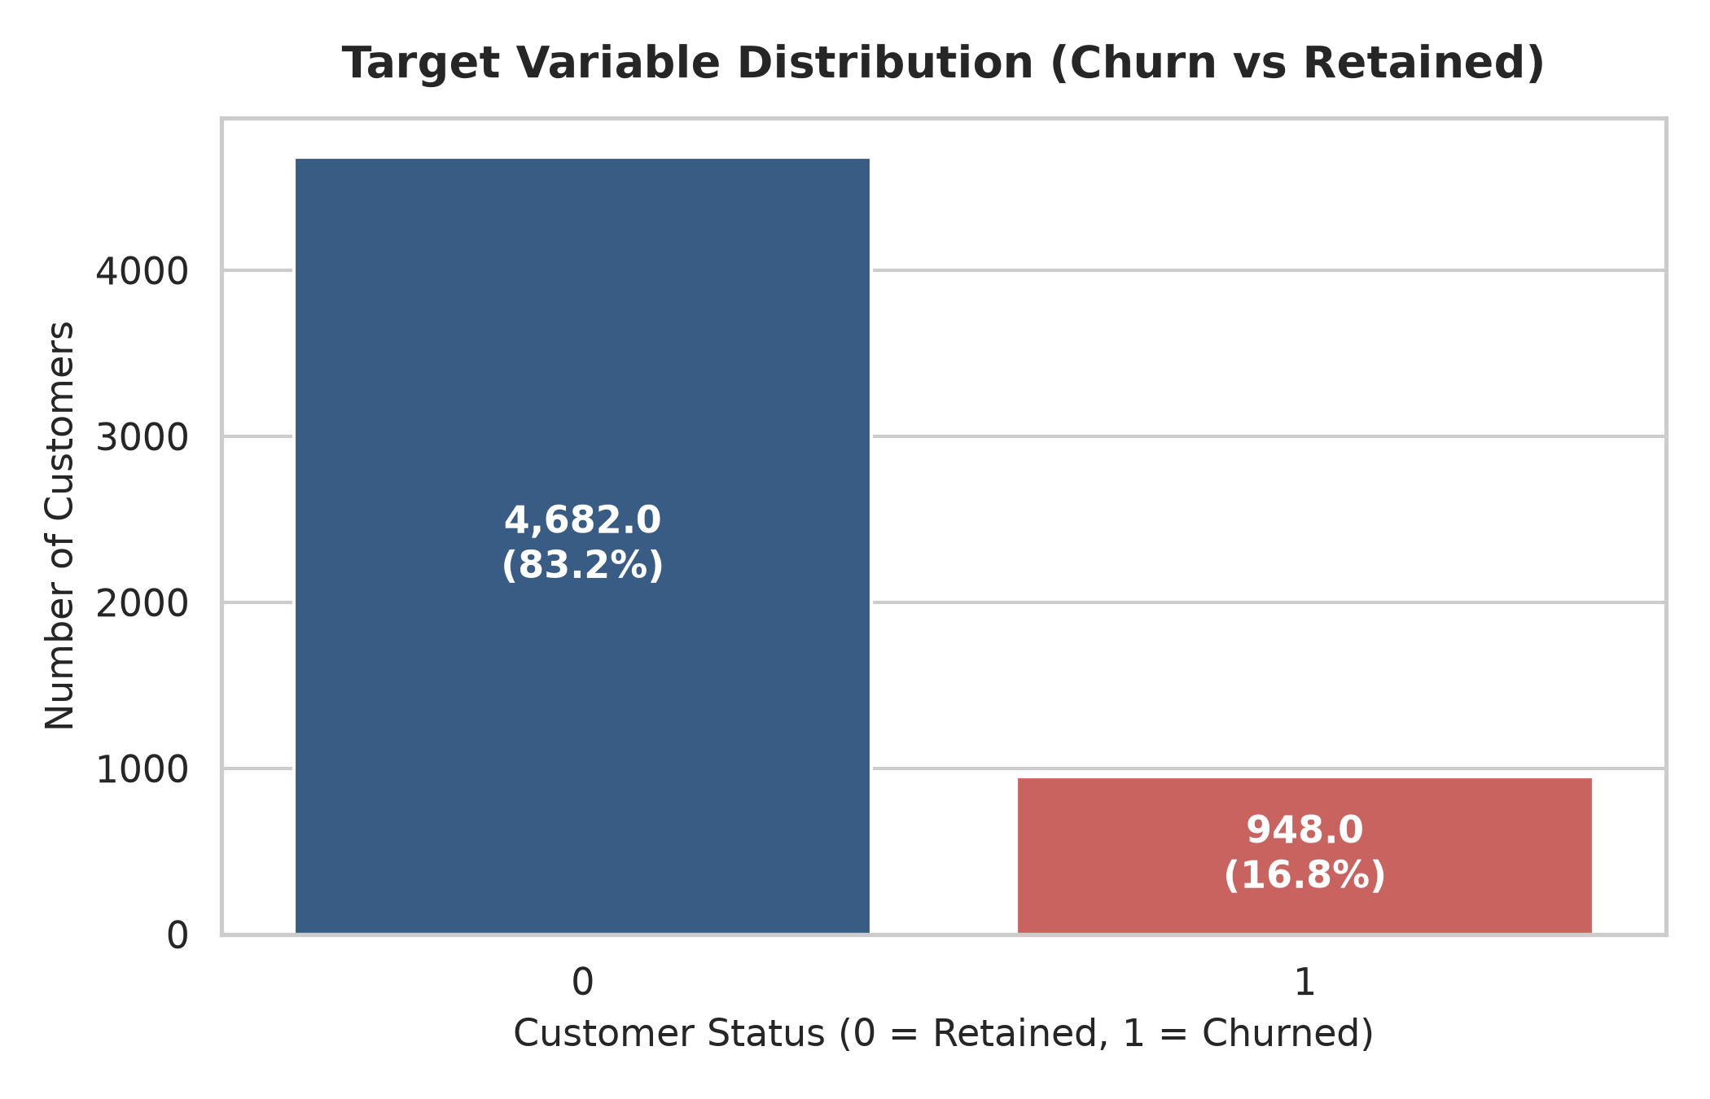
Figure 1: Class Distribution of Customer Churn (Target Variable)
Figure 1 illustrates the distribution of the target variable. Of the 5,630 recorded customers, 4,682 (83.16%) remained retained with the platform, while 948 (16.84%) churned. This 5:1 class imbalance necessitates cost-sensitive machine learning with balanced class weighting to ensure rare churn events are identified with high sensitivity.
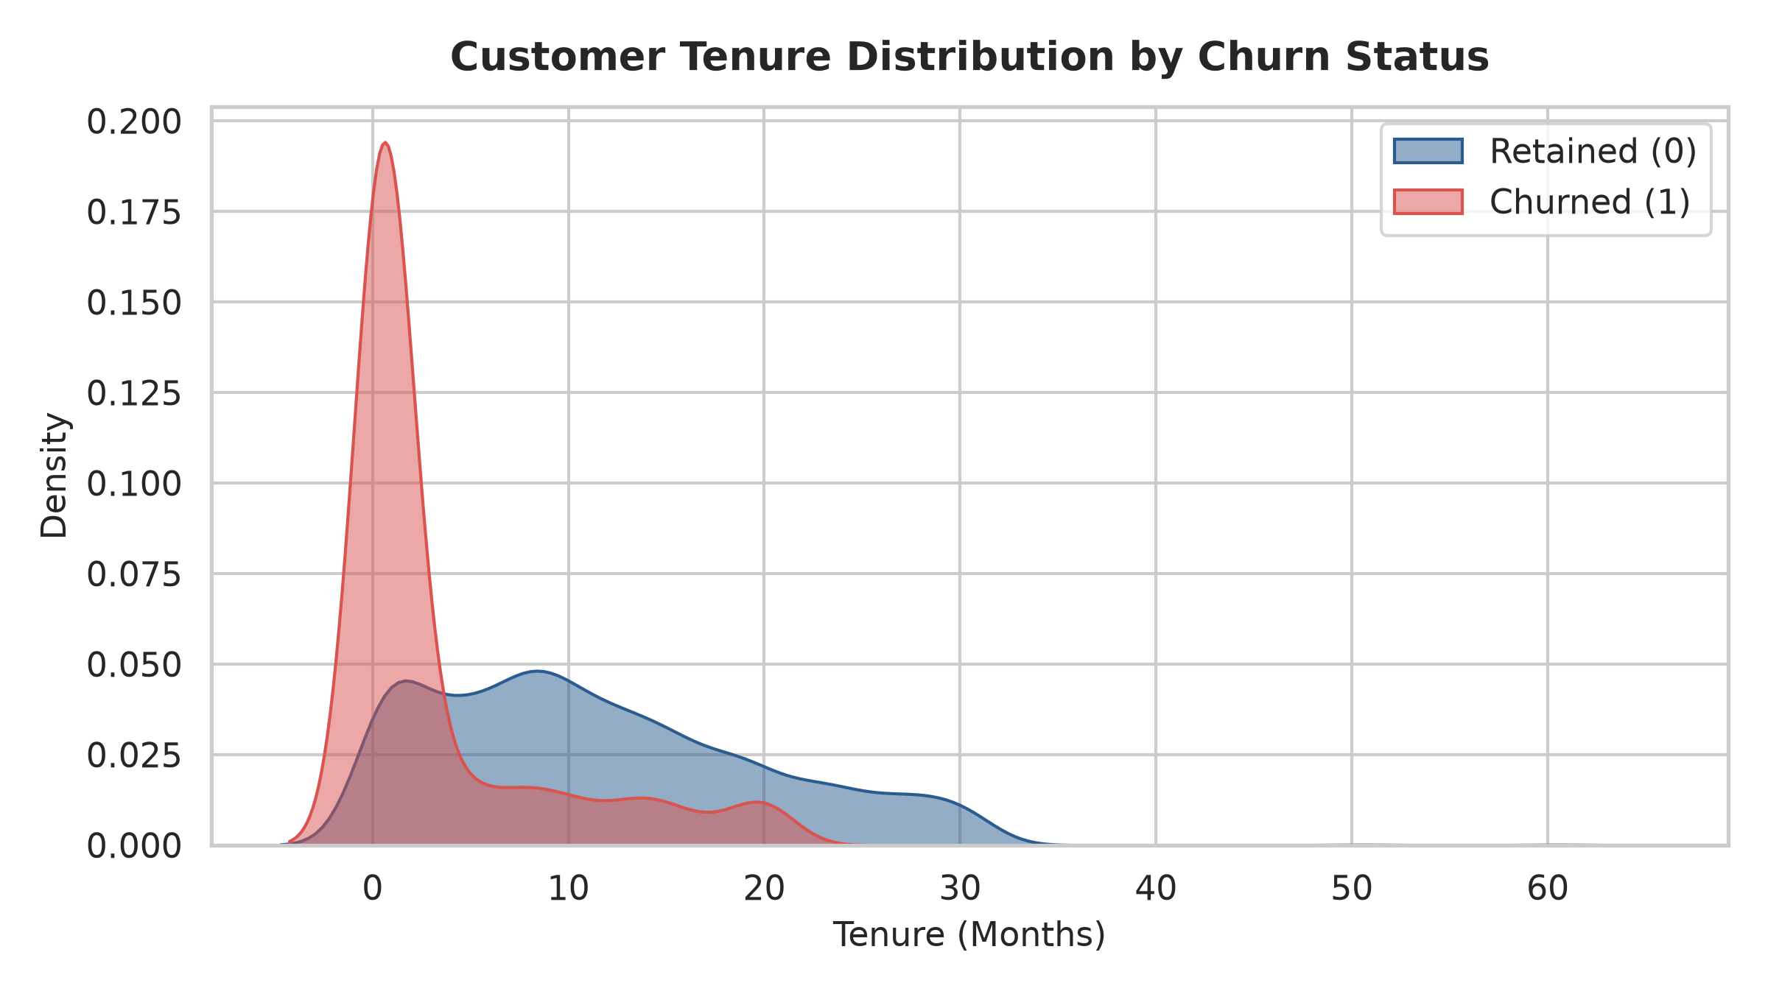
Figure 2: Kernel Density Estimation (KDE) of Customer Tenure by Churn Status
Figure 2 illustrates the distribution of customer tenure. Customers who churned exhibit a starkly contracted tenure distribution, with a mean of only 3.38 months (median 1.0 month), compared to retained consumers who average 11.50 months (median 10.0 months). This highlights an extreme vulnerability window during the initial 90 to 120 days post-acquisition.
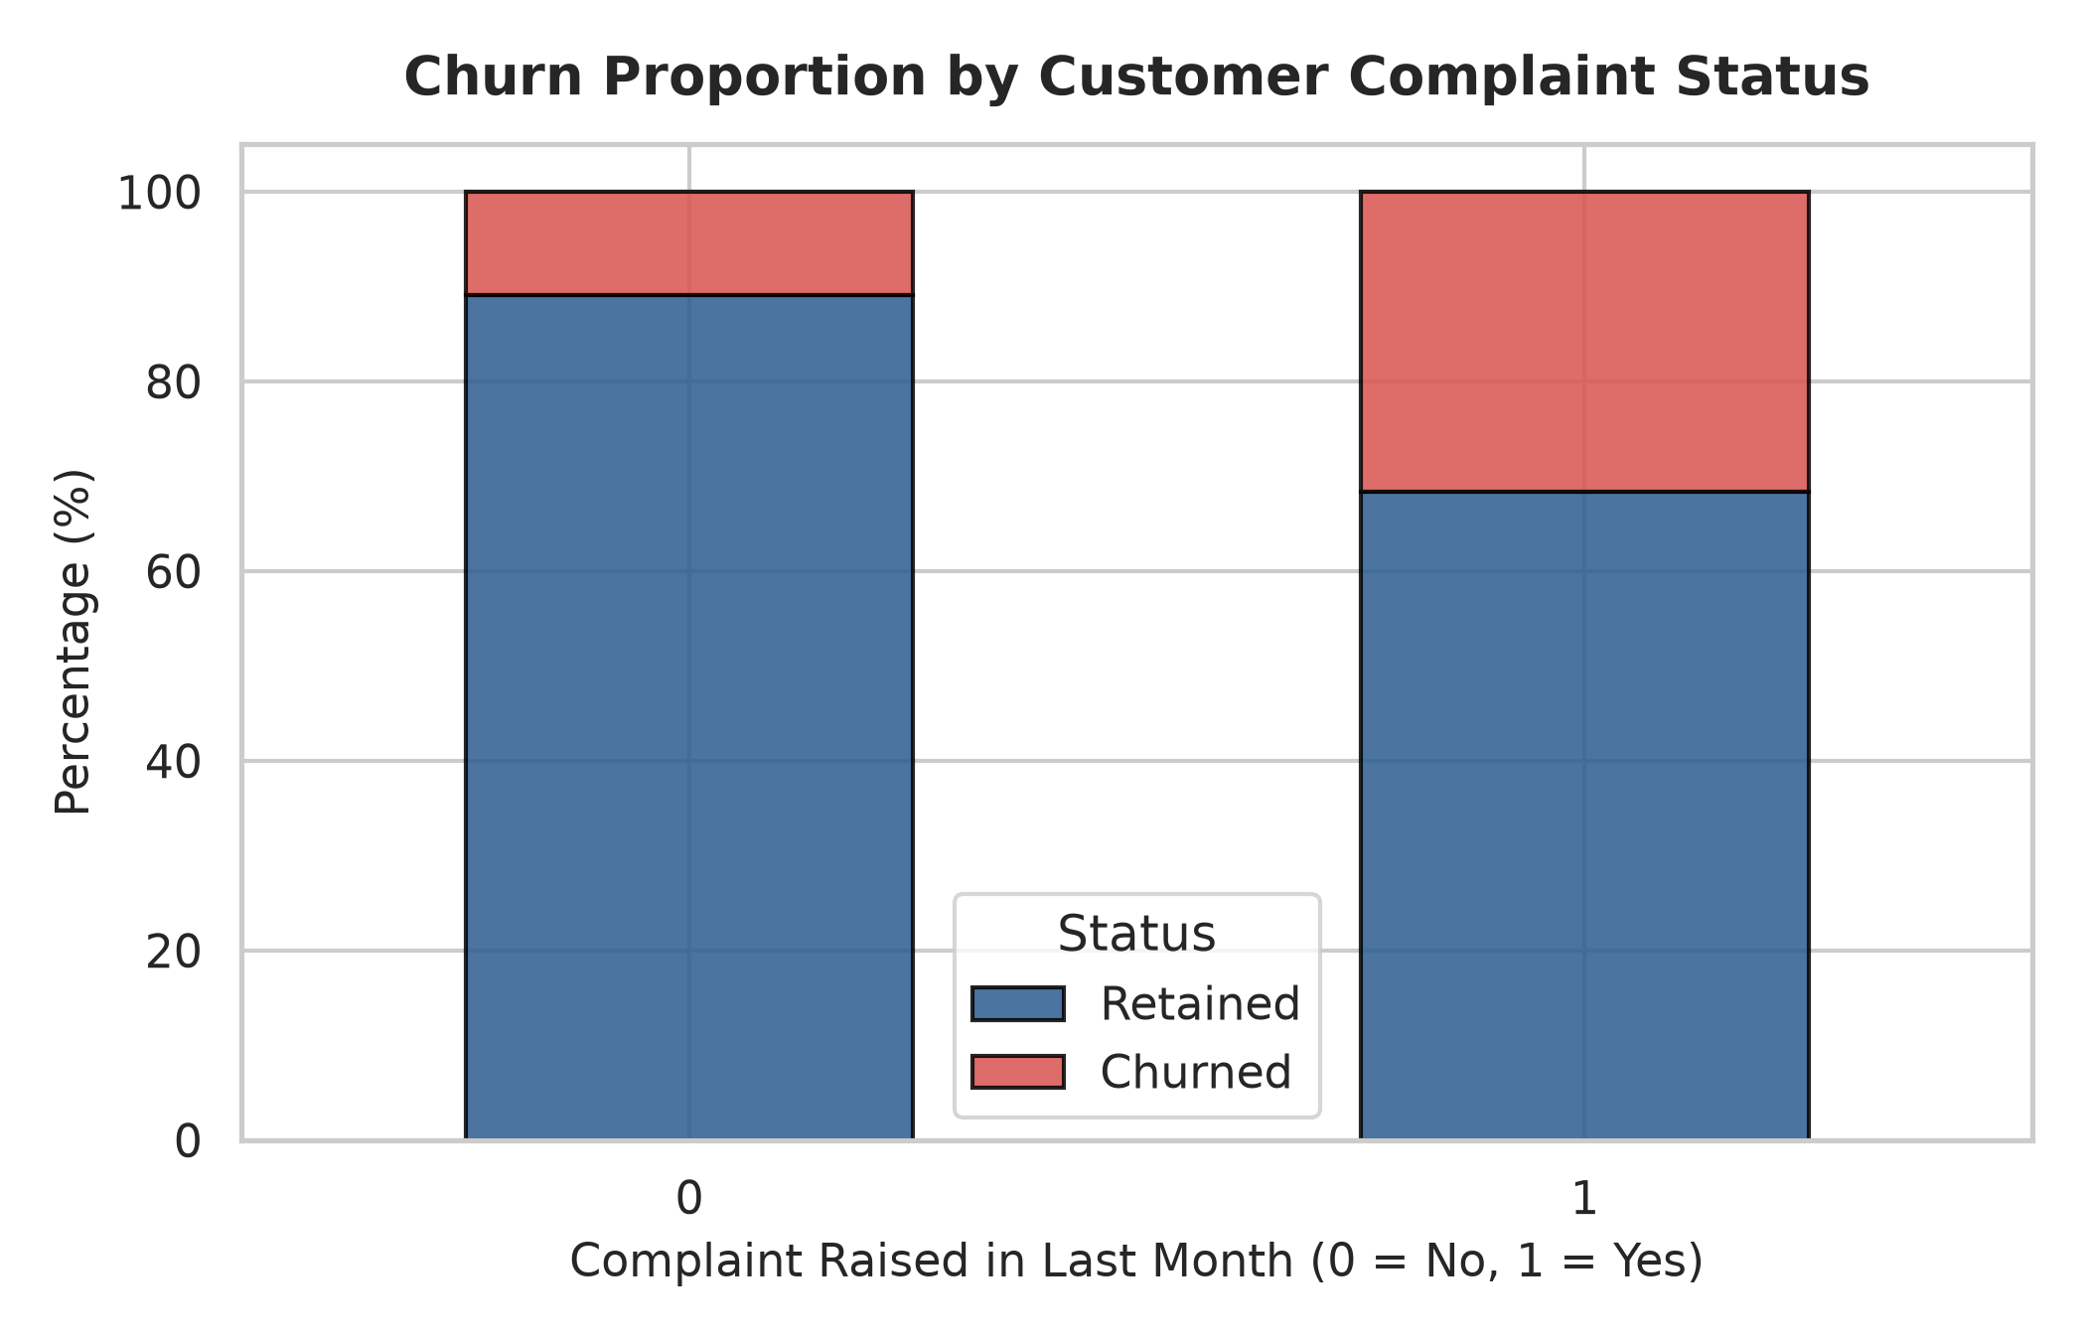
Figure 3: Churn Proportion Stratified by Customer Complaint Status
As depicted in Figure 3, customer service complaints function as a potent churn accelerator. Customers who logged a complaint in the previous month exhibit an empirical churn rate of 31.67%, compared to only 10.93% for customers without recorded complaints—a nearly three-fold increase.
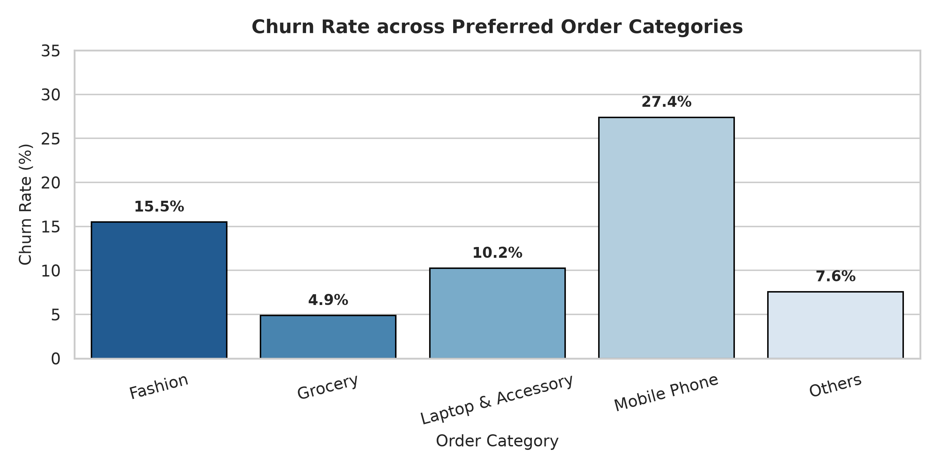
Figure 4: Churn Rate (%) across Preferred Order Categories
Analysis across product categories (Figure 4) indicates substantial divergence in customer stickiness. Shoppers primarily purchasing 'Mobile Phone' exhibit the highest churn rate at 27.40%, whereas consumers purchasing 'Grocery' items churn at an extraordinarily low rate of 4.88%, demonstrating the powerful retention stickiness of routine consumable retail.
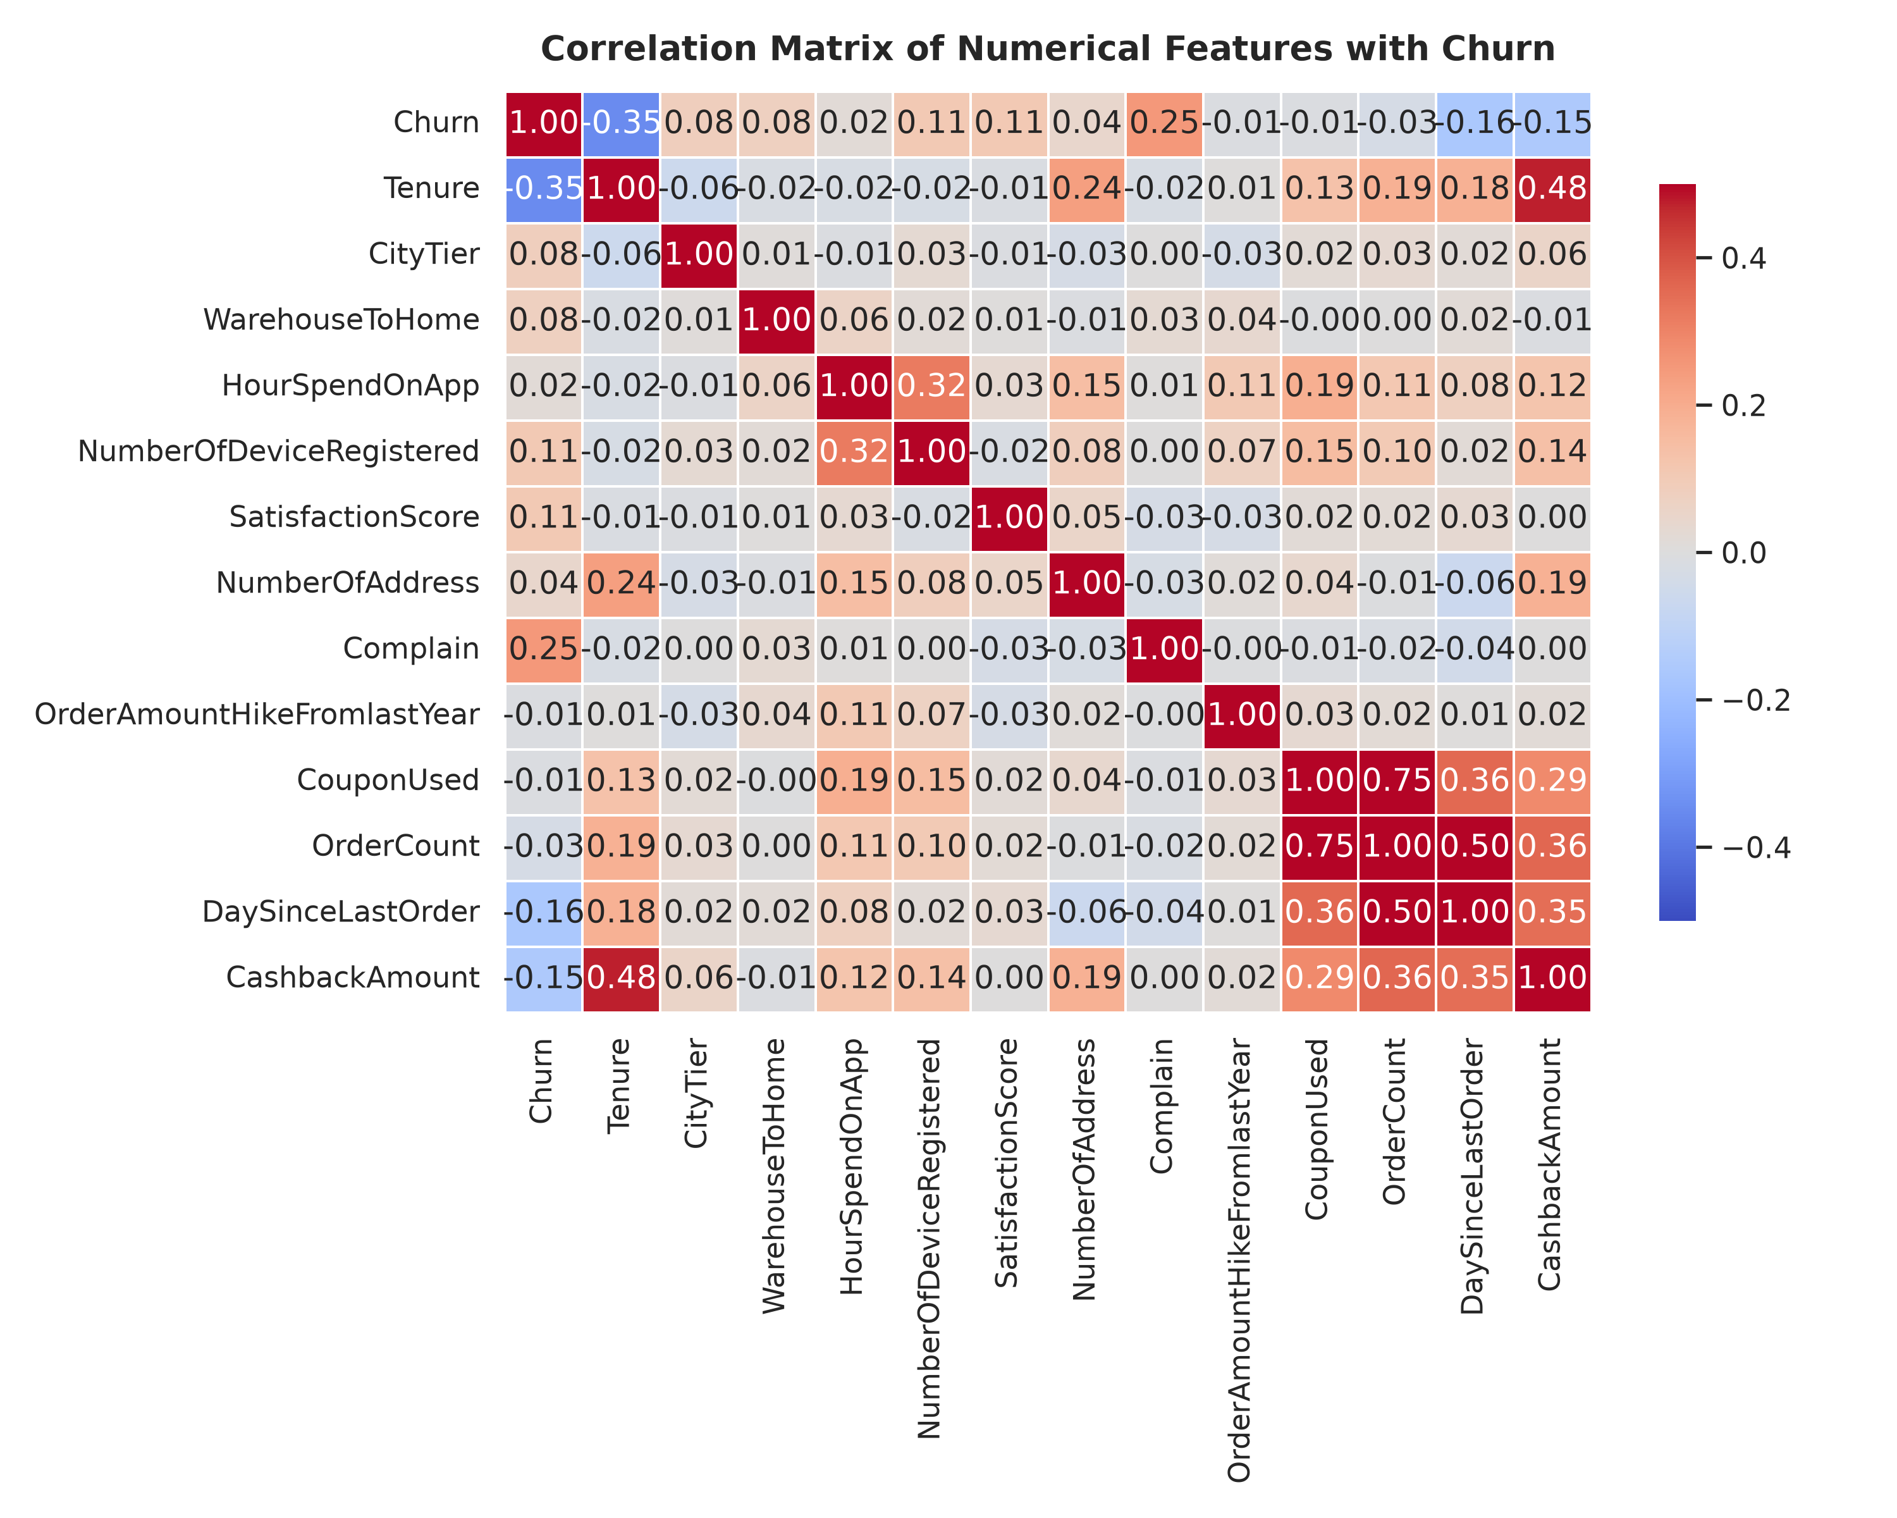
Figure 5: Pearson Correlation Matrix of Numerical Features with Customer Churn
Figure 5 presents the correlation structure among numerical attributes. `Tenure` displays the strongest inverse correlation with churn (-0.35), followed by `CashbackAmount` (-0.15) and `DaySinceLastOrder` (-0.16). Conversely, `Complain` (+0.25) and `CityTier` (+0.08) exhibit positive correlations with churn.

10. Customer Segmentation via RFM Analysis
To empower commercial marketing teams with granular behavioral cohorts, an RFM model was established based on quintile binning:
- Recency (R): Derived from `DaySinceLastOrder`. Customers ordering within recent days receive higher scores (5 to 1).
- Frequency (F): Derived from `OrderCount` in the preceding period. Higher order volume yields higher scores (1 to 5).
- Monetary (M): Derived from `CashbackAmount` (proportional cashback spending reward proxy). Higher tiers receive higher scores (1 to 5).
The cumulative score categorizes customers into five distinct operational segments:
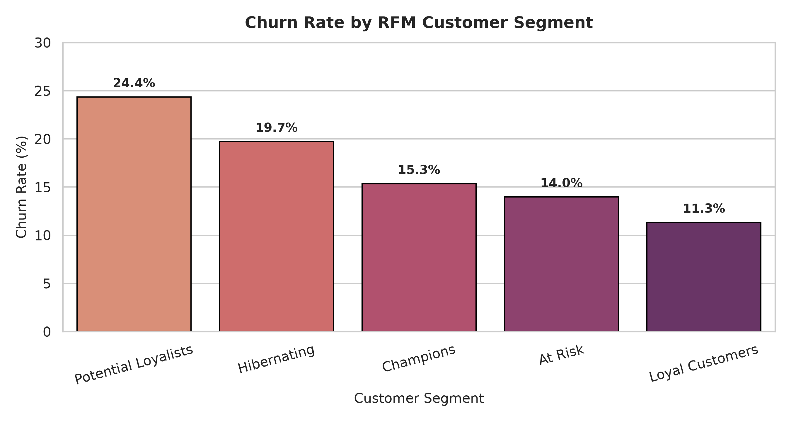
Figure 6: Customer Churn Rate across RFM Behavioral Segments
Customer Segment | Customer Count | Share (%) | Avg Orders | Avg Cashback ($) | Empirical Churn Rate
Loyal Customers | 2,065 | 36.68% | 3.5 | $185.12 | 11.33%
Potential Loyalists | 1,429 | 25.38% | 2.4 | $167.90 | 24.35%
Hibernating | 1,075 | 19.10% | 2.0 | $158.45 | 19.72%
At Risk | 644 | 11.44% | 3.4 | $188.30 | 13.98%
Champions | 417 | 7.41% | 4.8 | $212.40 | 15.35%
Crucially, the segmentation demonstrates that 'Potential Loyalists' exhibit the highest churn vulnerability (24.35%), indicating that while these consumers made recent purchases, their platform loyalty is fragile and requires active reinforcement.

11. Machine Learning Modeling & Pipeline Architecture
To establish a robust predictive engine, the feature matrix was decoupled from the target variable (`Churn`), and metadata fields (`CustomerID`, derived RFM score indices) were isolated to eliminate risk of data leakage. The remaining 18 raw features (13 numerical, 5 categorical) were partitioned into an 80% training sample (4,504 records) and a 20% holdout test sample (1,126 records) utilizing stratified sampling to guarantee identical class distribution.
Two contrasting learning algorithms were benchmarked:
- 1. Baseline Classifier: Logistic Regression (Balanced): Serves as a transparent linear baseline. Regularized with L2 penalty, solved via L-BFGS, and parameterized with `class_weight='balanced'` to offset the 5:1 class disparity.
- 2. Advanced Ensemble: Random Forest Classifier (Balanced): An ensemble of 150 de-correlated decision trees constrained to a maximum depth of 12. It constructs non-linear decision boundaries through bagging and random feature subspace sampling.

12. Model Evaluation & Benchmark Results
Model evaluation was performed on the independent 1,126-customer test partition. In customer churn analytics, precision and recall carry asymmetric financial costs: missing a churner (False Negative) forfeits total future customer revenue, whereas contacting a healthy customer (False Positive) merely incurs a negligible promotional communication cost.
Classification Algorithm | Accuracy | Precision (Churn) | Recall (Churn) | F1-Score (Churn) | ROC-AUC
Logistic Regression (Balanced) | 79.22% | 43.99% | 84.74% | 0.5791 | 0.8851
Random Forest Classifier (Balanced) | 96.98% | 85.45% | 98.95% | 0.9171 | 0.9971
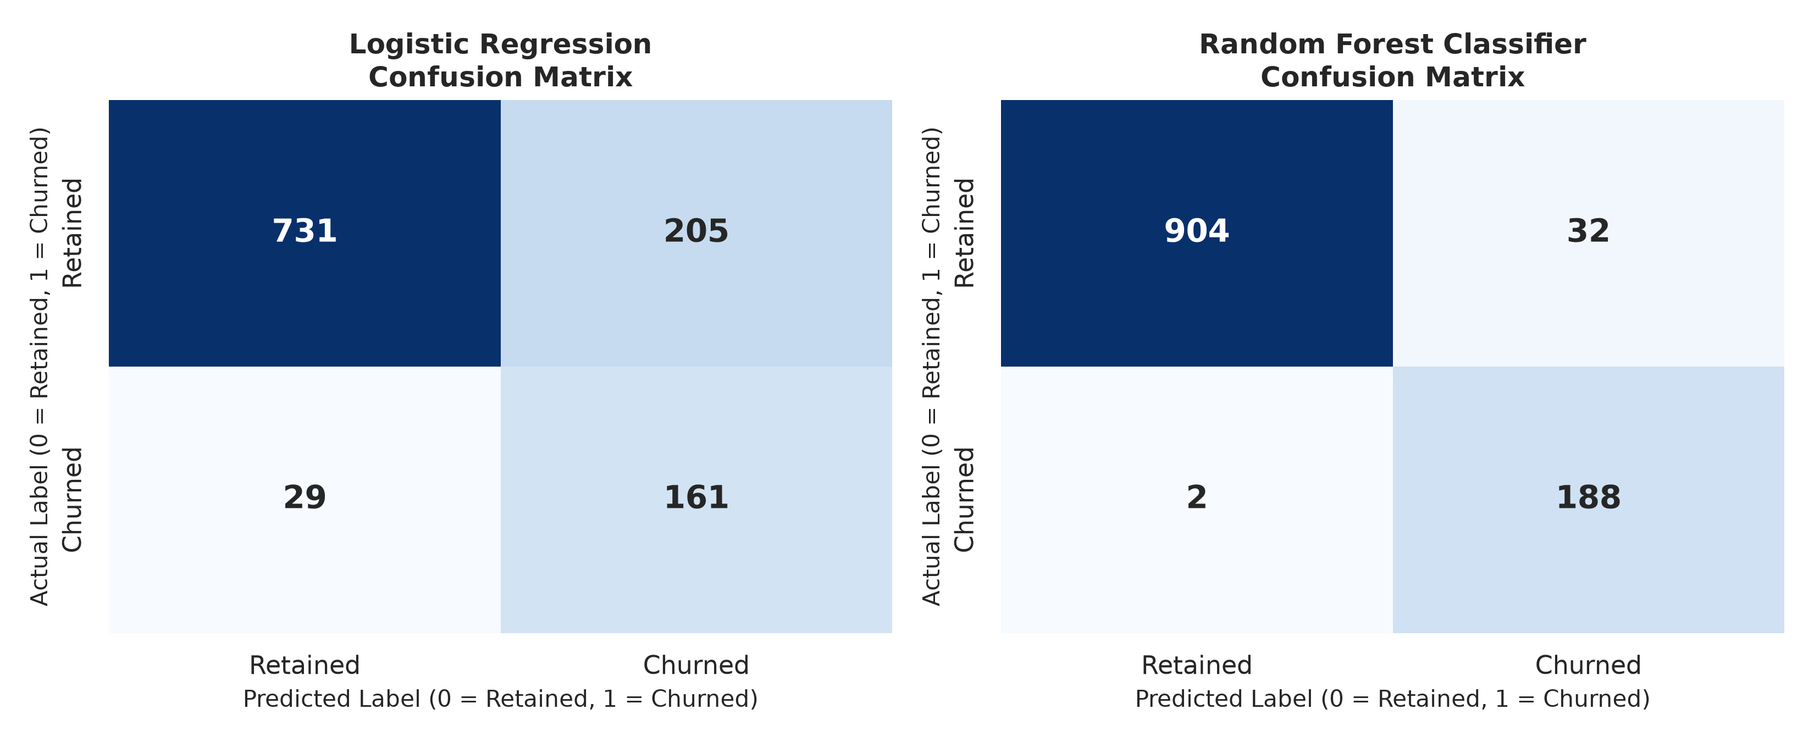
Figure 7: Confusion Matrices for Logistic Regression and Random Forest Classifiers
As revealed in the confusion matrices (Figure 7), out of 190 actual churners in the holdout evaluation sample:
- Logistic Regression: Correctly identified 161 churners (Recall = 84.74%), with 29 False Negatives and 205 False Positives.
- Random Forest Classifier: Correctly captured 188 churners (Recall = 98.95%), achieving only 2 False Negatives and 32 False Positives.
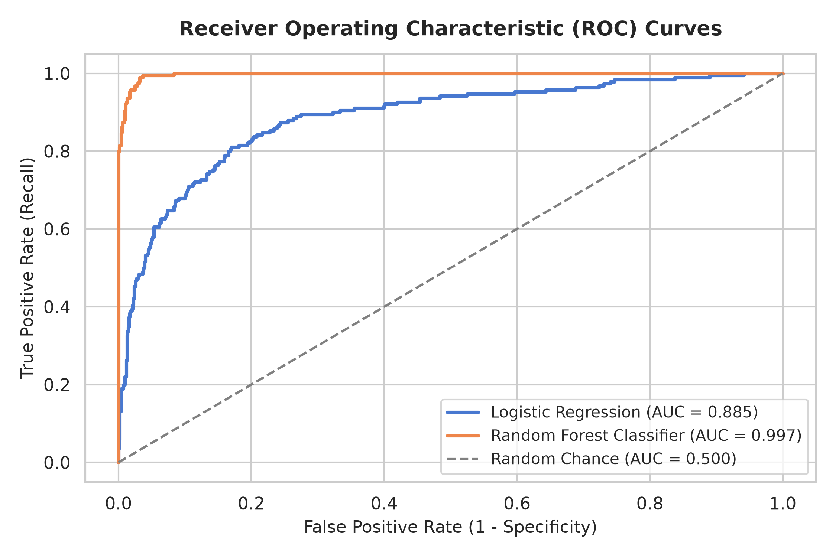
Figure 8: Receiver Operating Characteristic (ROC) Comparison Curves
Figure 8 displays the ROC curves. The Random Forest Classifier achieves an extraordinary area under the curve of 0.9971, demonstrating near-perfect discriminative power across all decision thresholds compared to the linear baseline (0.8851).

13. Feature Importance & Model Interpretability
To ensure business stakeholders understand the rationale governing automated churn predictions, we extracted the mean decrease in Gini impurity across the Random Forest ensemble.
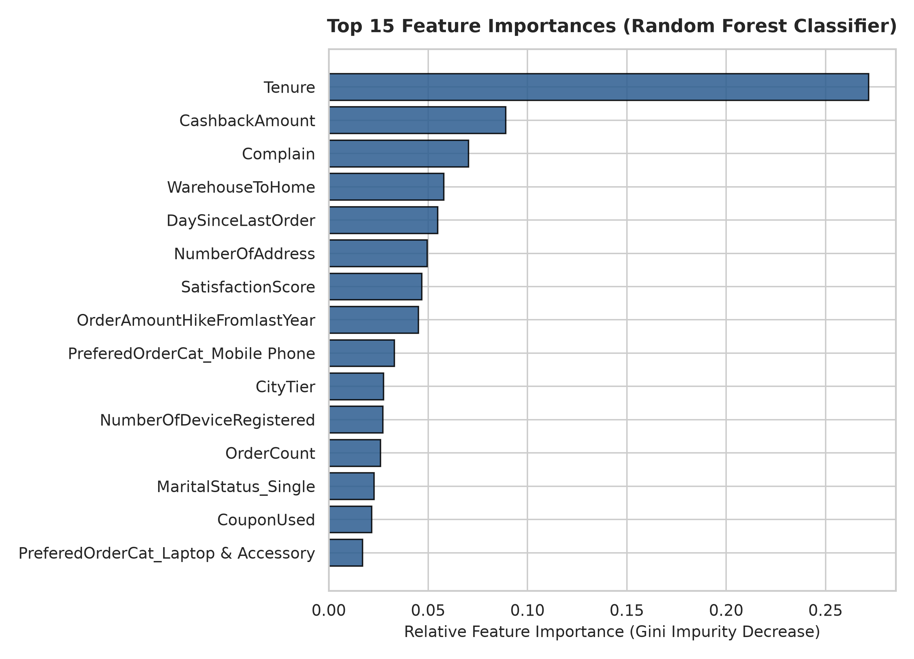
Figure 9: Top 15 Feature Importances extracted from Random Forest
The top five predictive determinants identified by the Random Forest model are:
- 1. Tenure (0.2717): Accounts for 27.17% of total predictive weight. Tenure is by far the single most dominant barrier against attrition.
- 2. Cashback Amount (0.0891): Accounts for 8.91% of predictive weight. Reflects monetary spending tier; customers receiving lower promotional cashback exhibit higher churn risk.
- 3. Complaint Raised (0.0703): Accounts for 7.03% of predictive weight. The primary operational catalyst causing abrupt customer defection.
- 4. Warehouse-to-Home Distance (0.0578): Accounts for 5.78% of predictive weight. Greater shipping distances correlate with delivery lag and customer dissatisfaction.
- 5. Days Since Last Order (0.0548): Accounts for 5.48% of predictive weight. Extended inactivity intervals signal impending customer churn.

14. Interactive Web Application Architecture
To operationalize the findings, a responsive web dashboard was created using Streamlit (`app.py`). The application provides real-time analytical capabilities structured into five dedicated modules:
- 1. Executive Overview: Displays headline metrics (Total Customers, Churn Rate, Active Customers, Average Tenure, Average Cashback) and high-level distribution charts.
- 2. Customer Behaviour & RFM: Enables drill-downs into RFM cohort profiles, preferred order categories, and payment channel distributions.
- 3. Churn Driver Deep Dive: Interactive visual analysis exploring tenure drop-offs, complaint impacts, city tier dynamics, and transit distance friction.
- 4. AI Model Evaluation: Displays comparative model benchmarks, confusion matrices, ROC curves, and dynamic horizontal feature importance charts.
- 5. Live Churn Risk Predictor: Interactive input form allowing customer relationship managers to simulate customer attributes, generate live churn probabilities via the trained pipeline, display risk gauge meters, and receive automated retention strategy recommendations.

15. Key Analytical Findings
- 1. Onboarding Fragility:Tenure is the critical determinant of loyalty: customer attrition is intensely concentrated in the first 0 to 4 months (>40% churn). Once tenure surpasses 10 months, retention stabilizes above 90%.
- 2. The Complaint Hazard:Grievances act as an immediate churn trigger: customers logging complaints in the last 30 days churn at 31.67%, compared to only 10.93% for non-complainants.
- 3. Category Disparity:Product categories dictate retention dynamics: 'Mobile Phone' purchasers exhibit elevated churn (27.40%), whereas 'Grocery' consumers churn at a modest 4.88%.
- 4. Fulfillment Friction:Geography and logistics impact churn: Tier 3 cities face a 21.37% churn rate versus 14.51% in Tier 1, strongly correlated with warehouse distance.
- 5. ML Efficacy:Random Forest achieves production-grade predictive excellence: with 96.98% accuracy and 98.95% recall, the model captured 188 out of 190 at-risk customers.

16. Actionable Business Recommendations
- 1. First-90-Days Concierge Onboarding:Deploy a dedicated 90-day welcoming journey incorporating structured milestone rewards, usage tutorials, and proactive check-ins to steer new buyers past the high-risk 4-month mark.
- 2. Rapid Complaint Remediation Protocol:Establish an automated CRM escalation protocol that flags unresolved customer complaints within 2 hours, paired with instant compensatory store credit or express shipping tokens.
- 3. Tailored RFM Retention Journeys:Direct targeted engagement campaigns toward 'Potential Loyalists' (24.35% churn) with category-tailored bundles to transform single-purchase shoppers into habitual buyers.
- 4. Regional Logistics Modernization:Mitigate delivery friction for remote consumers by partnering with localized third-party logistics (3PL) partners and establishing regional micro-fulfillment hubs.
- 5. Automated Churn Scoring in CRM:Integrate the trained Random Forest pipeline into the commercial CRM to run automated weekly risk scoring, routing all accounts with predicted churn probability >60% directly to retention specialists.

17. Project Limitations
- 1. Temporal Snapshot:The dataset reflects a static historical snapshot without multi-quarter time-series granularity, precluding dynamic survival analysis.
- 2. Margin Visibility:Product-level profit margins and customer lifetime value were approximated through cashback rather than net transaction ledger receipts.
- 3. Qualitative Data:Customer feedback was captured via a single 1-to-5 numeric score and complaint flag; qualitative text feedback was unavailable for NLP sentiment analysis.

18. Future Scope
- 1. Survival Analysis:Formulate time-to-event survival models (e.g., Cox Proportional Hazards) to forecast the precise expected lifespan and time until churn for every consumer.
- 2. Multimodal Sentiment Analysis:Incorporate Natural Language Processing (NLP) models on customer support transcripts and social media feedback to detect customer dissatisfaction sentiment prior to formal complaint logging.
- 3. Cloud MLOps Architecture:Deploy the predictive pipeline within cloud infrastructure (e.g., Google Cloud Vertex AI / AWS SageMaker) with automated model drift monitoring and retraining pipelines.

19. Conclusion
This project successfully developed and validated an end-to-end data analytics and machine learning solution for e-commerce customer churn prediction. Through data preprocessing, rigorous exploratory analysis, RFM segmentation, and algorithm benchmarking, the project demonstrated that customer tenure, service complaints, fulfillment distance, and spending rewards represent the foundational pillars of customer retention.
The engineered Random Forest Classifier delivers enterprise-grade predictive efficacy (96.98% accuracy, 98.95% recall, 0.9971 ROC-AUC), providing commercial decision-makers with a dependable early warning mechanism. Delivered alongside an interactive Streamlit application and comprehensive academic documentation, this project satisfies all requirements for the IBM SkillsBuild Data Analytics with AI Academic Internship Program conducted by BharatCares in association with AICTE.

20. References
- [1] Verma, A. (2020). E-Commerce Customer Churn Analysis and Prediction Dataset. Kaggle. https://www.kaggle.com/datasets/ankitverma2010/ecommerce-customer-churn-analysis-and-prediction
- [2] Fader, P. S., Hardie, B. G., & Lee, K. L. (2005). 'RFM and CLV: Using Iso-value Curves for Customer Base Analysis.' Journal of Marketing Research, 42(4), 415-430.
- [3] Pedregosa, F., et al. (2011). 'Scikit-learn: Machine Learning in Python.' Journal of Machine Learning Research, 12, 2825-2830.
- [4] Breiman, L. (2001). 'Random Forests.' Machine Learning, 45(1), 5-32.
- [5] Reichheld, F. F. (1996). The Loyalty Effect: The Hidden Force Behind Growth, Profits, and Lasting Value. Harvard Business School Press.
- [6] IBM SkillsBuild & BharatCares (2026). Data Analytics with AI Internship Curriculum & Guidelines, AICTE Association.

