**Project-5**

**Virus Propagation**

**Q.1]** The code for this question has been done and can be seen in the folder Scripts of zip. Here are the answers to the sub-questions.

a. Yes, the infection will spread in the network as the effective strength of the virus is >=1.

b. & c.

Here is the plot for varying values of β and δ when 1 is varying and other is kept constant we see the effect of it on effective strength of virus.

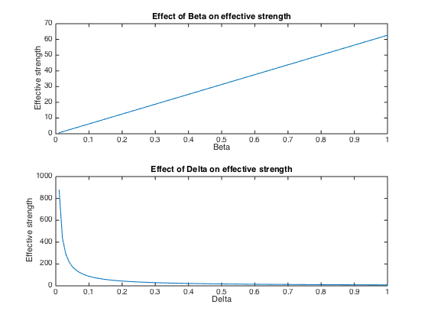

So as the value of β goes on increasing the strength of virus increases as more people in network will be infected. The minimum transmission probability β that results in network wide epidemic is 0.016

Similarly, as the value of δ increases the immunization of infected people increases which leads to more healing and hence the strength of virus decreases. The maximum healing probability (δ) is 8.7709 and since it goes beyond 1 here so the epidemic is imminent and cannot be cured.

d. Changing the values of β=0.01 and δ=0.6

The infection will not spread in the network as the effective strength of virus is <1.

The plot of β and δ on effective strength can be given as follows:

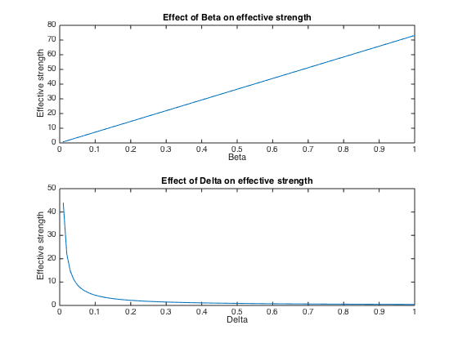

So as the value of β goes on increasing the strength of virus increases as more people in network will be infected. The minimum transmission probability β that results in network wide epidemic is 0.0137

Similarly, as the value of δ increases the immunization of infected people increases which leads to more healing and hence the strength of virus decreases. The maximum healing probability (δ) is 0.4385.

**Q.2]**

a. The code for simulation is done and can be seen in the scripts folder.

b. The plot of average value of simulations for β=0.2 and δ=0.7 can be seen as follows:

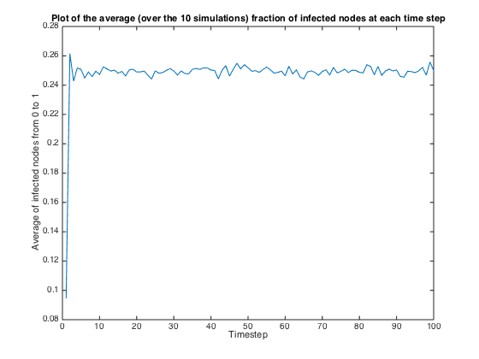

As we see that the epidemic once starts it grows and stays in the network throughout time and does not die out. The curve shows average of infected nodes in the network. This is consistent with our earlier result that the epidemic with β = 0.2 and δ = 0.7 never dies out.

c. The plot of average value of simulations for β=0.01 and δ=0.6 can be seen as follows:

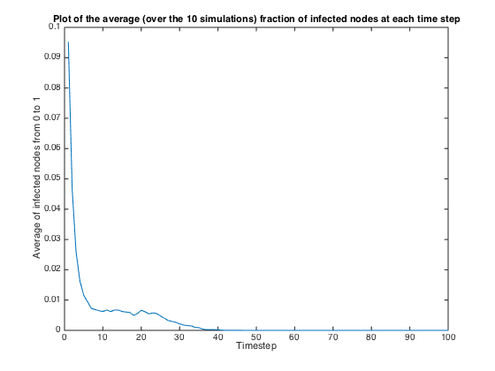

As we see that the epidemic once starts it goes on decreasing and dies out eventually. The curve shows average of infected nodes in the network. This is consistent with our earlier result that the epidemic with β = 0.01 and δ = 0.6 dies out and does not cause an epidemic

**Q.3]**

**a.** The optimal immunization policy would be to select and immunize those nodes that have maximum level of interaction in the graph. It need not be to immunize those sub graphs which form a clique. According to me, the most optimum strategy would be to find out node with corresponding to highest eigenvalue in adjacency matrix and immunizing that node by removing it from the graph and all its edges. We keep doing this for k number of times so at every step the node with highest interaction is immunized to prevent outbreak of epidemic. The running time of this algorithm can be given as O (k*n^3) where k <<n. It appears to be slower but the results are far better than the other approaches. This algorithm is feasible as other policies mentioned in supplementary material appear to be running in almost same time and it is expected the results of this algorithm will be better.

**Policy A: Select k random nodes for immunization.**

**b.** The heuristic behind this policy is to select random nodes so that the algorithm runs fast and there is not much logic required in determining appropriate nodes in a graph. It is suitable for dynamic graphs where the behavior of node keeps changing or for strongly connected graph where there is little difference between each vertex.

**c.** The Pseudo code for this policy might look something like this:

from graph G select k random nodes.

Remove those K nodes from G including all the edges.

Calculate the effective strength of the epidemic with new graph.

The time complexity of this policy is O(1) as the time required to generate random number is constant.

The above policy is coded and can be seen in scripts folder.

**d.** The effective strength of the immunized contact network is 3.539 and the policy cannot prevent epidemic.

**e.** The plot of K vs Effective strength can be given as follows when β and δ are kept constant is given as follows:

It is natural that the values of K and effective strength are inversely proportional but the optimality of this policy is weak as can be seen from graph that it requires significant of nodes to be immunized to make the network epidemic free.

The minimum value of vaccination required to prohibit network-wide epidemic comes out to be around 2650.

**f.** Here is the plot of values for simulation after removing k randomly chosen nodes from the graph.

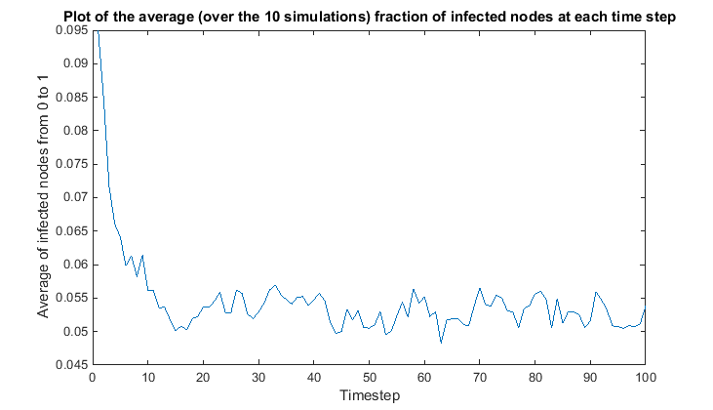

So, we see that the epidemic still persists in the network and it is not properly immunized hence it is consistent with our empirical calculations.

**Policy B: Select the k nodes with highest degree for immunization**

**b.** The heuristic behind this policy is that we immunize those nodes which are having most connection in the network. If the nodes which have maximum degree signifies that they have most connection with other nodes hence it makes practical sense in immunizing these nodes so the transmission can be reduced.

**c.** The pseud code for the above policy can be given as follows:

a. Calculate the degree of each node in the network. (Time complexity O(V+E)).

b. Find k largest degree node in the network. (Time complexity O(kV)).

c. Remove these nodes and their edges and then calculate strength of epidemic.

Hence, the time complexity of the policy can be given as sum of each step which is O(V +V^2+kV) 🡪 O(V^2+kV).

**d.** The value of effective strength comes out to be around 1.08 which is very close to threshold of 1 hence, it will prevent network wide epidemic. But since it is above threshold the algorithm suggests that epidemic will stay in the network.

**e.** The plot of values of k vs effective strength can be given as follows:

So we see that the value of effective strength goes below threshold at around k = 250. Hence, this policy could have prevented epidemic if we could have immunized few more nodes. This policy provides more optimal results as compared to Policy A. The minimum number of vaccinations required to prevent network-wide epidemic comes out to be around 250-260.

**f.** We try to simulate the above policy after immunizing the chosen nodes and we get following plot.

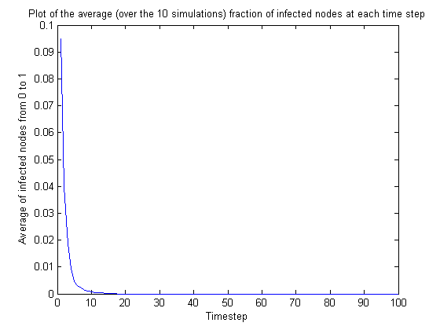

So the epidemic dies out after a few time steps. This is consistent with our results partially in predicting that there won’t be a network-wide epidemic and it will die out eventually.

**Policy C: Select the node with the highest degree for immunization. Remove this node (and its incident edges) from the contact network. Repeat until all vaccines are administered.**

**b.** The heuristic behind this policy is very much similar to the approach we used for the policy B but here we consider the effect of each node that is being removed and then selecting the next node with highest degree. This methodology helps us in minimizing a chance of fault that might occur in graphs where high degree nodes are connected to each other. If we remove some nodes then the degree of other present node changes and in such a scenario we must consider the best among these changed node and not those that were pre-decided.

**c.** The pseudo code for the policy can be given as follows:

i. for each k nodes to be removed.

a. Select the maximum degree node in network to be removed.

b. Remove the node along with the edges from network.

ii. After removing these k nodes we pass the network for calculating effective strength.

The time complexity of finding degree of each node in a graph is O(V+V^2) and we do this k number of times hence the time complexity is O(k(V+V^2)).

**d.** The value of effective strength of virus is same as there in policy B as 1.0845. This again means that there will be an epidemic but the low value also suggests that it will prevent network wide epidemic and again we see same case happening as policy B.

**e.** The plot for K vs effective strength of the virus can be given as follows:

From the graph we see that the value of immunization greatly decreases the effective strength and it is more stronger than rest of the policy although for this network both Policy B and Policy C show same behavior because the nodes are scattered and removal of node does not have much effect on other higher order nodes.

**f.** The simulation of virus propagation that can be observed after removing k nodes from the network based on policy can be given as follows:

The simulation results suggest that the virus grows in the network but it starts decreasing after few time steps. This is consistent with our empirical result as the virus will die down for certain value of K very close to 200 and policy also predicted that virus won’t be a network wide epidemic.

But we also see that the simulation results suggest that policy C is more optimal than policy B in eradicating epidemic from the network soon enough as it selects better nodes.

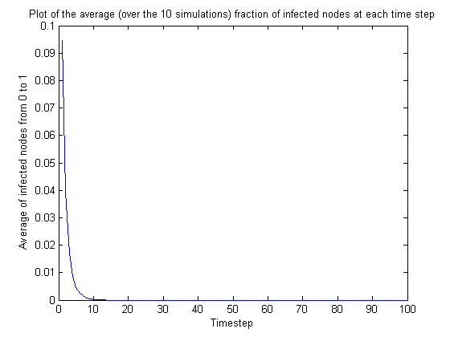

**Policy D: Find the eigenvector corresponding to the largest eigenvalue of the contact network’s adjacency matrix. Find the k largest (absolute) values in the eigenvector. Select the k nodes at the corresponding positions in the eigenvector.**

**b.** The heuristic behind this algorithm is that by analyzing eigenvalues we analyze the spectrum of graph and this tells us about the activity or involvement of each node in the network. So we select the highest eigenvalue and analyze the vector to capture corresponding nodes having high activity. So immunizing such nodes will decrease the transmission of epidemic.

**c.** The Pseudo code for this policy can be given as follows:

i. Calculate the eigenvalue and eigenvector for the network.

ii. Choose the eigenvector corresponding to largest eigenvalue of network.

iii. Select k absolute largest value in eigenvector and use the corresponding position in eigenvector as basis of selecting nodes that will be removed from the network.

iv. Remove those k nodes and their respective edges from the graph.

The time complexity of this policy is O(n^3+ kn) where O(n^3) is for calculating eigenvalues and eigenvector and O(kn) is for selecting k largest node from eigenvector.

**d.** The effective strength value of virus is 3.07 suggesting that the epidemic will persist but it will prevent network wide epidemic as suggested by low value of S.

**e.** The plot of K vs the effective strength of the network can be shown as follows:

We see that the policy reduces the network wide epidemic drastically and then behaves linearly. There is no particular value of number of vaccination that can be obtained from this policy.

**f.** The result of the simulation that can be seen when we remove the k selected nodes based on policy D can be show as follows:

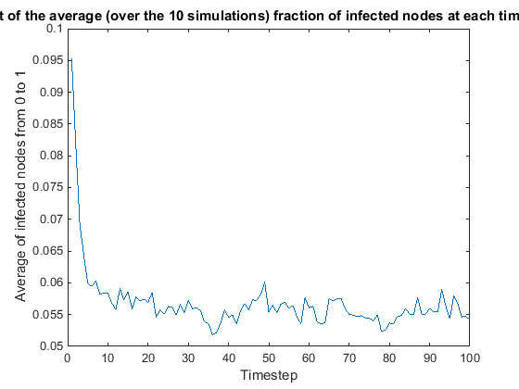

The result of simulation matches with our prediction as the policy succeeds in reducing the network-wide epidemic but it never dies out from the network.