GT AI Risk Assessment Framework
Methodology for identifying, assessing, treating and monitoring risks across the AI lifecycle
Aligned to ISO/IEC 23894 | ISO/IEC 42001 | ISO/IEC 42005 | NIST AI RMF & AI 600-1 | EU AI Act | Bahrain PDPL & iGA AI Policy | NSW AIAF

Grant Thornton Bahrain | AI Governance, Risk & Compliance Service Line
Version 1.1 | September 2026
Classification: Internal / Client-ready methodology

This framework is a Grant Thornton Bahrain methodology document. It is intended to be tailored to each client's context, risk appetite and regulatory obligations. It does not constitute legal advice.

Document control
Item | Detail
Document | GT AI Risk Assessment Framework
Version | 1.1 - adds agentic-AI security (ISACA 2026), ISO/IEC 42001 checks, AI security audit checklist integration and data classification for AI (v1.0: 24 Sept 2026)
Date | 26 September 2026
Owner | Grant Thornton Bahrain - AI GRC Service Line
Companion artefacts | GT AI Risk Assessment Toolkit (Excel) - template and worked example  GT AI RCM v2.1 (2026) - control library referenced by this framework  GT AI Security & Agent Audit Checklist v2.0 - item-level security audit programme  GT AI Readiness Assessment Tool - organisation-level readiness
Review cycle | Annually, or earlier on material regulatory change (e.g., EU AI Act Digital Omnibus outcome, Bahrain AI law enactment)

Contents
Right-click and select 'Update Field' to build the table of contents.

1. Executive summary
Artificial intelligence introduces risks that conventional IT, model or operational risk frameworks do not fully capture: probabilistic and opaque behaviour, dependence on data and foundation-model providers, new attack surfaces such as prompt injection, impacts on individuals' rights, and fast-moving regulation such as the EU AI Act and the region's emerging AI policies. Organisations in Bahrain are adopting AI quickly - the national General Policy for the Use of AI (iGA, 2025) and Bahrain Economic Vision 2030 actively encourage it - but most do not yet have a structured, repeatable way to decide which AI uses are acceptable and under what conditions.
The GT AI Risk Assessment Framework (GT-AIRAF) provides that method. It combines the ISO 31000 / ISO/IEC 23894 risk-management process with AI-specific practices from NIST AI RMF, ISO/IEC 42005 impact assessment, the EU AI Act risk-based classification and the tiered self-assessment model of the NSW AI Assessment Framework. Its key features are:
- Proportionality by design - a 10-factor inherent-risk tiering (Low / Medium / High / Critical) determines assessment depth, approval authority and review frequency, so low-risk productivity uses are not slowed down while high-impact systems receive rigorous scrutiny.
- A comprehensive AI risk taxonomy - 52 risks in 12 categories, spanning governance, legal, fairness, privacy, data, performance, transparency, security, human oversight, third-party, operational and societal risks, including emerging agentic-AI and AI-enabled threat risks.
- Multi-dimensional impact assessment - impacts on individuals and rights are assessed alongside financial, regulatory, operational, reputational and safety/societal impacts, on a common 5x5 scale.
- Direct link to controls - every risk maps to controls in the GT AI Risk & Control Matrix (RCM v2.1, 81 controls), which in turn map to ISO/IEC 42001, EU AI Act, NIST AI RMF, Bahrain PDPL and CBB requirements.
- Lifecycle coverage - assessments are triggered at defined lifecycle gates and on material change, with KRIs for continuous monitoring.
- Practical tooling - an Excel toolkit automates tiering, scoring, heat maps, top-risk reporting and sign-off.
How the framework fits the GT AI GRC service line
Organisation level: the GT AI Readiness Assessment Tool (and AI Ready7) measures capability maturity. Control level: the GT AI RCM v2.1 defines what 'good' looks like. Use-case level: this framework assesses and treats risk for each AI system and feeds the AI register, risk register and management reporting.

2. Purpose, scope and application

2.1 Purpose
- Provide a consistent, defensible and auditable method to identify, analyse, evaluate, treat and monitor risks from the development, procurement and use of AI systems.
- Enable informed go / no-go and conditional-approval decisions proportionate to the risk of each AI use case.
- Demonstrate conformity with ISO/IEC 42001 clauses 6.1.2 (AI risk assessment), 6.1.3 (AI risk treatment) and 6.1.4 (AI system impact assessment), EU AI Act Art. 9 / Art. 26-27, and supervisory expectations of regulators such as the CBB.
- Generate the evidence (risk register, impact assessment, approvals) required by auditors, certification bodies and regulators.

2.2 Scope
The framework applies to any 'AI system' as defined by the OECD / EU AI Act: a machine-based system that, for explicit or implicit objectives, infers from the input it receives how to generate outputs such as predictions, content, recommendations or decisions that can influence physical or virtual environments. In scope are:
- AI developed in-house, customised by vendors, or procured as commercial off-the-shelf or SaaS services;
- AI features embedded in existing enterprise software (e.g., CRM, ERP, productivity suites);
- generative AI and large language model (LLM) applications, retrieval-augmented generation (RAG) and AI agents;
- traditional machine-learning models (e.g., credit scoring, fraud detection, forecasting) and intelligent automation;
- third-party AI used by suppliers to deliver services to the organisation.
Publicly available general-purpose AI tools used for low-risk productivity tasks may be governed by the AI Acceptable Use Policy (RCM GL-5) rather than a full assessment, provided the policy explicitly authorises that use - consistent with the NSW AIAF approach.

2.3 When to apply the framework
Trigger type | Assessment points
Lifecycle gates | Concept / design (initial tiering) - Procurement (vendor due diligence) - Pilot / validation - Pre-deployment (full assessment & approval) - Operation (periodic review per tier) - Retirement
Material change | New or changed purpose, user population or geography - change of model, provider or model version - new data sources or categories - reduced human oversight or increased autonomy (e.g., adding agent actions) - integration with new systems
Risk signals | KRI threshold breach - incident or near miss - complaint or contest trend - new regulation or guidance - new threat intelligence (e.g., new jailbreak technique) - discovery of unassessed (shadow) AI

3. Standards basis and alignment
The framework is deliberately standards-based so that outputs are recognisable to auditors, certification bodies and regulators. The table below shows how each reference is used.
Reference | How it is used in GT-AIRAF
ISO 31000:2018 / ISO/IEC 23894:2023 | Core process (context, identification, analysis, evaluation, treatment, monitoring, communication) and AI-specific risk sources.
ISO/IEC 42001:2023 | Management-system requirements for AI risk assessment (6.1.2), treatment (6.1.3), impact assessment (6.1.4), Annex A controls and objectives.
ISO/IEC 42005:2025 | Structure and content of AI system impact assessments (individuals, groups, society).
NIST AI RMF 1.0 & AI 600-1 (GenAI Profile) | Govern-Map-Measure-Manage functions; trustworthiness characteristics; 12 generative-AI risk categories used in the taxonomy.
EU AI Act (Reg. 2024/1689) | Prohibited practices (Art. 5), high-risk classification (Art. 6, Annex III), risk management (Art. 9), deployer duties and FRIA (Art. 26-27), transparency (Art. 50).
NSW AI Assessment Framework (AIAF) | Tiered self-assessment model: risk triggers, Low-Critical risk bands, escalation to an AI review committee, contestability principle.
OWASP Top 10 for LLM / Agentic Applications; MITRE ATLAS; NIST AI 100-2 | Security risk identification and threat modelling for AI systems.
Bahrain PDPL (Law 30/2018); iGA General Policy for the Use of AI (2025); GCC AI Ethics Manual; CBB Rulebook | Local legal and regulatory criteria in impact scales, taxonomy and treatment.
MIT AI Risk Repository; OECD AI Incidents Monitor | Completeness check of the taxonomy; incident-based likelihood calibration.
GT AI Ready7 & GT AI RCM v2.1 | Organisation-level maturity inputs and the control library used for treatment.

4. Guiding principles
Principle | What it means in practice
Proportionate | Effort and approval levels scale with inherent risk tier; Low-tier uses follow a light path.
Lifecycle-based | Risk is assessed at every gate and re-assessed on material change - not a one-off exercise.
Socio-technical | Risks to people, rights and society are considered alongside technical, financial and legal risks.
Evidence-based | Ratings are supported by testing, monitoring data, incident history and documentation.
Human accountability | Every AI system has named business and technical owners; AI never 'owns' a decision.
Integrated | AI risk feeds the enterprise risk register, uses the enterprise risk scales and escalation routes, and links to existing privacy, security and model-risk processes.
Transparent & contestable | Assessments are documented; affected persons have a route to challenge AI-supported decisions.

5. Governance, roles and responsibilities
The framework operates within a three-lines model with board-level oversight of AI risk appetite.
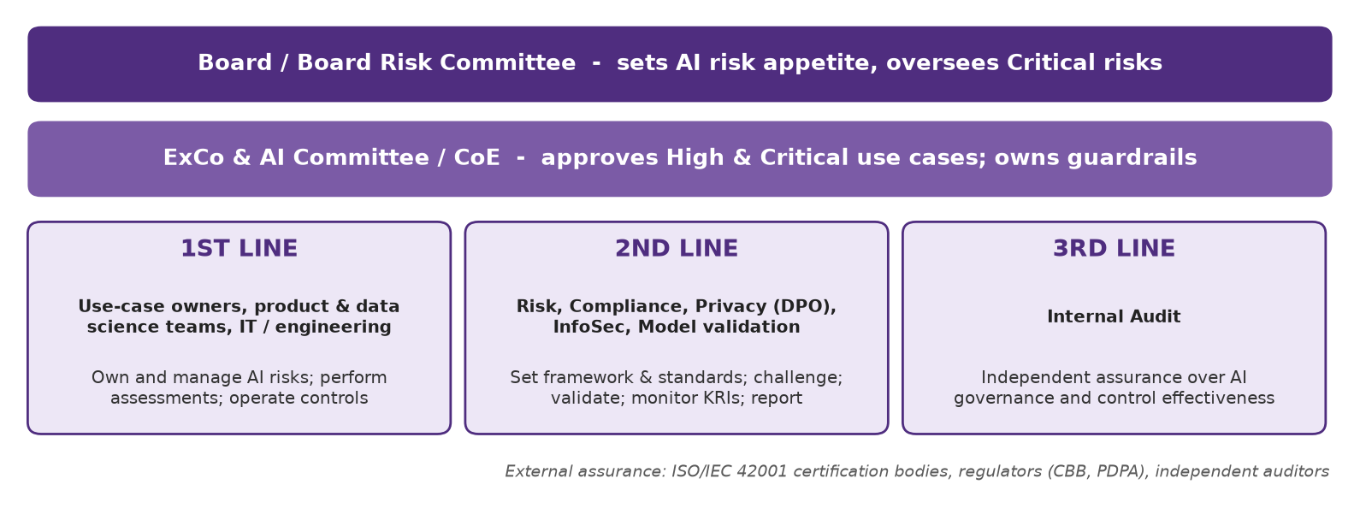
Activity | Use-case owner | Tech / data team | Risk (2nd line) | Privacy / Legal / Compliance | InfoSec | AI Committee | Internal Audit
Use-case profile & tiering | A/R | C | C | C | C | I | -
Prohibited-practice screening | R | C | C | A | - | I | -
Risk identification & analysis | A | R | C | C | C | I | -
Impact assessment (High/Critical) | A | R | R | R | C | I | -
Independent validation / challenge | I | C | A/R | C | R | I | -
Treatment plan & controls | A | R | C | C | R | I | -
Approval - Low / Medium | A | - | C | C | C | I | -
Approval - High / Critical | R | C | C | C | C | A | -
KRI monitoring & re-assessment | A | R | R | C | C | I | -
Independent assurance | I | I | I | I | I | I | A/R

R = Responsible, A = Accountable, C = Consulted, I = Informed.

6. The AI risk assessment process
The process has seven stages. Stages 0-1 are completed for every AI use case; stages 2-6 are completed at a depth determined by the tier.
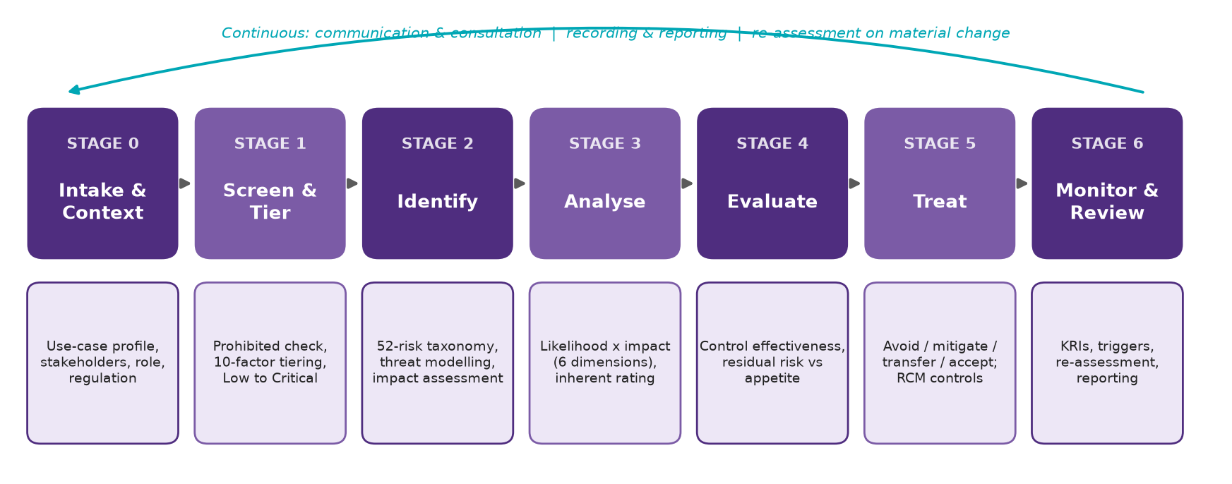

Stage 0 - Intake and context establishment
The use-case owner registers the AI use case in the AI register (RCM GL-8) and completes the use-case profile. The objective is a shared understanding of what the system is intended to do, for whom and under which constraints.
- Intended purpose, out-of-scope uses and success measures;
- AI system type (GenAI, agentic, predictive ML, computer vision, embedded AI, etc.) and lifecycle stage;
- the organisation's role - provider, deployer, importer or distributor - which determines EU AI Act obligations;
- affected stakeholders, including vulnerable groups;
- data sources and categories (personal, sensitive, confidential, client data);
- third parties and hosting locations (relevant for PDPL cross-border rules);
- applicable laws, regulations, contracts and internal policies.

Stage 1 - Screening and inherent risk tiering
Step 1a - Prohibited-practice screen. Eight questions based on EU AI Act Art. 5 (manipulation, exploitation of vulnerabilities, social scoring, predictive policing on profiling alone, untargeted facial scraping, workplace/education emotion recognition, sensitive biometric categorisation, real-time remote biometric identification). Any 'Yes' stops the assessment pending Legal review.
Step 1b - Inherent risk tiering. Ten factors are rated 0-4 before considering controls. Each factor has a weight reflecting its contribution to potential harm. The weighted score is normalised to 0-100.
# | Factor | Weight | Level 0 (lowest) | Level 4 (highest)
T1 | Impact of decisions on individuals | 3 | No decisions about individuals (e.g., internal content drafting, code assistance) | Makes or determines decisions with legal or similarly significant effects (credit, hiring, eligibility, health, law enforcement)
T2 | Autonomy & human oversight | 3 | AI provides information only; humans make all decisions | AI agent acts autonomously on systems / external parties with no practical real-time intervention
T3 | Data sensitivity | 2 | Public or synthetic data only | Sensitive personal data (health, biometric, financial, children, criminal) or regulated/classified data
T4 | Scale & reach | 1 | Fewer than 10 internal users; pilot | Large-scale public or market-wide impact (> 10,000 people)
T5 | Reversibility of outcomes | 2 | Outputs are advisory drafts with no direct effect | Irreversible harm possible (safety, liberty, significant financial loss)
T6 | Vulnerable groups affected | 2 | No individuals affected | Children, patients, persons in financial distress or other highly vulnerable persons
T7 | Regulatory classification & sector criticality | 2 | Unregulated, non-critical activity | High-risk AI classification (e.g., EU AI Act Annex III) or critical infrastructure
T8 | Technology novelty & opacity | 1 | Rules-based / deterministic automation | Agentic or multi-model AI ecosystem, self-learning in production
T9 | External exposure | 1 | Offline / isolated system | Public-facing and able to act on external systems / third parties
T10 | Third-party dependence | 1 | Fully in-house model and infrastructure | Critical dependence on a single opaque third-party AI provider

Tier thresholds and override rules:
Tier | Score | Assessment requirements | Approval authority | Review
Low | 0-24 | Self-managed by use-case owner; lightweight assessment; register entry. | Use-case owner | Every 24 months or on material change
Medium | >= 25 | Standard risk assessment; SME review (privacy, security, data); documented controls. | Head of function + Risk (2nd line) review | Every 12 months or on material change
High | >= 50 | Full risk & impact assessment (ISO/IEC 42005 / FRIA where required); independent validation; AI Committee approval. | AI Committee / CoE | Every 6 months + continuous KRI monitoring
Critical | >= 75 | As High plus legal review, executive sign-off, board notification, pre-deployment red teaming and staged rollout. | Executive Committee / Board Risk Committee | Quarterly + continuous KRI monitoring

- Decisions with legal or similarly significant effects (T1 = 4) or high-risk regulatory classification such as EU AI Act Annex III (T7 = 4) - minimum tier High.
- Material decisions about individuals (T1 >= 3) with limited human oversight (T2 >= 3) - minimum tier High.
- Significant-effect decisions made autonomously (T1 = 4 and T2 = 4) - tier Critical.
- Processing of sensitive personal or regulated data (T3 = 4) - minimum tier Medium.
Override rules mirror the AIAF 'pattern risk' concept: certain combinations are high-risk regardless of the average score.

Stage 2 - Risk identification
Risks are identified by working systematically through the GT AI risk taxonomy (Section 7), supplemented by:
- structured workshops with the use-case owner, data scientists, IT, risk, privacy, legal and business users;
- an AI system impact assessment per ISO/IEC 42005 for High and Critical tiers - covering intended and unintended impacts on individuals, groups and society, and a Fundamental Rights Impact Assessment where EU AI Act Art. 27 applies;
- threat modelling using OWASP LLM / Agentic Top 10 and MITRE ATLAS for systems with external exposure or agent capabilities - for agents, model every stage of the workflow (user input, retrieval, memory, inference, tool calls / APIs, human approvals, output delivery, tenant boundaries and privileged actions) as recommended by ISACA (2026);
- the GT AI Security & Agent Audit Checklist v2.0 (125 items, incl. the ISACA agent section and ISO/IEC 42001 checks) to identify control gaps that raise likelihood ratings;
- review of incidents in comparable systems (AI Incident Database, OECD AIM) and vendor documentation (model cards, system cards);
- a data-protection impact assessment where personal data is processed (Bahrain PDPL).
Each identified risk is recorded as a scenario: cause -> event -> consequence (e.g., 'Indirect prompt injection in a retrieved document causes the assistant to disclose another customer's balance, resulting in a PDPL breach and customer harm').

Stage 3 - Risk analysis
Each risk is rated on inherent likelihood and inherent impact, assuming no controls (or only controls inherent to the design). The inherent score is Likelihood x Impact (1-25).
Score | Likelihood | Definition
1 | Rare | May occur only in exceptional circumstances; < 5% chance within 12 months; no known occurrences in similar systems.
2 | Unlikely | Could occur but not expected; 5-20% within 12 months; isolated occurrences in industry.
3 | Possible | Might occur; 20-50% within 12 months; has occurred in comparable organisations.
4 | Likely | Will probably occur; 50-80% within 12 months; has occurred previously in the organisation.
5 | Almost certain | Expected to occur; > 80% within 12 months or recurring.

Impact is rated on the highest applicable of six dimensions. Financial thresholds are indicative for a mid-sized Bahraini organisation and must be calibrated to the client's enterprise risk scales.
Score | Individuals & rights | Financial | Regulatory & legal | Operational | Reputational & client trust | Safety, societal & environmental
1 Insignificant | No discernible effect on individuals | < BHD 5,000 | No breach; no regulatory interest | Negligible disruption (< 1 hour) | No external awareness | No harm
2 Minor | Minor inconvenience to a few individuals, easily remedied | BHD 5,000 - 50,000 | Minor breach; self-reported; no sanction | Minor disruption (< 1 day); workaround available | Limited local / client awareness | Minor, temporary, contained harm
3 Moderate | Adverse effect on a group; rights affected but remediable | BHD 50,000 - 250,000 | Breach resulting in regulatory enquiry or warning | Disruption of key process (1-3 days) | Negative media / client complaints; short-term | Moderate harm; limited environmental impact
4 Major | Significant harm or discrimination affecting many individuals | BHD 250,000 - 1,000,000 | Regulatory sanction, fine or enforcement action | Critical service outage (> 3 days) | Sustained national media coverage; loss of key clients | Serious injury / significant societal harm
5 Severe | Irreversible harm to individuals' rights, safety or livelihood at scale | > BHD 1,000,000 | Licence suspension / criminal liability / prohibited practice | Prolonged failure of critical operations | Long-term, international reputational damage | Loss of life / widespread irreversible harm

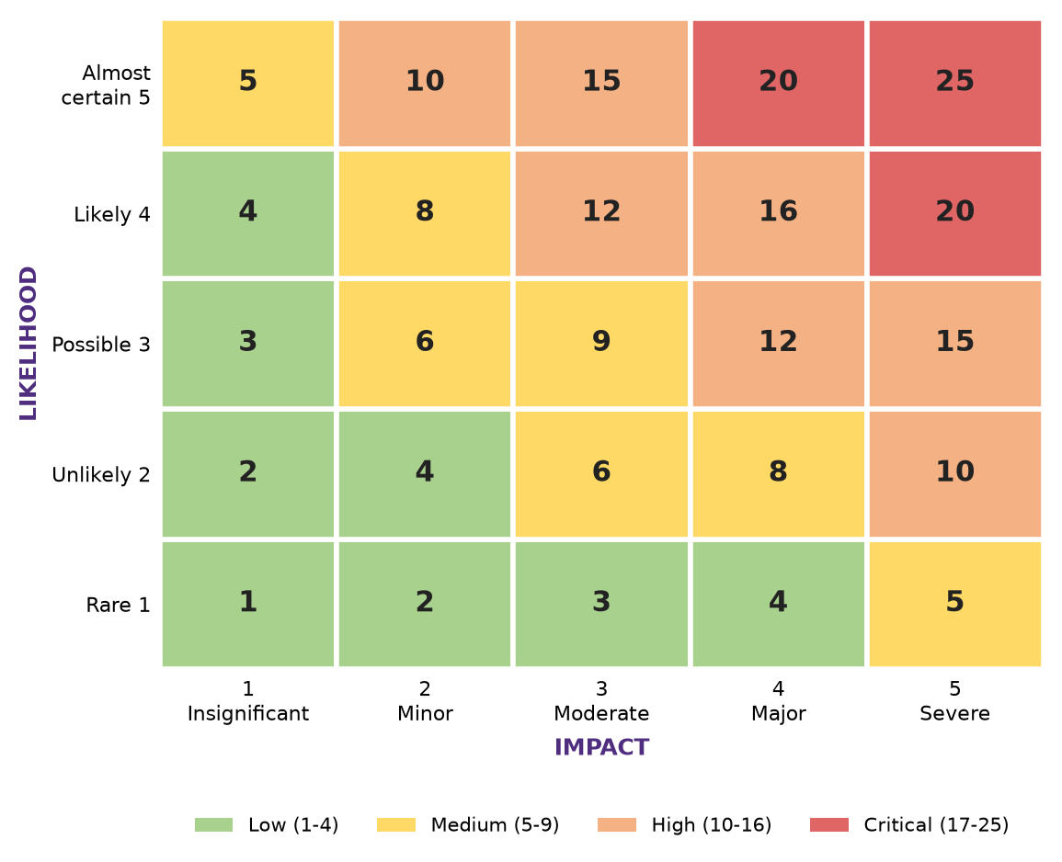

Stage 4 - Risk evaluation
Existing controls are identified (using RCM v2.1 control IDs) and their effectiveness rated. The residual score is the inherent score multiplied by the control-effectiveness factor. Residual risk is then compared with the organisation's AI risk appetite (RCM RM-6).
Control effectiveness | Factor | Definition
Strong | 0.4 | Controls designed and operating effectively; tested with no material exceptions; automated where appropriate.
Satisfactory | 0.6 | Controls largely designed and operating; minor exceptions; improvement opportunities identified.
Needs improvement | 0.8 | Controls partly designed or inconsistently operated; material exceptions; reliance limited.
Weak / None | 1.0 | Controls absent, not designed to address the risk, or not operating.

Residual rating | Score | Required response
Low | 1-4 | Accept; monitor through normal governance.
Medium | 5-9 | Treat within normal planning cycle; owner accountable; monitor KRIs.
High | 10-16 | Treatment plan within 90 days; AI Committee oversight; consider restricting use.
Critical | 17-25 | Outside appetite: immediate action; escalate to Executive / Board; suspend or do not deploy until reduced.

Default risk appetite
Unless the board has approved a different AI risk appetite: residual Low and Medium risks are within appetite; residual High risks require a time-bound treatment plan approved by the AI Committee; residual Critical risks are outside appetite - the system must not be deployed (or must be suspended) until the risk is reduced, unless formally accepted by the Executive Committee with board notification.

Stage 5 - Risk treatment
Option | When to use | Examples for AI systems
Avoid | Risk is unacceptable and cannot be reduced cost-effectively; prohibited practice | Do not deploy; remove a high-risk feature (e.g., autonomous payment execution); restrict scope
Mitigate | Controls can reduce likelihood or impact to within appetite | Guardrails, human-in-the-loop, retrieval grounding, bias mitigation, PII redaction, least-privilege agent permissions, monitoring
Transfer / share | Part of the risk can be borne by a third party | Contractual indemnities and SLAs with AI vendors; cyber / professional-indemnity insurance
Accept | Residual risk is within appetite, or formally accepted by the correct authority | Documented acceptance with rationale, conditions, owner and review date

Treatment plans specify the actions, RCM controls to implement, owner, due date and expected residual rating. For High and Critical tiers, treatment effectiveness must be verified by testing (e.g., bias testing, red teaming, independent validation - RCM RS-5, AA-3, LC-9) before approval.

Stage 6 - Monitoring, review and reporting
- KRIs: each material risk has at least one key risk indicator with thresholds and a mandatory response (e.g., drift score, hallucination rate, override rate, blocked injection attempts, complaints).
- Re-assessment: per tier frequency (Critical quarterly, High six-monthly, Medium annually, Low every 24 months) and on any trigger in Section 2.3.
- Reporting: portfolio-level AI risk dashboard to the AI Committee quarterly and to the board risk committee at least semi-annually - tier distribution, residual High/Critical risks, overdue actions, incidents and KRI breaches.
- Incidents: AI incidents are managed through RCM IM-1 to IM-3, including regulatory notification (EU AI Act Art. 73, PDPL, CBB) where required, and feed back into risk ratings.

7. GT AI risk taxonomy
The taxonomy contains 52 risks in 12 categories. It consolidates the NIST AI 600-1 generative-AI risks, ISO/IEC 23894 risk sources, EU AI Act requirements, OWASP and MITRE ATLAS security threats and the GT AI Ready7 pillars. Each risk is linked to RCM v2.1 controls and an example KRI in the toolkit.

7.1 Governance & Accountability
ID | Risk | Description / scenario | RCM controls
GOV-01 | Unclear accountability for AI outcomes | No named business or technical owner for an AI system; decisions and incidents cannot be attributed or escalated. | GL-1, GL-2, GL-8
GOV-02 | Shadow / unsanctioned AI use | Staff use unapproved AI tools, bypassing risk assessment and exposing confidential data. | GL-5, GL-8
GOV-03 | AI deployed without adequate risk assessment | Use case moves to production without tiering, impact assessment or approval proportionate to risk. | RM-2, RM-5, GL-7
GOV-04 | Misaligned or low-value AI investment | AI initiatives lack defined benefits, leading to wasted spend and continued investment in ineffective or risky solutions. | GL-3, GL-6

7.2 Legal, Regulatory & Compliance
ID | Risk | Description / scenario | RCM controls
LEG-01 | Use of a prohibited AI practice | AI system falls within a prohibited category (e.g., manipulative techniques, social scoring, workplace emotion recognition). | RM-5, RS-2
LEG-02 | Non-compliance with high-risk AI obligations | Provider or deployer duties (risk management, data governance, logging, oversight, FRIA, registration) not met for a high-risk system. | RO-1, RO-6, RM-5
LEG-03 | Breach of sector or local regulation | AI use breaches Bahrain PDPL, CBB Rulebook, iGA policy or other applicable regimes (incl. KSA/UAE where operating). | RO-5, PR-1, TP-3
LEG-04 | Intellectual property / copyright infringement | Training data, prompts or outputs infringe third-party IP, licence terms or client confidentiality. | LC-11, LC-6
LEG-05 | Liability for AI-caused harm | Organisation is liable for damage caused by AI outputs or actions (contractual, tort or product liability). | TP-3, CO-3, IM-2

7.3 Fairness, Bias & Human Rights
ID | Risk | Description / scenario | RCM controls
FAI-01 | Discriminatory or biased outcomes | Model produces systematically different outcomes for protected or vulnerable groups (e.g., gender, nationality, age). | RS-5, LC-1
FAI-02 | Unrepresentative training or evaluation data | Data does not reflect the population or context of use (e.g., Arabic dialects, local customer segments). | LC-1, RS-7
FAI-03 | Infringement of fundamental rights / dignity | AI use undermines autonomy, dignity, freedom of expression or access to essential services. | RM-2, RO-6
FAI-04 | Exclusion and accessibility barriers | Persons with disabilities, low digital literacy or non-English speakers cannot use or benefit from AI services. | RS-7

7.4 Privacy & Data Protection
ID | Risk | Description / scenario | RCM controls
PRI-01 | Unlawful processing of personal data | Personal data used for AI without lawful basis, beyond original purpose, or without notice. | PR-1, PR-2
PRI-02 | Leakage of confidential / personal data via AI | Sensitive data entered into prompts, memorised by models or exposed in outputs / logs. | GL-5, SE-4, PR-4
PRI-03 | Unassessed cross-border data transfer | AI service processes data outside Bahrain without transfer assessment or safeguards. | PR-6
PRI-04 | Inability to honour data-subject rights | Access, objection, rectification or erasure requests cannot be fulfilled for data embedded in models or vector stores. | PR-5
PRI-05 | Re-identification / inference of sensitive attributes | Model infers sensitive attributes or re-identifies individuals from anonymised data. | PR-4, SE-6

7.5 Data Quality & Integrity
ID | Risk | Description / scenario | RCM controls
DAT-01 | Poor data quality | Incomplete, inaccurate, stale or inconsistent data degrades model outputs. | LC-1
DAT-02 | Lack of data provenance and lineage | Origin, transformations and rights of data cannot be traced, undermining defensibility. | LC-1, LC-11
DAT-03 | Data / model drift | Changes in input data distribution or real-world relationships reduce performance over time. | OM-1, RM-6

7.6 Model Performance, Reliability & Robustness
ID | Risk | Description / scenario | RCM controls
PER-01 | Inaccurate or unreliable outputs | Model error rates exceed acceptable levels for the intended purpose. | RS-6, LC-9
PER-02 | Hallucination / confabulation | Generative AI produces plausible but false content (facts, citations, calculations). | LC-7
PER-03 | Lack of robustness to edge cases | Performance collapses on unusual inputs, adversarial perturbations or out-of-distribution data. | RS-3, AA-3
PER-04 | Uncontrolled model or provider changes | Provider updates foundation model or system is changed without re-validation, altering behaviour. | LC-5, LC-6
PER-05 | Uncontrolled prompt / configuration changes | Changes to prompts, guardrails, tool permissions or retrieval sources degrade safety or behaviour without regression testing. | LC-12

7.7 Transparency, Explainability & Contestability
ID | Risk | Description / scenario | RCM controls
TRA-01 | Undisclosed AI interaction or content | Users are unaware they interact with AI or that content is AI-generated. | CO-1, LC-7
TRA-02 | Unexplainable decisions | Organisation cannot explain AI-supported decisions to affected persons, regulators or auditors. | RS-4, LC-4
TRA-03 | No effective contest or redress route | Affected persons cannot challenge or obtain human review of AI-supported decisions. | CO-3, PR-5
TRA-04 | Inadequate documentation and records | Technical documentation, logs or decisions are insufficient for audit or regulatory inspection. | LC-4, OM-2, RO-3

7.8 Security of AI Systems
ID | Risk | Description / scenario | RCM controls
SEC-01 | Prompt injection and jailbreak | Attacker manipulates model behaviour via direct or indirect (embedded content) instructions. | SE-6
SEC-02 | Data or model poisoning | Training, fine-tuning or retrieval data is manipulated to corrupt outputs or insert backdoors. | SE-6, LC-1, SE-7
SEC-03 | Model theft, extraction or inversion | Model weights, system prompts or training data are extracted. | SE-4, SE-6
SEC-04 | Insecure integration and excessive privilege | AI components have excessive permissions or insecure APIs/plugins, enabling unauthorised actions. | SE-2, LC-8
SEC-06 | Agent memory poisoning & cross-session leakage | Poisoned or unauthorised content persists in agent memory / vector stores, or context leaks across users, sessions or tenants. | SE-8
SEC-07 | Unsafe code execution, SSRF & sandbox escape | Agent-generated code or tool calls reach internal networks, cloud metadata services or production secrets. | SE-9, SE-10
SEC-05 | Compromised AI supply chain | Malicious or vulnerable third-party models, libraries, plugins or MCP servers. | SE-7

7.9 Human Oversight & Autonomy
ID | Risk | Description / scenario | RCM controls
HUM-01 | Automation bias and over-reliance | Users accept AI outputs without adequate scrutiny, eroding professional judgement. | RS-1, GL-4, LC-7
HUM-02 | Ineffective human oversight | Oversight persons lack competence, authority, time or information to intervene. | RS-1, GL-4
HUM-03 | Unbounded autonomous agent actions | AI agents take high-impact actions (payments, communications, code execution) without adequate limits or approval. | LC-8
HUM-04 | Adverse workforce impact | AI adoption causes skills erosion, job anxiety or unconsulted changes to working conditions. | RS-9, GL-4

7.10 Third-Party & Supply Chain
ID | Risk | Description / scenario | RCM controls
TPR-01 | Vendor lock-in and concentration | Critical dependence on a single AI provider or cloud creates resilience and bargaining risk. | TP-2, TP-3
TPR-02 | Inadequate vendor transparency and assurance | Vendor cannot provide documentation, testing evidence or incident information needed for compliance. | TP-1, TP-3, LC-6
TPR-03 | Vendor use of organisation data | Provider uses prompts, outputs or client data to train models or retains data beyond agreed terms. | TP-3, PR-6

7.11 Operational, Financial & Sustainability
ID | Risk | Description / scenario | RCM controls
OPS-01 | AI service outage or degradation | Business processes dependent on AI are disrupted by service unavailability or latency. | OM-1, SE-1
OPS-02 | Uncontrolled AI cost and consumption | Compute and API spend escalate without governance (incl. denial-of-wallet attacks). | GL-6, SE-6
OPS-04 | No safe degradation or kill switch | A failing or compromised AI system cannot be stopped quickly or the business process cannot revert to manual operation. | OM-4
OPS-03 | Environmental impact of AI | Energy, water and carbon footprint of AI workloads conflicts with sustainability commitments. | RS-8

7.12 Societal, Reputational & AI-Enabled Threats
ID | Risk | Description / scenario | RCM controls
SOC-01 | Harmful, toxic or unsafe content | AI generates offensive, dangerous or culturally inappropriate content. | RS-2, SE-6
SOC-02 | Misinformation and loss of stakeholder trust | AI-generated errors or undisclosed AI use damage client, regulator or public trust. | LC-7, CO-1, CO-2
SOC-03 | Deepfake and AI-enabled fraud against the organisation | Voice/video impersonation or AI-crafted phishing leads to fraudulent payments or data release. | AT-3, GL-4
SOC-04 | AI-accelerated cyber attacks | Adversaries use AI for automated discovery, exploit chaining and scaled social engineering, outpacing defences. | AT-1, AT-2, AT-4

8. Minimum requirements by tier
Requirement | Low | Medium | High | Critical
AI register entry & owner | Yes | Yes | Yes | Yes
Prohibited-practice screen & tiering | Yes | Yes | Yes | Yes
Risk register (taxonomy walkthrough) | Key risks only | Yes | Yes | Yes
DPIA (if personal data) | Screening | Yes | Yes | Yes
AI system impact assessment (ISO/IEC 42005) / FRIA | - | Light | Full | Full + external input
Security threat model (OWASP / ATLAS) | - | If external exposure | Yes | Yes
Bias / fairness testing | - | If affects individuals | Yes | Yes + independent
Independent validation (LC-9) / red teaming (AA-3) | - | - | Yes | Yes (pre-deployment)
Human oversight design (RS-1) | Policy | Documented | Documented & tested | Documented, tested, staffed
Legal review | - | If flagged | Yes | Yes
Approval | Owner | Function head + Risk | AI Committee | ExCo / Board Risk Committee
Staged rollout & kill-switch (RCM OM-4) | - | - | Recommended | Mandatory
GT AI Security & Agent Audit Checklist | - | Core sections | Full (+ agent section if agentic) | Full + independent auditor
Agentic AI secure-by-default baseline (Appendix D) | - | If agentic | Mandatory if agentic | Mandatory + red team
KRI monitoring | - | Periodic | Continuous | Continuous + real-time alerting
Re-assessment | 24 months | 12 months | 6 months | Quarterly

9. Integration with the GT AI GRC toolset
Artefact | Relationship to this framework
GT AI Readiness Assessment Tool | Organisation-level: identifies capability gaps (e.g., missing inventory, weak monitoring) that increase likelihood ratings across use cases; its inherent-risk questions reuse the tiering factors T1-T3.
GT AI Ready7 | Pillar maturity scores inform control-effectiveness ratings (e.g., Protect AI Systems maturity informs security controls).
GT AI RCM v2.1 | Control library for treatment; the taxonomy maps each risk to control IDs; control test results inform effectiveness ratings.
AI register (RCM GL-8) | Records tier, residual rating, approval and next review date for every AI system.
Enterprise risk register | High and Critical residual AI risks are escalated into the enterprise risk register using common scales.
ISO/IEC 42001 AIMS | Framework outputs constitute the documented information required by clauses 6.1.2-6.1.4 and 8.2-8.4.

10. Worked example (summary)
Use case: agentic GenAI customer-service assistant ('Ask Aya') for a CBB-licensed retail bank, answering product questions in Arabic and English and performing low-value servicing actions (card freeze, statement requests, standing-order changes up to BHD 500) through core-banking APIs. The full example is provided in the toolkit (Worked Example file).
Stage | Outcome
Screening | No prohibited practice identified.
Tiering | Weighted score 74 / 100 - tier HIGH (drivers: autonomy of actions, sensitive financial personal data, customer-facing agentic GenAI, vulnerable customers). Approval: AI Committee; six-monthly review.
Identification | 18 applicable taxonomy risks (incl. agent memory leakage and kill-switch risks); ISO/IEC 42005 impact assessment, DPIA and the agent section of the GT AI Security & Agent Audit Checklist required.
Analysis | Highest inherent risks: prompt injection (16), data leakage (16), unbounded agent actions (15), insecure integration / excessive privilege (15).
Evaluation | 4 residual High risks outside appetite before treatment (SEC-01, PRI-02, HUM-03, SEC-04).
Treatment | PII redaction and no-training vendor clauses; prompt-injection filters and content separation; scoped OAuth tokens and BHD 500 limit; human approval for standing-order changes; kill-switch; OWASP red-team before launch; Art. 50 disclosure.
Monitoring | KRIs: blocked injection attempts, DLP events, hallucination rate from weekly QA sampling, agent actions without approval, AI-related complaints.

Appendix A - Risk register fields
Field | Description
Risk ID / category / title | From the taxonomy or bespoke (BSP-nn)
Scenario | Cause -> event -> consequence, specific to the use case
Inherent likelihood / impact / score / rating | Before controls; 1-5 scales; score 1-25
Existing / required controls | RCM v2.1 control IDs
Control effectiveness | Strong / Satisfactory / Needs improvement / Weak-None
Residual score / rating / within appetite | Inherent x effectiveness factor
Treatment option & actions | Avoid / Mitigate / Transfer / Accept; specific actions
Owner, due date, status | Accountable individual and tracking
KRI | Indicator, threshold and response

Appendix B - Glossary
Term | Definition
AI system | Machine-based system that infers from inputs how to generate outputs such as predictions, content, recommendations or decisions (OECD / EU AI Act Art. 3(1)).
Provider / deployer | Provider develops an AI system or places it on the market under its name; deployer uses an AI system under its authority (EU AI Act Art. 3).
General-purpose AI (GPAI) model | Model displaying significant generality, capable of a wide range of tasks (e.g., large language models).
Agentic AI | AI systems that plan and take actions via tools, APIs or other systems with some autonomy.
Inherent / residual risk | Risk before / after considering the effect of existing controls.
FRIA | Fundamental Rights Impact Assessment (EU AI Act Art. 27).
KRI | Key risk indicator - metric providing early warning of increasing risk exposure.
Hallucination / confabulation | Generation of plausible but false or unsupported content.
Prompt injection | Manipulation of an LLM through crafted input, directly or via content it processes.

Appendix D - Secure-by-default baseline for AI agents
AI agents ingest untrusted content, reason over enterprise data and act through tools and APIs, which gives them a distinct risk profile. For any use case with agent capabilities (tiering factor T2 >= 3 or T8 = 4), the following baseline, adapted from ISACA's Cybersecurity Recommendations for Securing AI Agents (2026), is a minimum requirement before deployment. Each item maps to GT AI RCM v2.1.
# | Baseline requirement | RCM v2.1
1 | Inventory all agents, tools, models, memory stores and providers | GL-8
2 | Define trust boundaries and control owners | LC-8
3 | Use per-agent identity and least privilege | LC-8, SE-2
4 | Prefer short-lived credentials and federated workload identity | SE-8
5 | Run tool / code execution in sandboxes and segment networks | SE-9
6 | Deny outbound access by default | SE-9
7 | Treat all retrieved content and tool output as untrusted | SE-6
8 | Protect memory with tenant / session isolation and retention controls | SE-8
9 | Put all tool actions behind a policy enforcement point | SE-10
10 | Require human approval for high-risk (destructive, financial, legal, irreversible) actions | LC-8, RS-1
11 | Log prompts, tool calls, decisions and approvals with redaction | OM-2
12 | Pin models and dependencies; use SBOM / AI-BOM and signing | SE-7, LC-13
13 | Integrate secure SDLC and change control for prompts, policies and tool permissions | LC-12
14 | Add kill switches, rollback and safe-mode operation | OM-4
15 | Red-team continuously for prompt injection and tool misuse | AT-4, AA-3

Appendix E - Data classification and handling for AI
Data classification drives which AI tools may process which data (RCM LC-1, SE-4, GL-5). The scheme below adapts the ISACA (2026) data classification and handling guide and adds AI-specific rules.
Class | Examples | Handling | AI-specific rule
Public | Website content, press releases, brochures | Approved systems; protect from unauthorised change | May be used in any approved AI tool
Internal | Procedures, org charts, meeting notes, routine email | Approved company systems only; business-need access | Approved enterprise AI tools only; no public GenAI
Confidential | Client records, contracts, financial reports, most personal data | Encrypted at rest and in transit; role-based, logged access; documented retention | Enterprise AI with no-training, retention and residency terms; DPIA where personal data; human review of outputs
Restricted / highly sensitive | Health, special-category data, government IDs, payment data, credentials, keys, M&A | Tightly controlled systems; strong encryption; MFA; strict need-to-know; shortest retention | Not permitted in GenAI prompts unless explicitly approved by the AI Committee for a High-tier use case with redaction / tokenisation; never place secrets in prompts

Appendix F - Key references
- ISO/IEC 23894:2023 Information technology - AI - Guidance on risk management
- ISO/IEC 42001:2023 AI management system; ISO/IEC 42005:2025 AI system impact assessment
- ISO 31000:2018 Risk management - Guidelines
- NIST AI 100-1 AI Risk Management Framework (2023); NIST AI 600-1 Generative AI Profile (2024); NIST AI 100-2 E2025 Adversarial Machine Learning
- Regulation (EU) 2024/1689 (Artificial Intelligence Act)
- OWASP Top 10 for LLM Applications 2025; OWASP Top 10 for Agentic Applications; MITRE ATLAS
- ISACA - Cybersecurity Recommendations for Securing AI Agents (2026)
- CWS ISO 42001 Checklist - 45 checks (2026); AI Security Audit Checklist v1.0
- Kingdom of Bahrain Law No. 30 of 2018 (Personal Data Protection Law); iGA General Policy for the Use of AI v1.0 (2025); GCC Guiding Manual on the Ethics of AI Use
- Central Bank of Bahrain Rulebook (HC, RM, OM, BC modules)
- Digital NSW - NSW AI Assessment Framework (AIAF)
- MIT AI Risk Repository; OECD AI Incidents Monitor

