**Introduction to Python Theory:**

**Q1) Introduction to Python and its Features (simple, high-level, interpreted language).**

ANS) **Introduction:**

* Python is an interpreted, object-oriented, high-level programming language with dynamic semantics.
* Its high-level built in data structures, combined with dynamic typing and dynamic binding, make it very attractive for Rapid Application Development.
* Python supports modules and packages, which encourages program modularity and code reuse.
* The Python interpreter and the extensive standard library are available in source or binary form without charge for all major platforms, and can be freely distributed.

**Features of Python:**

* Clean syntax plus high-level data types:
* Leads to fast coding (First language in many universities abroad!)
* Uses white-space to delimitblocks:
* Humans generally do, so why not the language?
* Try it, you will end up liking it
* Uses white-space to delimit blocks:
* Variables do not need declaration.
* Although not a type-less language.

**Q2) History and evolution of Python.**

**ANS)History:**

* In the late 1980s, history was about to be written. It was that time when working on Python started. Soon after that, Guido Van Rossum began doing its application-based work in December of 1989 at Centrum Wiskunde & Informatica (CWI) which is situated in the Netherlands. It was started as a hobby project because he was looking for an interesting project to keep him occupied during Christmas.

**Evolution:**

* The language was finally released in 1991. When it was released, it used a lot fewer codes to express the concepts, when we compare it with [Java](https://www.geeksforgeeks.org/java), [C++](https://www.geeksforgeeks.org/c-plus-plus)& [C](https://www.geeksforgeeks.org/c-programming-language). Its design philosophy was quite good too. Its main objective is to provide code readability and advanced developer productivity. When it was released, it had more than enough capability to provide classes with inheritance, several core data types of exception handling and functions.

**Q3)** **Advantages of using Python over other programming languages.**

**ANS)Advantages:**

* **Versatile, easy to read, learn, and write:** Python is known for its simplicity and readability, making it an excellent choice for both beginners and experienced programmers.
* **Open source and large active community base:** Python is open source, and it has a large and active community that contributes to its development and provides support.
* **High-level language:** Python is a high-level language that abstracts low-level details, making it more user-friendly.
* **Extensive support libraries:** Python boasts extensive support libraries like NumPy for numerical calculations and Pandas for data analytics, making it suitable for scientific and data-related applications.
* **Object-Oriented and Procedural programming language:** Python supports both object-oriented and procedural programming, providing versatility in coding styles.
* **Dynamically typed language:** Python is dynamically typed, meaning you don't need to declare data types explicitly, making it flexible but still reliable.
* **Interpreted language:** Python is interpreted, which allows for easier debugging and code development.

**Q4)** **Installing Python and setting up the development environment (Anaconda, PyCharm, or VS Code)**.

**ANS) Step 1:**

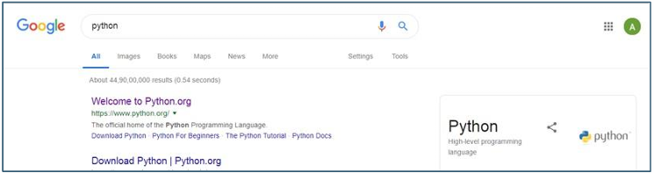

**STEP 2:**

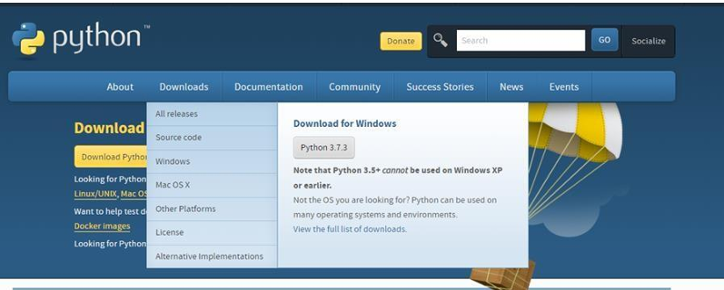

**STEP 3:**

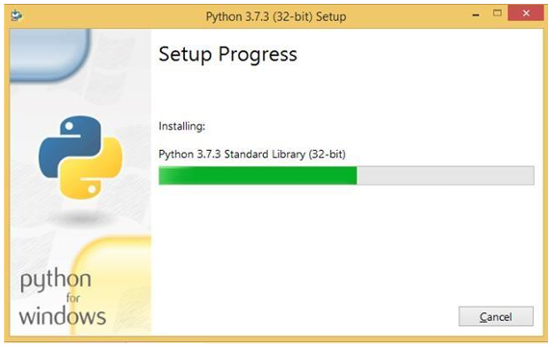

**Q5)** **Writing and executing your first Python program.**

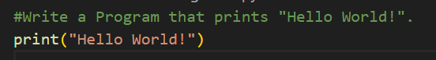

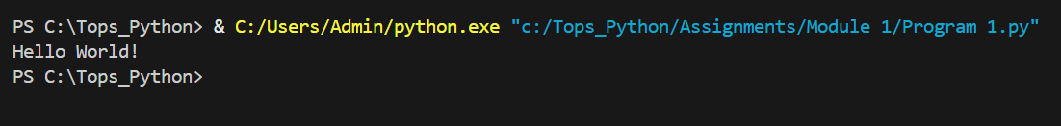

**Q6)** **Understanding Python’s PEP 8 guidelines.**

**ANS) PEP 8 Guidelines:**

1. **Use docstrings :**There are both single and multi-line docstrings that can be used in Python. However, the single line comment fits in one line, triple quotes are used in both cases.
2. **Use of regular and updated comments are valuable to both the coders and users** : There are also various types and conditions that if followed can be of great help from programs and users point of view. Comments should form complete sentences.
3. **Use of trailing commas :** This is not mandatory except while making a tuple.
4. **Use spaces around operators and after commas, but not directly inside bracketing constructs.**
5. **Naming Conventions :** There are few naming conventions that should be followed in order to make the program less complex and more readable.
6. **Characters that should not be used for identifiers :**'l' (lowercase letter el), 'O' (uppercase letter oh), or 'I' (uppercase letter eye) as single character variable names as these are similar to the numerals one and zero.
7. **Name your classes and functions consistently:**The convention is to use **CamelCase** for classes and **lower_case_with_underscores** for functions and methods.
8. **While naming of function of methods always use self for the first argument.**

**Q7)** **Indentation, comments, and naming conventions in Python.**

**ANS) Indentation:**

* Whitespace is used for **indentation in Python**. Unlike many other programming languages which only serve to make the code easier to read, **Python indentation** is mandatory.

**Comments:**

* Python comments start with the hash symbol # and continue to the end of the line. [Comments in Python](https://www.geeksforgeeks.org/python-comments/) are useful information that the developers provide to make the reader understand the source code.
* Types of comments in Python:

1. Single Line Comments
2. Multiple Line Comments

**Naming Conventions**:

* Naming conventions in Python refer to rules and guidelines for naming variables, functions, classes, and other entities in your code. Adhering to these conventions ensures consistency, readability, and better collaboration among developers.
* Naming Conventions in python are:

1. Modules
2. Variables
3. Classes
4. Exceptions

**Q8)** **Writing readable and maintainable code.**

**ANS) Guidelines:**

1. Consistent Naming Conventions
2. Avoid Long Functions
3. Comment Wisely
4. Use Proper Indentation
5. Modular Design

**Q9)** **Understanding data types: integers, floats, strings, lists, tuples, dictionaries, sets.**

**ANS) Integers:**

* This value is represented by int class. It contains positive or negative whole numbers (without fractions or decimals). In Python, there is no limit to how long an integer value can be.

**Float:**

* This value is represented by the float class. It is a real number with a floating-point representation. It is specified by a decimal point. Optionally, the character e or E followed by a positive or negative integer may be appended to specify scientific notation.

**String:**

* Python Strings are arrays of bytes representing Unicode characters. In Python, there is no character data type Python, a character is a string of length one. It is represented by str class.
* Strings in Python can be created using single quotes, double quotes or even triple quotes.
* We can access individual characters of a String using index.

**Lists:**

* Lists are just like arrays, declared in other languages which is an ordered collection of data. It is very flexible as the items in a list do not need to be of the same type.

**Tuples**:

* Just like a list, a tuple is also an ordered collection of Python objects. The only difference between a tuple and a list is that tuples are immutable. Tuples cannot be modified after it is created.

**Dictionaries:**

* A dictionary in Python is a collection of data values, used to store data values like a map, unlike other Python Data Types that hold only a single value as an element, a Dictionary holds a key: value pair. Key-value is provided in the dictionary to make it more optimized.
* Each key-value pair in a Dictionary is separated by a colon : whereas each key is separated by a ‘comma’.

**Sets:**

* In Python Data Types, Set is an unordered collection of data types that is iterable, mutable, and has no duplicate elements.

**Q10)** **Python variables and memory allocation.**

**ANS) There are two parts of memory:**

1. Stack Memory
2. Heap Memory

* The methods/method calls and the references are stored in stack memory and all the values objects are stored in a private heap.