––––1. SDLC OVERVIEW
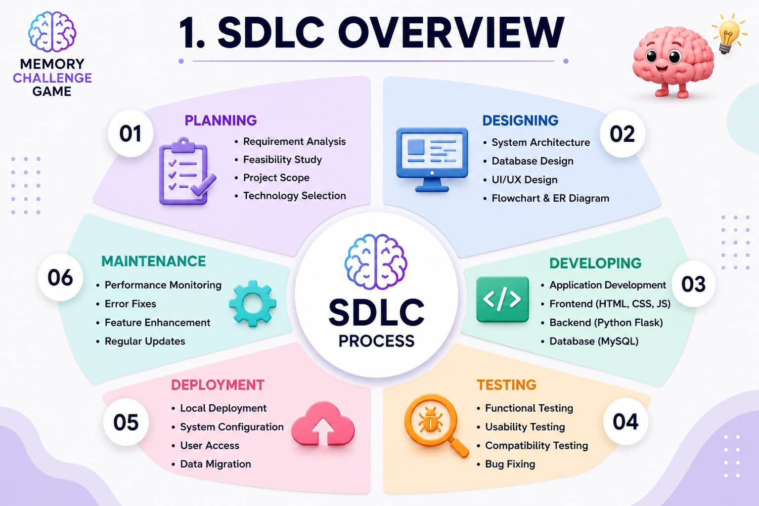

2. REQUIREMENT GATHERING AND ANALYSIS

  - ORGANIZATION DETAILS:

1. Name of the Organization: -
Innovate Tech Solutions Pvt. Ltd.

2. Brief detail of the organization: -
TechNova Solutions is an IT training and software development organization that provides practical knowledge in programming, web development, and database management. It guides students in developing real-time projects and improving their technical skills.

  - MEETINGS:

I. Meeting with Project Manager

1. Name of Project Manager:
- Mr. Rahul Sharma
2. Project Manager’s Requirement
The project should be user-friendly.
- The project should be user-friendly.
- It should improve users' memory and concentration.
- The project should be tested properly and completed on time.

II. Meeting with user

- Name of the user.
-Ms. Riya Patel

- User requirement in her words.
A simple and interactive memory game is required to improve users' memory, concentration, and observation skills through different game levels.
2.3 Data which will be the input into the system….
- User Name
- Login Details
- Game Level Selection
- User Answers
2.4 Data which will be the output from the system….
- Memory Sequence
- Game Result
- Score
- Accuracy/Performance
2.5 Type of project….
- Web-Based Application
2.6 Method for collecting data.
- Interviews.
- User Feedback
- Internet Research

3. SYSTEM REQUIREMENT SPECIFICATIONS

3.1 Introduction:
The Memory Challenge Game is a web-based application developed to improve users' memory, concentration, and observation skills through interactive game levels. The system provides a simple and engaging interface where users can register, log in, play memory games, and view their results

3.1.1 Purpose:
The purpose of the Memory Challenge Game is to help users enhance their memory skills by remembering and recalling numbers, words, or patterns within a limited time. It also provides an enjoyable learning experience through different difficulty levels.
.

    - Intended Audience and Reading Suggestions:
This document is intended for project guides, developers, testers, and end users. It provides complete information about the design, development, and functionality of the Memory Challenge Game.
    - Product Scope:

The Memory Challenge Game allows users to register, log in, play memory-based challenges, and view their scores. The system aims to improve memory and concentration while providing an interactive and user-friendly gaming experience.

  - Overall Description:

    - Product Function:

- Admin Module :
- User Registration
- User Login
- Dashboard
- Start Memory Challenge
- Display Random Numbers/Words
- Timer for memorization
- Submit Answer
- View Score / Result
- Logout

- User Module :
- Register
- Login
- Play Memory Challenge
- Logout

    - User classes and characteristics:

- User Classes :
- Administrator
- User

- User Characteristics :
- Administrator:
- Manages user accounts.
- Monitors game data and scores.
- Updates game levels when required.
- User :
- Registers and logs into the system.
- Plays the memory challenge game.
- Selects difficulty level.
- Views score and game results.

    - Operating Environment:
The Memory Challenge Game is a web-based application that runs on computers or laptops with an internet connection. It is compatible with Windows operating systems and can be accessed through a web browser

    - Design and Implementation constraints:

- User-friendly graphical interface.
- Internet connection is required.
- User should have basic computer knowledge.
- 0The system is developed using Python Flask and MySQL.

    - Assumptions and dependencies:

- Users must register before playing the game.
- Internet connection is required.
- The database stores user details and scores..

3.3 External Interface Requirement:

3.3.1 User Interface:
The system provides a simple and user-friendly interface. Users can register, log in, start the memory game, submit answers, and view their scores easily
3.3.2 Software Interface:

- Operating System: Windows 10/11
- Frontend: HTML, CSS, JavaScript
- Backend: Python (Flask)
- Database: MySQL
- IDE: Visual Studio Code

  - System Features:

- User Registration
- User Login
- Play Memory Game
- View Score
- Logout

  - Other Nonfunctional Requirements:

3.5.1 Performance requirement:

- Overall System should be fast and error free.
- It should have built in error checking and correction facilities.
- The system should be able to handle large amount of data.

    - Security Requirement:
- The system should respond quickly.
- The game should run without errors.

    - Safety Requirement:

- User information should be protected.
- The system should prevent data loss

  - Feasibility Study

A feasibility study is conducted to determine whether the Memory Challenge Game can be developed and implemented successfully using the available resources and technologies.

3.6.1 Operational Feasibility: -

The system is easy to use and helps users improve their memory through an interactive game. It provides a simple interface and can be operated without difficulty.

3.6.2 Technical Feasibility: -

The project is developed using Python (Flask), HTML, CSS, JavaScript, and MySQL, which are suitable technologies for building a web-based application.

3.6.3 Economic Feasibility: -

The project is cost-effective because it uses open-source software and requires minimal hardware resources.

3.6.4 Schedule Feasibility: -

The project can be completed within the given academic timeline using the available resources.

- SYSTEM ANALYSIS AND MODELING

  - Use case Diagram:
1) Admin Side

Login

Manage Users

Manage Game

View Score

Logout

ADMIN

2) User Side
Login
Register

View
Dashboard

Play
Game

View Score

Logout
USER

  - Normalization & E-R Diagram:

Normalization is the process of organizing the columns (attributes) and tables (relations) of a relational database to reduce data redundancy and improve data integrity.

- De Normalized Form:

uid | uname | sid | sname | subcode | image
1 | Parth | 10 | Asp.net | ASP | img_asp.jpg
2 | Arjun | 17 | Oracle | ORC | img_orc.jpg
3 | Paras | 12 | Java | JAV | img_jav.png

- Normalized Form:

- 1st Normal Form:

id * (AI) | name | email | mobile | password
1 | Parth D Bheda | parthjam09@gmail.com | 72290 72200 | parth@123
2 | Bhavin D Badiyani | badiyani169@gmail.com | 97123 24710 | bhavin@123
- Table Name : tbl_user
Primary Key: id (Auto Increment)

- Table Name : tbl_subject
Primary Key: id (Auto Increment)
id * (AI) | Subject Name | Image
1 | Html | img_html
2 | J2ee | img_j2ee

- 2nd Normal Form:

- Table Name : tbl_files
Primary Key: id (Auto Increment)
Foreign Key: subject_code

id *(AI) | pdf_name | subject_code *(FK) | image | file_url
1 | Ado Dot Net | ASP.NET | img_pdf.png | adonet.pdf
2 | Rich Controls | ASP.NET | img_pdf.png | richcontrols.pdf

- Table Name : tbl_forgot_password
Primary Key: id (Auto Increment)
Foreign Key: email

id* (AI) | email* (FK) | otp
1 | parthjam09@gmail.com | 4578
2 | badiyani169@gmail.com | 8945

- E-R Diagram:

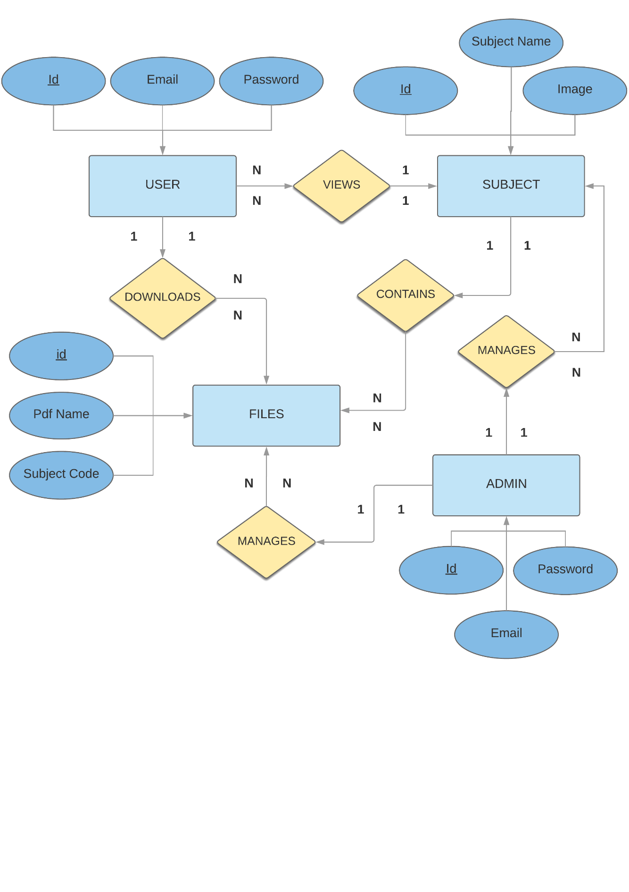

  - Data Dictionary

- tbl_user:

SRNO. | COLUMN NAME | DATATYPE | NULL | LINKS TO | COMMENTS
1 | Id | Int(11) | NO |  | Primary Key, Auto Increment
2 | Name | Varchar(30) | NO
3 | Email | Varchar(50) | NO | tbl_forgot_password  email
4 | mobile_number | Varchar(11) | NO
5 | password | Varchar(16) | NO

- tbl_subject:

SRNO. | COLUMN NAME | DATATYPE | NULL | LINKS TO | COMMENTS
1 | Id | Int(11) | NO |  | Primary Key, Auto Increment
2 | subject_name | Varchar(30) | NO | tbl_filessubject_code
3 | Image | Varchar(50) | NO

- tbl_files:

SRNO. | COLUMN NAME | DATATYPE | NULL | LINKS TO | COMMENTS
1 | Id | Int(11) | NO |  | Primary Key, Auto Increment
2 | pdf_name | Varchar(30) | NO
3 | subject_code | Varchar(30) | NO | tbl_subject  subject_name | Foreign Key
4 | image | Varchar(50) | NO
5 | file_url | Varchar(100)

4)tbl_forgot_password:

SRNO. | COLUMN NAME | DATATYPE | NULL | LINKS TO | COMMENTS
1 | Id | Int(11) | NO |  | Primary Key, Auto Increment
2 | email | Varchar(50) | NO | tbl_user email
3 | Otp | Varchar(20) | NO

4.3Functional and behavior modeling

    - Context Diagram(0-level Diagram)

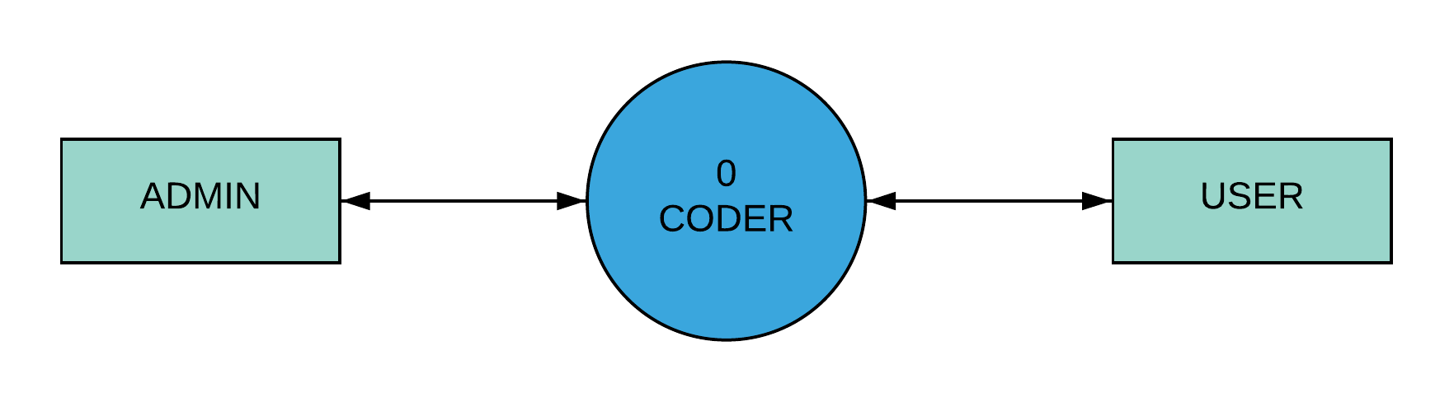

4.3.2 First Level Diagram (1-level Diagram)

- ADMIN
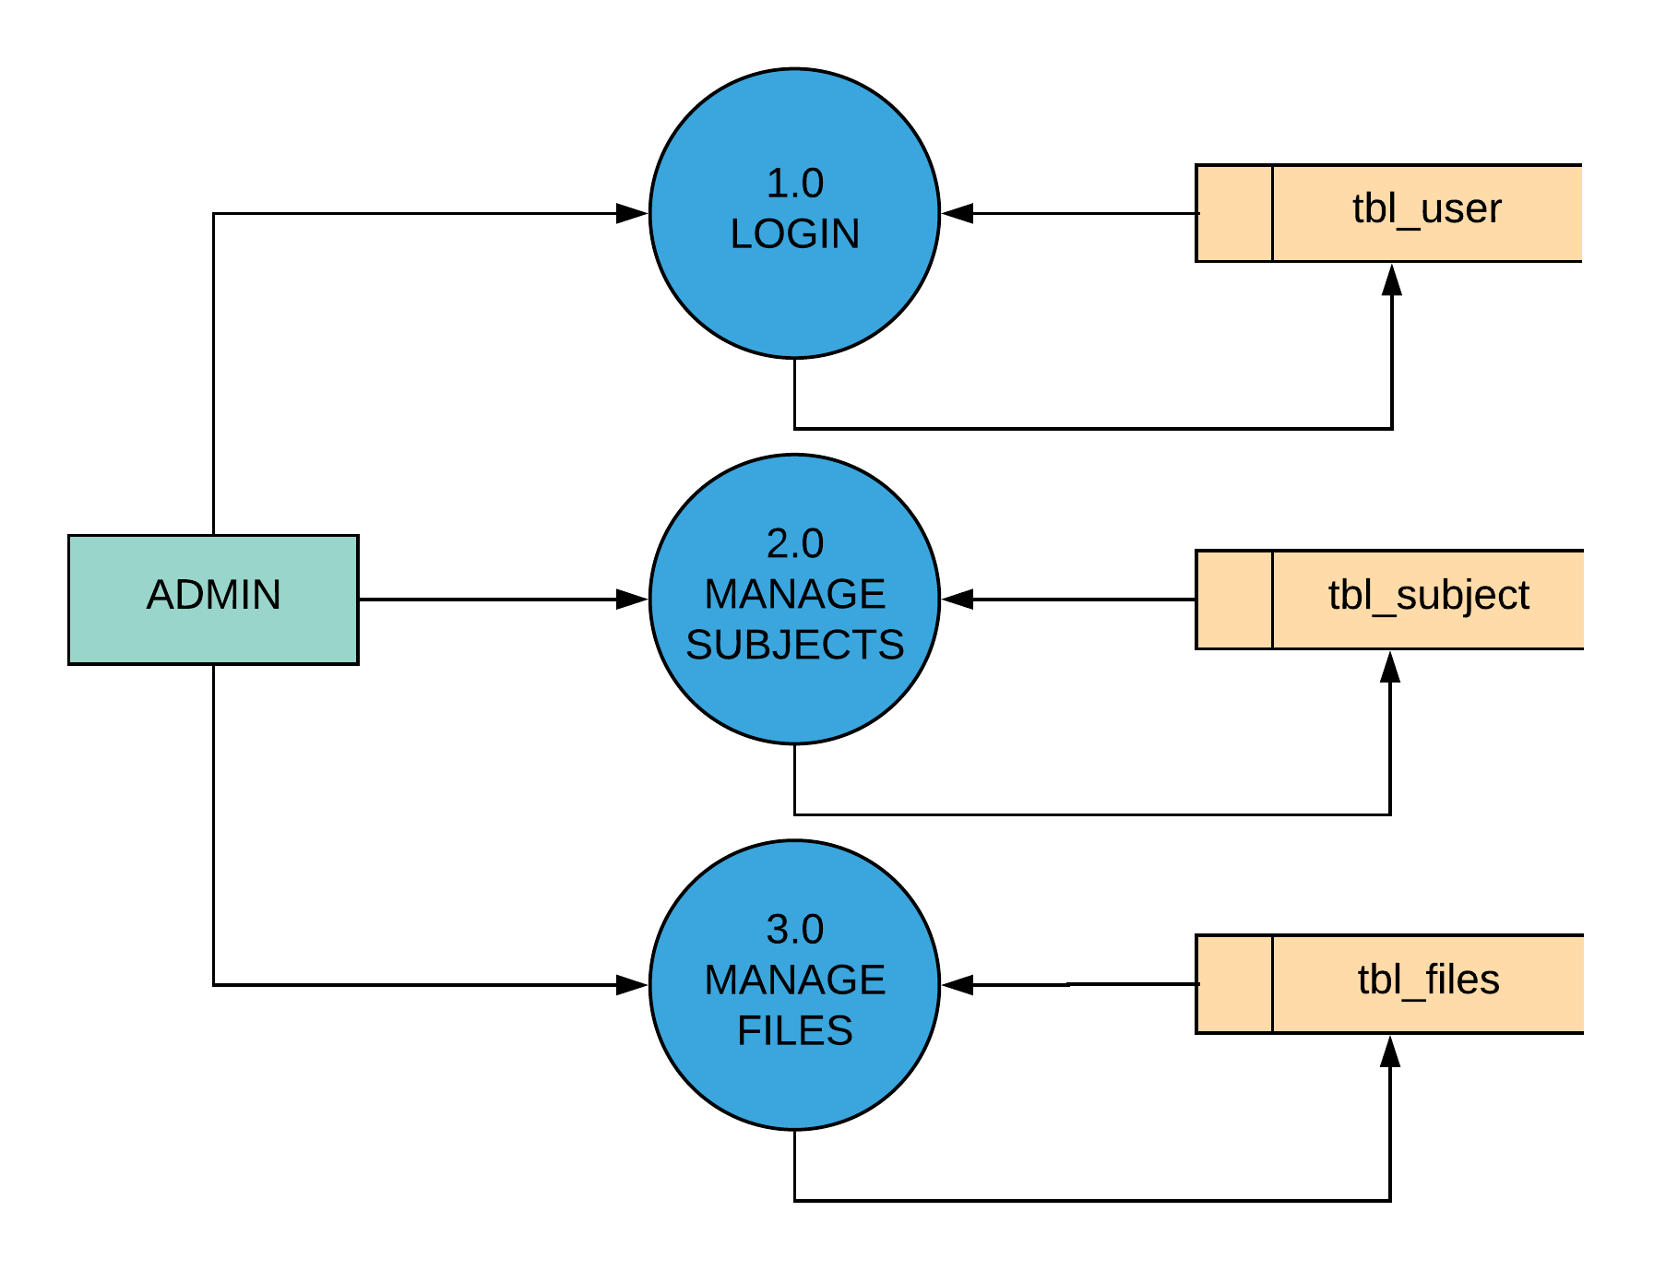

- USER

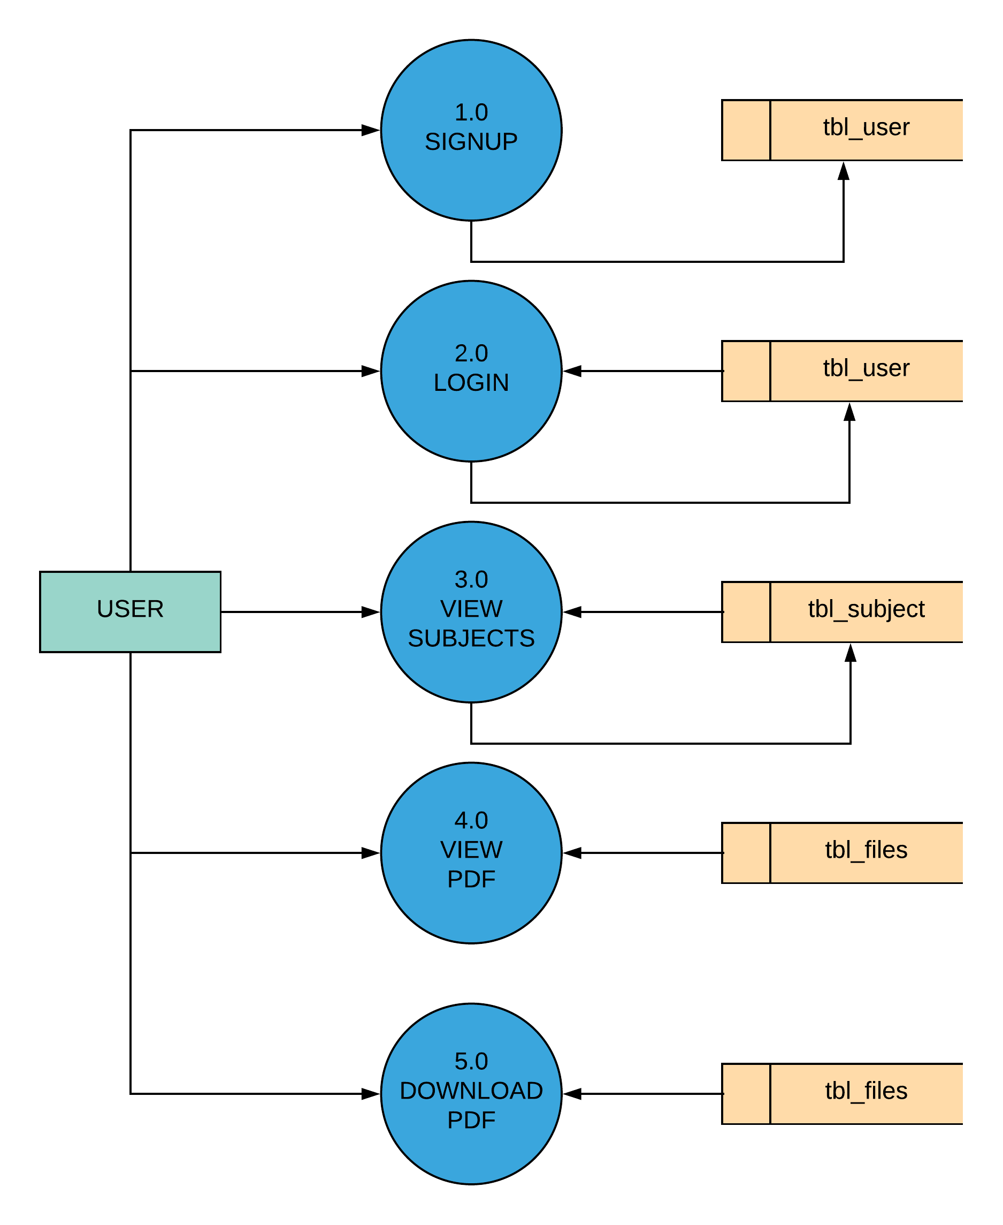

4.4 Gantt Chart

- Expected Time.

- Actual Time.

No. | Task | November | December | January | February
1 | Requirement Gathering And SRS
2 | System Analysis
3 | System Design
4 | System Development
5 | System Testing

- TEST CASE

Login Module
TEST CASE No. 1 |  |  | TEST CASE DESIGN DATE : 5/Feb/2018
TEST TITLE : Login Module Test |  |  | TEST CASE EXECUTION DATE : 5/Feb/2018
DESCRIPTION : In this test case Login module would be tested
PRECONDITION : Login Activity must be working
STEP No. | TEST STEP | TEST DATA | EXPECTED RESULT | ACTUAL RESULT | STATUS
1 | Navigate to Login Page | Login Activity | Login Activity is visible | Same As Expected | PASS
2 | Enter Email | admin@gmail | Email is accepted | Invalid Email | FAIL
3 | Enter Password | admin123 | Password is accepted | Same As Expected | PASS
4 | Click Login Button | Button Click | Check Credentials | Same As Expected | PASS

* Note :- Email is not accepted in above test case due to invalid format.

Signup Module
TEST CASE No. 2 |  |  | TEST CASE DESIGN DATE :  5/Feb/2018
TEST TITLE : Signup Module Test |  |  | TEST CASE EXECUTION DATE : 5/Feb/2018
DESCRIPTION : In this test case Signup Activity would be tested
PRECONDITION : Signup Activity must be working
STEP No. | TEST STEP | TEST DATA | EXPECTED RESULT | ACTUAL RESULT | STATUS
1 | Navigate to Signup Activity | Signup Activity | Signup Activity is visible | Same As Expected | PASS
2 | Enter All Fields | Data | Check Data Integrity | Same As Expected | PASS
4 | Click Signup Button | Button Click | Signup done  With all Validation | Same As Expected | PASS

- SCREEN SHOTS

- User Side
- Splash Screen

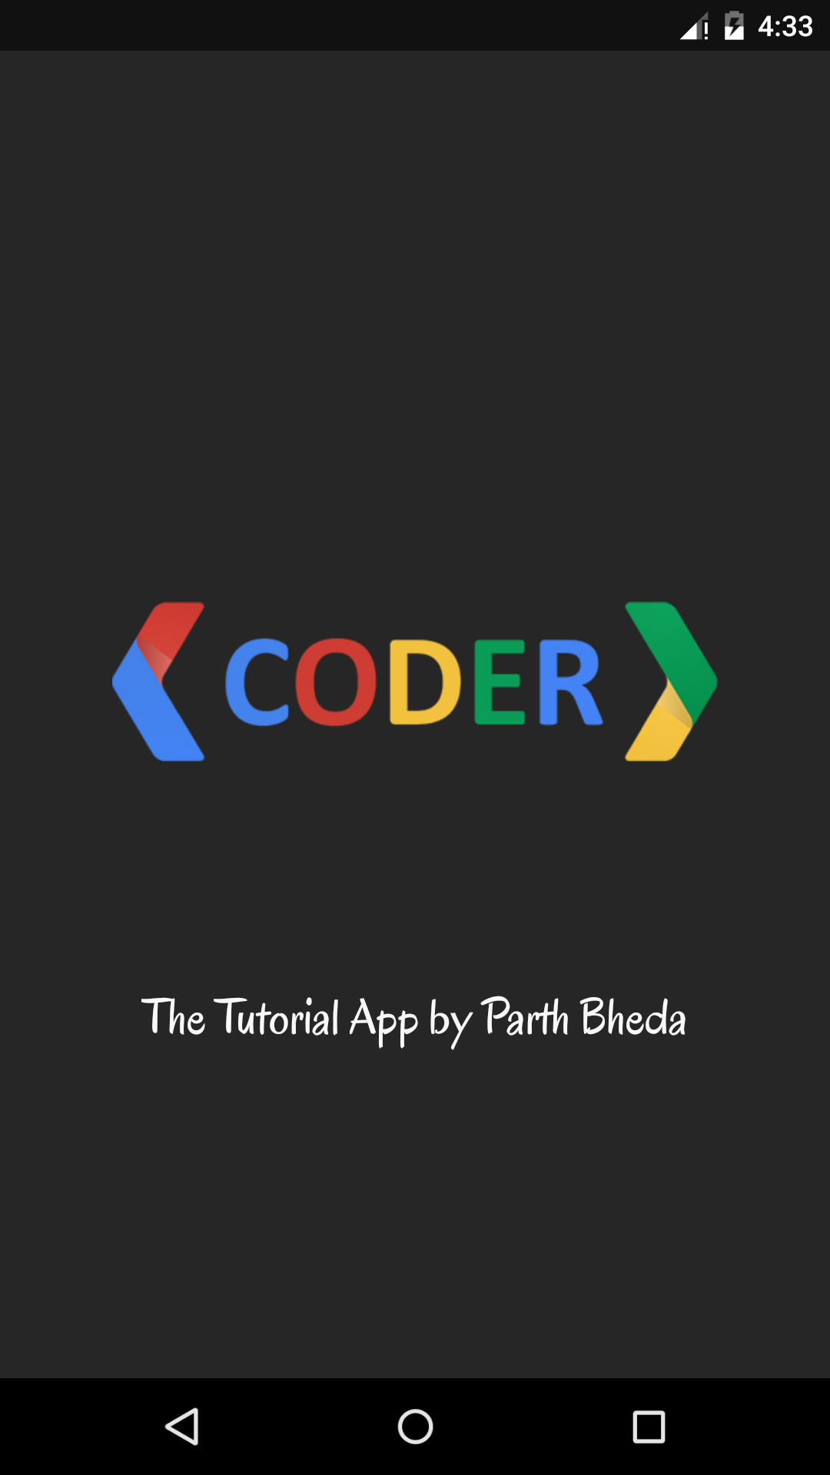
6.1 This Activity Displays Brand Logo.

- Login Activity

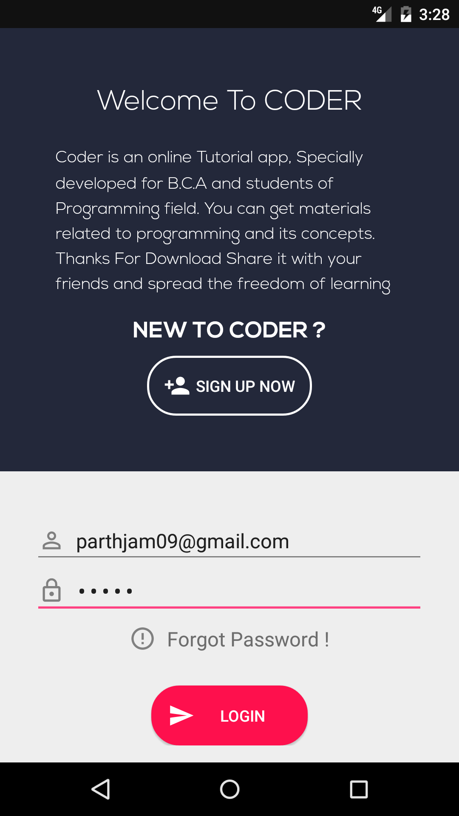
  - This Activity Displays Login Screen

- Signup Activity

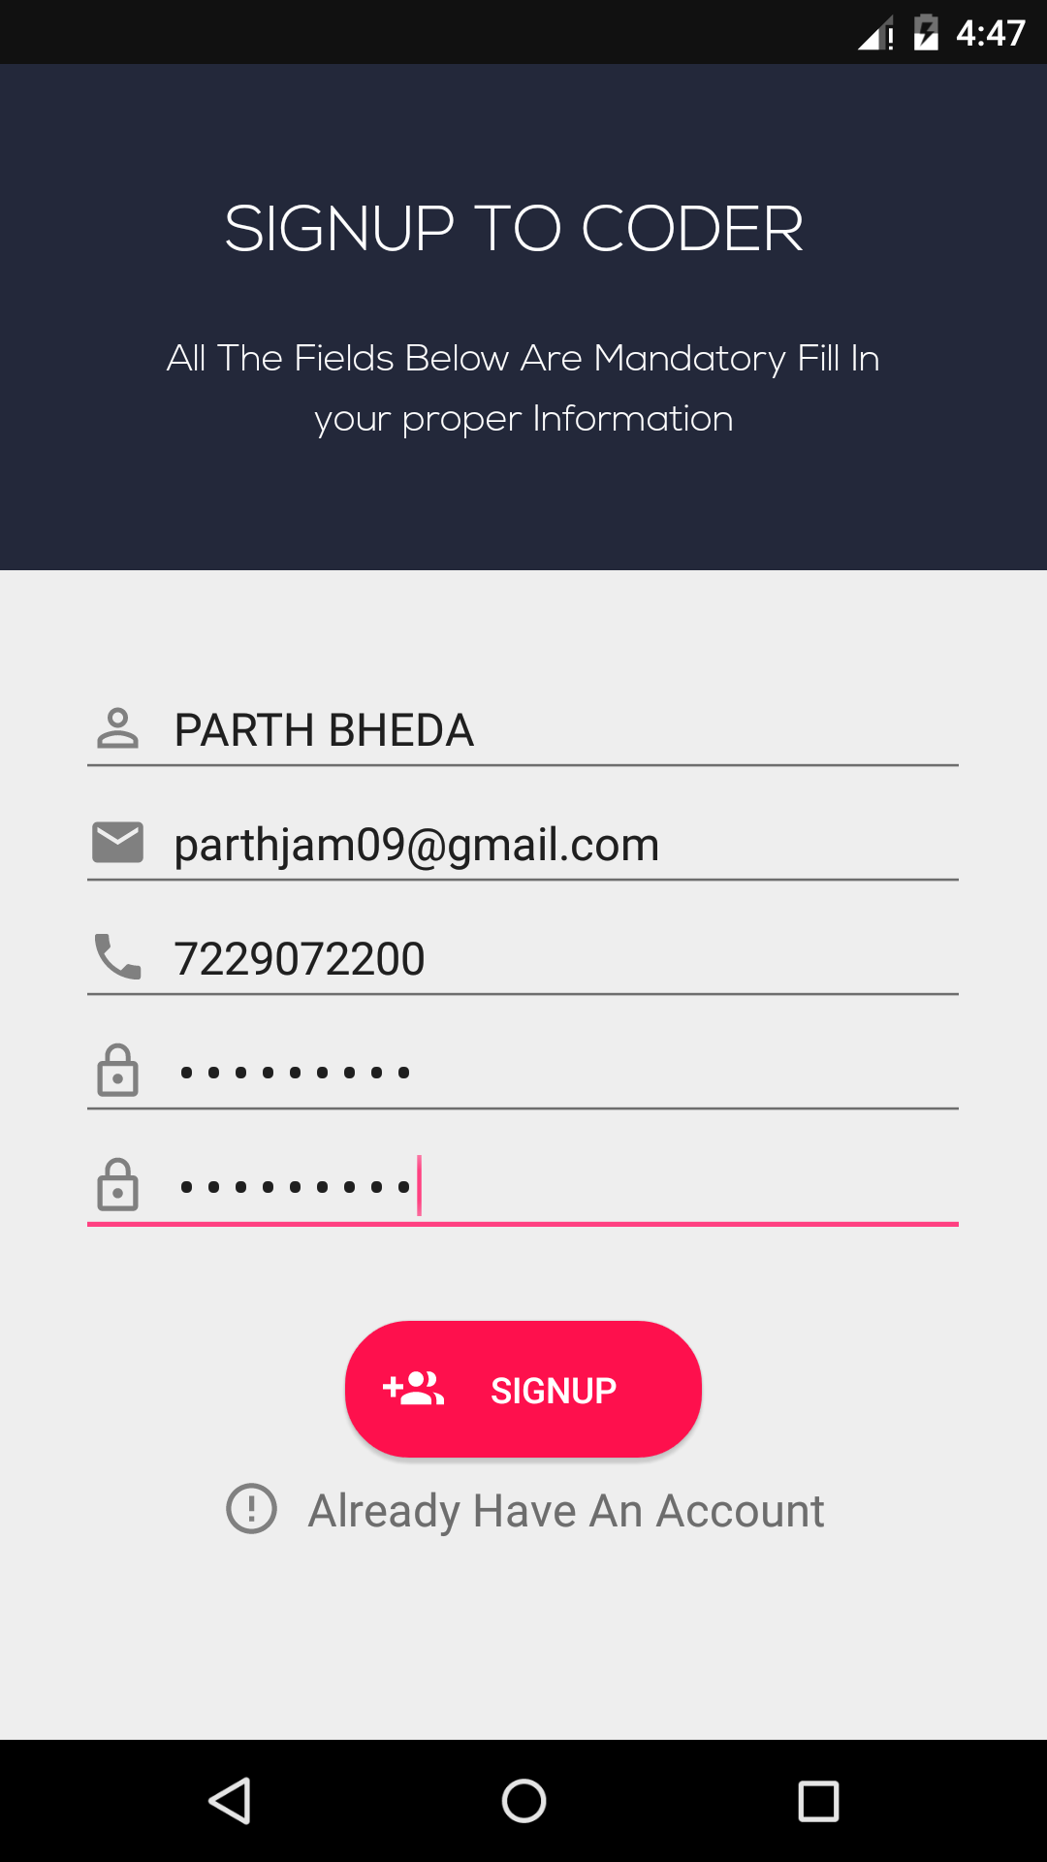
6.3 This Activity Displays Signup Screen

- Home Activity

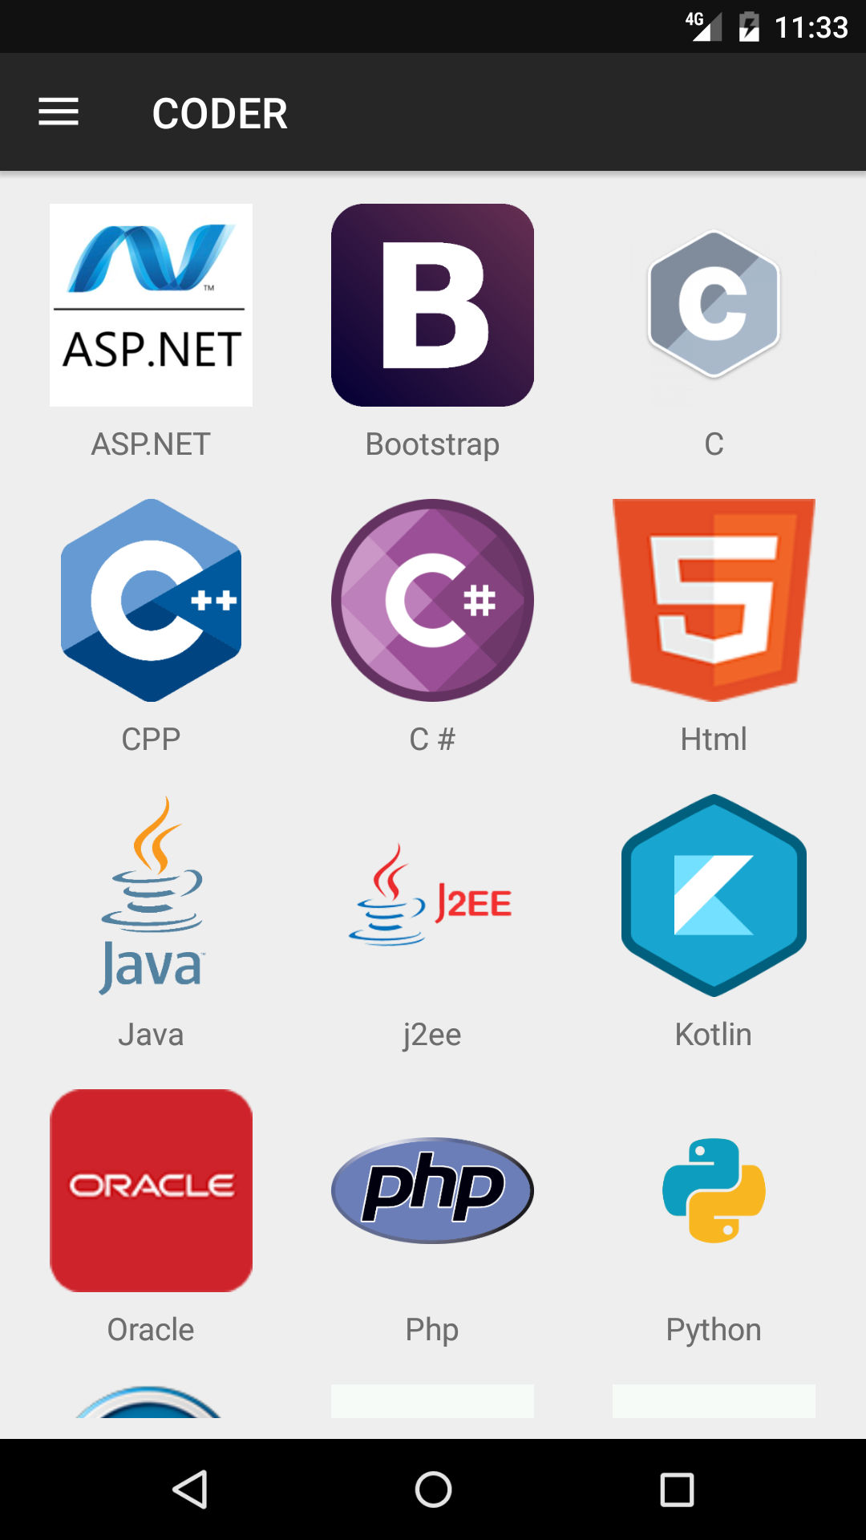
6.4 This Activity Displays Home Screen With all Subjects

- Navigation Drawer Activity

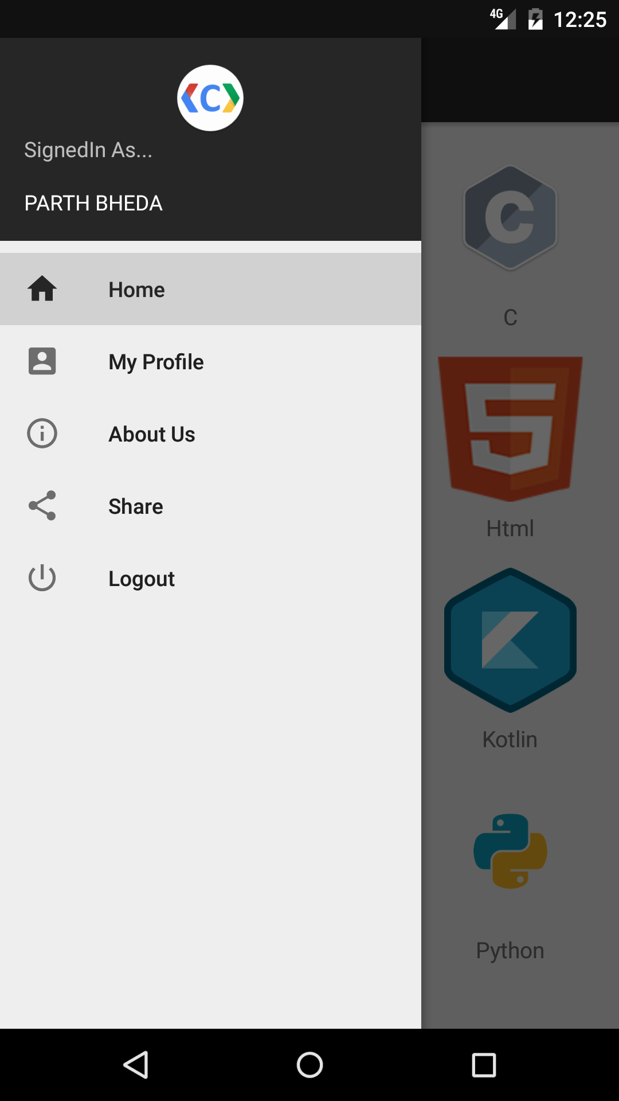
6.5 This Menu Allows User to Navigate To Activities

- View PDF List Activity

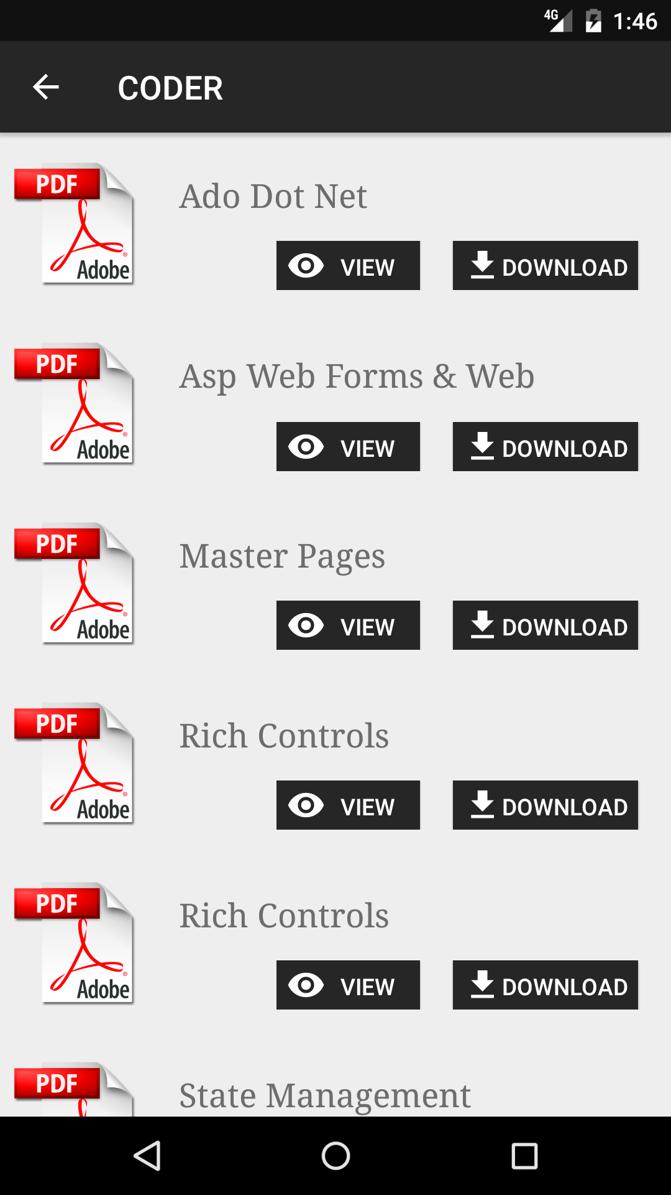
6.6 This Activity shows a list of PDF from selected subject

- View Single PDF

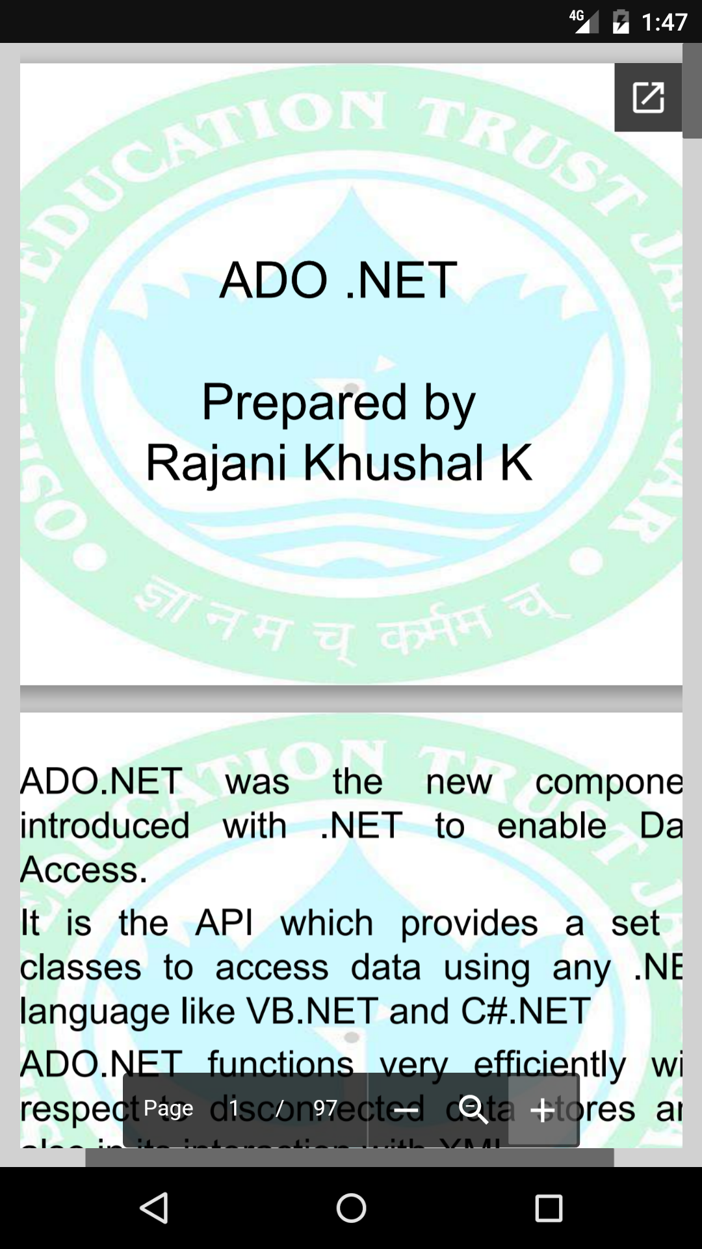
6.7 This Webview Shows a Single Selected PDF

- Download PDF

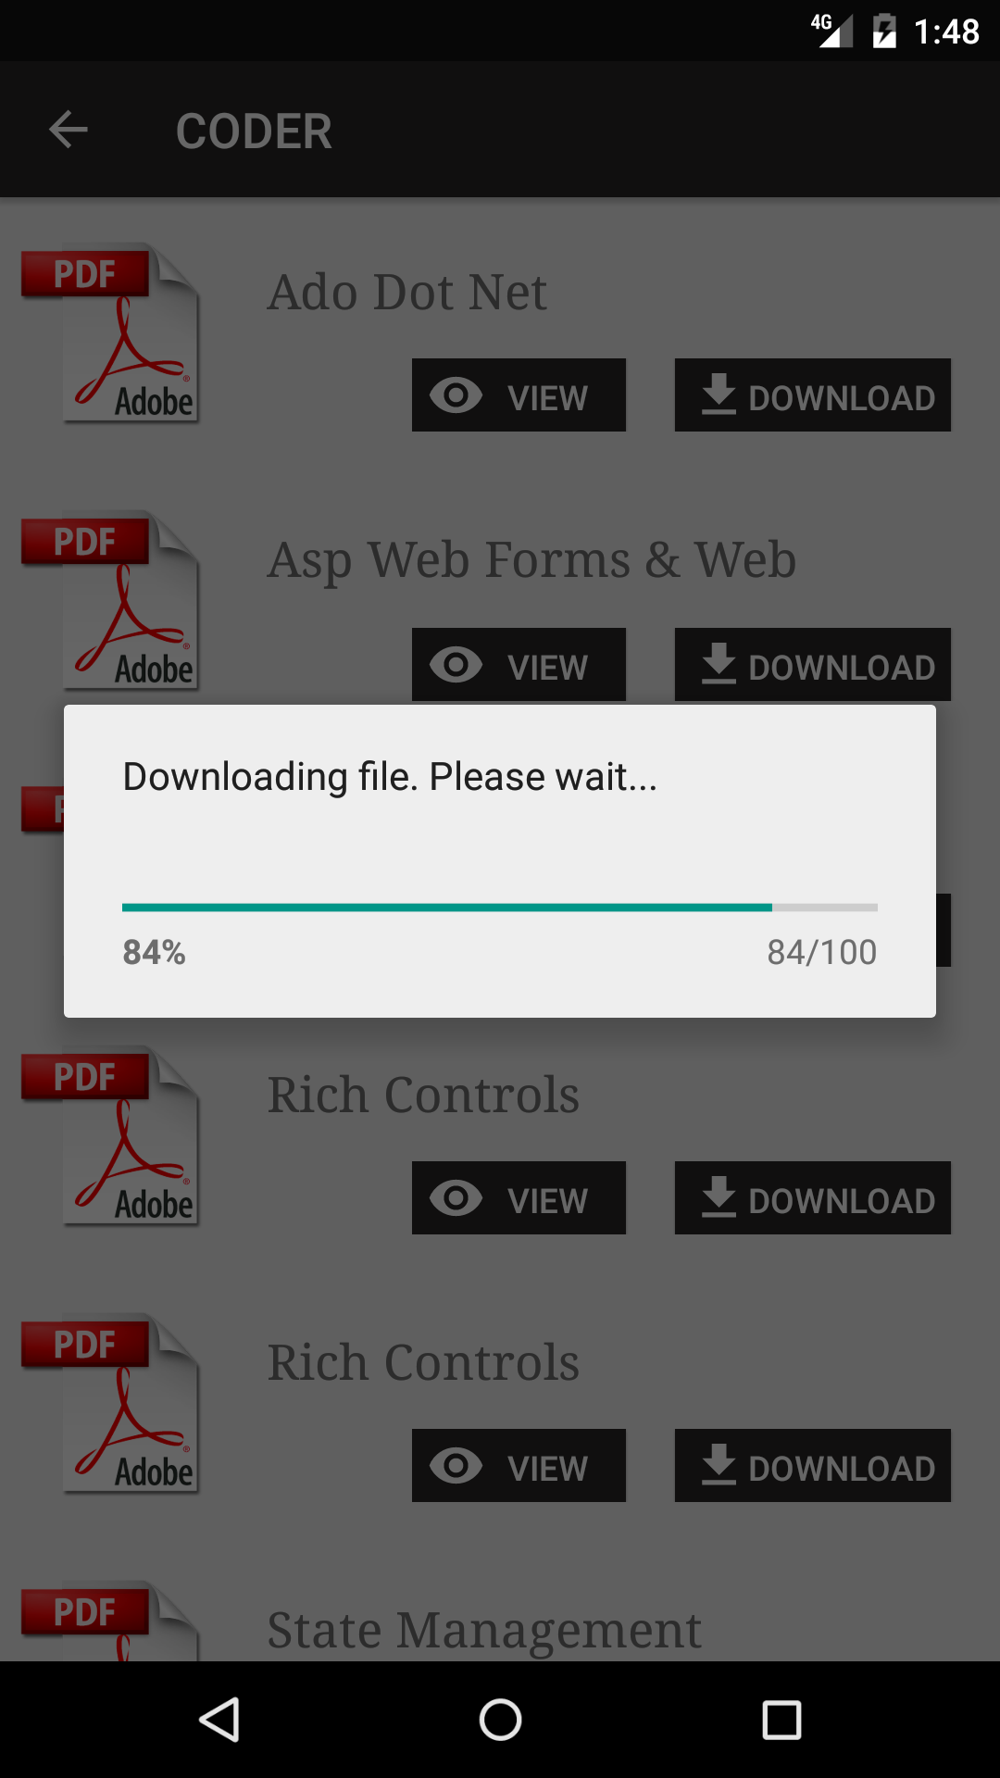
6.8 User can download any of the listed PDF

- Forgot Password Activity

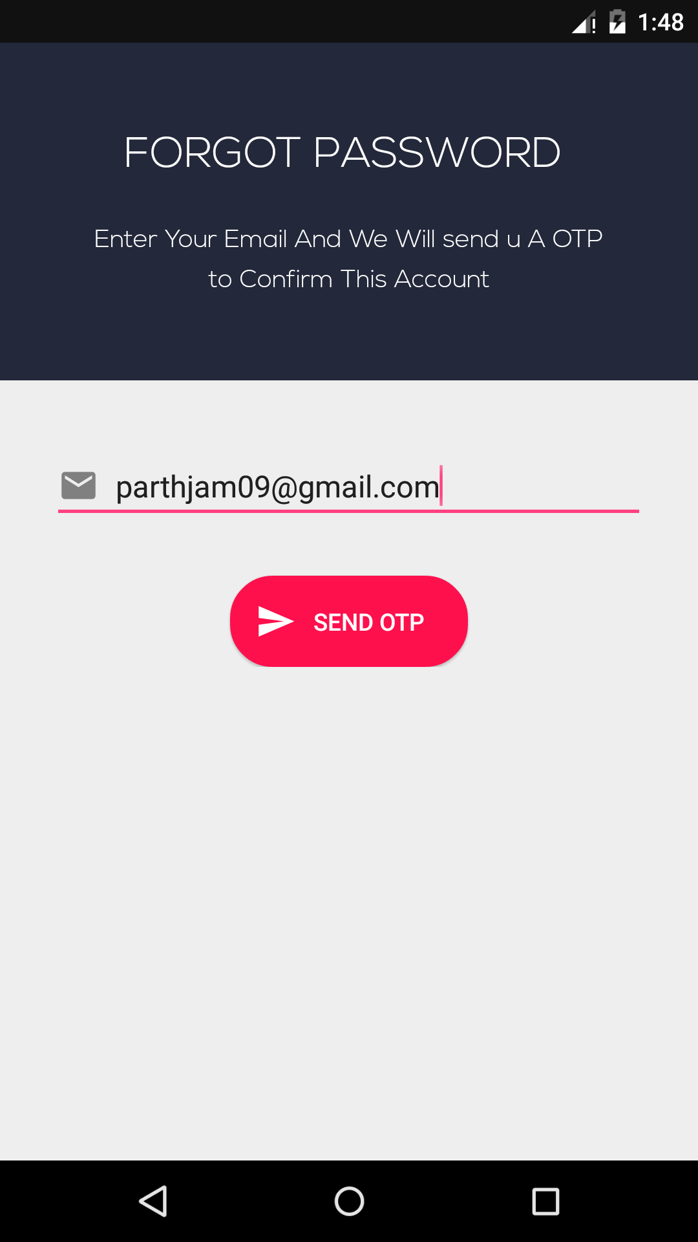

6.9 This Activity Displays Forget Password Screen

- Verify OTP Activity

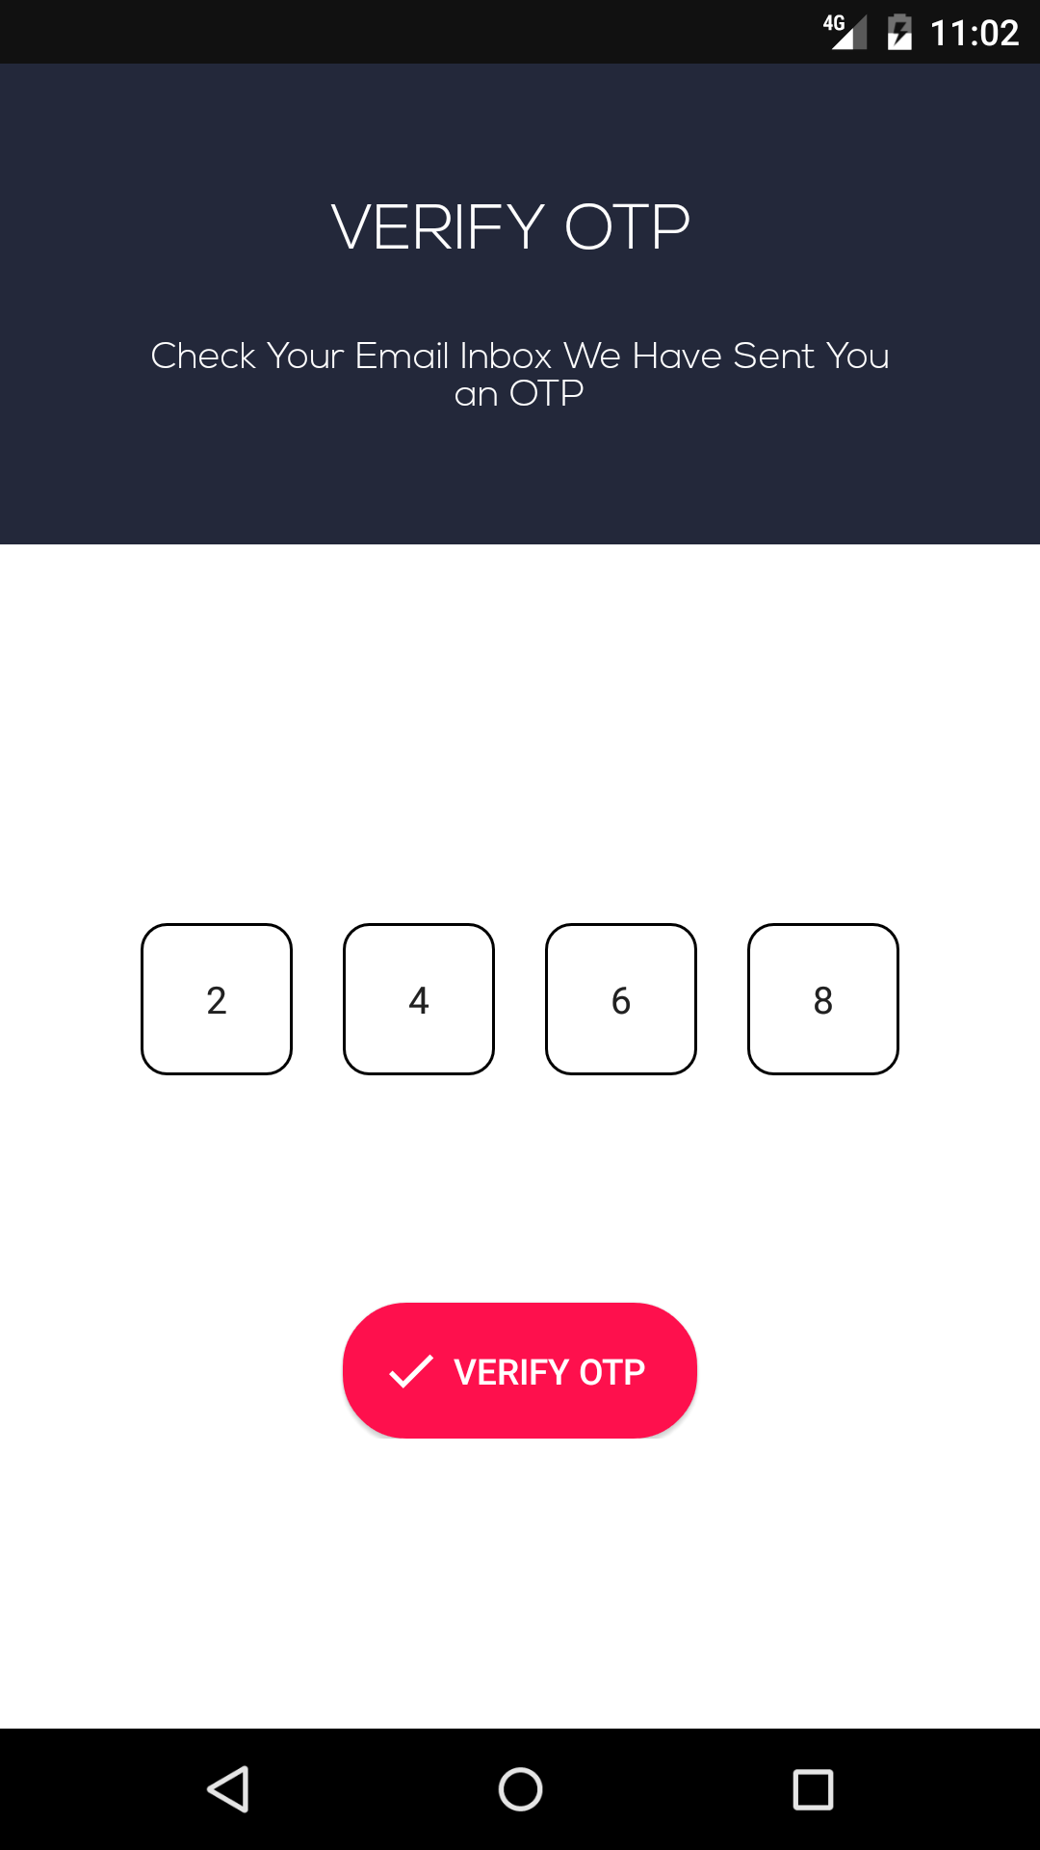
6.10 This Activity Displays OTP Verification Screen

- Change Password Activity

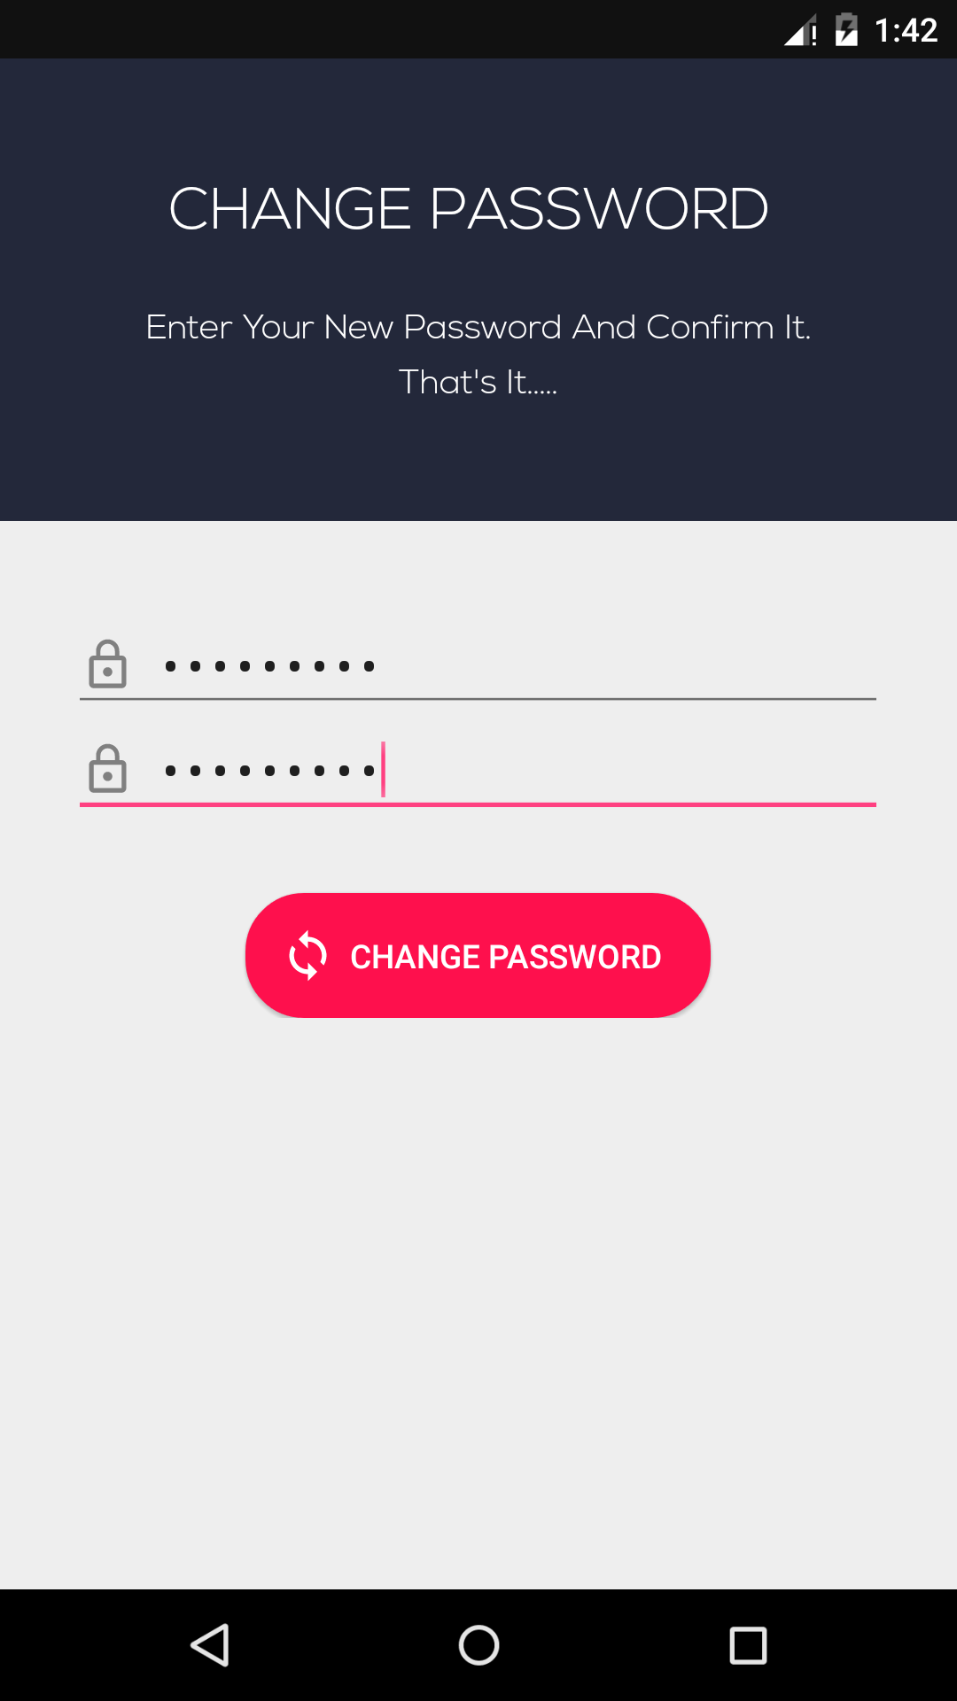
6.11 This Activity Allows User to change Password

- About Us Activity

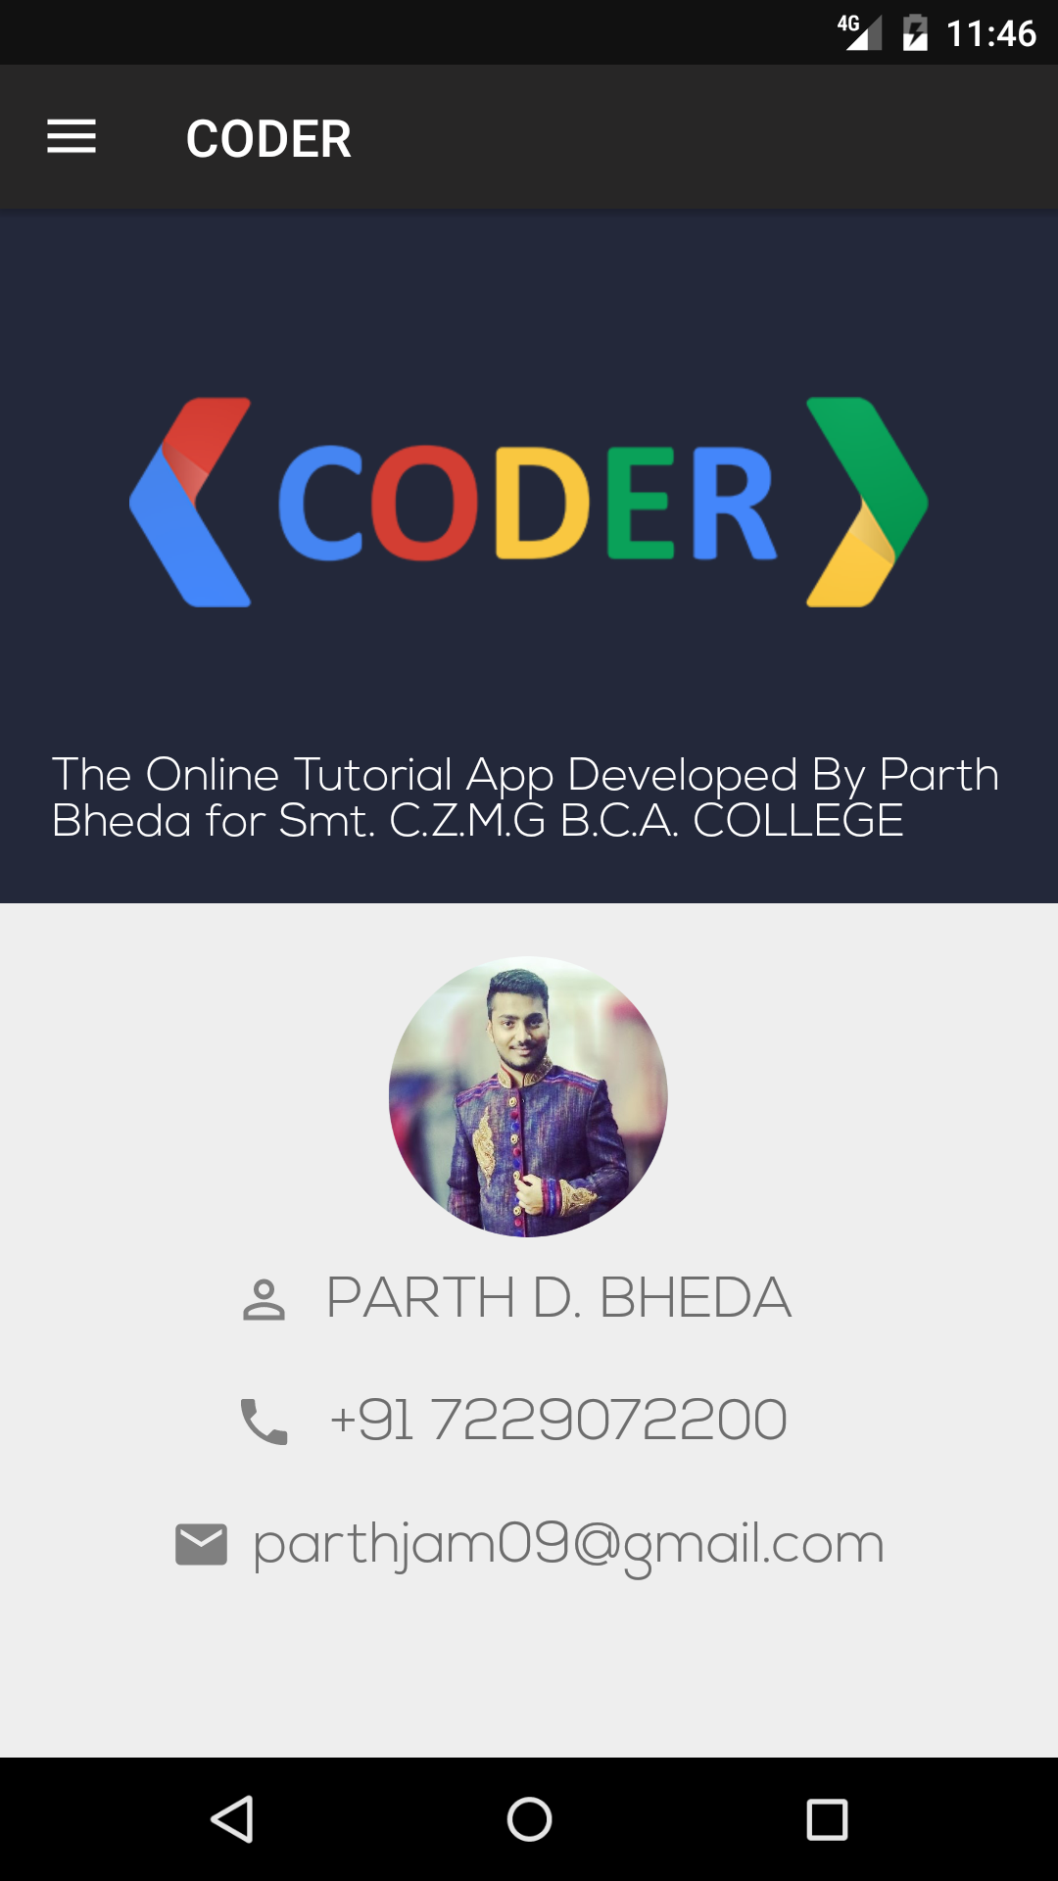
6.12 This Activity Shows Personal Information of Developer

- User Profile Activity

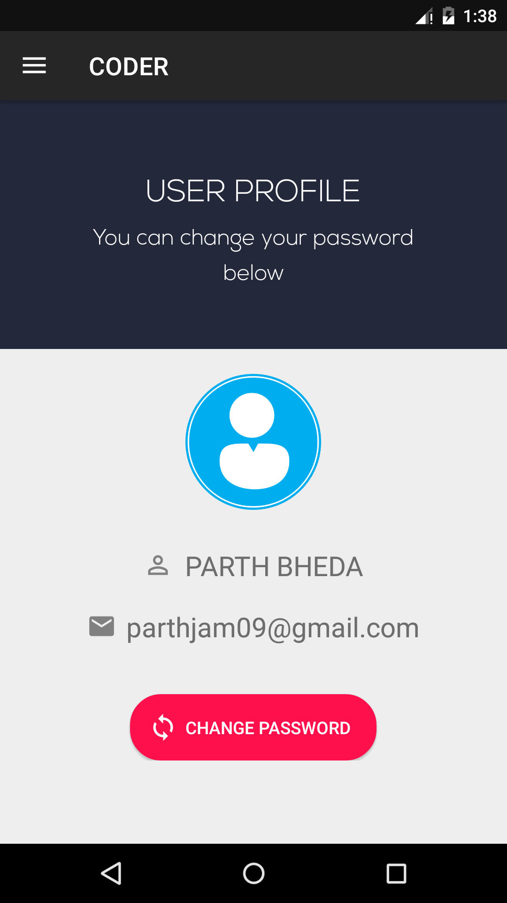
6.13 This Activity Shows User Profile

- Admin Side
- Login Page
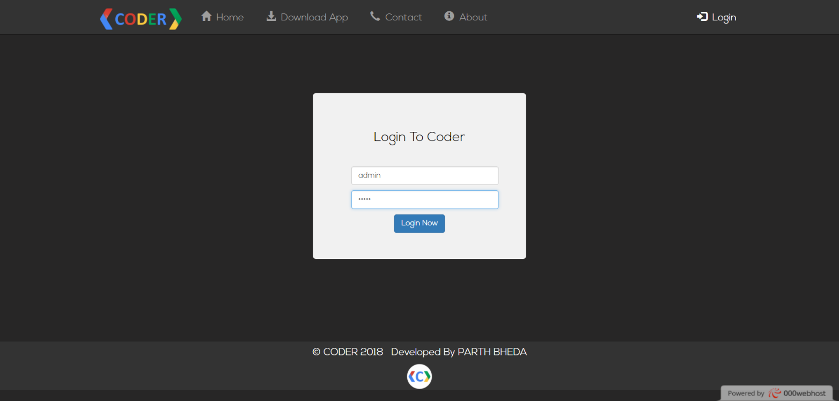
6.1.1 This Page Allows Admin to login
- Manage Subject
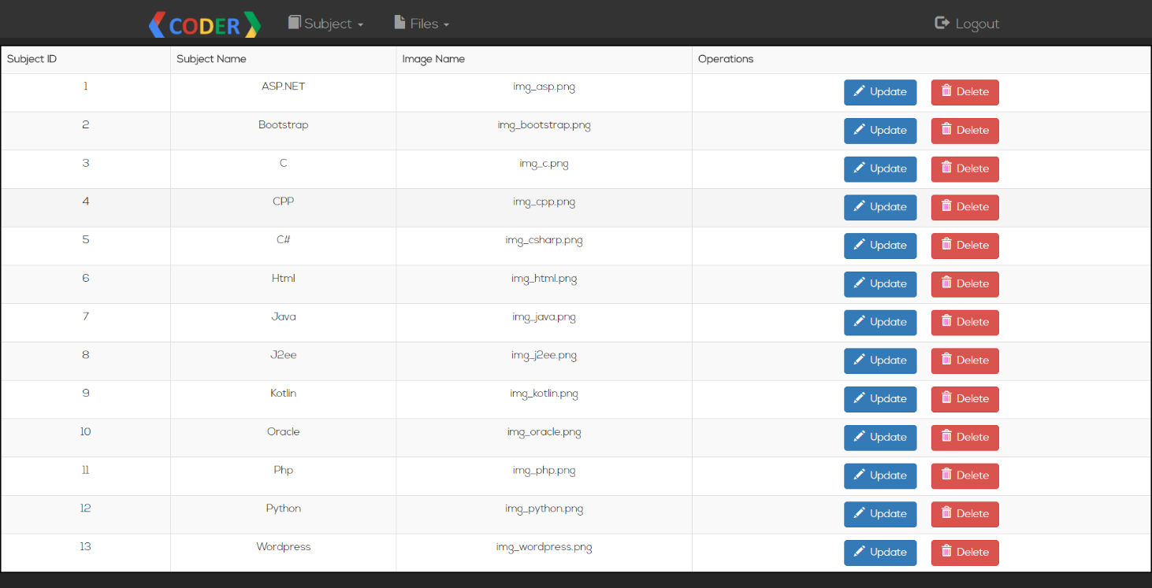
6.1.2 This Page Allows Admin to Manage Subject

- Subject Update Page

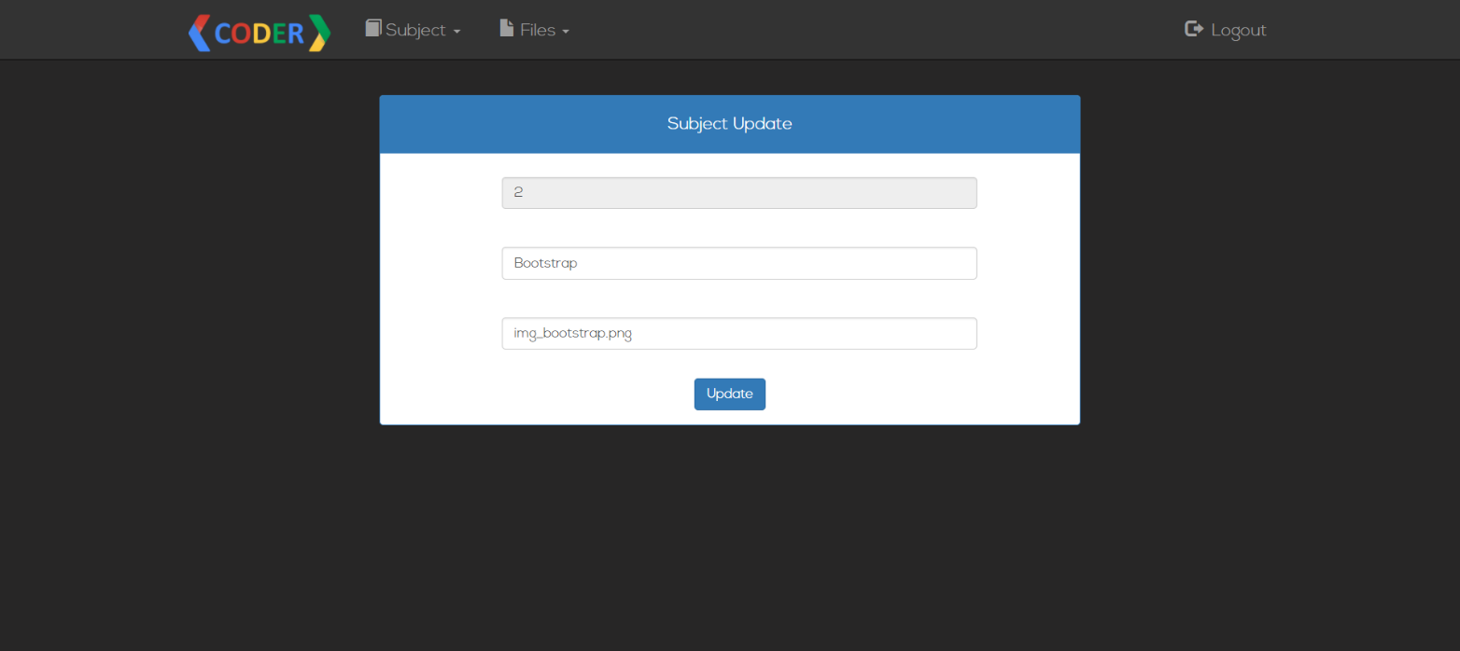
6.1.3 This Page Allows Admin to Update Subject

- Add Files Page

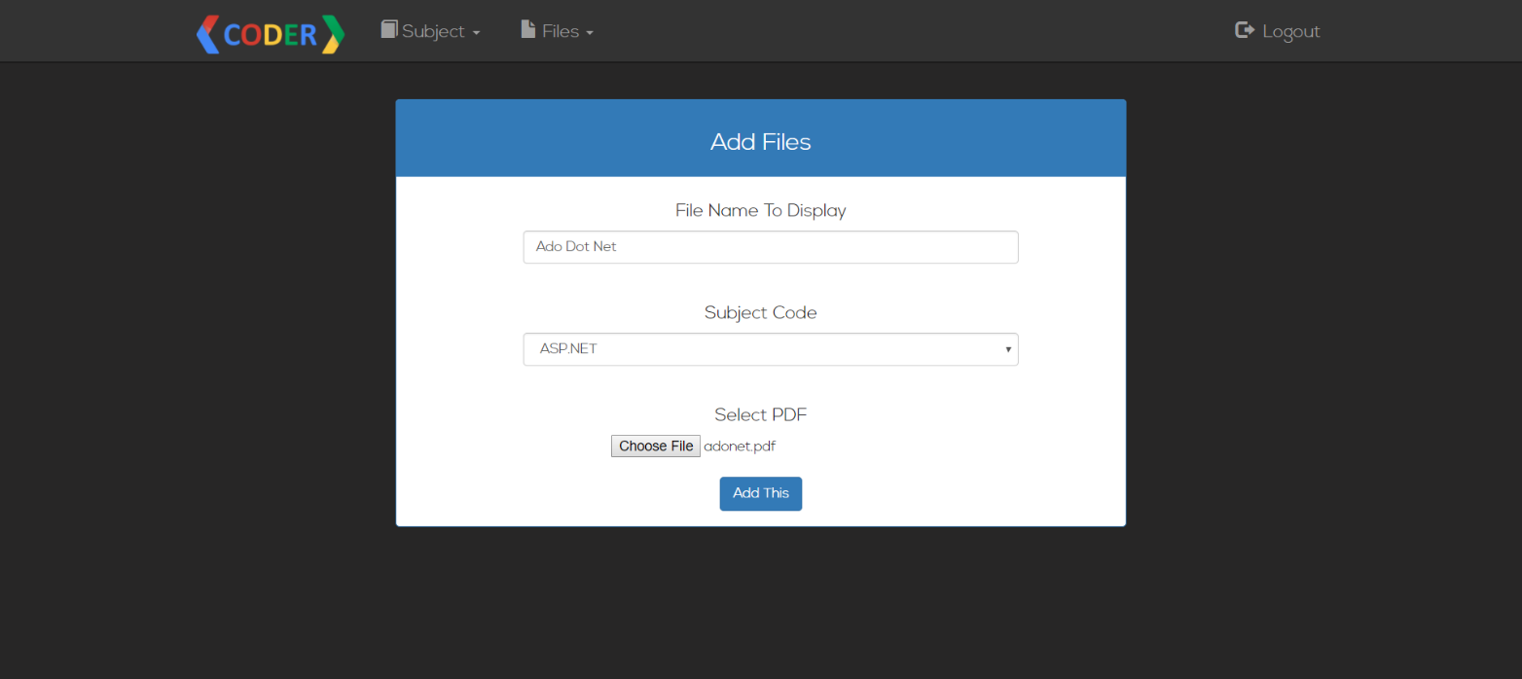
6.1.4 This Page Allows Admin to Upload Files

- Manage Files Page

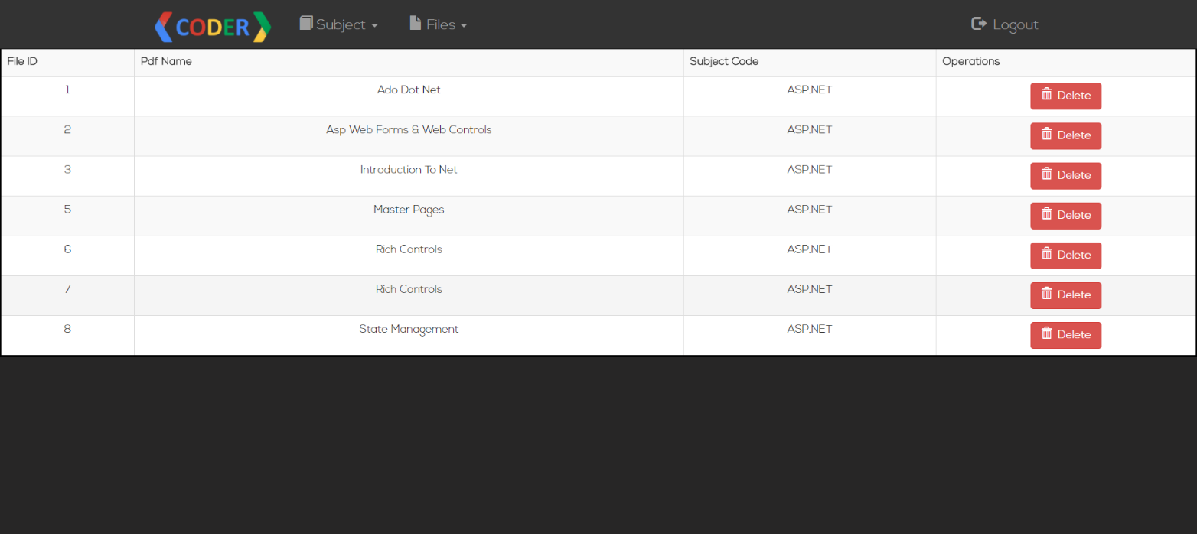
6.1.5 This Page Allows Admin to Manage files

- LIMITATIONS AND FUTURE ENHANCEMENT

- Limitations :-

- The limitation of CODER is that, only one admin can be assigned to the system.
- Option to view pdf without downloading is depended on google drive’s view link.

- Future Enhancement:-

- In future, overall application designing will be improved.
- Alternative solution for viewing Pdf would be found.
- User management rights would be provided to admin.
- Profile based progress work would be shown to user in future.
- All other limitations would be removed.

- CONCLUSION

The project report entitled CODER has been completed successfully. This android application has been developed with much care that is free of errors and at a same time it is efficient and less time consuming. I have tried my level best to make this app as dynamic as possible. Also provision is provided for future development in the android app. This android app will be approved and implemented soon.

- REFERENCES AND BIBLIOGRAPHY

All the references listed below were used to develop and design this android app and were also used for documentation. I am thankful to each and every person who helped me and supported for this project completion.

- Books :-

  - Android Application Development for Dummies
  - Mobile Computing Using Android & IPhone (Bharat & Co.)

- Android Libraries :-

  - Apache.
  - Glide.
  - Card View.

- Websites:-

  - www.000webhost.com
  - developer.android.com
  - www.stackoverflow.com
  - www.lucidchart.com
  - www.androidhive.info

