1 . PROJECT TITLE

SB Stock - Stock Trending App

2. PROJECT DESCRIPTION

System Overview

SB Stocks is a web-based stock trading simulation platform designed to help users understand and practice stock trading without financial risk. The system allows users to explore US-listed stocks, analyze market data, and perform simulated trading using virtual funds.
The platform provides features such as stock browsing, portfolio management, transaction tracking, and performance analysis. By simulating real-world trading conditions, SB Stocks allows users to experiment with trading strategies and learn how financial markets operate.
The application follows a modern full-stack architecture where the frontend provides an interactive user interface, the backend handles business logic and API processing, and the database stores user data, stock information, and transaction records.

Problem Domain

Many beginners are interested in stock trading but hesitate due to financial risks and lack of practical experience. Real stock trading platforms involve real money, making it difficult for learners to experiment and develop strategies safely.
SB Stocks addresses this problem by providing a risk-free simulated trading environment where users can practice buying and selling stocks, manage portfolios, and analyze market trends without using real money.

Core Technology Used

- Frontend: React.js
- Backend: Node.js with Express.js
- Database: MongoDB with Mongoose
- API Integration: Stock market data APIs
- Version Control: Git and GitHub

Key Capabilities

- Secure user registration and authentication
- Real-time stock price monitoring
- Virtual portfolio creation and management
- Buy and sell stocks using virtual funds
- Transaction history tracking
- Portfolio performance analysis
- Market trend visualization using charts

Target Users
- Students learning stock market concepts
- Beginner traders practicing investment strategies
- Financial education platforms
- Researchers analyzing trading behavior

Real-world Relevance

Stock trading knowledge is becoming increasingly important in modern financial literacy. A simulation platform like SB Stocks helps individuals understand trading mechanisms, portfolio diversification, and market analysis before investing real money.

3. APPLICATION SCENARIOS / USE CASES

Educational Usage

The SB Stocks platform can serve as an effective educational tool for universities, colleges, and financial training institutes that aim to teach students about the functioning of stock markets. Traditional classroom learning often focuses on theoretical concepts such as stock valuation, portfolio diversification, and market analysis, but students may lack opportunities to apply these concepts in a practical environment.
By using the SB Stocks simulation platform, students can gain hands-on experience with stock trading without the risk of losing real money. They can explore stock market behavior, analyze price trends, and experiment with different trading strategies using virtual funds. Instructors can also use the platform to demonstrate real-time trading scenarios, portfolio management techniques, and investment decision-making processes. This practical exposure enhances students' financial literacy and helps them better understand the dynamics of financial markets.

End-User Usage

SB Stocks is particularly beneficial for beginner investors who want to understand stock trading before entering the real financial market. Many individuals are interested in investing but hesitate due to the potential financial risks involved.
The platform provides a safe and risk-free environment where users can practice buying and selling stocks using virtual funds.
Users can explore different stocks, analyze market trends, and build diversified portfolios without worrying about real financial loss. Over time, they can monitor the performance of their investments, learn from their mistakes, and improve their trading strategies. This process helps beginners develop confidence, improve decision-making skills, and gain practical experience that can later be applied to real-world investments.

Enterprise Usage

Financial organizations, investment firms, and corporate training institutions can utilize the SB Stocks platform as a training tool for employees and clients. In the financial industry, understanding market operations, trading strategies, and risk management techniques is essential for professionals. The platform can be integrated into corporate training programs to simulate real-world trading environments.
Trainees can practice executing trades, managing portfolios, and analyzing market data without involving actual financial transactions. This simulated environment allows organizations to train employees effectively, evaluate their trading skills, and improve their understanding of investment strategies before they participate in real market activities.

Research Usage

Researchers and analysts studying financial markets, trading behaviors, and investment strategies can also benefit from the SB Stocks platform. The system records simulated trading activities, including stock selections, transaction frequency, portfolio diversification patterns, and decision-making trends. By analyzing this data, researchers can study how users respond to market changes, how they manage risk, and how different trading strategies impact portfolio performance.
Such insights can contribute to academic research in fields such as financial economics, behavioral finance, and investment strategy development. The platform thus provides a controlled environment where trading behaviors can be observed and analyzed without the unpredictability of real financial consequences.

4. TECHNICAL ARCHITECTURE OVERVIEW

High-level Architecture

The SB Stocks platform follows a three-tier architecture, which separates the system into the frontend layer, backend layer, and database layer. This architecture improves scalability, maintainability, and system performance by separating user interface logic, application processing, and data storage.
The High-Level Architecture diagram provides a visual representation of how different components of the system interact with each other. It shows how the user interface communicates with the backend server through APIs, and how the backend interacts with the database to store and retrieve information.

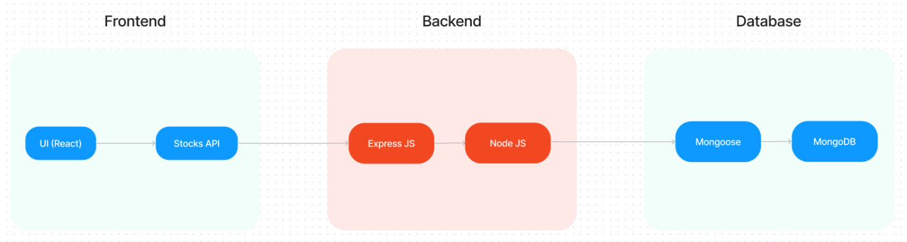

Users access the system through a web browser, where the frontend application provides an interactive interface for stock browsing, portfolio management, and trading operations. The frontend sends requests to the backend server whenever a user performs actions such as logging in, viewing stock data, or executing a trade.

The backend server processes these requests using application logic implemented in the controller layer. It validates user inputs, performs trading operations, updates portfolio data, and retrieves stock market information. The backend communicates with the MongoDB database to store user accounts, portfolio details, stock data, and transaction history.
The database layer maintains structured collections for users, stocks, portfolios, and transactions. This layer ensures efficient data storage, retrieval, and consistency across the system.

External stock market APIs may also be integrated into the system to fetch real-time stock prices and historical market data, which helps provide a realistic trading simulation environment.

Overall, the high-level architecture ensures smooth communication between system components and enables the SB Stocks platform to deliver a reliable and responsive trading simulation experience.

Data / Request Flow

1. Entry Point

User visits the SB Stocks web app.

2. Authentication

New User → Click Register → Enter details (name, email, password, contact) → Account created → Redirect to Login.

Existing User → Click Login → Enter credentials → Redirect to Dashboard.

3. Dashboard (Main Hub)

View overall virtual funds, portfolios, and recent activity.

Options: Browse Stocks, Create Portfolio, View Portfolio, Trade Stocks.

4. Browse & Explore Stocks

Search for US-listed stocks.

View real-time price, historical trends, and company details.

5. Paper Trading (Buy/Sell)

Select a stock → Choose Buy or Sell → Enter quantity → Confirm transaction.

Transactions get logged and portfolio updates in real-time.

6. Portfolio Management

Create multiple virtual portfolios.

Add/remove stocks.

View current holdings, profits/losses, and performance charts.

7. Transactions History

Review log of all buy/sell activities with timestamps.

8. Learning & Strategy Testing

Analyze historical data.

Compare strategies using portfolio performance.

9. Logout

End session securely.

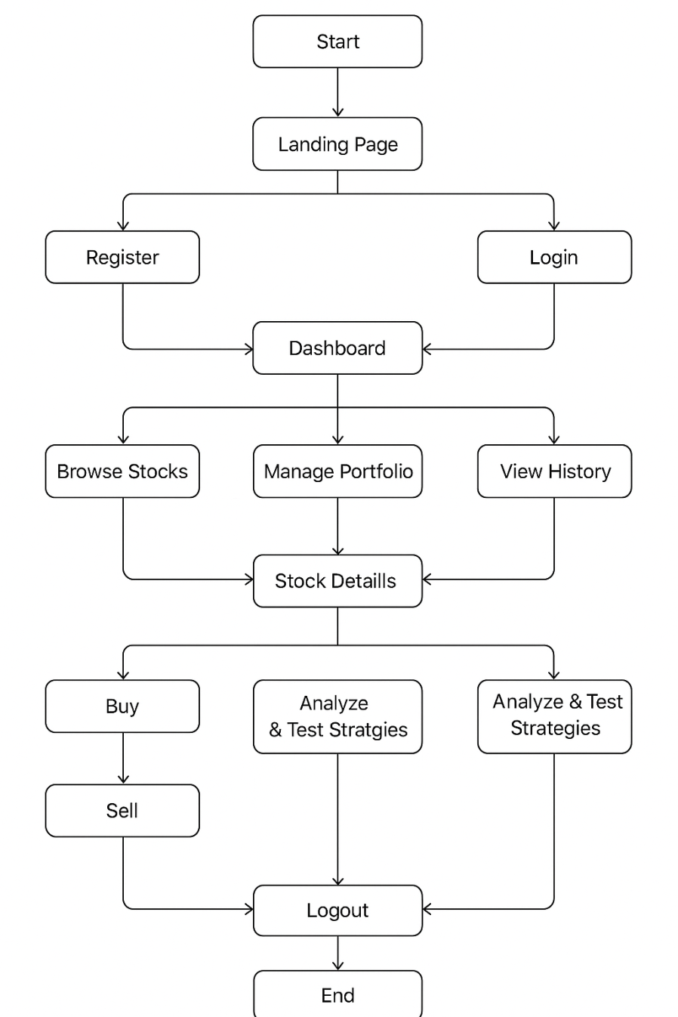

5. PREREQUISITES

5.1 Software Requirements
- Node.js
- MongoDB
- Git
- Visual Studio Code
- Web Browser (Chrome/Firefox)

5.2 Libraries / Frameworks / Dependencies
- React.js
- Express.js
- Mongoose
- Axios
- Chart libraries (Chart.js or Recharts)
- JWT Authentication

5.3 Hardware Requirements
Minimum System Requirements:
- Processor: Intel i3 or above
- RAM: 4GB minimum
- Storage: 10GB free space
- Internet connection

6. PRIOR KNOWLEDGE REQUIRED
- JavaScript programming
- React.js fundamentals
- Node.js and Express.js basics
- MongoDB database concepts
- REST API development
- Basic understanding of stock market concepts

7. PROJECT OBJECTIVES

Technical Objectives
The main technical objective of this project is to develop a full-stack web application that simulates stock trading activities in a virtual environment. The system integrates frontend technologies for an interactive user interface and backend technologies for handling application logic, API requests, and database operations. Another key objective is to implement secure authentication and reliable data management to ensure safe handling of user information and transactions.

Performance Objectives
The project aims to provide a responsive and efficient system that can process user requests quickly. It focuses on ensuring fast response times for stock data retrieval and trading operations while maintaining efficient database performance for storing and retrieving portfolio and transaction records.

Deployment Objectives
Another objective is to deploy the application in a cloud-based environment so that users can access the platform easily through the internet. Cloud deployment improves system availability, scalability, and accessibility for users across different locations.

Learning Outcomes
This project also aims to enhance practical knowledge of full-stack development by integrating frontend, backend, and database technologies. It helps in understanding API integration, database management, and the implementation of trading logic while also

8. SYSTEM WORKFLOW
- User Accesses the Platform
The user opens the SB Stocks web application through a web browser and lands on the home or landing page of the platform.
- User Registration or Login
New users create an account by providing basic details such as name, email, and password. Existing users log in using their registered credentials.
- User Authentication
The system verifies the login credentials through the backend authentication mechanism and grants access if the credentials are valid.
- Dashboard Access
After successful login, the user is redirected to the dashboard where they can view their virtual balance, portfolios, recent transactions, and available trading options.
- Stock Exploration
The user browses or searches for available stocks, where they can view real-time prices, historical trends, and basic company information.
- Trading Operations (Buy/Sell)
The user selects a stock and chooses to buy or sell shares by entering the desired quantity. The system processes the request and checks the available virtual balance before confirming the transaction.
- Portfolio and Transaction Update
Once the transaction is completed, the system records the transaction in the database and updates the user's portfolio holdings and virtual balance accordingly.
- Portfolio Monitoring
The user can view their portfolio to track stock holdings, profit or loss, and overall portfolio performance using charts and data summaries.
- Secure Logout
After completing their activities, the user can log out of the system, which securely ends the session.

9. MILESTONE 1: REQUIREMENT ANALYSIS & SYSTEM DESIGN

9.1 Problem Definition
Beginners lack a safe environment to learn stock trading without financial risk. SB Stocks provides a simulated platform where users can practice trading and develop strategies.

9.2 Functional Requirements
- User registration and login
- Stock browsing and search
- Buy and sell stocks
- Portfolio creation and management
- Transaction history tracking
- Market data visualization

9.3 Non-Functional Requirements
- Security and data protection
- High system availability
- Fast response time
- User-friendly interface

9.4 System Design Decisions

The system follows MVC architecture to separate application logic, data management, and request handling, improving maintainability and scalability.
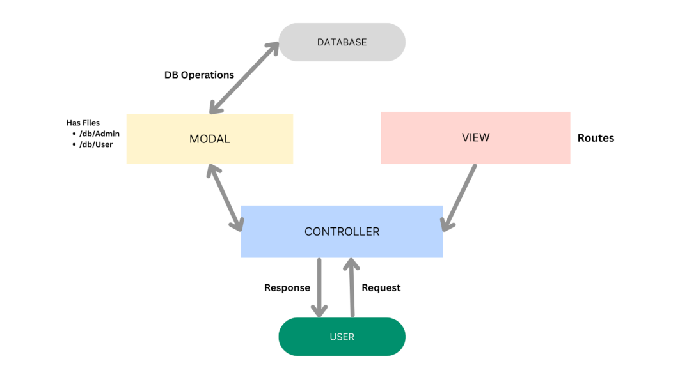
The SB Stocks application follows the Model-View-Controller (MVC) architectural pattern, a software design approach that separates an application into three interconnected layers. This separation allows for modularity, easier maintenance, and scalability.
Model Layer (Data Layer)
The Model layer is responsible for handling all data-related logic. This includes the definition of data schemas and the operations performed on the database using those schemas. The models are implemented using Mongoose, which provides a schema-based solution to model application data for MongoDB.

Controller Layer
The Controller layer acts as an intermediary between the view (routes) and the model. It receives incoming requests, processes the input (which may include validation or transformation), calls the appropriate methods from the model, and then returns a response to the client.

View Layer (Routing Layer)
In the context of a backend REST API, the View is implemented as the routing layer, where various endpoints are defined. These endpoints determine how the backend responds to different HTTP requests (GET, POST, PUT, DELETE) and are responsible for invoking the appropriate controller functions.

9.5 Technology Stack Selection Justification

- React.js: Efficient UI development
React.js was selected for the frontend because it enables the development of interactive and dynamic user interfaces through reusable components. Its efficient rendering mechanism improves the performance of web applications and provides a smooth user experience.
- Node.js: Scalable backend environment
Node.js was chosen as the backend runtime environment because it supports asynchronous and event-driven processing, which helps handle multiple client requests efficiently. It also allows developers to use JavaScript for both frontend and backend development, improving development consistency.

- Express.js: Lightweight API framework
Express.js was selected as the backend framework because it simplifies the creation of RESTful APIs and provides a lightweight structure for handling routes, middleware, and HTTP requests. This makes backend development faster and more organized.

- MongoDB: Flexible NoSQL database for dynamic data
MongoDB was chosen as the database because it is a flexible NoSQL database that stores data in a document-based format. This structure is well-suited for handling dynamic data such as user information, portfolios, stock data, and transaction records, making it ideal for modern web applications.

- MILESTONE 2: ENVIRONMENT SETUP & INITIAL CONFIGURATION

10.1 Development Environment Setup
Before starting the development of the application, the required software tools and development environment were properly configured. The following tools were installed to support both frontend and backend development.
- Node.js: Used as the runtime environment for executing backend JavaScript code and managing dependencies.
- MongoDB: Used as the database system for storing user accounts, stock information, portfolio data, and transaction records.
- Visual Studio Code: Used as the primary code editor due to its powerful extensions, debugging tools, and developer-friendly interface.

10.2 Dependency Installation

After setting up the development environment, the necessary libraries and project dependencies were installed using the Node Package Manager (NPM). These dependencies support backend server creation, API development, database connectivity, and frontend functionality.
Example command used to install dependencies:
npm install

This command automatically installs all required packages listed in the package.json file.
Key dependencies used in the project include:
- Express.js – for backend API development
- Mongoose – for MongoDB database interaction
- Axios – for handling API requests
- bcrypt – for secure password encryption
- jsonwebtoken (JWT) – for authentication and authorization

10.3 Project Structure Creation

FrontEnd
- Open the Client folder in the terminal of VScode.
npm create vite@latest . -- --template react
- Select React framework from the given options.
Select a framework:
React
- Select JavaScript variant from the given options.
Select a variant:
JavaScript
- Now lets navigate to the client folder by giving the following command.
cd client
- To install all the packages run the following command.
npm install
- To start the React server type the following command.
npm run dev

BackEnd
- Open Server folder in terminal of VScode.
npm init -y
- Create files:
server.js
- Create folders:
models
controllers
Routes

10.4 Configuration Setup

Configuration settings were implemented using environment variables to securely store sensitive information and system parameters.
Important configuration settings include:
- Database Connection String – used to connect the backend server with MongoDB.
- Authentication Secret Key – used for generating secure JWT tokens.
- API Keys – used for accessing external stock market data services.
These values are typically stored in a .env file, which keeps sensitive information separate from the main application code and improves security.

11. MILESTONE 3: CORE SYSTEM DEVELOPMENT

11.1 Feature 1 – User Authentication & Account Management

Description
This feature allows users to create accounts, log in securely, and manage their profiles. Authentication ensures that only authorized users can access trading features.

Code Explanation
The authentication logic is implemented in userController.js and the user data structure is defined in userModel.js. Passwords are encrypted using bcrypt, and user sessions are managed using JWT authentication.

API Endpoints
- POST /api/users/register – Register new user
- POST /api/users/login – User login authentication
- GET /api/users/profile – Retrieve user profile details

Database Schema
The userModel.js stores:
- User ID
- Name
- Email
- Password (hashed)
- Account balance

Screenshots / Outputs

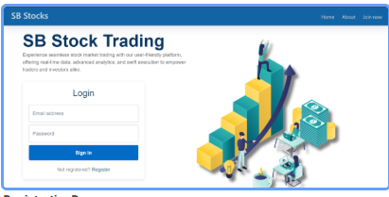
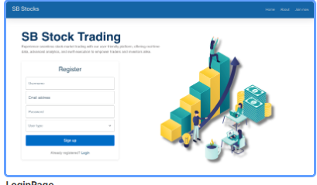

11.2 Feature 2 – Stock Market Data & Visualization

Description
This feature displays stock market data and visualizes price trends through charts. Users can view stock details and analyze performance before trading.

Code Explanation
Stock data is handled by stockController.js and stored using stockSchema.js. The frontend component StockChart.jsx displays stock performance charts for better visualization.

API Endpoints
- GET /api/stocks – Retrieve stock list
- GET /api/stocks/:id – Retrieve specific stock details

Model Architecture
The stockSchema.js includes fields such as:
- Stock symbol
- Stock name
- Current price
- Market data

Screenshots / Outputs

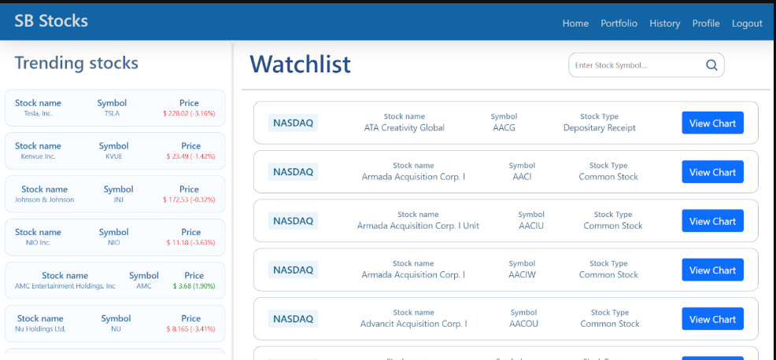

11.3 Feature 3 – Stock Trading System (Buy/Sell)

Description
This feature enables users to simulate stock trading by buying and selling stocks using virtual funds.

Code Explanation
Trading operations are implemented in orderController.js and transactionController.js. The system validates the user's balance and records every trade.

API Endpoints
- POST /api/orders/buy – Buy stock
- POST /api/orders/sell – Sell stock
- GET /api/orders – Retrieve user orders

Database Schema
- orderSchema.js – Stores order details
- transactionModel.js – Stores transaction history

Business Logic Layer
- Validate stock purchase requests
- Check user balance before buying
- Update portfolio and transaction records

Screenshots / Outputs
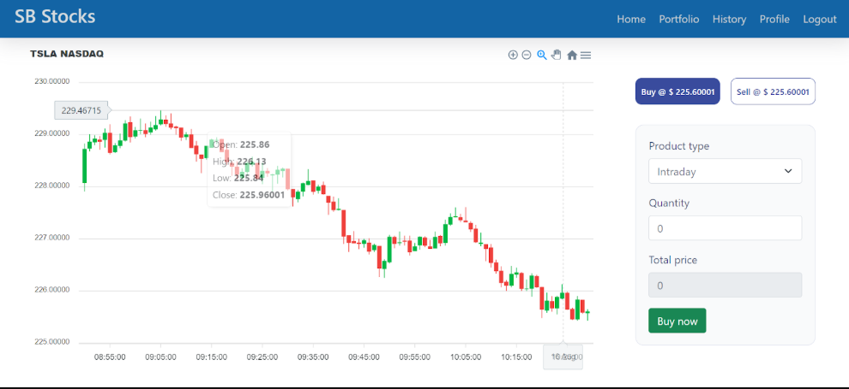

11.4 Feature 4 – Portfolio Management & Trading History

Description
This feature allows users to track their investments, view portfolio performance, and review past trading activities.

Code Explanation
Frontend pages Portfolio.jsx and History.jsx fetch portfolio and transaction data from backend APIs using Axios.

API Endpoints
- GET /api/portfolio – Retrieve portfolio details
- GET /api/transactions – Retrieve transaction history

Screenshots / Outputs

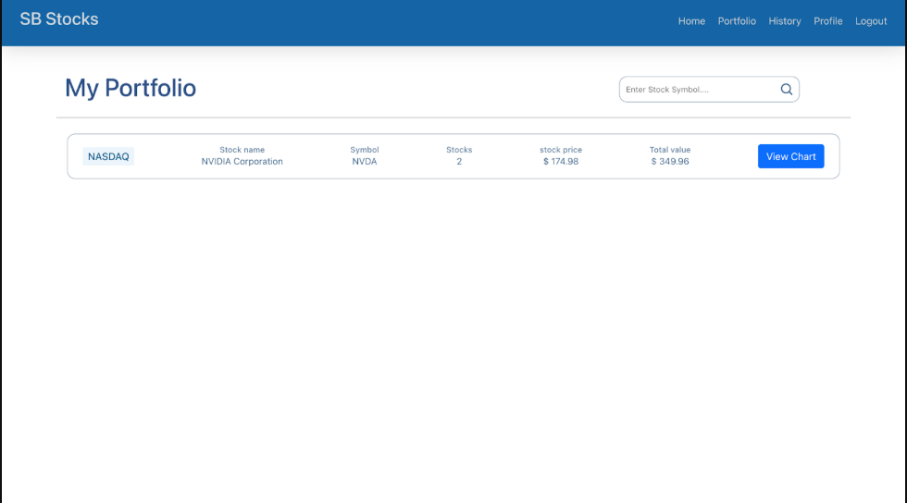

11.5 Feature 5 – Admin Management System

Description
The admin panel allows administrators to monitor system activity, view users, and track orders and transactions.

Code Explanation
Admin pages such as Admin.jsx, AllOrders.jsx, AllTransactions.jsx, and Users.jsx allow administrators to manage system data.

Screenshots / Outputs

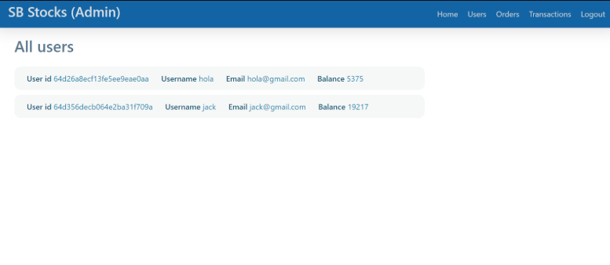

- MILESTONE 4: INTEGRATION & OPTIMIZATION

11.1 Component Integration
The frontend components are integrated with backend APIs to enable smooth communication between the user interface and the server. This integration allows users to perform actions such as logging in, viewing stocks, buying or selling shares, and managing their portfolios in real time.

11.2 Performance Optimization
To ensure efficient system performance, several optimization techniques are implemented:
- Efficient Database Queries → Optimized MongoDB queries are used to retrieve and update data quickly.
- API Response Optimization → Backend APIs are structured to return only necessary data, improving response time and reducing server load.

11.3 Security Enhancements
Security measures are implemented to protect user data and system operations:
- JWT Authentication → JSON Web Tokens are used to securely authenticate users and manage sessions.
- Password Hashing with bcrypt → User passwords are encrypted using bcrypt before being stored in the database.

11.4 Error Handling & Validation
Proper error handling and input validation mechanisms are implemented to maintain system stability. The system validates user inputs, prevents invalid data submissions, and displays meaningful error messages to guide users and avoid system failures.

- MILESTONE 5: TESTING & VALIDATION

13.1 Test Cases
Test Case ID | Input / Action | Expected Output | Status
TC1 | User Registration | New user account created successfully | Pass
TC2 | User Login | Successful login and dashboard access | Pass
TC3 | Invalid Login | Error message for incorrect credentials | Pass
TC4 | View Stock List | System displays available stocks and prices | Pass
TC5 | Search Stock | Relevant stock information displayed | Pass
TC6 | Buy Stock | Stock added and portfolio updated | Pass
TC7 | Sell Stock | Transaction recorded and portfolio updated | Pass
TC8 | View Portfolio | User portfolio and holdings displayed | Pass
TC9 | View Transaction History | System shows previous buy/sell records | Pass
TC10 | Update User Profile | Profile information updated successfully | Pass
TC11 | Admin View Users | Admin can view list of registered users | Pass
TC12 | Admin View Transactions | Admin can access all transaction records | Pass
TC13 | Logout | User session terminated and redirected to login page | Pass
TC14 | Invalid Stock Purchase (Insufficient Funds) | System shows error message and prevents purchase | Pass
TC15 | Unauthorized Access to Admin Page | Access denied message displayed | Pass

13.2 Unit Testing
Unit testing is performed to verify that individual backend modules and functions work correctly before integrating them with other components.
Module Tested | Function Tested | Expected Result | Status
User Controller | User Registration Function | New user data saved in database | Pass
User Controller | Login Authentication | Valid credentials allow login | Pass
Stock Controller | Fetch Stock Data | Stock data retrieved successfully | Pass
Order Controller | Create Order | Order stored in database | Pass
Transaction Controller | Record Transaction | Transaction recorded correctly | Pass

13.3 Integration Testing
Integration testing ensures that the frontend, backend APIs, and database communicate properly and data flows correctly across the system.
Components Integrated | Action Tested | Expected Result | Status
Frontend Login Form + Backend API | User login request | Successful authentication and dashboard access | Pass
Stock Page + Stock API | Fetch stock list | Stocks displayed correctly | Pass
Buy Stock Page + Order API | Buy stock request | Portfolio updated and order recorded | Pass
Sell Stock Page + Transaction API | Sell stock request | Transaction saved and portfolio updated | Pass
Portfolio Page + Database | Fetch portfolio data | User holdings displayed correctly | Pass

13.4 User Acceptance Testing (UAT)
User Acceptance Testing is conducted by end users to ensure the system meets usability and functional requirements.
Test Scenario | User Action | Expected Result | Status
User Registration | User creates a new account | Account created successfully | Accepted
User Login | User logs into the system | Dashboard loads successfully | Accepted
Buy Stock | User purchases a stock | Stock added to portfolio | Accepted
Sell Stock | User sells owned stock | Portfolio and balance updated | Accepted
View Portfolio | User checks portfolio page | Holdings and profit/loss displayed | Accepted
View Transaction History | User opens history page | Past transactions displayed | Accepted

13.5 Performance Testing
Performance testing evaluates system responsiveness and stability under different loads.
Test Scenario | Condition | Expected Result | Status
API Response Time | Fetch stock data request | Response returned within acceptable time | Pass
Multiple User Requests | Several users access the system simultaneously | System remains stable | Pass
Database Query Performance | Large transaction data retrieval | Data retrieved efficiently | Pass
Page Loading Speed | Dashboard loading | Page loads quickly without delay | Pass

  - . DEPLOYMENT

Deployment Architecture

14.1 System Deployment
The SB Stocks platform is deployed on a cloud-based environment to ensure accessibility, scalability, and reliability. The backend server built with Node.js and Express.js handles API requests and communicates with the MongoDB database, while the frontend application is hosted separately for efficient delivery to users.

14.2 Hosting Platform
The system can be deployed using modern cloud hosting platforms that support full-stack applications. Possible platforms include:
- Render → Used for hosting backend services and APIs.
- Vercel → Suitable for deploying frontend React applications.
- AWS (Amazon Web Services) → Provides scalable cloud infrastructure for hosting full applications.

14.3 Deployment Steps
- Push the complete project code to a GitHub repository.
- Connect the repository to the selected cloud hosting platform.
- Configure required environment variables such as database connection strings and API keys.
- Build and deploy the application to make it accessible online.

14.4 Production Considerations
To ensure secure and reliable operation in a production environment, the following aspects are considered:
- Database Security → Protect database access using secure credentials and restricted connections.
- Backup Mechanisms → Maintain regular backups of the database to prevent data loss.
- API Rate Limits → Implement request limits to prevent server overload and potential misuse..

15. PROJECT STRUCTURE
SB-stocks-project/
│
├── client/ # React Frontend
│ └── src/
│ ├── components/
│ │ ├── axiosInstance.js
│ │ ├── Login.jsx
│ │ ├── Register.jsx
│ │ └── Navbar.jsx
│ │
│ ├── context/
│ │ └── GeneralContext.jsx
│ │
│ ├── pages/
│ │ ├── Landing.jsx
│ │ ├── Home.jsx
│ │ ├── Portfolio.jsx
│ │ ├── History.jsx
│ │ ├── Profile.jsx
│ │ ├── StockChart.jsx
│ │ ├── Admin.jsx
│ │ ├── AdminStockChart.jsx
│ │ ├── AllOrders.jsx
│ │ ├── AllTransactions.jsx
│ │ └── Users.jsx
│ │
│ ├── App.js
│ └── index.js
│
├── server/ # Node.js Backend
│ ├── config/
│ │ └── db.js
│ │
│ ├── controllers/
│ │ ├── orderController.js
│ │ ├── stockController.js
│ │ ├── transactionController.js
│ │ └── userController.js
│ │
│ ├── middleware/
│ │ └── authMiddleware.js
│ │
│ ├── models/
│ │ ├── orderSchema.js
│ │ ├── stockSchema.js
│ │ ├── transactionModel.js
│ │ └── userModel.js
│ │
│ ├── routes/
│ │ ├── orderRoute.js
│ │ ├── stockRoute.js
│ │ ├── transactionRoute.js
│ │ └── userRoute.js
│ │
│ ├── Schemas.js
│ └── index.js
│
├── tests/ # Testing scripts
│
├── .env # Environment variables
├── package.json
├── package-lock.json
└── README.md
client/ – Contains the React frontend application.
public/ – Static files such as HTML template and icons.
src/ – Main React source code.
components/ – Reusable UI components like Navbar, Login form, etc.
pages/ – Application pages such as Home, Portfolio, Dashboard.
context/ – Global state management for authentication and shared data.
services/ – Handles API requests using Axios.
assets/ – Images, CSS files, and other static resources.
server/ – Backend built with Node.js and Express.js.
config/ – Configuration files such as MongoDB connection setup.
controllers/ – Contains business logic for handling requests.
models/ – MongoDB schemas and data models.
routes/ – API endpoints for different modules.
middleware/ – Authentication and request validation logic.
utils/ – Helper functions used across the backend.
server.js – Main entry point that starts the backend server.
database/ – Contains database-related scripts or additional configurations.
tests/ – Includes unit tests and integration tests.
.env – Stores sensitive environment variables such as database URI and API keys.
package.json – Lists project dependencies and scripts.

16. RESULTS
The implementation of the SB Stocks platform successfully demonstrates the functionality of a simulated stock trading system. The system allows users to interact with stock market data and manage virtual investments through an intuitive web interface.
Key Results
• Successful Simulation of Stock Trading – Users can buy and sell stocks using virtual funds, and all transactions are recorded in the system.
• Portfolio Performance Tracking – The platform tracks user holdings and provides insights into portfolio value and performance.
• Real-Time Stock Data Visualization – Stock price movements are displayed using interactive charts, allowing users to analyze market trends.
Screenshots :
Landing page

Registration Page

Home page

Profile page (User)
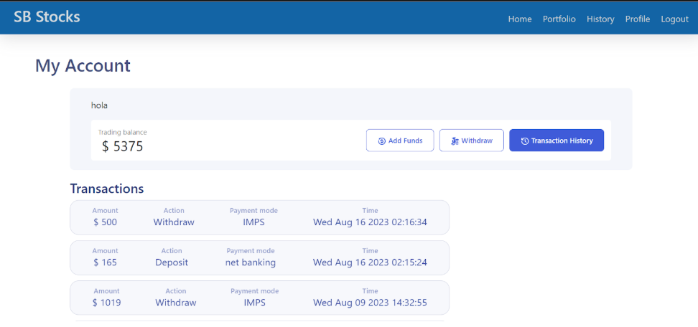
Stockchart

Portfolio


17. ADVANTAGES & LIMITATIONS

Advantages
- Risk-free trading simulation
- Educational platform for beginners
- Easy-to-use interface
- Real-time market insights

Limitations
- Does not involve real financial transactions
- Limited to simulated trading environment

18. FUTURE ENHANCEMENTS
- Mobile application version
- Advanced trading analytics
- AI-based trading recommendations
- Cloud scalability improvements
- Automated trading simulations

19. CONCLUSION

The SB Stocks platform successfully provides a realistic stock trading simulation environment where users can learn and practice trading strategies without financial risk. The project demonstrates the implementation of a full-stack web application using modern technologies such as React, Node.js, and MongoDB.
The system enhances financial learning by allowing users to explore stock markets, manage portfolios, and analyze trading performance.

20. APPENDIX

Source Code
Include complete project source code.

Dataset / API
Stock market data APIs.

GitHub Repository Link
(Your GitHub link here)

Live Demo Link
(Project deployment link)

