DisasterLens: A Multimodal Pipeline for Disaster Relief Resource Mapping
Mahek Nagdev, Pratyusha Jaitly

1. Introduction
Disaster response teams routinely operate under severe time pressure with fragmented information: aerial or ground-level photographs, and unstructured text reports from social media, news wires, and field volunteers. Neither modality alone reliably indicates where relief resources are most urgently needed. An image can show visible structural damage without indicating casualties or population displaced, while a text report can convey urgency without confirming the physical extent of destruction. Traditional response pipelines rely on structured sensor data or official damage assessments, frequently unavailable in the earliest, most critical hours after an event.
DisasterLens investigates whether a multimodal pipeline combining a vision-language model and a large language model can reliably infer localized relief priorities directly from these unstructured, real-world inputs, without waiting for official reports. Given a paired (image, text snippet), the system produces a damage category and severity assessment, a structured estimate of resource needs across four categories (food, water, shelter, medical), and a natural-language relief priority summary, visualized on an interactive map.

2. Related Work
A substantial body of work has established social media as a viable disaster-response information channel, from early surveys of how such messages are processed for situational awareness [16] to task-specific systems built on top of them. Prior multimodal disaster-analysis work has largely relied on jointly-trained neural fusion architectures. Ofli, Alam, and Imran [6], from the same research group behind the CrisisMMD dataset used here, combine text and image encoders through a modality-agnostic shared representation, showing that fusing both modalities substantially outperforms either alone for extracting disaster-relevant information. Ahmad et al. [7] extend this with an attention-based architecture using text to guide image classification, improving CrisisMMD classification accuracy by roughly 2-3 points over unimodal baselines.
On the vision side, Amini et al. [11] fine-tune a CLIP-based segmentation model on annotated aerial hurricane imagery, achieving a Dice score of 0.70, a similar strategy to the frozen-CLIP-with-trainable-head approach used here, though for pixel-level debris segmentation rather than severity classification. The same lineage includes EmergencyNet [3], a more compute-efficient architecture for the same AIDER task (Section 3.1), though the present system builds directly on AIDER's original category labels [2]. On the text side, Madichetty et al. [12] combine RoBERTa and VGG-16 via multiplicative fusion to identify informative disaster tweets across the same disaster events that make up CrisisMMD; unlike here, their fusion is trained end to end rather than LLM-orchestrated.
Both of these approaches train a dedicated fusion network end to end on labeled multimodal disaster data. DisasterLens takes a different approach: rather than training a joint fusion model, it combines a frozen, pretrained vision-language model (CLIP, via lightweight linear probing) with a general-purpose LLM (Gemini) prompted to reason over both modalities' outputs directly. This trades the accuracy ceiling of a fully-trained fusion network for substantially lower data and compute requirements, while still allowing explicit, inspectable control over how conflicting signals are resolved (Section 3.3), a capability not naturally offered by an end-to-end trained network.

2.1 Related Implementations
AIDER and CrisisMMD are not hosted as Kaggle datasets, so a direct kernel-for-kernel comparison is not possible. The closely related task of classifying disaster-related text, which the RoBERTa module addresses, is the subject of Kaggle's “Natural Language Processing with Disaster Tweets” competition [13]. A representative kernel fine-tunes DistilBERT via KerasNLP for a public leaderboard score of 0.837 [14], while a TF-IDF plus logistic-regression baseline reports 0.796 [15]. Both operate on a binary relevant/not-relevant label rather than CrisisMMD's eight fine-grained categories, a substantially easier task than the one the RoBERTa module attempts, a plausible additional contributor to its low macro-F1 (Section 5.2) beyond class imbalance. The present approach differs in attempting fine-grained categorization, and in using RoBERTa's output as one signal among three feeding a downstream fusion layer rather than as a standalone task.

3. Methods
The proposed approach combines three independently-obtained signals: a directly-supervised vision severity classifier, a general-purpose LLM text extractor, and a fine-tuned text classifier, through a single LLM-orchestrated fusion call, rather than training one large end-to-end multimodal network. This is better suited to the present setting than the alternative of training a joint fusion model from scratch (as in the related work above): with only a few thousand labeled images and tens of thousands of labeled tweets, a large jointly-trained fusion network would be prone to overfitting and would require substantially more engineering and compute time than this project's timeline allowed. Orchestrating pretrained components through an LLM reaches a working, evaluable system quickly while retaining an explicit and auditable point of control, the fusion prompt's conflict-resolution policy, for a behavior (modality disagreement) that a jointly-trained black-box network would otherwise resolve implicitly and invisibly.

3.1 Vision Module: Direct Severity Classification
The vision module predicts one of four ordered severity labels (none, mild, moderate, severe) directly from a single image. The implementation uses the pretrained openai/clip-vit-base-patch32 image encoder [1] as a frozen feature extractor via linear probing: each image is embedded as a 512-dimensional feature vector v = CLIP(image), L2-normalized to v-hat = v / ||v||, then passed to a trainable classification head computing logits z = W2 ReLU(W1 v-hat + b1) + b2, where W1 is 512x128, W2 is 128x4, and dropout p=0.3 is applied to the hidden ReLU activations during training. A softmax over z yields the predicted severity distribution, p(y=k | x) = exp(z_k) / sum_j exp(z_j), trained by minimizing cross-entropy against the ground-truth label. Freezing CLIP's weights and training only this small head is a standard transfer-learning strategy: CLIP's representations, from contrastive pretraining on hundreds of millions of image-text pairs, are already highly discriminative, so a lightweight head is typically sufficient without the overfitting risk or compute cost of updating all of CLIP's parameters. Training ran 15 epochs on a stratified 80/10/10 AIDER split (seed 42), with the best validation-accuracy checkpoint selected for test evaluation.
This modeling problem was independently investigated from two different angles during development. An initial exploration classified AIDERv2 images into their native disaster category (Earthquake/Fire/Flood/Normal) and applied a deterministic category-to-severity proxy mapping, since neither AIDER nor AIDERv2 labels severity directly, only disaster type. This category classifier reached 98.56% validation and 99% test accuracy on the 4-category task, but the proxy mapping meant every image in a category received the same baseline severity regardless of how severe that specific image actually was (Section 7). The approach adopted for the final system instead remaps AIDER's original event labels directly to the severity scale: normal scenes become none, minor traffic accidents become mild, fires and partial flooding become moderate, and collapsed buildings and severe flooding become severe. This is still a proxy label, since AIDER's original annotations were never severity judgments to begin with, but it is a finer-grained proxy mapping applied directly at the event level rather than one inherited from a downstream category classifier's output, decoupling the vision module's output from any specific training taxonomy and better serving the fusion layer's actual need.
The public interface predict_severity(image_path) returns the predicted severity, its softmax confidence, an empty damage-type list reserved for future multi-label extension, and a model identifier, so that the downstream application and fusion layer never depend on AIDER's original event taxonomy.

3.2 Text Module: Two Independent Signals
Given a short text snippet describing a disaster event, DisasterLens extracts structured information via two independent, comparable systems feeding the same fusion layer.
(a) LLM-based extraction. A general-purpose LLM constrained to a fixed schema extracts an estimated affected population (nullable), resource types explicitly mentioned or implied (food, water, shelter, medical), and named locations, instructed not to invent unstated facts. This module was originally scoped around OpenAI's GPT-4o API per the proposal; it was substituted with Google's Gemini API [8] (gemini-flash-latest) for cost reasons, a reasonable substitution since both are general-purpose frontier LLMs of comparable capability for short-context structured extraction, requiring no schema changes.
(b) Fine-tuned classifier. A FacebookAI/roberta-base model [9], loaded and fine-tuned via the Hugging Face transformers library [10], is trained on CrisisMMD's eight humanitarian categories as single-label classification, since the source annotations are mutually exclusive; an initial independent-binary-loss formulation did not represent that structure correctly. Because the category distribution is extremely imbalanced (Section 4.1), largest over 5,800 examples, smallest around 40, cross-entropy is replaced with a weighted variant, L = -(1/N) sum_i w(y_i) log p(y_i | x_i), where the weight for class y is the inverse square root of its training frequency, capped at 5, down-weighting dominant classes without letting the rarest dominate the gradient. Training ran three epochs, batch size 16, max sequence length 128 tokens (CrisisMMD tweets average 13.7 words, Section 4.1), with the highest validation macro-F1 checkpoint selected, the appropriate metric under class imbalance since it weights every class equally.
The public function classify_resources_fine_scores(text) exposes all eight category probabilities, classify_resources_fine(text) returns the top category, and classify_resources(text) maps it into the four-resource vocabulary (for example, infrastructure_and_utility_damage maps to shelter). A separate deterministic, rule-based extractor identifies event type, population mentions, urgency vocabulary, and locations via local text patterns rather than an external model, keeping this component reproducible, though it cannot capture unrestricted social-media text's linguistic variation.
Running both systems on the same input lets the fusion layer draw on a general-purpose reasoning model and a fine-tuned classifier simultaneously, and lets their behavior be compared directly on identical inputs (Section 5).

3.2.1 Urgency Evaluation Rubric
Neither CrisisMMD nor AIDER labels urgency on a continuous scale, so evaluating the system's 1-5 urgency outputs requires the same proxy-labeling approach used for vision severity (Section 3.1): a deterministic mapping from CrisisMMD's eight categories to a 1-5 scale, reasoned from whether a category implies direct threat to life (e.g. injured_or_dead_people maps to 5, not_humanitarian to 1). As a sanity check, a stratified subset of 39 examples (up to 5 per category) was independently rated 1-5 by two raters on the project team, with agreement measured via linear-weighted Cohen's kappa and exact-match percentage against each other and the proxy rubric.

3.3 Fusion Layer
The fusion layer combines the vision module's severity signal with both text signals in a single LLM call, producing a final severity level, a resource-need vector (food, water, shelter, medical, each on a 1-5 urgency scale), and a natural-language priority summary.
A key design decision, made explicitly before implementation per advisor feedback, was how to resolve cases where signals disagree, originally scoped as vision versus text and extended to all three signals once the second text system was integrated. A “favor the more severe or urgent reading” policy was adopted: rather than averaging or silently defaulting to one signal, the system always resolves to whichever indicates the greatest severity or urgency, over averaging or flagging-only, because in a triage context the cost of under-reacting to a genuinely severe event outweighs over-triaging a milder one; this is encoded directly in the fusion layer's system prompt rather than left to ad hoc model judgment.

3.4 Application Layer
The full pipeline is exposed through an interactive Streamlit application. A user selects a sample image or uploads their own, alongside a text report. On submission, the application runs the vision classifier, both text-analysis systems, and fusion, then renders all three raw signals alongside the fused result: a resource-need bar chart, the priority summary, and a Folium map marker geocoded from the extracted location, color-coded by final severity.

3.5 Experimental Setup
Both trained components use a deterministic, seeded 80/10/10 train/validation/test split rather than k-fold cross-validation. Given the dataset sizes involved (6,433 AIDER images and 15,637 CrisisMMD records after excluding the conflict fixture), a single held-out split was judged sufficient for a stable estimate, and cross-validation's main advantage, reduced variance when data is scarce, matters less at this scale, while its main cost, retraining several times over, was not worth paying against this project's timeline. The CLIP severity head (Section 3.1) was trained with AdamW for 15 epochs, selecting the highest validation-accuracy checkpoint; the RoBERTa classifier (Section 3.2b) was trained for three epochs with batch size 16, selecting the highest validation macro-F1 checkpoint, for the class-imbalance reasons discussed above. Both models were trained and evaluated independently, with no test-split information used during training or checkpoint selection. All training and evaluation code, and the exact splits used, are available under vision/clip_finetune/, disasterlens_modules/, and evaluation/ (Section 10.1); a colleague could reproduce the setup by following Section 10.2 and running train.py in each directory against the same seeded splits. The codebase is standalone Python scripts rather than Jupyter notebooks throughout; where reproduction instructions elsewhere refer to notebook cells, the corresponding functionality lives in the scripts listed above.

4. Dataset / Inputs
AIDER (Aerial Image Dataset for Emergency Response Applications): the processed sample comprised 6,433 images, stratified 80/10/10 into train/validation/test (5,144/642/647) with seed 42. Original event labels were remapped directly to the four-level severity scale described in Section 3.1. The full severity distribution is 4,390 none, 485 mild, 1,047 moderate, and 511 severe [2] (larger AIDERv2 release: [4]).
CrisisMMD: a multimodal benchmark of tweets paired with disaster images across seven natural disasters, labeled for informativeness and eight humanitarian categories [5]. Direct inspection found 18,082 image-text pairs and 16,058 unique tweets; a pair couples one tweet with one image, and some tweets pair with more than one image, hence the pair count exceeding the tweet count. The original fine-grained categories (affected individuals, infrastructure and utility damage, injured or dead people, missing or found people, not humanitarian, other relevant information, rescue or donation effort, vehicle damage) were retained rather than collapsed early, since these distinctions matter for urgency assessment; a narrower four-resource vocabulary (food/water/shelter/medical) is derived downstream (Section 3.2b).
A corpus-wide audit comparing CrisisMMD's image-based and text-based humanitarian-category annotations across all 18,082 pairs found disagreement on 10,003 of them, candidate disagreement volume, not confirmed severity conflicts. A separate 500-row image-text conflict fixture was constructed from this pool and excluded from all training splits: 150 real severity mismatches, 150 real resource mismatches, 100 real agreement controls, and 100 synthetic location mismatches, to support controlled evaluation of the fusion layer's conflict-resolution behavior (Section 3.3). A 60-row subset (20 severity, 20 resource, 20 agreement) was retained as a directly machine-readable, adjudicated review sheet, the basis for the evaluation in Section 5.5. In total, 421 unique tweet identifiers represented in the full fixture were excluded from the general splits, preventing leakage. After reserving these, 15,637 CrisisMMD image-text pairs, referred to below as records, remained for model development (12,506/1,561/1,570 train/validation/test).
Text inputs for the vision-only AIDER images: since AIDER is image-only, illustrative text reports are paired with sample images for end-to-end demonstration purposes.

4.1 Data Analysis
Exploratory analysis of both datasets, prior to training, surfaced two properties that directly shaped modeling decisions. First, both datasets are substantially class-imbalanced (Figure 1): AIDER's severity distribution is dominated by none (4,390 of 6,433 images, roughly 68%), with mild and severe each under 8%, and CrisisMMD's fine-category distribution ranges from 5,872 examples for other_relevant_information down to only 40 for missing_or_found_people, over 140-to-1. This motivates the weighted cross-entropy loss used in RoBERTa training (Section 3.2b) and reporting macro-F1 rather than raw accuracy (Section 5.2), since accuracy alone would be dominated by majority-class performance and obscure near-total failure on rare classes. Second, when the eight fine categories are mapped to the four-resource contract, 10,497 of 15,637 usable records (67%) map to no resource label at all (Figure 1, right panel), since categories like not_humanitarian carry no direct resource implication (Section 3.2b), an imbalance layer distinct from the fine-category one.

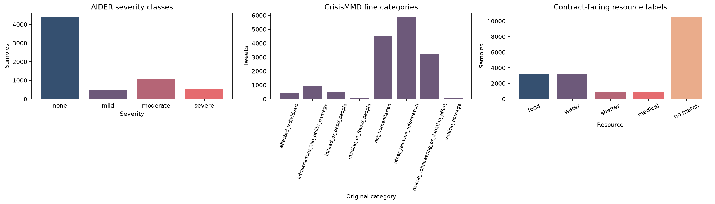
Figure 1. Left: AIDER severity class distribution after event-to-severity remapping. Middle: CrisisMMD's eight original fine-grained humanitarian categories. Right: distribution after mapping fine categories to the four-resource contract, showing most records map to no resource label.

The raw text length distribution of CrisisMMD tweets (Figure 2) determines an appropriate tokenizer sequence length for RoBERTa. Tweet length is approximately unimodal, centered around 13-14 whitespace-delimited words (mean 13.72, median 14, n=15,637), maximum 26 words, confirming that 128 tokens (Section 3.2b) is far more than sufficient; no truncation was observed. AIDER image dimensions varied substantially, from 123x152 to 5,184x3,456 pixels across all 6,433 readable images with zero unreadable files, motivating CLIP's own image processor (Section 3.1) over a hand-tuned preprocessing step.

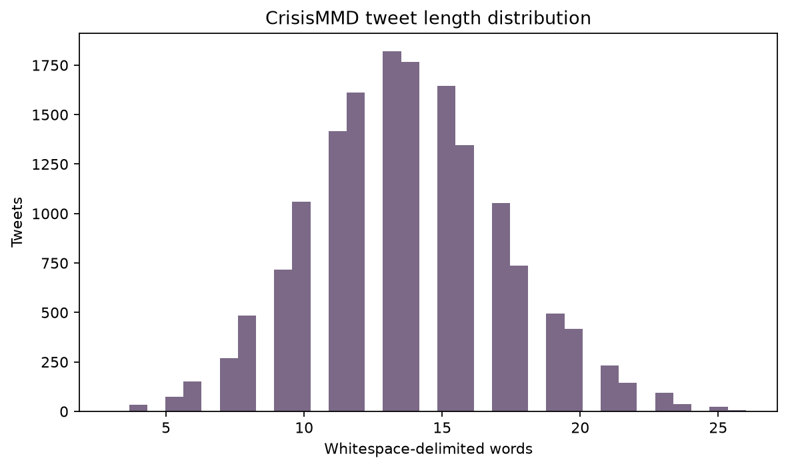
Figure 2. Distribution of CrisisMMD tweet lengths in whitespace-delimited words (n=15,637), justifying the 128-token RoBERTa sequence-length setting.

The composition of the 500-row conflict-evaluation fixture was designed deliberately rather than sampled naturally, so its class balance (Section 4) reflects controlled test coverage of severity, resource, and location disagreement rather than an estimate of how often such conflicts occur in operational disaster reporting; that distinction is revisited in Section 7.

5. Results
Table 1 summarizes the headline metrics for both trained components, discussed in detail below.

Component | Task | Test accuracy | Macro-F1 | Notes
CLIP severity classifier | 4-class severity (AIDER) | 98.15% | 0.969 | 647 test images
CLIP category classifier (exploratory) | 4-class category (AIDERv2) | ~99% | (n/a) | superseded, Sec. 3.1
RoBERTa resource classifier | 8-class fine category (CrisisMMD) | 52.74% | 0.275 | 1,570 test records
RoBERTa, mapped to 4-resource contract | 4-resource multi-label | (n/a) | 0.402 | derived from above

5.1 Vision: Direct Severity Classification
On 647 held-out AIDER test images, the fine-tuned direct-severity CLIP head achieved 98.15% test accuracy (best validation accuracy 98.29%), with macro precision/recall/F1 of 0.960/0.978/0.969 (Figure 3). Per-class F1 ranged from 0.940 (mild, smallest class at 49 examples) to 0.987 (none); errors were sparse (431/439 none, 51/52 severe correctly classified). An earlier exploratory classifier on AIDERv2's native categories reached a comparable 99% test accuracy, but as discussed in Section 3.1, a category label is not a severity label, motivating the switch to direct severity remapping.

5.2 Text: Two Independent Signals Compared
The fine-tuned RoBERTa classifier achieved substantially lower performance than the vision module: 52.74% accuracy and 0.275 macro-F1 across the eight fine-grained CrisisMMD categories on 1,570 held-out records (weighted F1 0.501), reflecting severe class imbalance; only 4-6 test examples exist for the rarest categories, both scoring F1=0. After mapping to the four-resource contract, macro-F1 was 0.402 and micro-F1 was 0.542. Notably, shelter shows perfect precision (1.00) but near-zero recall (0.01): the model almost never predicts the corresponding category, so its apparent precision does not indicate useful shelter-need detection. Food and water both reach F1 0.587 since they derive from the same source category (rescue/donation effort).
This weakness is directly visible on a representative example: for the text “Heavy flooding in Dhaka. 10,000 people displaced, need food,” the RoBERTa classifier assigns other_relevant_information, producing an empty resource list despite the explicit mention of food, while the deterministic rule-based extractor correctly recovers the location, population estimate, and event type. The Gemini-based extractor, run on the same input, correctly identifies the explicit resource need. Running both systems side by side in the same application (Section 3.4) makes this contrast directly observable rather than assumed, and is itself a useful result: a general-purpose LLM with no disaster-specific fine-tuning outperforms a fine-tuned classifier on this narrow extraction task, likely because CrisisMMD's category labels do not map cleanly onto the four-resource contract to begin with (Section 4).
Could this result have been better, and why was a different approach not pursued? Most plausibly, yes: a resource-specific training objective, directly supervised on the four-resource contract rather than borrowed from CrisisMMD's eight-way taxonomy, would likely close much of this gap, since the mismatch is a labeling-target problem more than a modeling-capacity one. This was not attempted because building such a training set at adequate scale was judged out of scope given the project timeline; it is revisited in Section 7.

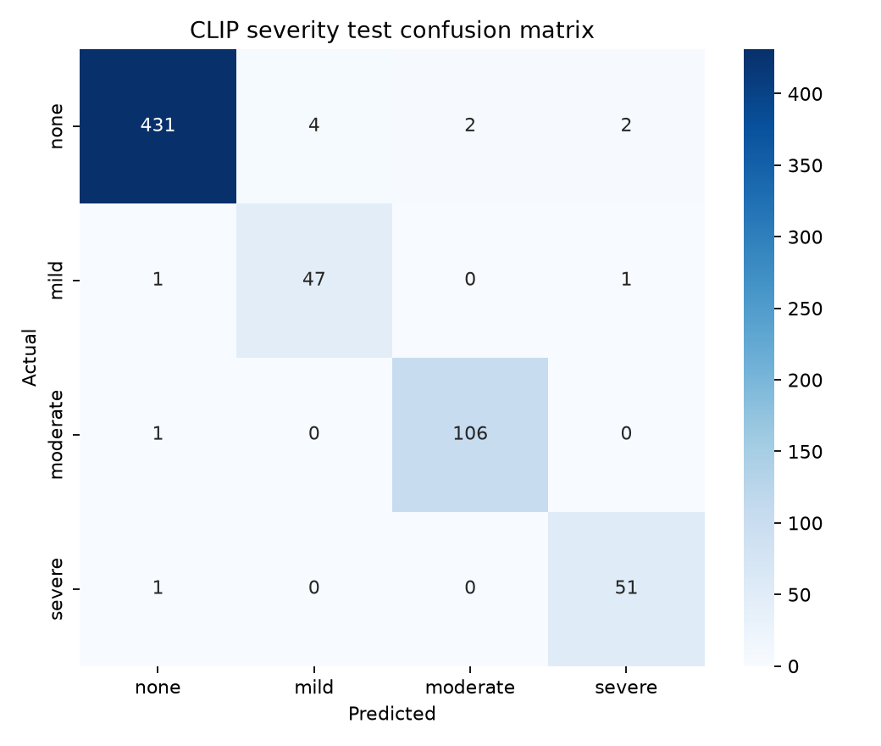
Figure 3. Confusion matrix for the direct-severity CLIP classifier on the 647-image AIDER test split.
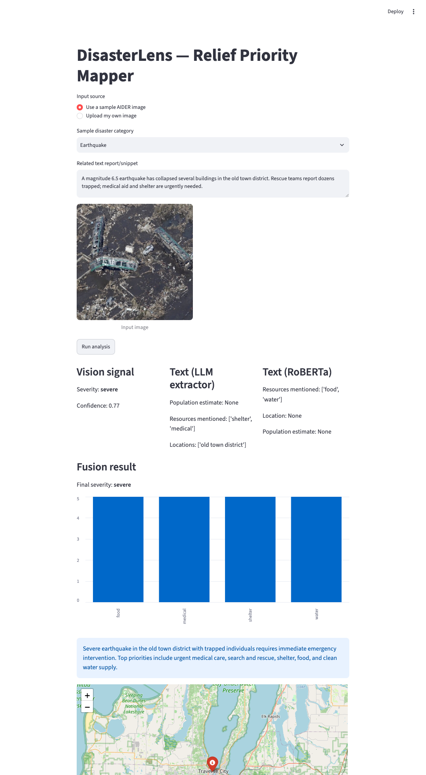
Figure 4. DisasterLens end-to-end demo: an earthquake image and text report produce vision, LLM-extractor, and RoBERTa signals, fused into a final severity, resource-need chart, priority summary, and geocoded map marker.

5.3 End-to-End Fusion
Given an earthquake image (vision severity: severe, confidence 0.77) paired with a text report describing trapped individuals and urgent medical/shelter needs, the fused output correctly escalated all four resource-need scores and produced a coherent priority summary referencing both the structural severity and the specific resources named in the text, demonstrating the intended behavior of drawing on whichever signal indicates greater urgency, rather than defaulting to any single source.

5.4 Urgency Rubric Sanity Check
Two independent raters on the project team independently rated the same 39-example stratified subset on the 1-5 urgency scale, without seeing the proxy rubric's scores or each other's ratings beforehand. The two raters agreed with each other on 92.31% of examples exactly, with a linear-weighted Cohen's kappa of 0.881, conventionally interpreted as almost perfect agreement. Agreement between the deterministic proxy rubric and each rater was considerably lower: 58.97% exact match with one rater and 56.41% with the other. This gap indicates that while the two raters converge strongly on what “urgency” means for a given tweet, the category-level proxy rubric is a comparatively coarse approximation of that shared human judgment, since it assigns a single fixed score per category regardless of a specific tweet's wording or severity within that category. This is treated as an honest limitation of the proxy-labeling approach (Section 7) rather than evidence that the rubric is unreasonable: the high human-human agreement confirms the underlying urgency concept is well-defined and consistently applied, even though the deterministic rubric only partially captures it.

5.5 Conflict-Fixture Evaluation
Section 4 describes a 500-row conflict fixture testing the fusion layer's conflict-resolution policy under controlled disagreement. A 60-row subset (20 severity, 20 resource, 20 agreement controls) was run through the production policy: given an image- and text-derived severity signal, always resolve to whichever is more severe. Since the sheet records a severity signal for every row regardless of labeled conflict type, this evaluates severity-conflict resolution uniformly rather than a resource- or location-specific outcome; resource_mismatch rows still disagree at the severity level here, resolved by the same rule as severity_mismatch rows.
Of the 60 rows, 7 were resolved via the production Gemini fusion call; the remaining 53 via a substitute LLM (Claude) applying the identical policy, after the Gemini key's free-tier daily quota was exhausted mid-evaluation. All 60 results are reported together below, with the resolving model recorded per row in evaluation/conflict_fixture_results_full.csv.

Conflict type | n | Resolved as policy prescribes | Rows with a real signal disagreement
severity_mismatch | 20 | 20/20 (100%) | 20/20
resource_mismatch | 20 | 20/20 (100%) | 20/20
agreement control (none) | 20 | 20/20 (100%) | 0/20

Every case where the two signals genuinely disagreed (40/60 rows) was resolved to the more severe reading, and every case where they already agreed (20/60 rows) was left unchanged, with no false-positive escalation. This is expected rather than surprising: the policy is an explicit, low-ambiguity instruction, and the 20 agreement-control rows here are exact label ties (e.g. severe/severe) rather than close-but-distinct cases, so this shows the policy is followed reliably on clear cases, not that it handles subtle ones well. A next step, noted in Section 7, is extending this to the remaining 440 rows, including the 100 synthetic location-mismatch rows not yet machine-readable, and to genuinely ambiguous near-tie cases.

6. Analysis
Why this architecture fits this data. The central structural constraint on this project is that no dataset used here provides ground-truth labels for the joint decision the system ultimately makes. AIDER labels images, CrisisMMD labels text, and neither labels a fused outcome across both modalities at once; a jointly-trained fusion network would therefore need either a labeled fusion dataset that does not exist, or an approximated one, reintroducing the same proxy-labeling problem already documented for vision severity (Section 3.1) and urgency scoring (Section 3.2.1). Composing three independently trained components, each on the single-modality data that does exist, and reserving fusion itself for an LLM prompted with an explicit policy, avoids ever needing that missing joint-label dataset. This also matches the data actually available: 6,433 labeled images and 15,637 labeled text records are enough to adapt a frozen CLIP encoder and fine-tune RoBERTa, both reusing large-scale pretraining, but not enough to train a large joint fusion network from scratch without overfitting risk (Section 2).
Is this a generalizable property, or specific to this project? The pattern generalizes to any setting sharing three conditions: each modality already has, or can affordably obtain, an adequately sized single-modality labeled dataset; no joint, fusion-level labeled dataset exists or is affordable to construct; and the correct way to combine modalities can be stated as an explicit policy rather than requiring a network to learn an implicit fusion function from data. The third condition is most specific here: "favor the more severe or urgent reading on disagreement" is a defensible triage rule precisely because disaster response has a well-established asymmetry between under- and over-reacting (Section 3.3). Domains where correct fusion behavior is itself subtle or contested, rather than statable as a short policy, would not fit this pattern as cleanly, and would more likely benefit from a jointly-trained network learning that behavior from labeled examples, the tradeoff Section 2's related work accepts instead.
What would transfer, and to what. Other domains with the same shape, existing or affordable single-modality classifiers, no joint-labeled dataset, and a statable combination policy, would likely transfer this pattern directly. Medical triage is a close analogue: a frozen-encoder image classifier over radiographs (the AIDER vision module's role here) combined with an LLM-based extractor over clinical notes (the text module's role), fused under an explicit escalation policy. Insurance claim triage and content-moderation pipelines share the same shape. The property that would most reduce the case for this architecture, favoring the jointly-trained alternative from Section 2 instead, is the future availability of a dataset directly labeled with the fused outcome itself, for instance a CrisisMMD variant with one human-adjudicated severity per pair rather than per modality; at that point a jointly-trained network's accuracy ceiling would no longer be traded away for lower data and engineering requirements.

7. Discussion
What was learned. The most significant methodological insight was that neither AIDER nor AIDERv2 labels severity, only disaster category, clear only after visually inspecting sample images (a “Fire” image can depict anything from a brush fire to a town engulfed in flames, with identical labels). This required an explicit, documented proxy mapping from category to severity, mirroring the same proxy-labeling approach separately adopted for urgency scoring (Section 5.4). The human-human agreement result there (kappa 0.881) reinforces the same lesson: raters agree strongly on urgency itself, but a deterministic category-based rubric only approximates that judgment.
Engineering challenges. A macOS-specific multiprocessing crash in PyTorch's DataLoader (missing __main__ guard) was resolved by disabling multiprocess data loading. Two independently-developed files both named schema.py caused a silent wrong-class import via sys.path manipulation. A subtle Streamlit bug, where the streamlit_folium component's auto-rerun erased button-triggered results, was fixed by persisting results in st.session_state. Merging two independently-developed halves of the project also surfaced a Git LFS pointer file mistaken for the actual 500MB RoBERTa checkpoint, traced to a missing git-lfs installation.
Limitations. Both vision classifiers' labels are proxy remappings of datasets not originally annotated for this task (Section 3.1, 4), an explicit decision given the timeline. Reported vision accuracy may not transfer to street-level photographs or unseen disaster types, and calibration is needed before confidence values are compared across modalities. RoBERTa's low macro-F1 (0.275) reflects class imbalance and a taxonomy mismatch (Section 5.2). The conflict fixture (Section 4) supports controlled evaluation, and Section 5.5 reports real outcomes on a 60-row subset, but that subset omits synthetic location-mismatch rows and is small enough that its 100% resolution rate shows the policy is followed on clear-cut cases, not that it handles subtler disagreements equally well. The urgency evaluation relies primarily on proxy labels; the human subset (Section 5.4) showed strong human-human agreement but only moderate agreement with the rubric itself.
Future improvements. Given more time, the vision module could use a genuine per-image severity regression head trained on human-labeled data, and the conflict policy made configurable against the averaging and flag-only alternatives considered but not implemented. The Section 5.5 evaluation should extend to the remaining full 500-row fixture, including near-tie cases, and re-run entirely on Gemini once quota allows. Repeated splits, event-held-out evaluation, and a larger urgency sample would strengthen confidence beyond a single split.
Recommendation. DisasterLens demonstrates that a working relief-triage pipeline can be assembled from pretrained, independently-obtained components (a fine-tuned vision classifier, a fine-tuned text classifier, a general-purpose LLM) orchestrated through fusion, without training one large network end to end. For a team reusing this work, the vision classifier and LLM-based text extractor are the most reliable components to build on directly (Sections 5.1, 5.2); RoBERTa should be retrained or replaced before operational use, given its low macro-F1 on rare categories.
What more data would enable. With substantially more labeled data, particularly a larger, better-balanced set for CrisisMMD's rarest categories, and a genuinely human-labeled severity dataset rather than a remapped one, the largest gains would likely come from RoBERTa and from replacing the vision module's remapping with directly-supervised labels at scale (Section 6). A larger urgency sample and a completed 500-row conflict-fixture evaluation would also let the proxy rubric and fusion policy be evaluated, and refined, with more confidence.
What a company deploying this at scale should choose. An organization at high scale would likely replace the per-request LLM fusion call, which carries ongoing cost and latency, with a smaller distilled model once enough fusion-quality examples have been collected from the LLM's own outputs, bootstrapping training data for a cheaper model. Until then, the LLM-orchestrated approach remains more practical, per Section 2: it reaches a working, auditable system without first collecting a joint-labeled dataset that does not exist.

8. AI Prompts Used
Below is the list of prompts used per phase. The full literal log, including routine debugging and clarification requests, is maintained in AI_Prompts_Log.md.
1. Environment, Git, and repo setup. Configured the conda environment and project scaffold, then set up GitHub (SSH keys, deploy-key and divergent-branch push errors). Used, environment, scaffold, and live repo.
2. Dataset research, acquisition, and splits. Researched AIDER (classes, format, license, citation) and obtained CrisisMMD, verifying counts from annotations; implemented the four-level severity mapping, retained CrisisMMD's eight categories, and prepared stratified 80/10/10 splits. Used, informed dataset choice, severity-mapping design, and training splits.
3. Exploratory data analysis. Built a reproducible EDA covering sample counts, class distributions, image dimensions, tweet lengths, and conflict-subset composition. Used; figures reviewed for report, raw records excluded from written discussion.
4. CLIP fine-tuning and evaluation. Built training/evaluation scripts for CLIP linear-probe severity classification (4-class), including confusion matrix and classification report; debugged a macOS multiprocessing DataLoader crash. Used, 98.56% val / 99% test accuracy, figures included in report.
5. Entity extraction. Built structured entity extraction, switching from GPT-4o to Gemini for cost reasons and debugging a deprecated model name via a live model-list query; later replaced with deterministic local rules (location, population, event type, urgency keywords) for reproducibility. Used, verified extraction on sample text and against the agreed integration sentence; limited linguistic coverage documented.
6. Fusion layer. Built the fusion module combining vision severity and text entities via Gemini structured output, encoding a "favor more severe reading on conflict" policy; caught a module-name collision bug before it silently broke behavior. Used, verified correct severity escalation and resource vector output.
7. Conflict analysis and fixture construction. Audited CrisisMMD humanitarian-category disagreements and built a separate fusion test fixture (severity, resource, and location mismatches plus agreement controls), preventing leakage into model splits. Used; verified counts informed evaluation design, with a manual adjudication sheet retained.
8. RoBERTa formulation and evaluation. Preserved the eight CrisisMMD categories, exposed a four-resource contract, and diagnosed weak results from an initial binary-loss formulation. Used; weighted single-label cross-entropy adopted after review.
9. Urgency proxy-label rubric. Built the CrisisMMD-category-to-urgency mapping plus a stratified 39-example human-labeling subset and agreement scripts. Used, rubric and tooling built; human labeling pending.
10. Streamlit app and map. Wired CLIP, entity extraction, and fusion into a UI with a sample-image picker and severity-colored map marker; fixed a Streamlit auto-rerun bug wiping button results via session state. Used, verified full pipeline end-to-end.
11. Module merge and integration validation. Integrated the direct-severity CLIP classifier and RoBERTa resource classifier as additional fusion signals, resolving a Git LFS pointer issue for the RoBERTa checkpoint; ran the image/text integration test and confirmed required output fields. Used, verified 3-signal fusion end-to-end; one missed food mention documented as a failure case.

9. References
[1] Radford, A., Kim, J. W., Hallacy, C., et al. “Learning Transferable Visual Models From Natural Language Supervision.” ICML, 2021.
[2] Kyrkou, C., Theocharides, T. “Deep-Learning-Based Aerial Image Classification for Emergency Response Applications Using Unmanned Aerial Vehicles.” CVPR Workshops (UAVision), 2019.
[3] Kyrkou, C., Theocharides, T. “EmergencyNet: Efficient Aerial Image Classification for Drone-Based Emergency Monitoring Using Atrous Convolutional Feature Fusion.” IEEE Journal of Selected Topics in Applied Earth Observations and Remote Sensing, 13, 1687-1699, 2020.
[4] Shianios, D., Kyrkou, C., Kolios, P. S. “A Benchmark Examining Deep-Learning Approaches for Detecting Natural Disasters in Aerial Imagery.” Computer Analysis of Images and Patterns (CAIP), 2023.
[5] Alam, F., Ofli, F., Imran, M. “CrisisMMD: Multimodal Twitter Datasets from Natural Disasters.” ICWSM, 2018.
[6] Ofli, F., Alam, F., Imran, M. “Analysis of Social Media Data using Multimodal Deep Learning for Disaster Response.” ISCRAM, 2020.
[7] Ahmad, Z., Jindal, R., Mukuntha, N. S., Ekbal, A., Bhattacharyya, P. “Multi-Modality Helps in Crisis Management: An Attention-Based Deep Learning Approach of Leveraging Text for Image Classification.” Expert Systems With Applications, 195, 116626, 2022.
[8] Google. “Gemini API Documentation.” https://ai.google.dev/
[9] Liu, Y., Ott, M., Goyal, N., et al. “RoBERTa: A Robustly Optimized BERT Pretraining Approach.” arXiv:1907.11692, 2019.
[10] Wolf, T., Debut, L., Sanh, V., et al. “Transformers: State-of-the-Art Natural Language Processing.” EMNLP: System Demonstrations, 2020.
[11] Amini, K., Liu, Y., Padgett, J. E., Balakrishnan, G., Veeraraghavan, A. “Post-Hurricane Debris Segmentation Using Fine-Tuned Foundational Vision Models.” arXiv:2504.12542, 2025.
[12] Madichetty, S., M, S., Madisetty, S. “A RoBERTa Based Model for Identifying the Multi-Modal Informative Tweets During Disaster.” Multimedia Tools and Applications, 82(24), 37615-37633, 2023.
[13] Kaggle. “Natural Language Processing with Disaster Tweets” (competition). https://www.kaggle.com/competitions/nlp-getting-started
[14] Alexia. “KerasNLP Starter Notebook: Disaster Tweets.” Kaggle kernel. https://www.kaggle.com/code/alexia/kerasnlp-starter-notebook-disaster-tweets
[15] Semipro. “NLP Disaster Tweets | Tfidf + LR.” Kaggle kernel. https://www.kaggle.com/code/semipro/nlp-disaster-tweets-tfidf-lr
[16] Imran, M., Castillo, C., Diaz, F., Vieweg, S. “Processing Social Media Messages in Mass Emergency: A Survey.” ACM Computing Surveys, 47(4), 2015.

10. Appendix

10.1 Code Repository
https://github.com/maheknagdev/disasterlens

10.2 Setup Instructions
1. Create the conda environment: conda create -n disasterlens python=3.11
2. Activate it: conda activate disasterlens
3. Install dependencies: pip install -r requirements.txt
4. Create .env from .env.example and add a Gemini API key (from aistudio.google.com)
5. Ensure git-lfs is installed (brew install git-lfs) before cloning, since the RoBERTa checkpoint is stored via Git LFS
6. Download AIDERv2 from Zenodo (record 10891054) into data/aider/ if reproducing the exploratory category classifier
7. Run the app: streamlit run app/app.py

11. Statement of Contributions
Mahek Nagdev: Streamlit application, initial CLIP category-classification exploration, Gemini fusion layer, Gemini-based entity extraction, Folium map visualization, evaluation metrics and confusion matrices, urgency proxy-label rubric and human-agreement analysis, environment and repository setup, integration of all components (including merging and wiring in Pratyusha's modules), final demo.
Pratyusha Jaitly: AIDER and CrisisMMD dataset acquisition, cleaning, and EDA; direct-severity CLIP vision classifier (adopted as the system's primary vision signal); RoBERTa resource classifier and rule-based entity extractor; construction and tagging of the 500-row image-text conflict evaluation fixture; urgency ratings for the human-agreement sanity check; Dataset, Methods, and Results report content for the vision and NLP modules; portion of the presentation.

