Design, Analysis and Manufacturing of a V8 - Solenoid Engine
Ruthwik Aki¹, N. V. Dharma Teja², K. S. V. Phanindra³, Setty Siddhartha⁴
^{1,2,3,4} Student, Department of Mechanical Engineering, Gokaraju Rangaraju Institute of Engineering and Technology, Hyderabad-500090, Telangana, India

Abstract – In an automobile, engine is a main power source in which by combustion of fuel takes place and heat energy is produced and is converted into mechanical energy. Due to combustion of fuel harmful gasses are released which causes air pollution. In these day's electric vehicles are being developed. Here we prefer electromagnetic engine for generation of power. In this paper we presented the design, analysis and manufacturing of a V8-Solenoid Engine.

Key Words: Engine, Solenoid, Power, Electromagnetic, Automobile, Solid works, Ansys.

INTRODUCTION
In today’s world most of the engines that are being used are petroleum-based engines which converts chemical energy into mechanical energy. These engines are mainly either petrol or diesel engines, are conventional engines, which release green house and toxic gases when converting the chemical energy to mechanical energy and these fumes which are emitted are highly undesirable as they cause a lot of pollution which leads to global warming and adversely affects the health of us humans. In order to tackle this problem, we have designed and fabricated a V-8 solenoid engine, this engine works on principle of electromagnetism. As the name indicates this has 8 solenoids or “pistons” which power the engine. In a solenoid engine the electrical energy is converted into mechanical energy, which does not result in the emission of harmful cases that is there in the case of a petrol or diesel engine.

  - Principle and Construction
In today’s world most of the engines that are being used are petroleum-based engines which converts chemical energy into mechanical energy. These engines are mainly either petrol or diesel engines, are conventional engines, which release green house and toxic gases when converting the chemical energy to mechanical energy and these fumes which are emitted are

- List of Parts:
The solenoid engine is made up of several components, all of which will be discussed below.

  - Crankshaft
  - Shaft
  - Spur gears
  - Pistons
  - Screw & nuts
  - L brackets
  - Fly-wheel
highly undesirable as they cause a lot of pollution which leads to global warming and adversely affects the health of us humans. In order to tackle this problem, we have designed and fabricated a V-8 solenoid engine, this engine works on principle of electromagnetism. As the name indicates this has 8 solenoids or “pistons” which power the engine. In a solenoid engine the electrical energy is converted into mechanical energy, which does not result in the emission of harmful cases that is there in the case of a petrol or diesel engine.

  - Working
The basic construction of a solenoid is where a long wire is helically wrapped around a hollow pipe repeatedly. This repeated helical wrapping of the wire causes an electromagnetic field to be produced inside of the pipe when electricity is passed through the wire. So when current is passed through the wire it produces a electromagnetic flux, which attracts any metal put inside the pipe towards it, and once the electrical supply is stopped then the electromagnetic flux is no longer present which drops the metal into its original position, and again when electrical supply is given then the metal rises again. This TO and FRO of the metal is used to produce mechanical energy of the engine, like the energy production of a conventional engine which is produced due to the to and fro motion of the pistons inside of the cylinder. The firing order of the pistons is 1-7-4-5-3-8-2-6

STRUCTURAL DESIGN

The structural design of this solenoid engine is inspired from the traditional V-8 engine, but with a few modifications. This engine comprises of 4 “pistons” on each side like a traditional V-8 engine but unlike the traditional one the pistons are parallel to each other. This was done to improve the thermal efficiency of the engine and to help cooling of the solenoid pistons as it does not have any external cooling mechanism.
- Crank web
- Solenoid
- Grub screw
Further details of the each component is given below:

SHAFT
A shaft is generally a component that is used to transfer torque from primary gear to the secondary gear. The shaft that is being used here is used to transfer the to and fro motion of the pistons into the rotational motion of the flywheel. It is done with the help of 2 gears. One of the gears is attached to the shaft connected to the pistons and the other is attached to the

flywheel. The shaft undergoes a lot of stress and it is subjected to forces along all angles and thus needs to be strong enough to transfer the torque that is being produced and also be strong enough to have a long lifetime and thus the shaft is made using stainless steel.

GEARS
The gears are rotating machine parts that usually have meshed teeth and are used to transmit torque from one shaft to another. The advantages of using gears as compared to another way of transmission is that, gears have very high efficiency and minimal losses which is ideal for power transmission. The gears that also undergo high levels of stress and need to be strong enough not to have any fatigue in the long term. Thus, the gears that used here are made of EN-8. The gears are 15 and 30 teeth. This ratio ensures that the power being produced at the flywheel it enough to have practical usage.
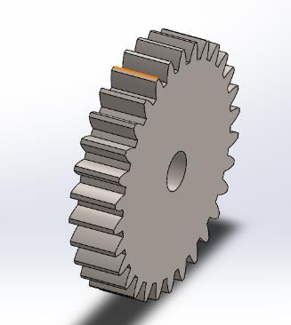
Spur gear PISTON
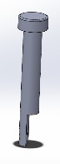
Pistons are the reciprocating part of the engine. The pistons have to and FRO movements along one direction and are the primary component that transfers the mechanical motion to the shaft. The pistons that are used here are made of mild steel. The bolt head is in the solenoid and the threaded part of the bolt is manufactured in such a way to be attached to the shaft with the help of an additional connecting rod.

Piston SCREWS AND NUTS
The screws and nuts are an important part of any mechanical component. They are components that are critical in holding towards different parts and components of the entire machine. The advantage of screws and nuts over the other types of fastening devices is that they are reliable in the long term, the do not need highly complex instruments to assemble them and they can easily be removed and put back together again and are thus performed in most of the machinery. The different types of screws and nuts that are used in this solenoid engines are cast iron

L-BRACKET
The L-Bracket that is used here is as the name suggests in L in shape and is used to hold the shaft straight. The L brackets are made of stainless steel. Its main purpose is to provide support to the shaft and make sure that the shaft does not undergo any deformation or bending due to the various forces acting on it.
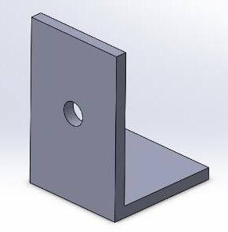
L bracket FLYWHEEL
The flywheel that is being used here is made up of mild steel. The flywheel is in cylindrical shape and its basic function is to transmit the energy. It is used to regulate the engine’s rotation to make sure that is rotating at a steady speed. The amount of energy is present and stored in the flywheel as inertia force comes to play.
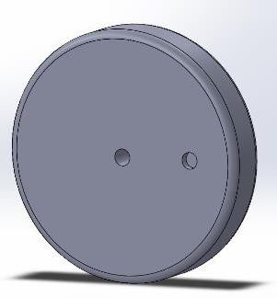
Flywheel CRANK WEB
The crank web is part of the crankshaft, it is the key component that is able to do the conversion of the reciprocating energy to rotational energy. The crank webs are present in various shapes and forms. Here, we make use of the circular crank webs as they are easy to manufacture as compared to the other ones and hand in operation due to its symmetricity.
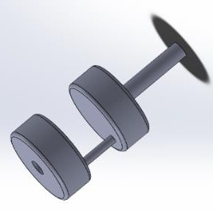
Crank web

SOLENOID
The solenoid is a tightly wound wire around a cylindrical pipe. This produces the electromagnetic effect that was discussed at the start of the paper. The power of the said solenoid is dependent on various factors like, diameter of the pipe, the diameter of the wire, the number of turns of wire over the solenoid and the amount of current that is being passed through the wire. The solenoid that is used has 1400 copper turns and of 25 gauge and the inner material is aluminum as it is a nonmagnetic material.

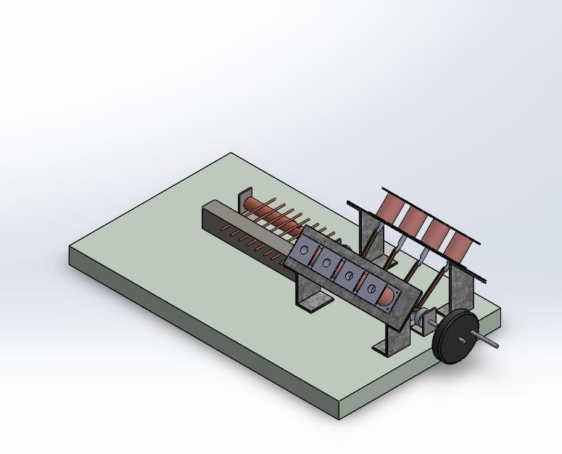
Assembly of solenoid engine

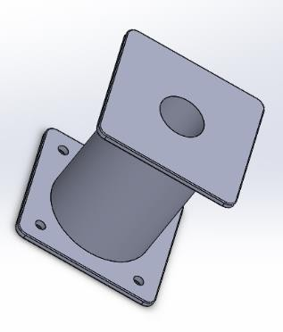
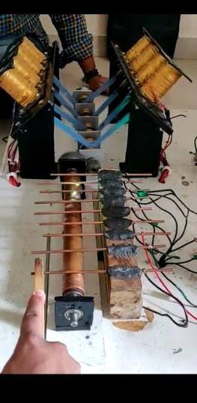
Solenoid coil
Cam Shaft

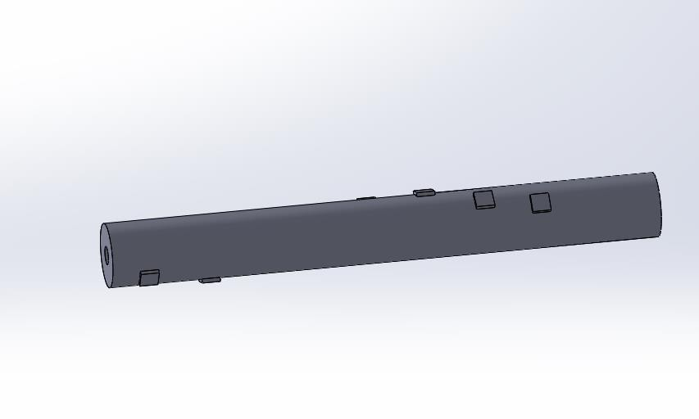
Cam shaft here used is a cooper rod with indents on it made of copper and is used for timing the power supply to the coils in order to fire properly. The camshaft is connected to the crank shaft with the help of the spur gears mentioned above.

Real assembly of v8 solenoid engine

Cam shaft
- ASSEMBLY
The above-mentioned parts are used in assembly and used in required numbers.

MATERIALS USED
- Copper
- Mild steel
- Phosphorus bronze
- Stainless steel
- Wood
- En-8

ANALYSIS
The analysis of piston and gears is done in ANSYS. Total heat flux and temperature distribution on the piston and stress distribution on the gears is done
The total heat flux in the piston is more at top when compared to the bottom.

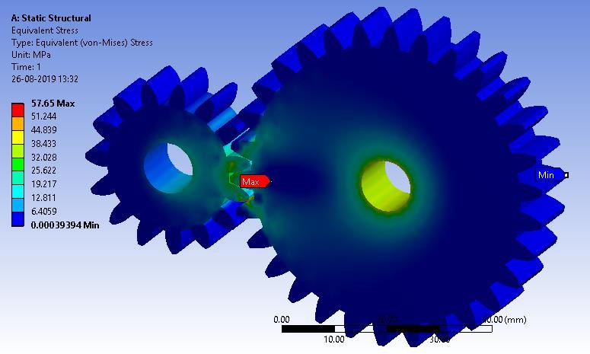

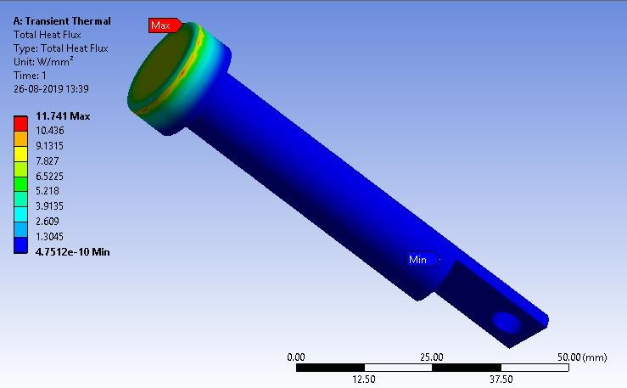
Total heat flux in piston
The temperature gradient in the piston shows that the temperature distribution in piston which is more at the top and decreases when going down
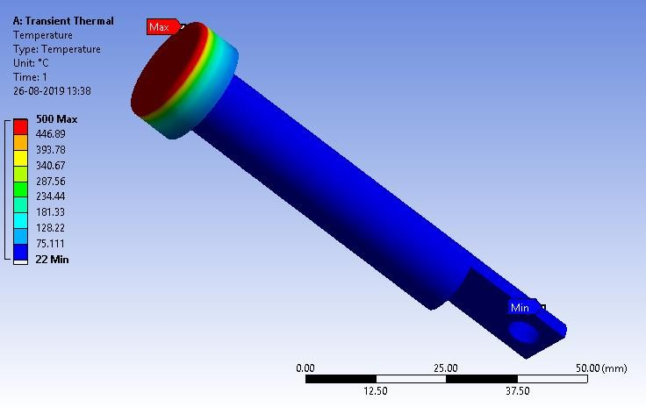
Temperature gradient in the piston

The static structural deformation shows the deformation stress in two spur gears which is greater in larger one when compared to the smaller one
Total deformation in gears
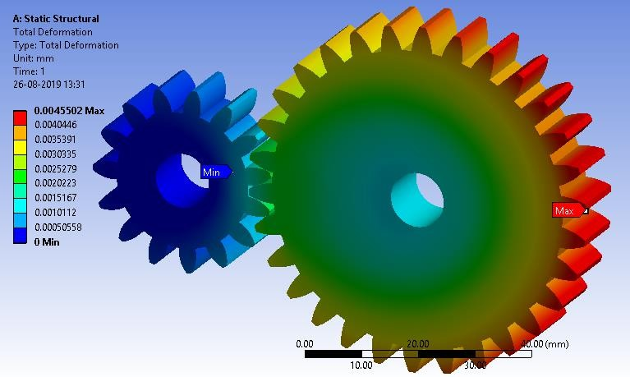

Total deformation in gears

The equivalent stress in the two gears are shown here which is not considerable because the material used and the design is way more taken high values than the required so we can’t see any stress in two gears
Equivalent stress

CALCULATIONS

These calculations are done on exemplary basis Input voltage = 36 V
Input current = 1 A
Input Power = Voltage × Current = 36 × 1 = 36W Max. Force exerted by electromagnet on piston F1 = (N2 I 2KA)/2G2
Where, N = number of turns = 1000
I = Current flowing through coil = 1 A
K = Permeability of free space = 4π×10-7
A = Cross-sectional area of electromagnet (radius r = 0.0175 m)
G = Least distance between electromagnet and permanent magnet = 0.005 m
On substitution, we get Max. Force F1 = 24.18 N
Force exerted by permanent magnet Force F2 = (B2A)/2µ0 Where, B = Flux density (T)
A = Cross-sectional area of magnet (radius r = 0.0125 m) µ 0 = Permeability of free space = 4π×10-7
Now flux density B = Br /2 × [(D + z)/(R2 + (D + z)2 ) 0.5 – z/(R2 + z 2 ) 0.5]
Where, Br = Remanence field = 1.21
T z = distance from a pole face = 0.005 m D = thickness of magnet = 0.012 m
R = semi-diameter of the magnet = 0.0125 m
On substitution we get flux density, B = 0.2547 T
Now substituting B in the equation of force, F 2 = 12.67 N Since, force F 1 and F 2 are repulsive,
Total force F = F 1 + F 2 F = 36.85 N Torque T = F × r
r = crank radius = 0.01m Torque T = 0.3685 N-m
Mass of Fly wheel ω = (2πN)/60, where N = speed = 200rpm Therefore ω = 20.94 rad/s
Energy stored on flywheel E = T × θ
Where T = torque θ = Angle of rotation = 180o = π radians On substitution we get energy stored E = 1.157 J
Also, E = 0.5 × I × ω 2
Where, I = moment of inertia of flywheel ω = angular velocity
On substitution we get moment of inertia, I = 5.277 × 10-7 Kg-m 2
Moment of inertia, I = 0.5 × m × r 2 Where, m = mass of fly wheel

r = radius of fly wheel = 0.07 m
On substitution, we get m = 2.154 Kg Output power
P = (2πNT)/60
Where, N = speed = 200 rpm T = Torque = 0.3685 N-m
On substitution, we get Output power P = 7.718 W Efficiency = (Output/Input) × 100 = (7.718/36) × 100 Therefore, Efficiency = 21.44

CONCLUSION

Based on our calculations we have obtained an efficiency of 21.44% and it can be increased by improving the design and selecting suitable materials which perform well in the given conditions, that is, making the mechanisms more fluid thereby reducing the friction and stresses induced. With that being said the current solenoid coils are limited by the fact that there is a high drop in efficiency due the unwanted heat generated by the coils. Even if this phenomenon is utilized for other purposes as done in an conventional Combustion Engine we are limited to today's technological advancements to further up the efficiency, however this model shows great promise for the future where today's limitations are overcome by new innovations.

REFERENCES

- Leland W. Gifford; "reciprocating electromagnetic engine"; US 5457349 A
- AmarnathJayaprakash, Balaji, G., Bala Subramanian; "Studies On Electromagnetic Engine"
- DruvaKumar.L1, Jathin.P ;"Future Energy Redefined By Magnetics"
- B. L. TherejaElectrical Technology, Volume II, pp.866 to 886 and Electro Droid software for Magnetic Coil Calculations

